3.1.1 - 3D View by tools - Tool Shelf
Detailed Table of content 2
Introduction 41
Tool Shelf 41
Tool Shelf in Object Mode 42
Tool Shelf in Object Mode - Tools Tab 42
Tool Shelf in Object Mode - Create Tab 47
Tool Shelf in Object Mode - Relations Tab 63
Tool Shelf in Object Mode - Animation Tab 70
Tool Shelf in Object Mode - Physics Tab 74
Tool Shelf in Edit Mode 77
Tool Shelf in Edit Mode - Mesh Object, Relations Tab 77
Tool Shelf in Edit Mode - Mesh Object, Tools Tab 77
Tool Shelf in Edit Mode - Mesh Object, Create Tab 121
Tool Shelf in Edit Mode - Mesh Object, Shade/UV's Tab 122
Tool Shelf in Edit Mode - Mesh Object, Options Tab 129
Tool Shelf in Edit Mode - Curve Object, Relations Tab 129
Tool Shelf in Edit Mode - Curve Object, Tools Tab 129
Tool Shelf in Edit Mode - Curve Object, Create Tab 137
Tool Shelf in Edit Mode - Curve Object, Options Tab 137
Tool Shelf in Edit Mode - Surface Object, Tools Tab 139
Tool Shelf in Edit Mode - Surface Object, Create Tab 143
Tool Shelf in Edit Mode - Surface Object, Relations Tab 144
Tool Shelf in Edit Mode - Metaball Object, Tools Tab 144
Tool Shelf in Edit Mode - Metaball Object, Create Tab 145
Tool Shelf in Edit Mode - Metaball Object, Relations Tab 145
Tool Shelf in Edit Mode - Text Object, Tools Tab 145
Tool Shelf in Edit Mode - Text Object, Relations Tab 146
Tool Shelf in Edit Mode - Armature Object, Tools Tab 147
Tool Shelf in Edit Mode - Armature Object, Relations Tab 150
Tool Shelf in Edit Mode - Armature Object, Options Tab 151
Tool Shelf in Edit Mode - Lattice Object, Tools Tab 153
Tool Shelf in Edit Mode - Force Field, Curve Guide Force 154
Tool Shelf in Pose Mode 155
Tool Shelf in Pose Mode - Armature Object, Tools Tab 155
Tool Shelf in Pose Mode - Armature Object, Relations Tab 160
Tool Shelf in Pose Mode - Armature Object, Options Tab 161
Tool Shelf in Sculpt Mode 161
Tool Shelf in Sculpt Mode - Mesh Object, Tools Tab 161
Tool Shelf in Sculpt Mode - Mesh Object, Options tab 179
Tool Shelf in Vertex Paint Mode 181
Tool Shelf in Vertex Paint Mode - Mesh Object, Tools Tab 182
Tool Shelf in Vertex paint Mode - Mesh Object, Options tab 196
Tool Shelf in Weight Paint Mode 197
Tool Shelf in Weight Paint Mode - Mesh Object, Tools Tab 201
Tool Shelf in Weight Paint Mode - Options Tab 215
Tool Shelf in Texture Paint Mode 217
Tool Shelf in Texture Paint Mode - Mesh Object, Tools Tab 217
Tool Shelf in Texture Paint Mode - Slots Tab 246
Tool Shelf in Texture Paint Mode - Options Tab 248
Tool shelf in Particle edit mode - Tools Tab 251
Tool Shelf in all Modes but Edit Mode 256
Tool Shelf in all Modes but Edit Mode - Layers Tab 256
Tool Shelf in all Modes - Grease Pencil Tab 259
Tool Shelf in all Modes - Tools Tab - Snap panel 269
Tool Shelf in all Modes - Tools Tab - Transform panel 270
Tool Shelf in all Modes - Tools Tab - History Panel 280
Tool Shelf in all Modes - Tools Tab - Bake Panel general 280
Tool Shelf in all Modes - Tools Tab - Bake Blender Render 281
Tool Shelf in all Modes - Tools Tab - Bake Cycles 284

Detailed Table of content

3.1.1 - 3D View by tools - Tool Shelf
Detailed Table of content 2
Introduction 41
Tool Shelf 41
Tool Shelf in Object Mode 42
Tool Shelf in Object Mode - Tools Tab 42
Edit Panel 42
Object Type Mesh, Curve, Surface 42
Mirror 42
Last Operator Mirror 42
Constraint Axis 42
Orientation 42
Proportional Editing 42
Proportional Editing Falloff 43
Proportional size 43
Edit Grease Pencil 43
Confirm on Release 43
Join 43
Set Origin 43
Last Operator Set Origin 43
Type 43
Centre 43
Shading 43
Auto Smooth 44
Data Transfer 44
Data 44
Last Operator Transfer Mesh Data 44
Freeze Operator 44
Data Transfer 44
Create Data 44
Edge Mapping 44
Auto Transform 44
Object Transform 44
Only Neighbour Geometry 45
Ray Radius 45
Mix Mode 45
Mix Factor 45
Data Layout 45
Last Operator Transfer Mesh Data Layout 45
Data Type 45
Exact Match 45
Source Layers Selection 45
Destination Layers Matching 45
Join UV's / UV Map 45
Object Type Meta ball, Lamp, Camera, Speaker, Empties, Force Fields 46
Mirror 46
Last Operator Mirror 46
Constraint Axis 46
Orientation 46
Proportional Editing 46
Proportional Editing Falloff 46
Proportional size 46
Edit Grease Pencil 46
Confirm on Release 46
Tool Shelf in Object Mode - Create Tab 47
Mesh Panel 47
Mesh 47
Plane 47
Last Operator Add Plane Panel 47
Cube 48
Last Operator Add Cube Panel 48
Circle 48
Last Operator Add Circle Panel 48
UV Sphere 48
Last Operator Add UV Sphere Panel 48
Ico Sphere 48
Last Operator Add Ico Sphere Panel 49
Cylinder 49
Last Operator Add Circle Panel 49
Cone 49
Last Operator Add Cone Panel 49
Torus 50
Last Operator Add Torus Panel 50
Grid 50
Last Operator Add Grid Panel 50
Monkey 50
Last Operator Add Monkey Panel 50
Misc Panel 51
Text 51
Last Operator Add Text 51
Armature 51
Last Operator Add Armature 51
Lattice 51
Usage 51
Last Operator Add Lattice object 52
Camera 52
Last Operator Add Camera 52
Speaker 52
Last Operator Add Speaker 52
Group Instance 52
Addons Add 53
Curve Panel 53
Bezier 53
Circle 53
Nurbs Curve 53
Nurbs Circle 53
Path 53
Last Operator Add Curve 53
Draw Curve 54
Surface Panel 54
Nurbs Curve 54
Nurbs Circle 54
Nurbs Surface 54
Nurbs Cylinder 54
Nurbs Sphere 54
Nurbs Torus 54
Last Operator Add Surface 54
Metaballs Panel 55
Ball 55
Capsule 55
Plane 55
Ellipsoid 55
Cube 55
Last Operator Add Meta ball 55
Group Instance 55
Lamp Panel 56
Point 56
Sun 56
Spot 56
Hemi 56
Area 56
Last Operator Add Lamp 56
Empties Panel 56
Last Operator Add Empty 57
Force Field Panel 57
Last Operator Add Effector 57
Add Modals Panel 58
Mini Lightlib Panel 59
Select Asset 59
Append Asset 59
Path Edit box 59
Simple Usage 60
Preparation 60
Load Assets 60
The available light set-ups 60
Tool Shelf in Object Mode - Relations Tab 63
Group 63
New Group 63
Last Operator Create New Group 63
Add to Active 63
Last Operator Add Selected to Active Group 63
Remove from Group 64
Last Operator Remove from Group 64
Remove from Active 64
Last Operator Remove from Group 64
Remove from All 64
Parent 64
Set Parent to Mesh Object 65
Object 65
Object (Keep Transform) 65
Vertex 65
Vertex (Triangle) 65
Last Operator Make Parent to mesh object 65
Set Parent to Armature 65
Object 65
Object (Keep Transform) 65
Armature Deform 65
With Empty Groups 65
With Envelope Weights 66
With Empty Groups 66
Bone 66
Bone Relative 66
Last Operator Make Parent to Armature 66
Set Parent to Curve 66
Object 66
Object (Keep Transform) 66
Curve Deform 66
Follow path 67
Path Constraint 67
Vertex 67
Vertex (Triangle) 67
Last Operator Make Parent to Curve 67
Set Parent to other object types 67
Object 67
Object (Keep Transform) 67
Last Operator Make Parent to other object types 67
Clear Parent 68
Clear Parent 68
Clear and Keep Transformation 68
Clear Parent Inverse 68
Last Operator Clear Parent 68
Object Data 68
Link Data 68
Last Operator Link Data 68
Make Single User 68
Last Operator Make Single User 68
Link to SCN 69
Last Operator Link Objects to Scene 69
Scene 69
Linked Objects 69
Make Local 69
Make Proxy 69
Tool Shelf in Object Mode - Animation Tab 70
Keyframes 70
Insert 70
Insert Keyframe Menu 70
Remove 70
Bake Action 71
Last Operator Bake Action 71
Start Frame 71
End Frame 71
Frame Step 71
Only Selected 71
Visual Keying 71
Clear Constraints 71
Clear Parents 71
Overwrite current Action 71
Bake Data 71
Clear 71
Set Keying Set 71
Location 72
Rotation 72
Scale 72
LocRot 72
LocScale 72
LocRotScale 72
RotScale 73
Visual Location 73
Visual Rotation 73
4Visual Scale 73
Visual LocRot 73
Visual LocScale 73
Visual LocRotScale 73
Visual RotScale 73
Delta Location 73
Delta Rotation 73
Delta Scale 73
Available 73
Motion Paths 74
Calculate 74
Last Operator Calculate Object Path 74
Clear 74
Tool Shelf in Object Mode - Physics Tab 74
Add / Remove 75
Add Active 75
Add Passive 75
Last Operator Add Rigid bodies 75
Remove 75
Object Tools 75
Change shape 75
Last Operator Change Collision shape 75
Calculate Mass 76
Last Operator Calculate Mass 76
Copy from Active 76
Apply visual transform 76
Bake to Keyframe 76
Constraints 76
Connect 76
Last Operator Connect Rigid Bodies 77
Tool Shelf in Edit Mode 77
Tool Shelf in Edit Mode - Mesh Object, Relations Tab 77
Relations Panel 77
Tool Shelf in Edit Mode - Mesh Object, Tools Tab 77
Mesh Tools Panel 78
Shrink/Fatten 78
Last Operator Shrink/Fatten 78
Offset 78
Offset Even 78
Proportional Editing 78
Proportional Editing Falloff 79
Proportional size 79
Confirm on Release 79
Mirror 79
Last Operator Mirror 79
Constraint Axis 79
Orientation 79
Proportional Editing 79
Proportional Editing Falloff 79
Proportional size 79
Edit Grease Pencil 79
Confirm on Release 79
Mirror Vertex Group 80
Last Operator Mirror Vertex Group 80
Mirror Weights 80
Flip Group Names 80
All Groups 80
Topology Mirror 80
Symmetrize 80
Last Operator Symmetrize 80
Direction 80
Threshold 80
Modify section 81
Extrude Region 81
Last Operator Extrude Region and Shrink/Fatten 81
Extrude Individual Faces 81
Offset Even 81
Proportional Editing 81
Proportional Editing Falloff 82
Proportional size 82
Confirm on Release 82
Individual Faces 82
Last Operator Extrude Individual Faces and Move 82
Extrude Individual Faces 82
Shrink/Fatten Offset 82
Offset Even 82
Proportional Editing 82
Proportional Editing Falloff 83
Proportional size 83
Confirm on Release 83
Extrude Drop-down box 83
Dupli Extrude 83
Dupli Extrude - with selected Faces 83
Dupli Extrude - with selected Vertices 84
Extrude Region 84
Last Operator Region and Move 84
Extrude Region label 84
Translate Vector 84
Constraint Axis 84
Orientation 84
Proportional Editing 85
Proportional Editing Falloff 85
Proportional size 85
Edit Grease Pencil 85
Edit Texture Space 85
Confirm on Release 85
Extrude Individual - In Face mode 85
Last Operator Extrude Individual Faces and Move 85
Extrude Individual Faces 85
Shrink/Fatten Offset 85
Offset Even 85
Proportional Editing 86
Proportional Editing Falloff 86
Proportional size 86
Confirm on Release 86
Extrude Individual in Edge and Vertice Mode 86
Spin 86
Last Operator Spin 86
Steps 86
Dupli 86
Centre 86
Axis 86
Screw 87
Last Operator Screw 87
Steps 87
Turns 87
Centre 87
Axis 87
Inset 87
Last Operator Inset 87
Boundary 87
Offset Even 87
Offset Relative 87
Edge Rail 87
Thickness 88
Depth 88
Outset 88
Select Outer 88
Individual 88
Interpolate 88
Make Edge/Face 88
Bevel 88
Last Operator Bevel 88
Amount type 89
Amount 89
Segments 89
Profile 89
Vertex only 89
Clamp Overlap 89
Loop Slide 89
Material 89
Vertex Bevel 89
Subdivide 89
Last Operator Subdivide 90
Number of Cuts 90
Smoothness. 90
Quad/Tri Mode 90
Quad Corner Type 90
Fractal 90
Along Normal 90
Random Seed 90
Bridge Edgeloops 90
Last Operator Bridge Edgeloops 90
Connect Loops 90
Merge 90
Merge Factor 90
Twist 90
Number of Cuts 90
Interpolation 90
Smoothness 91
Profile Factor 91
Profile shape 91
Cut Slide panel 91
Knife tool 91
Last Operator Knife Topology Tool 91
Knife Select Tool 91
Last Operator Knife Topology Tool 91
Loop Cut and Slide 92
Last Operator Loop Cut and Slide 92
Number of Cuts 92
Smoothness 92
Falloff 92
Edge Slide Factor 92
Even 92
Flipped 92
Clamp 92
Correct UV's 92
Confirm on Release 92
Offset Edge Slide 92
Last Operator Offset Edge Slide 92
Cap Endpoint 92
Edge Slide Factor 93
Even 93
Flipped 93
Clamp 93
Correct UV's 93
Confirm on Release 93
Knife Project 93
Last Operator Knife Project 93
Cut through 93
Bisect 93
Last Operator Bisect 94
Plane Point 94
Plane Normal 94
Fill 94
Clear Inner 94
Clear Outer 94
Axis threshold 94
Merge / Separate 94
Merge 94
Last Operator Merge 94
Type 94
UV's 94
Separate 94
Deform section 95
Edge Slide 95
Last Operator Edge Slide 95
Factor 95
Even 95
Flipped 95
Clamp 95
Correct UV's 95
Confirm on Release 95
Vertex Slide 96
Last Operator Vertex Slide 96
Factor 96
Even 96
Flipped 96
Clamp 96
Correct UV's 96
Confirm on Release 96
Smooth Vertex 96
Last Operator Smooth Vertex 96
Smoothing 96
Repeat 96
Axis 97
Laplacian Smooth Vertex 97
Last Operator Laplacian Smooth Vertex 97
Number of Iterations 97
Lambda Factor 97
Lambda Factor in border 97
Smooth Axis 97
Preserve Volume 97
Dissolve Section 97
Dissolve Vertices 98
Last Operator Dissolve Vertices 98
Face Split 98
Tear Boundary 98
Dissolve Edges 98
Last Operator Dissolve Edges 98
Dissolve Verts 98
Face Split 98
Dissolve Faces 98
Last Operator Dissolve Faces 98
Dissolve Verts 98
Remove Doubles 98
Last Operator Remove Doubles 98
Merge Distance 98
Unselected 98
Limited Dissolve 99
Last Operator Limited Dissolve 99
Max Angle 99
All Boundaries 99
Delimit 99
Dissolve Selection 99
Last Operator Dissolve Selection 99
Dissolve Verts 99
Face Split 99
Tear Boundary 99
Edge Collapse 99
F2 Tool 99
Vertices Tools Panel 100
Rip 100
Last Operator Rip 100
Vector 100
Constraint Axis 100
Orientation 100
Proportional Editing 100
Proportional Editing Falloff 101
Proportional Size 101
Edit Grease Pencil 101
Edit Texture Space 101
Rip Fill 101
Last Operator Rip Fill 101
Vector 101
Constraint Axis 101
Orientation 101
Proportional Editing 101
Proportional Editing Falloff 102
Proportional Size 102
Edit Grease Pencil 102
Edit Texture Space 102
Extend Vertices 102
Last Operator Extend Vertices 102
Vector 102
Constraint Axis 102
Orientation 102
Proportional Editing 102
Proportional Editing Falloff 103
Proportional Size 103
Edit Grease Pencil 103
Edit Texture Space 103
Split 103
Connect Vertex Path 103
Connect Vertices 103
Convex Hull 104
Last Operator Convex Hull 104
Delete Unused 104
Use existing Faces 104
Make Holes 104
Join Triangles 104
Max Face Angle 104
Max Shape Angle 104
Compare UV's 104
Compare Vcols 104
Compare Seam 104
Compare Sharp 104
Compare Materials 105
Edges Tools Panel 105
Subdivide Edge ring 105
Last Operator Subdivide Edge ring 105
Number of Cuts 105
Interpolation 105
Smoothness 105
Profile Factor 105
Profile Shape 105
Un-Subdivide 106
Last Operator Un-Subdivide 106
Iterations 106
Edge Crease 106
Last Operator Edge Crease 106
Factor 106
Edge Bevel Weight 106
Last Operator Edge Bevel Weight 107
Factor 107
Mark Sharp 107
Last Operator Mark Sharp 107
Clear 107
Vertices 107
Clear Sharp 107
Last Operator Mark Sharp 107
Clear 107
Vertices 107
Rotate Edge CW 107
Last Operator Rotate Selected Edge 108
Counter Clockwise 108
Edge Split 108
Mark Freestyle Edge 108
Last Operator Mark Freestyle Edge 108
Clear 108
Clear Freestyle Edge 108
Last Operator Mark Freestyle Edge 108
Clear 108
Faces Tools Panel 108
Faces 109
Fill 109
Last Operator Fill 109
Beauty 109
Grid Fill 109
Last Operator Grid Fill 109
Span 109
Offset 109
Simple Blending 109
Beautify Faces 109
Last Operator Beautify Faces 109
Max Angle 109
Solidify 110
Last Operator Solidify 110
Thickness 110
Intersect 110
Last Operator Intersect 110
Source 110
Separate Mode 110
Merge Threshold 110
Intersect ( Boolean ) 111
Last Operator Intersect (Boolean) 111
Boolean 111
Swap 111
Merge Threshold 111
Wire Frame 111
Last Operator Wire Frame 112
Boundary 112
Offset Even 112
Offset Relative 112
Replace 112
Thickness 112
Offset 112
Crease 112
Crease Weight 112
Poke Faces 112
Last Operator Poke Faces 112
Poke Offset 112
Offset Relative 112
Poke Center 112
Triangulate Faces 113
Last Operator Triangulate Faces 113
Quad Method 113
Shortest diagonal 113
Fixed Alternate 113
Fixed 113
Beauty 113
Polygon Method 113
Clip 113
Beauty 113
Tris to Quads 113
Last Operator Tris to Quads 113
Max Face Angle 113
Max Shape Angle 113
Compare UV's 114
Compare VCols 114
Compare Seam 114
Compare Sharp 114
Compare Materials 114
Split by Edges 114
Rotate UV's 114
Last Operator Rotate UV's 114
Reverse UV's 114
Rotate Colors 115
Last Operator Rotate Colors 115
Counter Clockwise 115
Reverse Colors 115
Mark Freestyle Face 115
Clear Freestyle Face 115
Clean Up Panel 115
Delete Loose 116
Last Operator Delete Loose 116
Vertices 116
Edges 116
Faces 116
Decimate Geometry 116
Last Operator Decimate Geometry 116
Ratio 116
Vertex Group 116
Weight 116
Invert 116
Symmetry 116
Degenerate Dissolve 117
Make Planar Faces 117
Last Operator Make Planar Faces 117
Factor 117
Iterations 117
Split Non-Planar Faces 117
Last Operator Split Non-Planar Faces 117
Max Angle 117
Split Concave Faces 117
Fill Holes 118
Last Operator Fill Holes 118
Sides 118
Weight Tools panel 118
Normalize All 118
Last Operator Normalize all 118
Subset 118
Lock Active 119
Normalize 119
Mirror 119
Last Operator Mirror Vertex Group 119
Mirror Weights 119
Flip Group Names 119
All Groups 119
Topology Mirror 119
Invert 119
Last Operator Invert Vertex Group 119
Subset 119
Add Weights 119
Remove Weights 119
Clean 119
Last Operator Clean Vertex Group 120
Subset 120
Limit 120
Keep Single 120
Quantize 120
Last Operator Quantize 120
Subset 120
Steps 120
Levels 120
Last Operator Levels 120
Subset 120
Offset 120
Gain 120
Smooth 120
Last Operator Smooth Vertex Weights 120
Subset 120
Factor 121
Iterations 121
Expand/Contract 121
Source 121
Limit Total 121
Last Operator Limit Total 121
Subset 121
Limit 121
Fix Deforms 121
Last Operator Fix Deforms 121
Distance 121
Strength 121
Change Sensitivity 121
Tool Shelf in Edit Mode - Mesh Object, Create Tab 121
Add Meshes Panel 122
Tool Shelf in Edit Mode - Mesh Object, Shade/UV's Tab 122
Shading Panel 122
Faces, Edges and Vertices 122
Faces 122
Smooth 122
Flat 122
Edges 123
Smooth 123
Sharp 123
Vertices 123
Smooth 123
Sharp 123
Normals 123
Recalc Outside 123
Last Operator Recalc Outside 123
Inside 123
Recalc Inside 123
Flip 123
Set from Faces 123
UVs Panel 123
UV Mapping 124
Unwrap ABF 124
Unwrap LSCM 124
Last Operator Unwrap 124
Method 124
Fill Holes 124
Correct Aspect 124
Use Subsurf Modifier 124
Margin 124
Smart UV Project 124
Smart UV Project Settings dialogue 124
Angle Limit 124
Island Margin 125
Area Weight 125
Correct Aspect 125
Last Operator Smart UV Project 125
Angle Limit 125
Island Margin 125
Area Weight 125
Correct Aspect 125
Lightmap Pack 125
Settings 125
Selection 125
Share Tex Space 125
New UV Map 125
New Image 125
Image Size 125
Pack Quality 126
Margin 126
Follow Active Quads 126
Settings 126
Edge Length Mode 126
Last Operator Follow Active Quads 126
Edge Length Mode 126
Cube Projection 126
Last Operator Cube Projection 126
Cube Size 126
Correct Aspect 126
Clip to Bounds 126
Scale to Bounds 126
Cylinder Projection 126
Last Operator Cylinder Projection 127
Direction 127
Align 127
Radius 127
Correct Aspect 127
Clip to Bounds 127
Scale to Bounds 127
Sphere Projection 127
Last Operator Sphere Projection 127
Direction 127
Align 127
Correct Aspect 127
Clip to Bounds 127
Scale to Bounds 127
Project from View 127
Last Operator Project from View 127
Orthographic 127
Camera Bounds 128
Correct Aspect 128
Clip to Bounds 128
Scale to Bounds 128
Project from View (Bounds) 128
Reset 128
Mark Seam 128
Last Operator Mark Seam 128
Clear 128
Clear Seam 129
Tool Shelf in Edit Mode - Mesh Object, Options Tab 129
Mesh Options Panel 129
X Mirror 129
Topology Mirror 129
Edge Select Mode 129
Live Unwrap 129
Double Threshold 129
Tool Shelf in Edit Mode - Curve Object, Relations Tab 129
Relations Panel 129
Tool Shelf in Edit Mode - Curve Object, Tools Tab 129
Curve Tools Panel 130
Tilt 130
Last Operator Tilt 130
Angle 130
Proportional Editing 130
Proportional Editing Falloff 130
Proportional Size 130
Confirm on Release 130
Shrink/ Fatten 131
Last Operator Transform 131
Values 131
Constraint Axis 131
Proportional Editing 131
Proportional Editing Falloff 131
Proportional Size 131
Edit Grease Pencil 131
Confirm on Release 131
Mirror 131
Last Operator Mirror 131
Constraint Axis 132
Orientation 132
Proportional Editing 132
Proportional Editing Falloff 132
Proportional size 132
Edit Grease Pencil 132
Confirm on Release 132
Curve 132
Toggle Cyclic 132
Last Operator Toggle Cyclic 132
Direction 132
Switch Direction 132
Set Spline Type 133
Last Operator Set Spline Type 133
Type 133
Handles 133
Set Curve Radius 133
Last Operator Set Radius 133
Radius 133
Handles 133
Auto 133
Vector 133
Align 133
Free 133
Last Operator Set Handle Type 133
Type 133
Recalc Normals 134
Last Operator Recalc Normals 134
Length 134
Modelling 134
Extrude 134
Last operator Extrude Curve and Move 134
Extrude 134
Mode 134
Translate 134
Vector 134
Constraint Axis 134
Orientation 134
Proportional Editing 134
Proportional Editing Falloff 135
Proportional size 135
Edit Grease Pencil 135
Edit Texture Space 135
Confirm on Release 135
Subdivide 135
Smooth 135
Split 135
Separate 135
Make Segment 136
Add Vertex 136
Last Operator Add Vertex 136
Location 136
Smooth Curve Tilt 136
Smooth Curve Radius 136
Smooth Curve Weight 136
Set Goal Weight 136
Last Operator Set Goal Weight 137
Weight 137
Tool Shelf in Edit Mode - Curve Object, Create Tab 137
Add Curves Panel 137
Tool Shelf in Edit Mode - Curve Object, Options Tab 137
Curve Stroke Panel 137
Curve Stroke Panel type Bezier 137
Type 137
Bezier Options 137
Tolerance 137
Method 137
Detect Corners 137
Corner Angle 137
Pressure Radius 138
Taper Radius 138
Projection depth 138
Cursor 138
Surface 138
Offset 138
Absolute Offset 138
Only First 138
Curve Stroke Panel type Poly 138
Type 138
Pressure Radius 138
Taper Radius 138
Projection depth 138
Cursor 139
Surface 139
Offset 139
Absolute Offset 139
Only First 139
Tool Shelf in Edit Mode - Surface Object, Tools Tab 139
Surface Tools Panel 139
Mirror 139
Last Operator Mirror 139
Constraint Axis 139
Orientation 139
Proportional Editing 140
Proportional Editing Falloff 140
Proportional size 140
Edit Grease Pencil 140
Confirm on Release 140
Curve 140
Toggle Cyclic 140
Last Operator Toggle Cyclic 140
Direction 140
Switch Direction 140
Modelling 140
Extrude 141
Last operator Extrude Curve and Move 141
Extrude 141
Mode 141
Translate 141
Vector 141
Constraint Axis 141
Orientation 141
Proportional Editing 141
Proportional Editing Falloff 141
Proportional size 141
Edit Grease Pencil 141
Edit Texture Space 141
Confirm on Release 141
Spin 142
Last Operator Spin 142
Centre 142
Axis 142
Subdivide 142
Split 142
Separate 142
Make Segment 142
Add Vertex 142
Last Operator Add Vertex 143
Location 143
Smooth Curve Tilt 143
Smooth Curve Radius 143
Smooth Curve Weight 143
Set Goal Weight 143
Last Operator Set Goal Weight 143
Weight 143
Tool Shelf in Edit Mode - Surface Object, Create Tab 143
Add Surfaces Panel 144
Tool Shelf in Edit Mode - Surface Object, Relations Tab 144
Relations Panel 144
Tool Shelf in Edit Mode - Metaball Object, Tools Tab 144
Meta Tools Panel 144
Mirror 144
Last Operator Mirror 144
Constraint Axis 144
Orientation 144
Proportional Editing 145
Proportional Editing Falloff 145
Proportional size 145
Edit Grease Pencil 145
Confirm on Release 145
Tool Shelf in Edit Mode - Metaball Object, Create Tab 145
Add Metaball Panel 145
Tool Shelf in Edit Mode - Metaball Object, Relations Tab 145
Relations Panel 145
Tool Shelf in Edit Mode - Text Object, Tools Tab 145
Text Tools Panel 146
Set Case 146
Last Operator Set Case 146
Case 146
To Upper 146
To Lower 146
Style 146
Last Operator Toggle Style 146
Bold 146
Italic 146
Underline 146
Toggle Small Caps 146
Tool Shelf in Edit Mode - Text Object, Relations Tab 146
Relations Panel 147
Tool Shelf in Edit Mode - Armature Object, Tools Tab 147
Armature Tools Panel 147
Mirror 147
Last Operator Mirror 147
Constraint Axis 147
Orientation 147
Proportional Editing 147
Proportional Editing Falloff 147
Proportional size 148
Edit Grease Pencil 148
Confirm on Release 148
Symmetrize 148
Last Operator Symmetrize 148
Direction 148
Bones section 148
Add 148
Last Operator Add Bone 148
Name 148
Merge Bones 148
Last Operator Merge Bones 149
Type 149
Fill between Joints 149
Split 149
Separate 149
Switch Direction 150
Tool Shelf in Edit Mode - Armature Object, Relations Tab 150
Relations Panel 150
Make Vertex Parent 150
Make 150
Connected 150
Keep Offset 151
Last Operator Make Parent 151
Parent Type 151
Tool Shelf in Edit Mode - Armature Object, Options Tab 151
Armature Options Panel 151
X Axis Mirror 151
Tool Shelf in Edit Mode - Lattice Object, Tools Tab 153
Lattice Tools Panel 153
Mirror 153
Last Operator Mirror 153
Constraint Axis 153
Orientation 153
Proportional Editing 153
Proportional Editing Falloff 153
Proportional size 153
Edit Grease Pencil 153
Confirm on Release 153
Mirror Vertex Group 154
Last Operator Mirror Vertex Group 154
Mirror Weights 154
Flip Group Names 154
All Groups 154
Topology Mirror 154
Make Regular 154
Tool Shelf in Edit Mode - Force Field, Curve Guide Force 154
Tool Shelf in Pose Mode 155
Tool Shelf in Pose Mode - Armature Object, Tools Tab 155
Pose Tools Panel 155
In Between 155
Push 155
Last Operator Push Pose 155
Previous Keyframe 155
Next Keyframe 155
Percentage 155
Relax 155
Last Operator Relax Pose 156
Previous Keyframe 156
Next Keyframe 156
Percentage 156
Channels 156
Axis Lock 156
Breakdowner 156
Last Operator Pose Breakdowner 156
Previous Keyframe 156
Next Keyframe 156
Percentage 156
Pose 156
Last Operator Propagate Pose 157
Terminate Mode 157
While Held 157
To Next Keyframe 157
To Last Keyframe 157
Before Frame 157
Before Last Keyframe 157
On Selected Keyframes 157
On Selected Markers 157
End Frame 157
Keyframes 157
Insert 158
Remove 158
Bake Action 158
Last Operator Bake Action 158
Start Frame 158
End Frame 158
Frame Step 158
Only Selected 158
Visual Keying 158
Clear Constraints 158
Clear Parents 158
Overwrite current Action 159
Bake Data 159
Set keying set 159
Motion Paths 159
Calculate Bone Paths 159
Last Operator Calculate Bone Paths 159
Start 159
End 159
Bake Locaton 160
Clear Bone Path 160
Last Operator Clear Bone Paths 160
Only Selected 160
Tool Shelf in Pose Mode - Armature Object, Relations Tab 160
Relations Panel 160
Parent 160
Set 160
Object 160
Object ( Keep Transform) 160
Armature Deform 160
With empty Groups 160
With Envelope Weights 160
With automatic Weights 160
Bone 160
Bone Relative 161
Last Operator Make Parent 161
Type 161
Keep Transform 161
Clear 161
Tool Shelf in Pose Mode - Armature Object, Options Tab 161
Pose Options Panel 161
Auto IK 161
Tool Shelf in Sculpt Mode 161
Tool Shelf in Sculpt Mode - Mesh Object, Tools Tab 161
Brush Panel 161
Browse Brush 161
Radius 162
Strength 163
Autosmooth 163
Sculpt Plane 163
Front Faces Only 163
Add / Subtract 163
Accumulate, Persistent, etc. 163
Texture Panel 164
Browse Texture to be linked 164
Texture Edit box 165
Brush Mapping 165
Brush Mapping with mapping method View Plane and Area Plane 166
Angle edit box 166
Rake 166
Random 166
Random edit box 166
Offset 166
Size 167
Sample Bias 167
Brush Mapping with mapping method Tiled 167
Angle edit box 167
Offset 167
Size 167
Sample Bias 167
Brush Mapping with mapping method 3D 168
Offset 168
Size 168
Sample Bias 168
Brush Mapping with mapping method Random 168
Angle edit box 169
Rake 169
Random 169
Random edit box 169
Offset 169
Size 169
Sample Bias 169
Brush Mapping with mapping method Stencil 169
Image Aspect 170
Stencil Brush controls 170
Angle edit box 170
Offset 170
Size 170
Stroke Panel 170
Stroke Panel with Stroke method Space 170
Spacing Edit Box 171
Jitter Edit Box 171
Smooth Stroke 171
Smooth Stroke Radius Edit Box 171
Smooth Stroke Factor Edit Box 171
Input Samples Edit Box 171
Stroke Panel with Stroke method Curve 171
Spacing Edit Box 172
Paint Curve edit box 172
Draw Curve Button 173
Jitter Edit Box 173
Input Samples Edit Box 173
Stroke Panel with Stroke method Line 173
Spacing Edit Box 173
Jitter Edit Box 174
Input Samples Edit Box 174
Stroke Panel with Stroke method Airbrush 174
Rate Edit Box 174
Jitter Edit Box 174
Smooth Stroke 175
Smooth Stroke Radius Edit Box 175
Smooth Stroke Factor Edit Box 175
Input Samples Edit Box 175
Stroke Panel with Stroke method Anchored 175
Edge to Edge 175
Input Samples Edit Box 175
Stroke Panel with Stroke method Drag dot 175
Input Samples Edit Box 176
Curve Panel 176
Navigation elements 176
Zoom in and out 176
Tools 176
Reset View 176
Vector Handle 176
Auto Handle 176
Auto Clamped Handle 176
Reset Curve 177
Curve Presets 177
Dyntopo Panel 177
Detail Size 177
Detail Refine method 177
Subdivide Collapse 178
Collapse Edges 178
Subdivide Edges 178
Detail Type Method 178
Brush Detail 178
Constant Detail 178
Relative Detail 178
Smooth shading 178
Optimize 178
Detail Floodfill 178
Direction 178
Symmetrize 179
Symmetry / Lock 179
Mirror 179
Radial 179
Feather 179
Lock 179
Tiling 179
Tile Offset 179
Tool Shelf in Sculpt Mode - Mesh Object, Options tab 179
Overlay Panel 180
Curve 180
Texture 180
Options Panel 180
Dab Gravity 180
Factor 180
Orientation 180
Threaded Sculpt 180
Fast Navigate 180
Use Deform only 180
Show Diffuse Color 180
Unified Settings 181
Size 181
Strength 181
Color 181
Enabled Brush Modes 181
Enabled Modes 181
Appearance Panel 181
Show Brush 181
Add 181
Subtract 181
Custom Brush Icon 181
Tool Shelf in Vertex Paint Mode 181
Tool Shelf in Vertex Paint Mode - Mesh Object, Tools Tab 182
Brush Panel 182
Browse Brush 182
Color dialog 183
Color Element 183
Radius 184
Strength 184
Blending Modes 184
Accumulate, Alpha, etc. 184
Palette Editbox 184
Display options 184
Texture Panel 185
Browse Texture to be linked 185
Texture Edit box 186
Brush Mapping 186
Brush Mapping with mapping method Tiled 187
Angle 187
Offset 187
Size 187
Brush Mapping with mapping method View Plane 187
Angle 187
Rake 187
Random 187
Offset 188
Size 188
Brush Mapping with mapping method 3D 188
Offset 188
Size 188
Brush Mapping with mapping method Random 188
Angle 189
Rake 189
Random 189
Offset 189
Size 189
Brush Mapping with mapping method Stencil 189
Image Aspect 189
Stencil Brush controls 189
Angle edit box 190
Offset 190
Size 190
Stroke Panel 190
Stroke Panel with Stroke method Space 190
Spacing Edit Box 190
Jitter Edit Box 191
Smooth Stroke 191
Smooth Stroke Radius Edit Box 191
Smooth Stroke Factor Edit Box 191
Input Samples Edit Box 191
Stroke Panel with Stroke method Curve 191
Spacing Edit Box 192
Paint Curve edit box 192
Draw Curve Button 193
Jitter Edit Box 193
Input Samples Edit Box 193
Stroke Panel with Stroke method Line 193
Spacing Edit Box 193
Jitter Edit Box 194
Input Samples Edit Box 194
Stroke Panel with Stroke method Airbrush 194
Rate Edit Box 194
Jitter Edit Box 194
Smooth Stroke 194
Smooth Stroke Radius Edit Box 194
Smooth Stroke Factor Edit Box 194
Input Samples Edit Box 195
Stroke Panel with Stroke method Dots 195
Jitter Edit Box 195
Smooth Stroke 195
Smooth Stroke Radius Edit Box 195
Smooth Stroke Factor Edit Box 195
Input Samples Edit Box 195
Curve Panel 195
Navigation elements 196
Zoom in and out 196
Tools 196
Reset View 196
Vector Handle 196
Auto Handle 196
Auto Clamped Handle 196
Reset Curve 196
Curve Presets 196
Tool Shelf in Vertex paint Mode - Mesh Object, Options tab 196
Overlay Panel 196
Curve 196
Texture 196
Appearance Panel 197
Show Brush 197
Color of cursor when adding 197
Custom Icon 197
Options Panel 197
Unified Settings 197
Size 197
Strength 197
Color 197
Enabled Brush Modes 197
Enabled Modes 197
Tool Shelf in Weight Paint Mode 197
Weight painting general 198
Weight painting at characters 198
Skinning 198
Enter and leave Weight painting 199
Switch bones 200
Weight painting without any further combination 200
Weight painting in combination with particles 200
Tool Shelf in Weight Paint Mode - Mesh Object, Tools Tab 201
Brush Panel 201
Browse Brush 201
Weight edit box 202
Radius 202
Strength 202
Blend 202
Darken 202
Lighten 202
Blur 202
Multiply 202
Subtract 202
Add 202
Mix 202
Auto Normalize 203
Multipaint 203
Stroke Panel 203
Stroke Panel with Stroke method Space 203
Spacing Edit Box 203
Jitter Edit Box 203
Smooth Stroke 203
Smooth Stroke Radius Edit Box 204
Smooth Stroke Factor Edit Box 204
Input Samples Edit Box 204
Stroke Panel with Stroke method Curve 204
Spacing Edit Box 204
Paint Curve edit box 205
Draw Curve Button 205
Jitter Edit Box 205
Input Samples Edit Box 205
Stroke Panel with Stroke method Line 205
Spacing Edit Box 206
Jitter Edit Box 206
Input Samples Edit Box 206
Stroke Panel with Stroke method Airbrush 206
Rate Edit Box 206
Jitter Edit Box 206
Smooth Stroke 206
Smooth Stroke Radius Edit Box 207
Smooth Stroke Factor Edit Box 207
Input Samples Edit Box 207
Stroke Panel with Stroke method Dots 207
Jitter Edit Box 207
Smooth Stroke 207
Smooth Stroke Radius Edit Box 207
Smooth Stroke Factor Edit Box 207
Input Samples Edit Box 207
Curve Panel 208
Navigation elements 208
Zoom in and out 208
Tools 208
Reset View 208
Vector Handle 208
Auto Handle 208
Auto Clamped Handle 208
Reset Curve 208
Curve Presets 208
Weight Tools 208
Normalize All 209
Last Operator Normalize All Vertex Groups 209
Subset 209
Lock Active 209
Normalize 209
Mirror 209
Last Operator Mirror Vertex Group 209
Mirror Weights 209
Flip Group Names 209
All Groups 209
Topology Mirror 209
Invert 209
Last Operator Invert Vertex Groups 209
Subset 209
Add Weights 210
Remove Weights 210
Clean 210
Last Operator Clean Vertex Groups 210
Subset 210
Limit 210
Keep Single 210
Quantize 210
Last Operator Quantize Vertex Weights 210
Subset 210
Steps 210
Levels 211
Last Operator Vertex Group Levels 211
Subset 211
Offset 211
Gain 211
Smooth 211
Last Operator Smooth Vertex Weights 211
Subset 211
Factor 211
Iterations 211
Expand/Contract 211
Source 212
Limit Total 212
Last Operator Limit Number of Weights 212
Subset 212
Limit 212
Fix Deforms 212
Usage 212
Last Operator Fix Vertex Group Deform 213
Distance 213
Strength 213
Change Sensitivity 213
Weight Gradient 213
Last Operator Weight Gradient 213
Type 213
Transfer Weights 213
Usage 213
Last Operator Transfer Mesh Data 214
Freeze Operator 214
Data Type 214
Create Data 214
Vertex Mapping 214
Auto Transform 214
Object Transform 214
Only Neighbour Geometry 214
Ray Radius 215
Source Layers Selection 215
Destination Layers Matching 215
Mix Mode 215
Mix Factor 215
Tool Shelf in Weight Paint Mode - Options Tab 215
Overlay Panel 215
Curve 215
Appearance Panel 215
Show Brush 215
Brush color 215
Custom Icon 215
Options Panel 216
Normals 216
Spray 216
Restrict 216
X Mirror 216
Topology Mirror 216
Show Zero Weights 216
None 216
Active 216
All 216
Unified Settings 216
Size 216
Strength 216
Weight 216
Enabled Brush Modes 216
Enabled Modes 216
Tool Shelf in Texture Paint Mode 217
Requirements 217
Available Renderers 217
Save Texture 217
Tool Shelf in Texture Paint Mode - Mesh Object, Tools Tab 217
Missing Data Panel 217
Add Simple UV's 218
Add Paint Slot 218
Add Paint Slot with Cycles 219
Add Paint Slot with Blender Internal 220
Brush Panel 221
Browse Brush 221
Color dialog 222
Color Element 223
Radius 223
Strength 223
Blend 223
Accumulate 224
Alpha 224
Use Gradient 224
Gradient Colors dialog 224
Usage 225
Palette 225
Texture Panel 226
Browse Texture to be linked 227
Texture Edit box 228
Brush Mapping 228
Brush Mapping with mapping method Tiled 229
Angle 229
Offset 229
Size 229
Brush Mapping with mapping method View Plane 229
Angle 229
Rake 229
Random 229
Offset 230
Size 230
Brush Mapping with mapping method 3D 230
Offset 230
Size 230
Brush Mapping with mapping method Random 230
Angle 230
Rake 230
Random 230
Offset 231
Size 231
Brush Mapping with mapping method Stencil 231
Image Aspect 231
Stencil Brush controls 231
Angle edit box 231
Offset 231
Size 232
Texture Mask Panel 232
Browse Texture to be linked 232
Brush Mapping with mapping method Tiled 233
Mask Pressure Mode 233
Angle 234
Offset 234
Size 234
Brush Mapping with mapping method View Plane 234
Mask Pressure Mode 234
Angle 234
Rake 234
Random 234
Offset 234
Size 234
Brush Mapping with mapping method Random 235
Mask Pressure Mode 235
Angle 235
Rake 235
Random 235
Offset 235
Size 235
Brush Mapping with mapping method Stencil 235
Mask Pressure Mode 236
Stencil Brush controls Secondary 236
Angle edit box 236
Offset 236
Size 236
Stroke Panel 236
Stroke Panel with Stroke method Space 237
Spacing Edit Box 237
Jitter Edit Box 237
Smooth Stroke 237
Smooth Stroke Radius Edit Box 237
Smooth Stroke Factor Edit Box 237
Input Samples Edit Box 237
Stroke Panel with Stroke method Curve 238
Spacing Edit Box 238
Paint Curve edit box 238
Draw Curve Button 239
Jitter Edit Box 239
Input Samples Edit Box 239
Stroke Panel with Stroke method Line 239
Spacing Edit Box 239
Jitter Edit Box 240
Input Samples Edit Box 240
Stroke Panel with Stroke method Airbrush 240
Rate Edit Box 240
Jitter Edit Box 240
Smooth Stroke 240
Smooth Stroke Radius Edit Box 240
Smooth Stroke Factor Edit Box 240
Input Samples Edit Box 240
Stroke Panel with Stroke method Dots 241
Jitter Edit Box 241
Smooth Stroke 241
Smooth Stroke Radius Edit Box 241
Smooth Stroke Factor Edit Box 241
Input Samples Edit Box 241
Curve Panel 241
Navigation elements 241
Zoom in and out 241
Tools 242
Reset View 242
Vector Handle 242
Auto Handle 242
Auto Clamped Handle 242
Reset Curve 242
Curve Presets 242
External Panel 242
Quick Edit 242
Apply 242
Resolution 242
Apply Camera Image 242
Preparations 243
Usage 244
Symmetry Panel 245
Tool Shelf in Texture Paint Mode - Slots Tab 246
Slots Panel 246
With painting mode Material 246
Painting Mode 246
Available Paint Slots 246
Save all Images 247
With painting mode Image 247
Painting Mode 247
Canvas Image 247
UV Map 247
Save all Images 247
Mask Panel 248
UV Map 248
Stencil Image 248
248
Visualization 248
Tool Shelf in Texture Paint Mode - Options Tab 248
Overlay Panel 249
Curve 249
Texture 249
Mask Texture 249
Appearance panel 249
Show Brush 249
Color Button 249
Custom Icon 249
Project Paint panel 250
Occlude 250
Cull 250
Normal 250
Cavity Mask 250
Bleed 250
Dither 250
Unified Settings 250
Size 250
Strength 250
Color 250
Enabled Brush Modes 250
Enabled Modes 250
Tool shelf in Particle edit mode - Tools Tab 251
Tools Panel 251
Mirror 251
Remove Doubles 251
Unify Length 251
Rekey 252
Last Operator Rekey 252
Number of keys 252
Weight Set 252
Last Operator Weight Set 252
Factor 252
Brush Panel 252
None 252
Comb 252
Radius 253
Strength 253
Smooth 253
Radius 253
Strength 253
Add 253
Radius 253
Count 253
Interpolate 253
Steps 253
Keys 253
Length 254
Radius 254
Strength 254
Grow/ Shrink 254
Puff 254
Radius 254
Strength 254
Add / Sub 254
Puff Volume 254
Cut 254
Radius 255
Strength 255
Weight 255
Radius 255
Strength 255
Options Panel 255
Particle Edit Type 255
Deflect Emitter 255
Distance 255
Keep Lengths 255
Keep Root 256
X Mirror 256
Shape 256
Shape Cut 256
Draw Path Steps 256
Children 256
Tool Shelf in all Modes but Edit Mode 256
Tool Shelf in all Modes but Edit Mode - Layers Tab 256
Layer Manager Panel 256
Move to Layer 257
Last Operator Move to Layer 257
Visible Layers 257
Lock Camera and Layers 257
Show Hide all Layers 257
Named Layers Panel 257
Options 257
Classic 258
Options 258
Indices 258
Hide Empty 258
Layer Bar 258
Eye icon at the left 258
Edit box 258
The option buttons 258
Select 258
Lock 258
Move to Layer 258
Render as Wire 259
Layer Groups Panel 259
Tool Shelf in all Modes - Grease Pencil Tab 259
Grease Pencil Panel 259
Draw 260
Draw 260
Erase 260
Line 260
Poly 260
Eraser Radius 260
Insert Blank Frame 260
Delete all active frames 260
Draw Settings 260
Additive Drawing 260
Continuous Draw 260
Eraser in Continuous Draw 261
End Continuous Draw 261
Draw on Back 261
Data Source 261
Stroke Placement 261
View 261
Cursor 261
Surface 261
Stroke 261
Only Endpoints 261
Tools 261
Edit Strokes 262
Edit Strokes Panel 262
Toggle Cyclic 262
Last operator Set Cyclical State 263
Mirror 263
Last Operator Mirror 263
Constraint Axis 263
Orientation 263
Proportional Editing 263
Proportional Editing Falloff 263
Proportional size 263
Edit Grease Pencil 263
Confirm on Release 263
Shrink / Fatten 263
Bend 264
Last Operator Bend 264
Shear 264
Last Operator Shear 264
Offset 264
Proportional Editing 264
Proportional Editing Falloff 264
Edit Grease Pencil 264
Confirm on Release 264
To Sphere 264
Last Operator To Sphere 264
Factor 264
Proportional Editing 264
Proportional Editing Falloff 265
Proportional Size 265
Edit Grease Pencil 265
Confirm on Release 265
Move to Color 265
Arrange Strokes drop-down box 265
Subdivide 265
Last Operator Subdivide Stroke 265
Number of Cuts 265
Join 265
Last Operator Join Strokes 265
Type 265
Leave Gaps 266
Join & Copy 266
Flip Direction 266
Show Directions 266
Re project Strokes Drop-down Box 266
Interpolate Panel 266
Interpolate 266
Sequence 266
Remove Breakdowns 266
Interpolate all Layers 267
Interpolate selected Strokes 267
Sequence Options, Type 267
Sculpt Strokes Panel 267
Sculpt Strokes Button 267
Radius 267
Strength 267
Use Falloff 267
Position 268
Strength 268
Thickness 268
Selection Mask 268
Alpha 268
Affect Pressure 268
Drawing Brushes panel 268
Brushes selection box 268
Thickness 268
Sensitivity 268
Strength 268
Randomness 268
Jitter 268
Angle 269
Factor 269
Smooth 269
Iterations 269
Subdivision 269
Randomness 269
Brush Curves Panel 269
Tool Shelf in all Modes - Tools Tab - Snap panel 269
Snap Panel 269
Selection to Grid 269
Selection to Cursor 269
Selection to Cursor ( Offset ) 270
Selection to Active 270
Cursor to Selected 270
Cursor to Centre 270
Cursor to Grid 270
Cursor to Active 270
Snap to Symmetry 270
Last Operator Snap to Symmetry 270
Direction 270
Threshold 270
Factor 270
Center 270
Tool Shelf in all Modes - Tools Tab - Transform panel 270
To Sphere 271
Last Operator To Sphere 271
Factor 271
Proportional Editing 271
Proportional Editing Falloff 271
Proportional Size 271
Edit Grease Pencil 271
Shear 272
Last Operator Shear 272
Factor 272
Proportional Editing 272
Proportional Editing Falloff 272
Proportional Size 272
Edit Grease Pencil 272
Bend 272
Push/Pull 273
Last Operator Shear 273
Factor 273
Proportional Editing 273
Proportional Editing Falloff 273
Proportional Size 273
Move Texture Space 273
Last Operator Translate 274
Vector 274
Constraint Axis 274
Orientation 274
Proportional Editing 274
Proportional Editing Falloff 274
Proportional Size 274
Edit Grease Pencil 274
Edit Texture Space 274
Scale Texture Space 274
Last Operator Resize Texture 275
Vector 275
Constraint Axis 275
Orientation 275
Proportional Editing 275
Proportional Editing Falloff 275
Proportional Size 275
Edit Grease Pencil 275
Edit Texture Space 275
Align to Transform Orientation 275
Last Operator Transform 276
Values 276
Constraint Axis 276
Orientation 276
Proportional Editing 276
Proportional Editing Falloff 276
Proportional Size 276
Edit Grease Pencil 276
Randomize Transform 276
Last Operator Randomize Transform 276
Random Seed 276
Transform Delta 277
Randomize Location checkbox 277
Location edit boxes 277
Randomize Rotation checkbox 277
Rotation edit boxes 277
Randomize Scale checkbox 277
Scale Even 277
Scale edit boxes 277
Align Objects 277
Last Operator Align Objects 277
High Quality 277
Align Mode 277
Relative To 277
Align 277
Warp 278
Last Operator Warp 278
Warp Angle 278
Offset Angle 278
Min 278
Max 278
Randomize 278
Last Operator Randomize 278
Amount 278
Uniform 278
Normal 278
Random Seed 278
Skin Resize 278
Last Operator Skin Resize 279
Vector 279
Constraint Axis 279
Orientation 279
Proportional Editing 279
Proportional Editing Falloff 279
Proportional Size 279
Align Bones 279
Set Dimensions 279
Last Operator Set Dimensions 280
New Dimensions 280
Tool Shelf in all Modes - Tools Tab - History Panel 280
History Panel 280
Undo 280
Redo 280
Undo History 280
Repeat last 280
Repeat History 280
Tool Shelf in all Modes - Tools Tab - Bake Panel general 280
Bake Panel 280
Tool Shelf in all Modes - Tools Tab - Bake Blender Render 281
Settings for all Texture types 281
Bake 281
Bake Mode 281
Specular Colors 282
Specular Intensity 282
Mirror Colors 282
Mirror Intensity 282
Alpha 282
Emission 282
Vertex Colors 282
Derivate 282
Displacement 282
Textures 282
Normals 282
Shadow 282
Ambient Occlusion 282
Full Render 282
Selected to Active 282
Bake to Vertex Color 283
Clear 283
Split 283
Margin 283
Distance 283
Bias 283
Settings for specific Texture types 283
Derivative 283
Bake from Multires 283
User 283
Displacement 283
Bake from Multires 283
Normalized 283
Normals 284
Bake from Multires 284
Normal Space 284
Ambient Occlusion 284
Bake from Multires 284
Normalized 284
Tool Shelf in all Modes - Tools Tab - Bake Cycles 284
Settings for all Texture types 284
Bake 284
Bake Type 284
Subsurface 285
Transmission 285
Glossy 285
Environment 285
Emit 285
UV 285
Normals 285
Shadow 285
Ambient Occlusion 285
Combined 285
Margin 285
Clear 285
Selected to Active 285
Cage 286
Ray Distance 286
Settings for specific Texture types 286
Subsurface, Transmission, Glossy, Diffuse 286
Direct 286
Indirect 286
Color 286
Normal 286
Space 286
Swizzle 286
Normals 286
Bake from Multires 286
Normal Space 286
Ambient Occlusion 287
Bake from Multires 287
Normalized 287
Combined 287
Direct 287
Indirect 287
Diffuse 287
Glossy 287
Transmission 287
Subsurface 287
AO 287
Emit 287

Introduction


The 3D View is made of several areas.

Yellow is the Tool Shelf.
Blue is the Header or Menu bar. It can be at the top or the bottom.

Green is the Viewport. Here you will see and work with your 3D data.

Red is the Properties Sidebar.

The content of the Tool Shelf , the Header and the Properties Sidebar can vary. It depends of the type of the objects and the modes that you are in.

This chapter here is about the Tool Shelf.

Tool Shelf
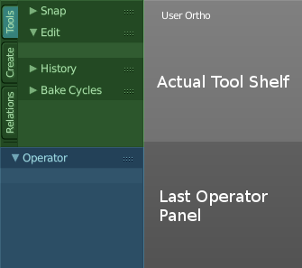
The Tool Shelf is split into two areas. The upper area with the tabs is the actual tool shelf where you find your tools. It is also a usual place where add-ons gets installed, and adds their tab too.

The lower area is the so called Last Operator panel. Here you will find settings of various types. For example adjustable settings for a new created primitive. In other software you will get this settings before you perform the tool. In Blender you get the settings after you perform the tool.

The tool shelf shelf part is made of several tabs. Tabs and content is varying dependant of what object type you use, and in what object mode you are. We will go through the tools by modes and object types.
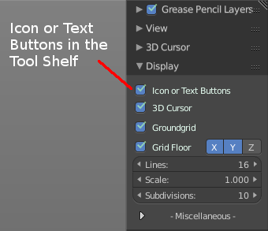
The tool shelf itself contains icon buttons by default. The tool tips tells you the name of the tool. But you can also turn the buttons into Text and Icon Buttons. Which makes it easier to recognize what is what at the beginning. Or when you search for a specific tool and cannot remember the icon for it.

To display the buttons as pure icons or as icon and text buttons can be turned on or of in the Display tab in the Properties Sidebar at the right side of the 3D View.

The reference manual will in the following shots provide both, the icon button toolbars and the text and icon toolbars where necessary and available.

Tool Shelf in Object Mode

The Tool Shelf in Object Mode provides you the tools to work with the objects at object level. Things like position, rotation, scale, mirror, or join or group etc. .
The Object mode is available for all object types.

Tool Shelf in Object Mode - Tools Tab

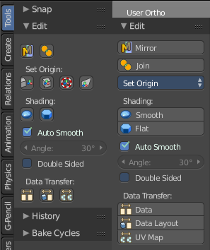
Edit Panel
The Edit panel contains tools around editing the selected object(s) at object level. Mirroring, set Origin, etc.

Object Type Mesh, Curve, Surface

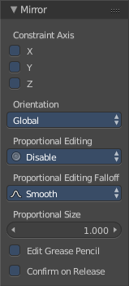
Mirror
Mirror mirrors the selected geometry along the defined axis. Click the Mirror button, type in X, Y or Z, then confirm with enter.

Last Operator Mirror
The Last Operator Mirror panel gives you tools to adjust the mirror action.

Constraint Axis
Constraint Axis gives you again the possibility to define the mirror axis. You can choose more than one axis here.

Orientation

Orientation is a drop-down box where you can choose the type of orientation for the mirroring action.

Proportional Editing

Proportional Editing is a drop-down box where you can choose to use proportional editing. When you choose one of the active methods then the neighbour geometry gets influenced by Shrink/Fatten too in a proportional way.

Proportional Editing Falloff
Proportional Editing Falloff is a drop-down box where you can choose a method for the falloff for the proportional editing.


Proportional size
Proportional size is a edit box where you can adjust the strength of the Proportional falloff.

Edit Grease Pencil
Edit Grease Pencil edits the selected Grease Pencil strokes.

Confirm on Release
With Confirm on Release checked the action gets performed when you release the mouse button.

Join
The join tool unions the selected mesh parts to one object.
Join has no settings in the Last Operator panel.

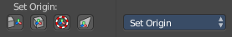
Set Origin
- Geometry to Origin sets the geometry to the origin.
- Origin to Geometry sets the origin to the centre of the object.
- Origin to 3D Cursor sets the origin to the 3D cursor.
- Origin to centre of mass sets the origin to the centre of the mass of the object.

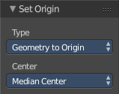
Last Operator Set Origin

Type
Type is a drop-down box where you can again choose how you want to set the origin.

Centre
Centre is a drop-down box where you can choose to use the Bounding Box centre of the object, or the Median Centre. The two are not necessarily at the same location.

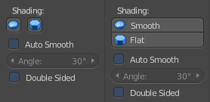
Shading
Smooth makes the shading of the object smooth. Last Operator Set Smooth has no settings.
Flat makes the shading of the object faceted. Last Operator Set Flat has no settings.

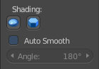
Auto Smooth
Auto Smooth just appears in the Shading section when you have a Mesh object selected. With Auto smooth you can define the angle after which the shading is set to smooth instead of faceted. It gives you fine control between the two extremes smooth and faceted.
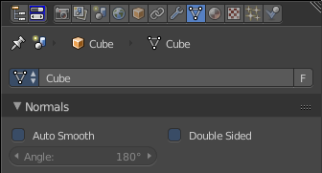
You need to have the Shading set to Smooth. Then tick Auto Smooth. And then you can adjust behind what angle the shading is set to smooth instead of faceted with the angle slider.
Note that the Auto Smooth feature also exists in the Data Properties of the object.

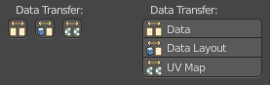
Data Transfer
Contains the data transfer tools Data, Data Layout and UV Map

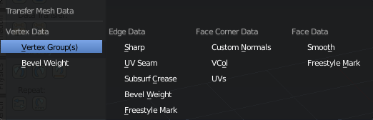
Data
Opens a Transfer Mesh data menu where you can choose different methods to transfer data layers from active to selected objects.

Last Operator Transfer Mesh Data
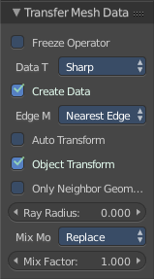
Last Operator Transfer Mesh Data displays different content, dependant of what data you want to transfer. To document all possible combinations would be a manual at its own. So we will just show the content for Edge Data Sharp here.

Freeze Operator
Prevent changes to the settings when rerun the operator.

Data Transfer
Opens a Transfer Mesh data menu where you can choose different methods to transfer data layers from active to selected objects.

Create Data
Add Data Layers on Destination Meshes if needed.

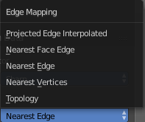
Edge Mapping
Edge Mapping is a drop-down box where you can choose the method for Edge Mapping

Auto Transform
Automatically compute transformation to get the best possible match between Source and Destination Object.

Object Transform
Evaluate Source and Destination object in Global Space.

Only Neighbour Geometry
Source Elements must be closer than given distance. This one reveals a Max Distance slider.

Ray Radius
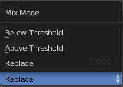
Width of Rays.

Mix Mode
Mix Mode is a drop-down box where you can choose the Mix Mode.

Mix Factor
A slider to adjust the Mix mode.

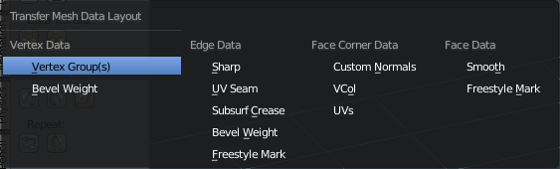
Data Layout
opens a menu where you can choose different methods to transfer the layout of data from active to selected objects.

Last Operator Transfer Mesh Data Layout
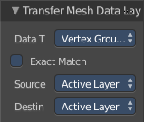
Last Operator Transfer Mesh Data displays different content, dependant of what data you want to transfer. To document all possible combinations would be a manual at
its own. So we will just show the content for Vertex Group here.

Data Type
opens a menu where you can choose different methods to transfer the layout of data from active to selected objects.

Exact Match
Also delete some data layers from destination if necessary. So that it matches exactly the source.

Source Layers Selection
A drop-down box where you can choose which Layers to transfer.

Destination Layers Matching
A drop-down box where you can choose how to match source and destination layers.

Join UV's / UV Map
Transfers the UV map from selected to active object. Requires to have matching geometry and the same vertex order.
Select the target mesh. Hold Shift and click to add the source object to the selection. Then perform the tool. The target mesh will now have the UV map from the source object.

Object Type Meta ball, Lamp, Camera, Speaker, Empties, Force Fields

Mirror
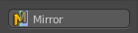
The Mirror tool mirrors the selected geometry.
When activated type in x y or z to define the mirror axis. Then hit enter.

Last Operator Mirror
The Last Operator Mirror panel gives you tools to adjust the mirror action.

Constraint Axis
Constraint Axis gives you again the possibility to define the mirror axis. You can choose more than one axis here.

Orientation
Orientation is a drop-down box where you can choose the type of orientation for the mirroring action.

Proportional Editing
Proportional Editing is a drop-down box where you can choose to use proportional editing. When you choose one of the active methods then the neighbour geometry gets influenced by Shrink/Fatten too in a proportional way.

Proportional Editing Falloff
Proportional Editing Falloff is a drop-down box where you can choose a method for the falloff for the proportional editing.

Proportional size
Proportional size is a edit box where you can adjust the strength of the Proportional falloff.

Edit Grease Pencil
Edit Grease Pencil edits the selected Grease Pencil strokes.

Confirm on Release
With Confirm on Release checked the action gets performed when you release the mouse button.

Tool Shelf in Object Mode - Create Tab

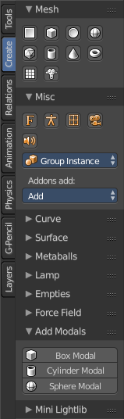
The Create tab provides you with some pre made objects. Mesh Objects, Lamps, Empties, etc. .
When you create a primitive then the Last Operator Panel shows some settings for this primitive.
Note that those settings are not longer available when you perform any operation at the object. And be it to move the primitive. Some of those settings might still be available in the Properties editor. But things like create UV not. So when you want to adjust those settings, then do it immediately after creation.
Several object types can be edited. A Mesh Primitive for example. They have different modes available then. Some not. Like an Empty. There is just the Object mode available for an Empty.

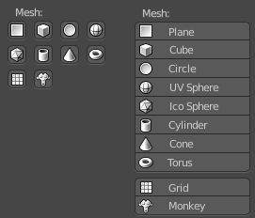
Mesh Panel

Mesh
The Mesh section contains the primitives that are made of meshes.
Mesh primitives are a good starting point for polygon modelling.

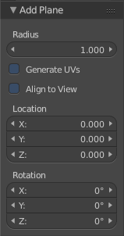
Plane
Plane creates a simple quad mesh

Last Operator Add Plane Panel
Radius is in real the size of the plane.
Generate UV's creates UV's for this primitive.
Align to view aligns the Plane to the current view.
Location Here you can adjust the location of the Plane.
Rotation defines the rotation of the Plane.

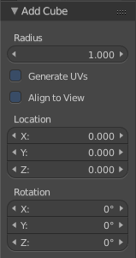
Cube
Cube creates a Cube mesh.

Last Operator Add Cube Panel
Radius is in real the size of the Cube.
Generate UV's creates UV's for this primitive.
Align to view aligns the Cube to the current view.
Location defines the location of the Cube.
Rotation defines the rotation of the Cube.

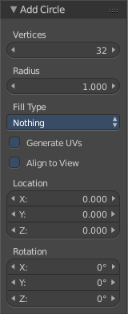
Circle
Circle creates a Circle mesh.

Last Operator Add Circle Panel
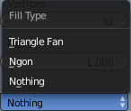
Vertices defines of how much vertices the circle is made.
Radius defines the radius of the circle.
Fill Type defines how the Circle mesh is filled.
- Nothing means you have pure edge geometry.
- N-Gon means that the circle face is a N-Gon face.
- Triangle Fan means that the circle face is triangulated.
Generate UV's creates UV's for this primitive.
Align to view aligns the Circle to the current view.
Location defines the location of the Circle.
Rotation defines the rotation of the Circle.

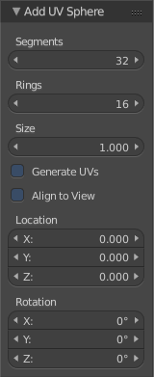
UV Sphere
UV Sphere creates a sphere mesh.

Last Operator Add UV Sphere Panel
Segments defines of how much segments the sphere has vertically.
Rings defines how much rings the sphere has horizontally.
Size defines the radius of the UV Sphere.
Generate UV's creates UV's for this primitive.
Align to view aligns the Sphere to the current view.
Location defines the location of the Sphere.
Rotation defines the rotation of the Sphere.

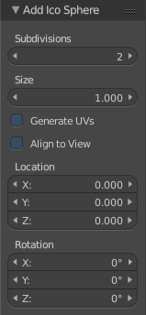
Ico Sphere
Ico Sphere creates a sphere mesh.

Last Operator Add Ico Sphere Panel
Subdivisions defines the subdivision level of the Ico Sphere.
Size defines the radius of the Ico Sphere.
Generate UV's creates UV's for this primitive.
Align to view aligns the Sphere to the current view.
Location defines the location of the Sphere.
Rotation defines the rotation of the Sphere.

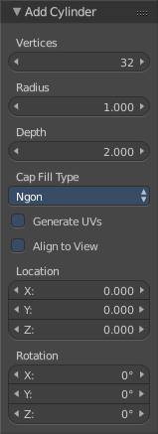
Cylinder
Cylinder creates a Cylinder mesh.

Last Operator Add Circle Panel
Vertices defines of how much vertices the circle is made.
Radius defines the radius of the Cylinder.
Depth defines the length of the Cylinder.
Cap Fill Type defines how the cap face is filled.
- Nothing means you have no face at the top and the bottom of the Cylinder.
- N-Gon means that the cap face is a N-Gon face.
- Triangle Fan means that the cap face is triangulated.
Generate UV's creates UV's for this primitive.
Align to view aligns the Cylinder to the current view.
Location defines the location of the Cylinder.
Rotation defines the rotation of the Cylinder.

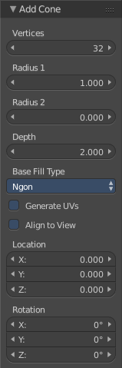
Cone
Cone creates a Cone mesh

Last Operator Add Cone Panel
Vertices defines of how much vertices the circle is made.
Radius 1 defines the base radius of the Cone.
Radius 2 defines the top radius of the Cone.
Depth defines the length of the Cone.
Base Fill Type defines how the Base face is filled.
- Nothing means you have no base face.
- N-Gon means that the base face is a N-Gon face.
- Triangle Fan means that the base face is triangulated.
Generate UV's creates UV's for this primitive.
Align to view aligns the Cone to the current view.
Location defines the location of the Cone.
Rotation defines the rotation of the Cone.

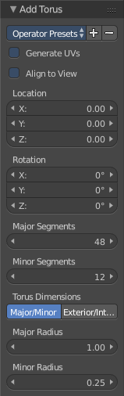
Torus
Torus creates a Torus mesh

Last Operator Add Torus Panel
Operator Presets allows you to store presets for the Torus. So that you don't have to start from scratch when you need different tori with different setup. This presets are temporary. And cannot be stored between sessions.
Align to view aligns the Cone to the current view.
Location defines the location of the Torus.
Rotation defines the rotation of the Torus.
Major segments defines the segment division of the Torus.
Minor segments defines the circle division of the Torus.
Torus Dimensions defines the method to use when changing Major and Minor Radius.
Major Radius changes the radius of the Torus.
Minor Radius changes the thickness of the Torus.

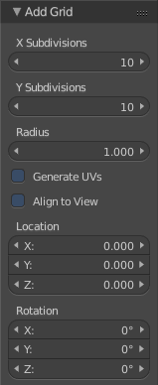
Grid
Grid creates a subidividable plane mesh

Last Operator Add Grid Panel
X Subdivisions defines the number of subdivisions in x direction.
X Subdivisions defines the number of subdivisions in Y direction.
Radius is in real the size of the plane.
Generate UV's creates UV's for this primitive.
Align to view aligns the Plane to the current view.
Location Here you can adjust the location of the Plane.
Rotation defines the rotation of the Plane.

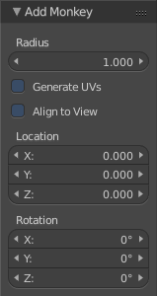
Monkey
Monkey creates a monkey head mesh.

Last Operator Add Monkey Panel
Radius is in real the size of the Monkey head mesh.
Align to view aligns the Monkey head mesh to the current view.
Location Here you can adjust the location of the Monkey head mesh.
Rotation defines the rotation of the Monkey head mesh.

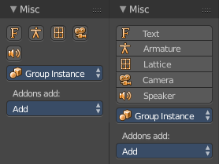
Misc Panel
The Misc Panel provides you with the buttons to create several types of objects. Here you will find mainly the objects that are not for modelling. But everything else. Lights, Bones, Camera, Empties etc.
And it containst the Group Instance menu and the legacy Add menu, which gets used for older addons. Quite a few, like the Sapling addon, places their entries here.

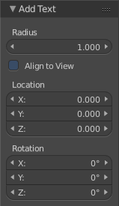
Text
Text creates a text object. Text is not mesh geometry. It is a special curve geometry.
Note
You can enter the Edit mode with the standard hotkey. But you cannot switch back to Object mode with the standard hotkey. Since this hotkey gets count as input for the text object in Edit mode. You have to use the mode drop-down box to leave the Edit mode.

Last Operator Add Text
Radius is in real the size of the Text object.
Align to view aligns the Text object to the current view.
Location Here you can adjust the location of the Text object.
Rotation defines the rotation of the Text object.

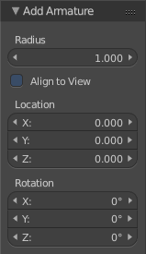
Armature
Armature creates a Armature. It adds the first bone of a skeleton.

Last Operator Add Armature
Radius is in real the size of the Armature object.
Align to view aligns the Armature object to the current view.
Location Here you can adjust the location of the Armature object.
Rotation defines the rotation of the Armature object.

Lattice
Lattice creates a Lattice. Which is a control cage to control deforming at another object.

Usage
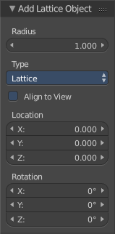
Create a Lattice object.
Make sure it is bigger than the object that you want to deform, and is around this object.
Add a Lattice Modifier to the object that you want to deform.
In the Object box of the Lattice Modifier add our created Lattice object.
Select Lattice Object. Enter Edit mode. And here you can deform the Lattice Object now, and the object to deform will follow.

Last Operator Add Lattice object
Radius is in real the size of the Lattice object.
Type is a drop-down box where you can define the type of Lattice object.
Align to view aligns the Lattice object to the current view.
Location Here you can adjust the location of the Lattice object.
Rotation defines the rotation of the Lattice object.

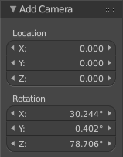
Camera
Camera creates a Camera object.

Last Operator Add Camera
Location Here you can adjust the location of the Camera object.
Rotation defines the rotation of the Camera object.

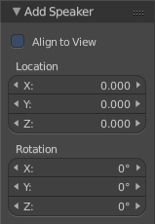
Speaker
Speaker creates a Speaker object.

Last Operator Add Speaker
Location Here you can adjust the location of the Speaker object.
Rotation defines the rotation of the Speaker object.

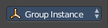
Group Instance
Group Instance is a drop-down box that contains the current groups. And you can add another instance of an existing group by clicking at the group in this drop-down list.
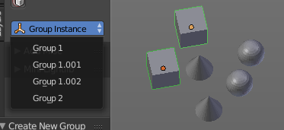
First create a group. It will display in the list.
Then click at one of the list items to add an instance of the group to the scene.

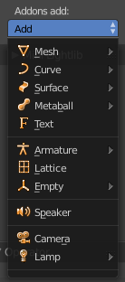
Addons Add
The Addons Add menu exists for historical reasons. Quite a few Blender addons adds their entries into this add menu. And so we have to keep it in Bforartists too. But it is now in the Tool Shelf, and not in the Header menu anymore like in Blender.
There are a handful of double menu entries left that cannot be removed for exact this reason. We would make some addons disfunctional.

Curve Panel
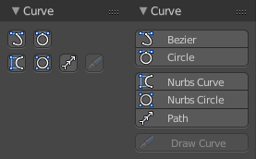
The Curve section contains the Curve primitives. Curves are handy to create curved shapes. Or a camera path.
The curve types are very similar. But do have some small differences. The difference between Bezier and Nurbs is that with Bezier you have handlers at the curve. And with a Nurbs you have a control geometry to influence the curve.
Note that Curves is no mesh data. You have to convert the Curves data to Mesh data when you want to work with it like with a mesh. Note also that you cannot convert it back to curve then.

Bezier
Bezier creates a Bezier type curve.

Circle
Circle creates a Bezier circle type curve.

Nurbs Curve
Nurbs Curve creates a Nurbs type curve.

Nurbs Circle
Nurbs Circle creates a Nurbs type circle curve.

Path
Path creates a Nurbs type curve.

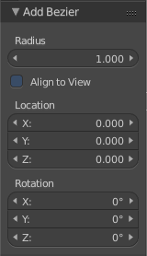
Last Operator Add Curve
The Last Operator add panel is for all curves equal.
Radius is in real the size of the curve.
Align to view aligns the curve to the current view.
Location Here you can adjust the location of the curve.
Rotation defines the rotation of the curve.

Draw Curve
Draw Curve is just active in Edit mode.

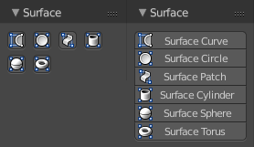
Surface Panel
The Surface section contains the Surface primitives. Surfaces are some kind of curves. But curves with which you can construct surfaces. Surfaces are all of type Nurbs curves.
Surfaces are handy to construct curved surfaces.
Note that Surfaces similar to Curves is no mesh data. You have to convert the Surfaces data to Mesh data when you want to work with it like with a mesh. Note also that you cannot convert it back to Surface then.

Nurbs Curve
Nurbs Curve creates a Nurbs type curve.

Nurbs Circle
Nurbs Circle creates a Nurbs type circle.

Nurbs Surface
Nurbs Surface creates a Nurbs type Surface.

Nurbs Cylinder
Nurbs Cylinder creates a Nurbs type cylinder.

Nurbs Sphere
Nurbs Sphere creates a Nurbs type sphere.

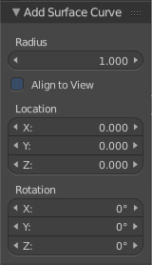
Nurbs Torus
Nurbs Torus creates a Nurbs type Torus.

Last Operator Add Surface
The Last Operator add panel is for all curves equal.
Radius is in real the size of the surface.
Align to view aligns the surface to the current view.
Location Here you can adjust the location of the surface.
Rotation defines the rotation of the surface.

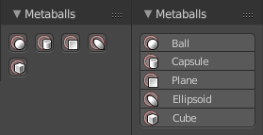
Metaballs Panel
Meta-balls are procedural primitives. They are not defined by vertices or curves. The interesting behaviour of meta-balls is that you can stick them into each other. And they have one surface then. Like merging two water drops. And this works in Object mode already.

Ball
Ball creates a meta-ball in Sphere shape.

Capsule
Capsule creates a meta-ball in Capsule shape.

Plane
Plane creates a meta-ball in Plane shape.

Ellipsoid
Ellipsoid creates a meta-ball in Ellipsoid shape.

Cube
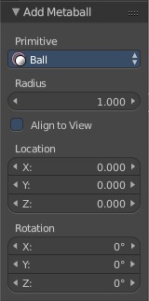
Cube creates a meta-ball in Cube shape.

Last Operator Add Meta ball
The Last Operator add panel is for all Meta-balls equal.
Primitive is a drop-down box where you can change the Meta ball type.
Radius is in real the size of the surface.
Align to view aligns the surface to the current view.
Location Here you can adjust the location of the surface.
Rotation defines the rotation of the surface.

Group Instance
Group Instance is a drop-down box that contains the current groups. And you can add another instance of an existing group by clicking at the group in this drop-down list.
First create a group. It will display in the list.
Then click at one of the list items to add an instance of the group to the scene.

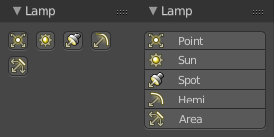
Lamp Panel
The lamps brings light into your scene. There are five different Lamp types.

Point
Point creates a Point Light. A point light shines into all directions.

Sun
Sun creates a light that behaves like a sun. It's a directional light.

Spot
Spot creates a Spot light. It's a directional light.

Hemi
Hemi creates a hemi light. It illuminates the whole scene.

Area
Area creates a Area light. It's a directional light.

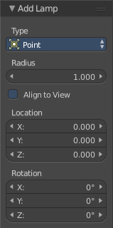
Last Operator Add Lamp
The Last Operator add panel is for all Lamps equal
Type is a drop-down box where you can change the light type.
Radius is in real the size of the surface.
Align to view aligns the surface to the current view.
Location Here you can adjust the location of the surface.
Rotation defines the rotation of the surface.

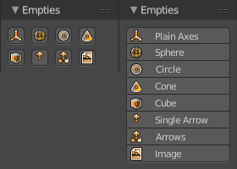
Empties Panel
An Empty is an object without any data attached. It is basically just a container. Empties can be used as anchor objects. Or as visible handlers at a skeleton for example.
The empty types differs just by how they gets displayed in the viewport.

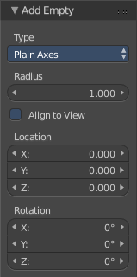
Last Operator Add Empty
Type is a drop-down box where you can define the type of Empty object.
Radius is in real the size of the Empty object.
Align to view aligns the Empty object to the current view.
Location Here you can adjust the location of the Empty object.
Rotation defines the rotation of the Empty object.

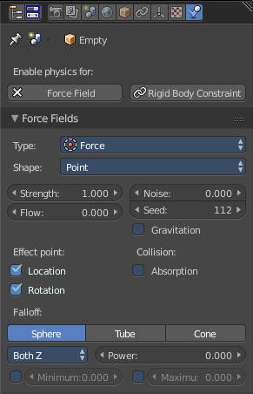
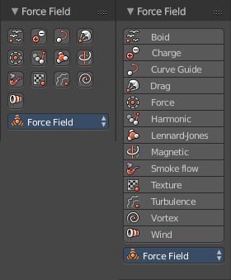
Force Field Panel
A Force Field is for physical simulations. It provides you with tools to add different forces to objects. Wind, Smoke, Gravity, Magnetic, etc. .
The added Force Fields can be further adjusted in the Properties panel then.
There is also the legacy dropdown menu available. it's a double menu, it contains the same buttons again. But some addons adds their entries here.

A Force Field is internally also called Effector. So our Last Operator panel has the title Add Effector.

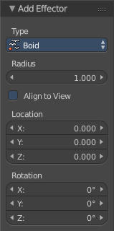
Last Operator Add Effector
Type is a drop-down box where you can define the type of Effector.
Radius is in real the size of the Effector.
Align to view aligns the Text object to the Effector.
Location Here you can adjust the location of the Effector.
Rotation defines the rotation of the Effector.

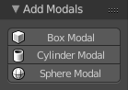
Add Modals Panel
Add Modals allows you to create primitives with adjustable divisions in 3DS Max style.
First you drag a rectangle in the 3D view. Then you drag the height. Then you adjust the divisions in the Last Operator.
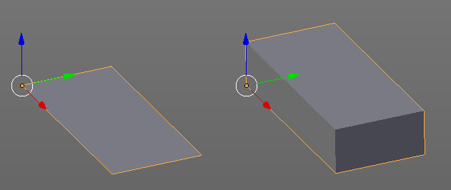

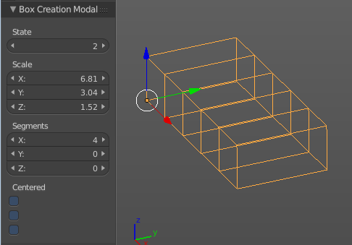

Add Modals is an addon. You can turn it off in the User Preferences when you don't need it.
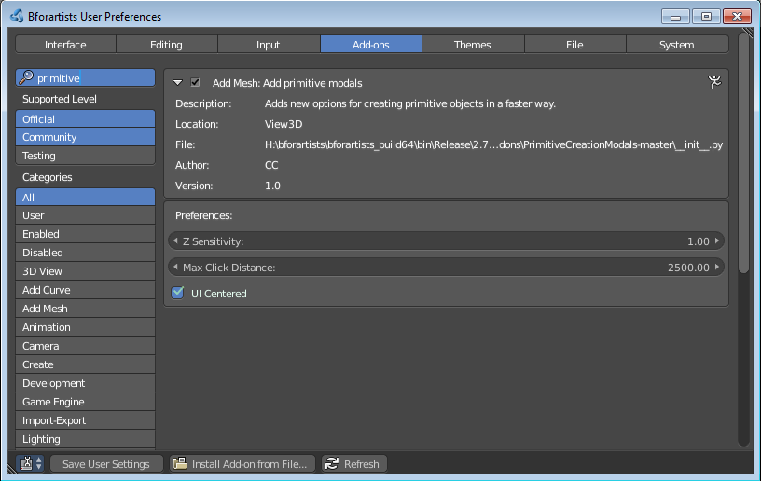

Mini Lightlib Panel
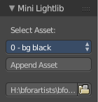
Mini Lightlib is a little add-on that gives you some standard lighting settings for the Cycles renderer. It contains for example the classical three-point setup. But also some basic volumetrics examples.

It can be turned off in the User Preferences.

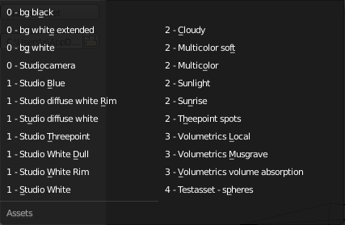
Select Asset
The Select Asset drop-down box contains the assets that comes with Mini Lightlib. Here you can select what you want to load.
The assets are grouped by numbers.
0 is everything setup. We have three backgrounds here. And the studio camera that fits to the setup.
1 are the light set-ups for a studio setup. From classical three-point to white.
2 is everything not studio setup.
3 are some volumetrics set-ups. Be very careful with this ones. Especially the Musgrave example renders eons.
4 is the included test asset. Some colored spheres.

Append Asset
The Append Asset Button appends what is currently selected in the drop-down box to the scene.

Path Edit box
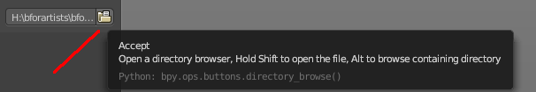
The Path Edit box shows the path to the library. You will usually not touch this edit box. This edit box gives you a hint where the Mini Lightlib library is located. So that you can add your own assets to that folder. At Windows it's in the Appdata Directory. Which is usually hidden and protected. You might need to adjust your rights to access this folder directly.
But it is also a Path selector. You can select other library folders here if you want, and append the assets from that folder. The Drop-down box will show the content of all blend files in this folder then.
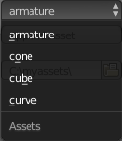
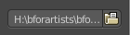
Every blend file is also a library file. The add-on appends the content of this blend file then. To make your own library file is as easy as saving your blend file with your asset. That's already a library. But note that Mini Lightlib will append the whole content from this blend file. There is no filter as in the Blender append feature. So when you plan to create your own libraries, then take care to remove everything except the asset that you want to load.
Note that changes in the Path Edit box are not permanent. The path to the Mini Lightlib is hard-coded. So when you restart Blender then every change is gone. That's also a quick method to get the original path to the light library back. Restart Blender.

Simple Usage

Preparation

Make sure that you have the Cycles renderer selected!

Mini Lightlib is made for the Cycles renderer. It will not work with the Blender Internal renderer. At least not without adjustments.

Throw out all lights and cameras from the scene.
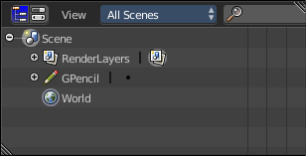
We don't want to have the standard lights ruin the result. Also the standard camera does not fit to our studio setup.

This can be done in the Outliner. Or you select the lights and camera in the viewport and hit delete.

Load Assets

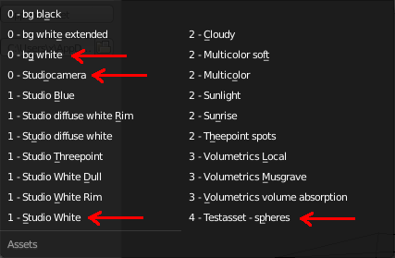
Select in the drop-down box what you want to append. And append it one by one to the scene.

Let's start with a studio setup. I suggest to use the bg white, which is a white background. The camera. One of the studio light set-ups. And finally our test asset to have something to render.

So we select bg white, and click at the Append Asset Button.
Then we select Studiocamera, and click at the Append Asset Button.
Then we select let's say the Studio White, and click at the Append Asset Button.
And then we select the Test asset Spheres, and click at the Append Asset Button. What's left is to click at the render button.

The available light set-ups
Here you can get an overview how the result looks like for the different lighting set-ups.

Be careful with the volumetrics examples. Especially the Musgrave example can render eons.

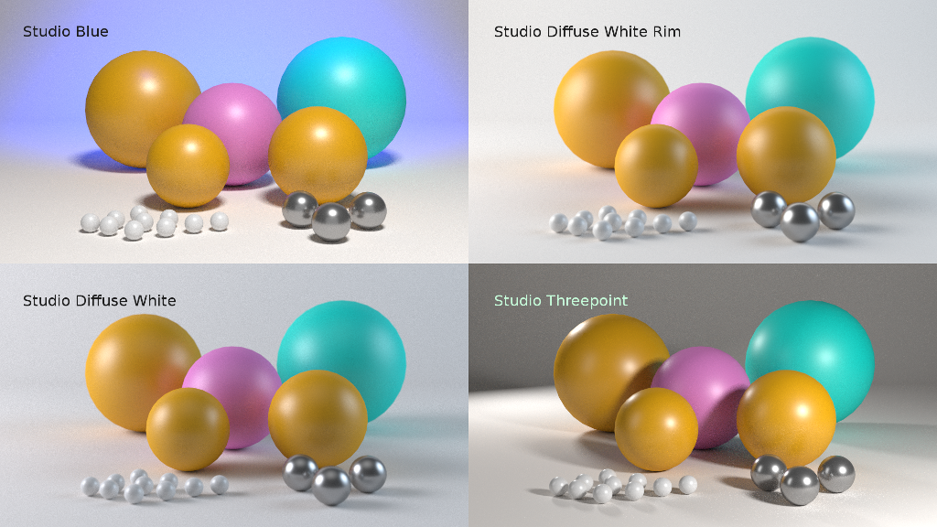
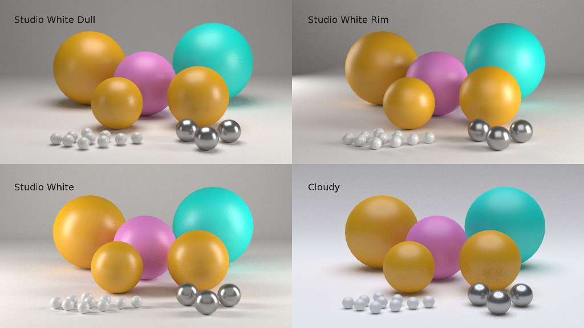

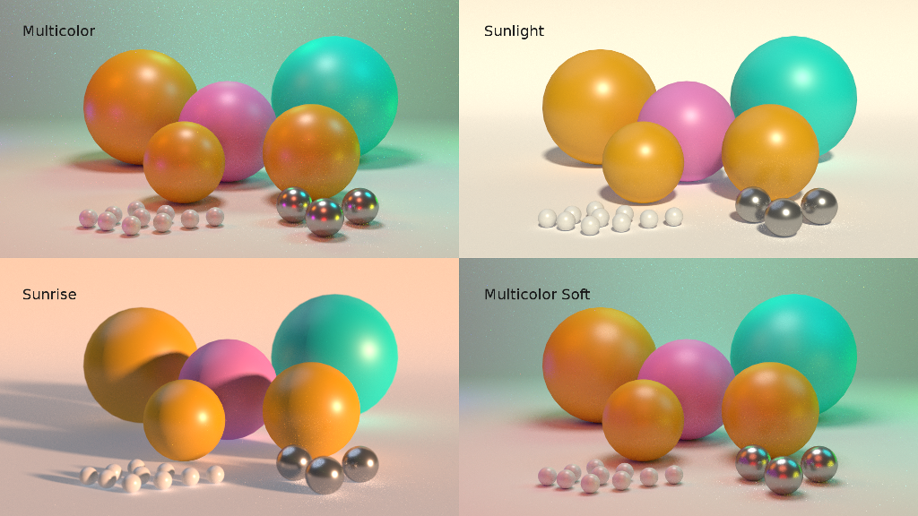

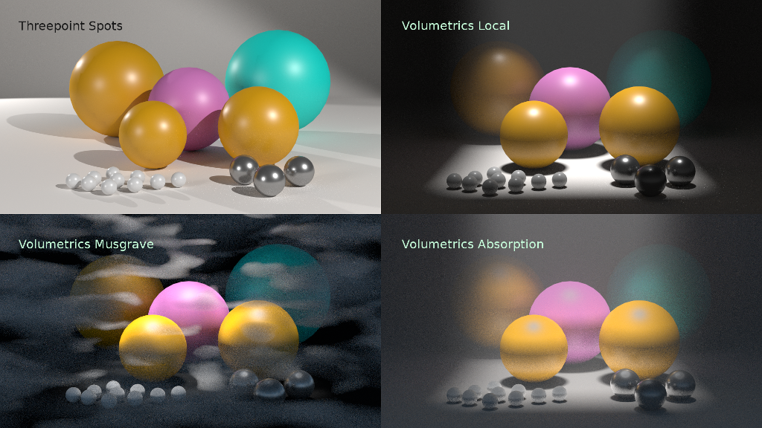

Tool Shelf in Object Mode - Relations Tab

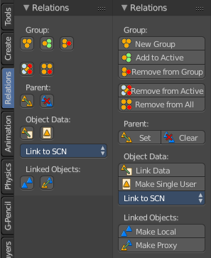
The Relations tab contains all tools that has to do with relations between objects. Grouping, Parenting, etc. .

Note that the Relations tab is empty when there is no object in the scene.

Relation settings also exists for every individual object in the Properties editor.

Group
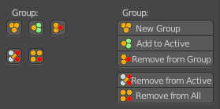
The Group section contains the group tools. Here you can to add and remove from a group.
Grouped objects are coloured different in the Viewport. They show green instead of orange. They have no difference in the Outliner though.

New Group
New Group creates a new group. When you have one or more objects selected, then this object(s) becomes part of the new group. You can name this Group in the Last Operator panel.

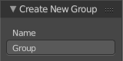
Last Operator Create New Group
Name is a edit box where you can change the name of the Group.

Add to Active
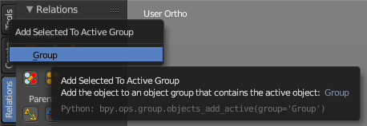
Add to Active adds the selected object to the group of the selected object.
First select the object to add. Then shift select one object of the group where you want to add it. So that both are selected. Then press the Add To Active button, and choose the group name. And the object will be added to this Group.

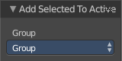
Last Operator Add Selected to Active Group
Name is a edit box where you can change the name of the Group.

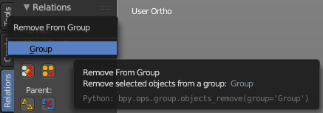
Remove from Group
Remove from Group removes the selected object from the Group.

Select the object, then click the button and choose the Group where you want to remove it from.

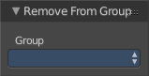
Last Operator Remove from Group
Name is a edit box where you can choose the group to remove from.

Remove from Active
A object can be in more than one group. Remove from Active removes the selected object from the currently active Group.
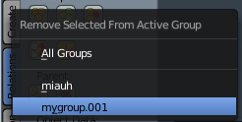
Select the object, then click the button and choose the group where you want to remove it from.

Last Operator Remove from Group
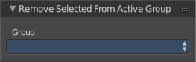
Name is a edit box where you can choose the group to remove from.

Remove from All
Remove from All removes the selected object from all Groups.
Last Operator Remove from All has no settings.

Parent
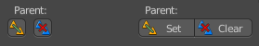
The Parent section contains a tool to deal with parent child relationships. This includes things like sending an object along a curve. Or skinning an armature.
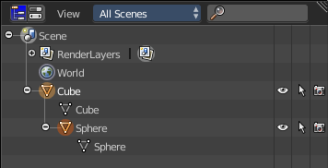
Child objects becomes part of the hierarchy of the parent object. You will see them in the outliner in the hierarchy of the parent object then. See image.
The usual way to parent an object is to select the child object, then shift click add the parent object to the selection, then click the Parent button, and finally choose the parenting method in the upcoming menu.
This menu has different content, dependant of what type the parent object is.

Set Parent to Mesh Object
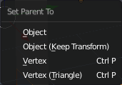
When your parent object is of type mesh, then you will have the following parent options:

Object
Object simply parents the current object to the target object.

Object (Keep Transform)
Object (Keep Transform) parents the current object to the target object, but keeps the transform intact.

Vertex
Vertex parents the current object to a vertex of the target object. The vertex will be chosen automatically, it's the closest vertice of the parent object. When you want to assign the object to a specific vertice, then you have to do the vertex parenting in Edit mode.

Vertex (Triangle)
Vertex (Triangle) parents the current object to a face of the target object. The face will be chosen automatically. It's the closest face of the parent object. When you want to assign the object to a specific face, then you have to do the vertex parenting in Edit mode.

Last Operator Make Parent to mesh object
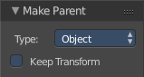
Type is a drop-down box where you can change the type of parenting. Note that this list also contains items that does not work for this object type parent relation.
Keep Transform applies transformation before parenting.

Set Parent to Armature
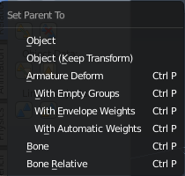
This is also known as skinning. When your parent object is of type mesh, then you will have the following parent options:

Object
Object simply parents the current object to the target object.

Object (Keep Transform)
Object (Keep Transform) parents the current object to the target object, but keeps the transform intact.

Armature Deform
Armature Deform parents the current object to the armature. But the mesh has no weighting of the vertices. And no groups.

With Empty Groups
With Empty Groups parents parents the current object to the armature. But the mesh has no weighting of the vertices.

With Envelope Weights
With Envelope Weights parents the current object to the armature. The mesh has weighting from the envelopes. When the mesh has vertices that are outside of the envelope, then this vertices has no weighting.

With Empty Groups
With Empty Groups parents parents the current object to the armature. The mesh gets weighted automatically. All vertices are weighted. Even when vertices are outside of envelopes.

Bone
Bone parents parents the current object to the currently selected bone. The whole object is influenced by this single bone. When you edit the bones position in edit mode and switch to pose mode, then the child object will follow to the new position.

Bone Relative
Bone parents parents the current object to the currently selected bone. The whole object is influenced by this single bone. When you edit the bones position in edit mode and switch to pose mode, then the child object will not follow to the new position.

Last Operator Make Parent to Armature
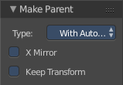
Type is a drop-down box where you can change the type of parenting. Note that this list also contains items that does not work for this object type parent relation.
X Mirror applies weight symmetrically along X axis for Envelope/ Automatic vertex group creation.
Keep Transform applies transformation before parenting

Set Parent to Curve
Curves can be used to define motion paths of objects. Curves can also be used to deform objects.
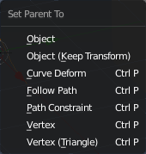
When your parent object is of type Curve, then you will have the following parent options:

Object
Object simply parents the current object to the target object.

Object (Keep Transform)
Object (Keep Transform) parents the current object to the target object, but keeps the transform intact.

Curve Deform
Curve Deform parents the current object to the target object. It allows you to deform the object by moving it along the curve axis.

Follow path
Follow path parents the current object to the target object. The object becomes animated. The number of key frames can be adjusted in the Properties editor. Select the curve, click the Data tab, and in the Path Animation tab adjust the number of frames to your needs.

Path Constraint
No idea. Seriously, no idea what this should do and how it should work.

Vertex
Vertex parents the current object to a vertex of the target object. The vertex will be chosen automatically, it's the closest vertice of the parent object. When you want to assign the object to a specific vertice, then you have to do the vertex parenting in Edit mode.

Vertex (Triangle)
Vertex (Triangle) parents the current object to a face of the target object. Problem is, a path has no faces. And so the operation will fail. Just ignore. It's a bug.

Last Operator Make Parent to Curve
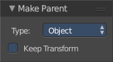
Type is a drop-down box where you can change the type of parenting. Note that this list also contains items that does not work for this object type parent relation.
Keep Transform applies transformation before parenting.

Set Parent to other object types
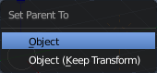
You can parent an object also to objects like lamps or an empty.

Object
Object simply parents the current object to the target object.

Object (Keep Transform)
Object (Keep Transform) parents the current object to the target object, but keeps the transform intact.

Last Operator Make Parent to other object types
Type is a drop-down box where you can change the type of parenting. Note that this list also contains items that does not work for this object type parent relation.
Keep Transform applies transformation before parenting.

Clear Parent

Clear Parent
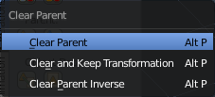
Clear Parent clears the parent relation completely, including involved modifiers.

Clear and Keep Transformation
Clear Parent clears the parent relation completely, including involved modifiers. But keeps the current visual transformation.

Clear Parent Inverse
Clear Parent Inverse resets the transform corrections applied to the parenting relationship. It does not remove the parenting itself.

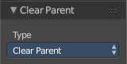
Last Operator Clear Parent
Type is a drop-down box where you can change the type of clearing. Same as the clear parent menu.

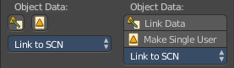
Object Data
The Object data section gives you tools to handle object data.

Link Data
Link Data links the data from the selected to the active object.

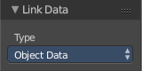
Last Operator Link Data
Type is a drop-down box where you can choose what data type you want to link

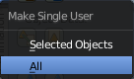
Make Single User
Selected Objects makes the linked data local to each selected objects.
All makes the linked data local to all objects.

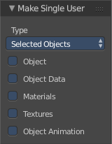
Last Operator Make Single User
Type is a drop-down box where you can choose if you want to handle selected objects or all objects.
The checkboxes defines what data type you want to make local.

Link to SCN
Link to SCN is a dropdown box where you can link to a specific scene. Obviouisly you need to have more than one scene to be able to do so. But Blender just supports to load one scene at a time. You can however create more than one scene data block in such a single scene. And that's the scene that you can link to.
Link to SCN makes the same object exist in 2 different scenes at once, including its position and animation data. You can tell this is a multi-user object by the blue color of its center-circle
If you don’t want the objects to be shared between the scenes, you can make them Single-User by using the Make Single User button above the dropddown box.
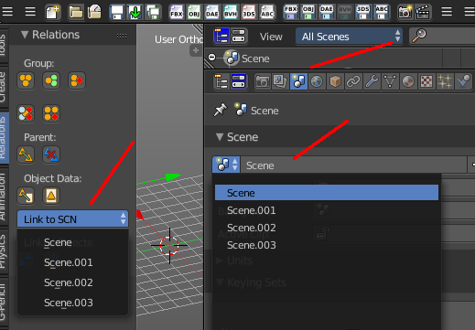
To create a new scene data block see Properties Editor, Scene Tab, Scene Panel.

Last Operator Link Objects to Scene
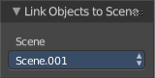

Scene
Scene is the same dropdown box like in the Relations panel. Here you can again adjust to which scene you want to link.

Linked Objects
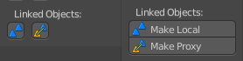
Linked objects means the objects that you might have linked from other blend files. When you don't have linked data in your scene then this buttons are of no use.

Make Local
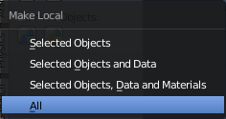
Make Local copies the object data from the original blend file to the new file. And removes the link to the blend file. It calls a menu where you can choose a method.
Selected Objects makes the selected objects local.
Selected Objects and Data makes the selected objects and its data local.
Selected Objects, Data and Materials makes the selected objects, its data and its material local.

Make Proxy
Make Proxy adds a new object and sets it as the parent of the linked data. This allows you to transform the empty while still retaining the link to the original blend file. The mesh is not editable though. The Object data block is cloned, but the Mesh data block is not.

Tool Shelf in Object Mode - Animation Tab

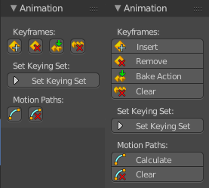
The animation tab gives you tools to work with animation. Here you can handle key frames, set keying set, etc.

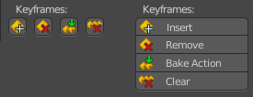
Keyframes
The Keyframes section allows you to insert and remove key frames, bake actions and clear all animation.

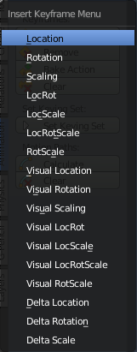
Insert
Insert inserts a keyframe.
When your object does have a active keying set, then a click at the button inserts the keyframe directly.

Insert Keyframe Menu
The keying set defines what kind of key frames gets recorded. When you start with an animation, and your object does not have a keying set yet, then you will be prompted with a menu where you can choose the proper keying set. The Insert Keyframe menu.
For the meaning of the single items see Set Keying Set below. It's the same items.
Insert has no settings in the Last Operator panel.

Remove
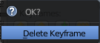
Removes the current active keyframe for the selected object. You will get a confirmation dialogue here.
Remove has no settings in the Last Operator panel.

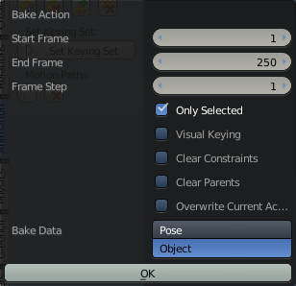
Bake Action
Bake Action bakes the object animation to a new action.
Bake action calls a panel where you can adjust the settings for the new action.

Last Operator Bake Action

Start Frame
Defines the start frame for baking.

End Frame
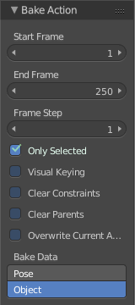
Defines the end frame for baking.

Frame Step
Defines the frame step for baking.

Only Selected
Pose Baking only.

Visual Keying
Keyframe from the final transform.

Clear Constraints
Remove all constraints from keyed objects / bones, and do visual keying.

Clear Parents
Bake animation onto the object, then clear parents (objects only)

Overwrite current Action
Bake Action into current action instead of creating a new one.

Bake Data
Which data transformations to bake to. You have the choice between Pose and Object here.

Clear
Clears all animation, and removes all key frames for the selected object.
Clear has no settings in the Last Operator panel.

Set Keying Set
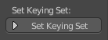
The keying set defines what kind of key frames gets recorded. Some keying sets have a specific purpose, and works just in specific context and with specific kind of objects.
A click at the set keying set button brings up a menu where you can choose the keying set. It is nearly the same menu as in the keying set drop-down box, and has the same functionality. With small differences. For example, the two items Whole Character and Available.
Available is context sensitive. So when you cannot see it in the list, then you can't use it yet. And Whole Character is just available in Pose Mode.
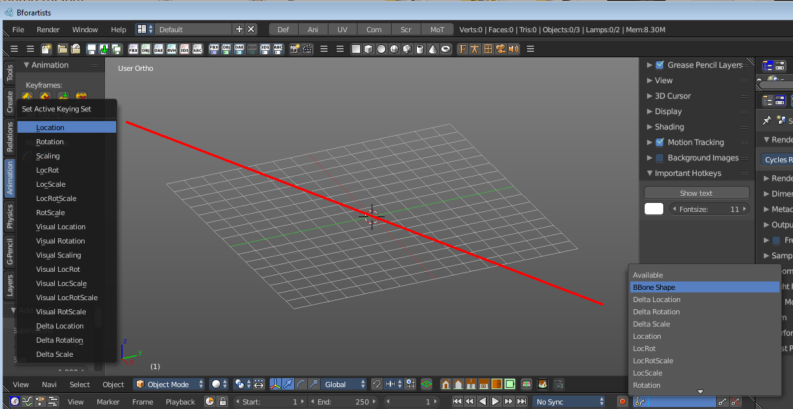
Keying Set in detail:

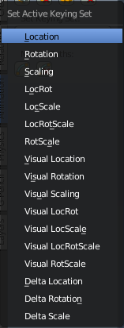
Location
Location records key frames for the location of the object, absolute in the world.

Rotation
Rotation records key frames for the rotation of the object, absolute in the world.

Scale
Scale records key frames for the scale of the object, absolute in the world.

LocRot
LocRot records key frames for the location and rotation of the object, absolute in the world.

LocScale
LocScale records key frames for the location and scale of the object, absolute in the world.

LocRotScale
LocRotScale records key frames for the location rotation and scale of the object, absolute in the world.

RotScale
RotScale records key frames for the rotation and scale of the object, absolute in the world.

Visual Location
Location records key frames for the location of the object, at 0/0/0 of the world.

Visual Rotation
Visual Rotation records key frames for the rotation of the object, at 0/0/0 of the world.

4Visual Scale
Visual Scale records key frames for the scale of the object, at 0/0/0 of the world.

Visual LocRot
Visual LocRot records key frames for the location and rotation of the object, at 0/0/0 of the world.

Visual LocScale
Visual LocScale records key frames for the location and scale of the object, at 0/0/0 of the world.

Visual LocRotScale
Visual LocRotScale records key frames for the location rotation and scale of the object, at 0/0/0 of the world.

Visual RotScale
Visual RotScale records key frames for the rotation and scale of the object, at 0/0/0 of the world.

Delta Location
Delta Location records key frames for the location of the object. It records the difference to the current location. Means local.

Delta Rotation
Delta Rotation records key frames for the rotation of the object. It records the difference to the current rotation. Means local.

Delta Scale
Delta Scale records key frames for the scale of the object. It records the difference to the current scale. Means local.

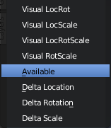
Available
Available records the keyframe in the current active keying set. This means that you need to have an active keying set already. The menu item is not available when you don't have an active keying set.

Motion Paths
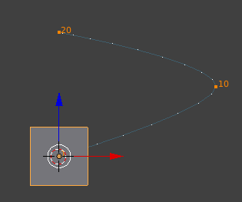
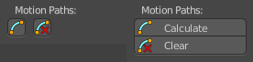
Objects can be animated. Let's say you send them from a to b to c. The object will move to b, then to c. Some kind of a path. This path is not visible by default.
With motion paths you can calculate this path, and make it visible.

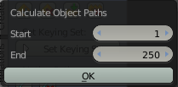
Calculate
Calculate calculates the motion path of the selected object. It opens a panel where you can define the start and end frame of the calculation.

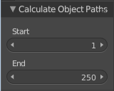
Last Operator Calculate Object Path
Start defines the start frame of the calculation.
End defines the end frame of the calculation.

Clear
Clear remove the motion path from the object.

Tool Shelf in Object Mode - Physics Tab

The Physics panel contains physics tools. It contains just one panel. Rigid Body Tools. You can do basic operations here. The setup has to happen in the Properties editor then.
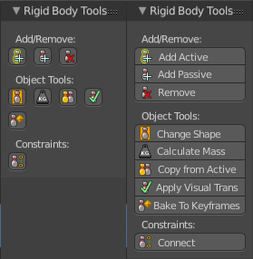
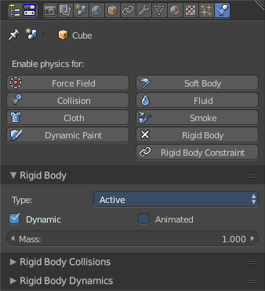

Add / Remove
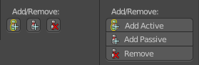
Here you can add and remove rigid bodys. Rigid bodies are needed for physics in Bforartists. Think of it as invisible colliders for your object where the forces can work at.

Add Active
Add Active adds a rigid body to the selected object. The type of this rigid body is active. This is useful for any actively moving object. Characters, bullets, etc.

Add Passive
Add Active adds a rigid body to the selected object. The type of this rigid body is passive. This is useful for any static object, like ground for example.

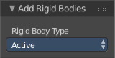
Last Operator Add Rigid bodies
The rigid body type is a drop-down box where you can choose if the type of the rigid body is active or passive.

Remove
Remove simply removes the rigid body from the current object. It has no Last Operator settings

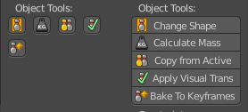
Object Tools
The Object tools gives you some tools for your rigid body.

Change shape
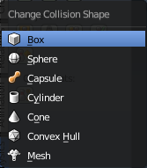
Change Shape opens a pop-up menu where you can change the shape of your rigid body.

Last Operator Change Collision shape
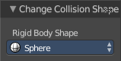
Rigid Body Shape is a pop-up menu where you can change the shape of your rigid body again.

Calculate Mass
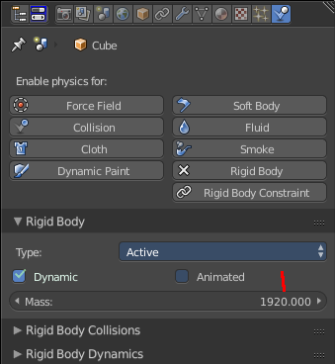
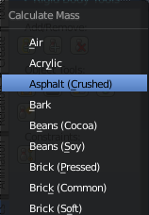
Calculate Mass does NOT calculate the mass. But gives you a pop-up menu where you can choose between different predefined mass set-ups. The corresponding value will then be set in the physics settings in the Rigid Body settings.

Last Operator Calculate Mass
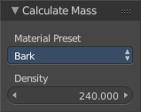
Material Preset is a pop-up menu where you can choose the type of preset again.
Density is the mass value from the Rigid Body panel.

Copy from Active
Copy from Active allows you to copy all the physics settings from the active object and apply it at the selected. First select the object that contains the physics settings. Then add the target object to the selection. Then press the button.

Apply visual transform
Apply visual transform applies the visual transform to the object.

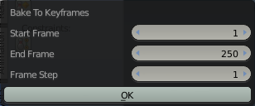
Bake to Keyframe
Bake to Keyframe bakes the whole physics animation to key frames. A click at the button brings up a menu where you can set the range and the number of frame steps.

Constraints
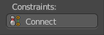
Constraints allows objects and rigid bodys to interact with each other. It can act as a joint. Or limit the movement along one axis, etc. .

Connect
Connect connects rigid bodies. It creates a new Empty object named “Constraint”, which has a physics constraint already attached. And is pointing at the two selected objects. The setup has to happen in the Properties editor then.

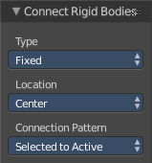
Last Operator Connect Rigid Bodies
Type is a drop-down box where you can choose the type of the constraint.
Location is a drop-down box where you can choose the location of the constraint empty.
Connection is a drop-down box where you can choose the type of connection pattern.

Tool Shelf in Edit Mode

The Tool Shelf in Edit Mode provides you the tools to edit the objects. Things like modifying geometry, modify an armature, modify Curves or 3D text, etc. .
Not all object types are editable. Editable object types are all object types in the Add Primitive panel. Mesh, Curve, Surface, Meta ball. In the Add Misc panel it's Text, Armature and Lattice from the Other category.
The tools differs from object type to object type. Even the available tabs differs. So in Edit mode we have to come from the Object type to explain the tabs and panels.

Tool Shelf in Edit Mode - Mesh Object, Relations Tab

Relations Panel
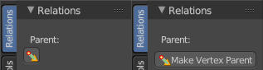
The Relation panel contains tools around relations. In Edit Mode it's just Make Vertex Parent.
In Object mode select the object that you want to parent to a vertex. Shift select the parent object so that both are selected. Enter Edit mode. Then select one vertex for a single point. Or three for an area. Then click the Make Vertex Parent button to make the relation.

Tool Shelf in Edit Mode - Mesh Object, Tools Tab

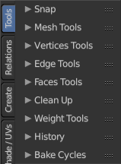
The Tools tab contains the tools to edit the mesh object. It contains the panels Mesh Tools, Vertices Tools, Edge Tools, Faces Tools, Clean Up, Weight Tools, History and Bake.

Which Bake panel is active is dependant of what render engine is selected. When it's cycles then you have the Cycles bake tools. When it's the Blender Render, then you have the Blender Render bake tools.

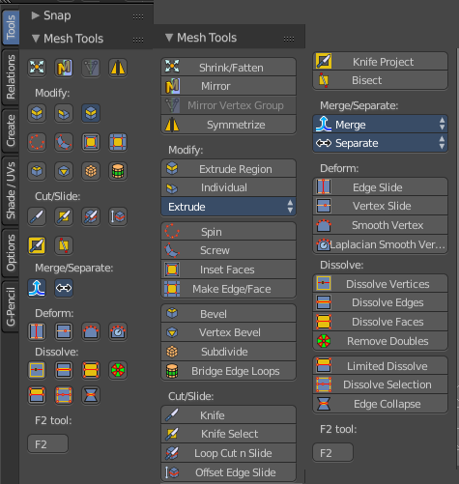
Mesh Tools Panel
The Mesh Tools Panel contains the tools to edit and manipulate the geometry of a mesh object.
There are four main tool groups in the Mesh Tools panel. Transform tools, Deform tools, Add tools, and Dissolve tools. The Transform tools at the top doesn't have a label.

Shrink/Fatten
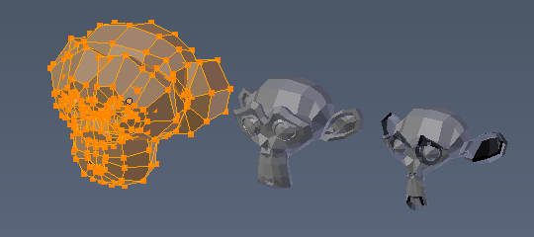
Shrink/Fatten scales the selected geometry along its normals. Transform orientation and Pivot point gets ignored.
A positive value pushes the vertices outwards. A negative value pushes the vertices inwards.

Last Operator Shrink/Fatten
The Last Operator Shrink/Fatten panel gives you tools to adjust the Shrink/Fatten operation. Here you have numeric input for the strength and a few more options.

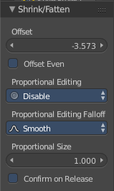
Offset
Offset is the strength of the offset for Shrink/Fatten.

Offset Even
Offset Even scales the selection to give more thickness in even areas.

Proportional Editing
Proportional Editing is a drop-down box where you can choose to use proportional editing. When you choose one of the active methods then the neighbour geometry gets influenced by Shrink/Fatten too in a proportional way.

Proportional Editing Falloff
Proportional Editing Falloff is a drop-down box where you can choose a method for the falloff for the proportional editing.

Proportional size
Proportional size is a edit box where you can adjust the strength of the Proportional falloff

Confirm on Release
With Confirm on Release checked the action gets performed when you release the mouse button.

Mirror
Mirror mirrors the selected geometry along the defined axis. Click the Mirror button, type in X, Y or Z, then confirm with enter.

Last Operator Mirror
The Last Operator Mirror panel gives you tools to adjust the mirror action.
The Last Operator Mirror panel gives you tools to adjust the mirror action.

Constraint Axis
Constraint Axis gives you again the possibility to define the mirror axis. You can choose more than one axis here.

Orientation
Orientation is a drop-down box where you can choose the type of orientation for the mirroring action.

Proportional Editing
Proportional Editing is a drop-down box where you can choose to use proportional editing. When you choose one of the active methods then the neighbour geometry gets influenced by Shrink/Fatten too in a proportional way.

Proportional Editing Falloff
Proportional Editing Falloff is a drop-down box where you can choose a method for the falloff for the proportional editing.

Proportional size
Proportional size is a edit box where you can adjust the strength of the Proportional falloff.

Edit Grease Pencil
Edit Grease Pencil edits the selected Grease Pencil strokes.

Confirm on Release
With Confirm on Release checked the action gets performed when you release the mouse button.

Mirror Vertex Group
This tool requires to have a vertex group assigned. It tries to mirror for example existing Weight Painting from one side to the other.
This tool works only with a perfectly symmetrical mesh along the local X axis. Vertices that have no corresponding vertex on the other side will not be affected.
Use case:
Let's say you have a rigged character, and do Weight Paint at one side of the mesh. Now you would have to repeat the Weight Painting at the other side. Instead, go to the vertex group panel in the Properties editor, and choose Copy Vertex Group (from the drop down menu) for each group you want to mirror. Then select the copy and choose Mirror Vertex Group.

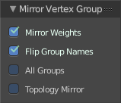
Last Operator Mirror Vertex Group

Mirror Weights
Mirrors the Weight Painting informations from the symmetrical counterpart. When both are selected it will become a group and weight information exchange. If only one is selected, then the information from the unselected vertice will go to the selected vertice.

Flip Group Names
Flip selected group names. This works with vertex groups with symmetrical name conventions. Like .L , .R, right, left.

All Groups
Pass information to all groups instead of the active one.

Topology Mirror
Use topology based mirroring.

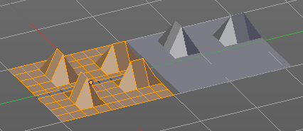
Symmetrize
The Symmetrize tool mirrors the selected geometry symmetrical along a world axis.

Last Operator Symmetrize

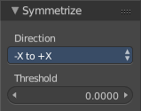

Direction
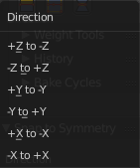
Direction is a drop down box where you can define the mirroring direction.

Threshold
Here you can adjust a distance after which the mirroring should happen, relative to the mirror axis. 0 means it mirrors the geometry directly at the axis.

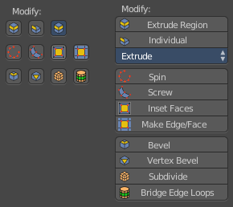
Modify section
This section contains tools for general mesh modifications.

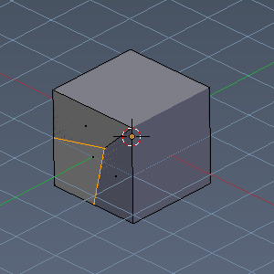

Extrude Region
The Extrude Region tool extrudes along the vertex normals. This leads at our standard cube with two selected faces and with a value of 1 to a extrude that goes inside of the mesh.
The method works the same in all Mesh select modes.

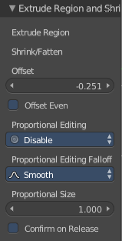
Last Operator Extrude Region and Shrink/Fatten
The Last Operator Extrude Region and Shrink/Fatten contains the tools to adjust the Extrude settings for the extrude method Region (Vertex Normals)

Extrude Individual Faces
Just ignore, it's a bug. It's the title of the panel when you call this menu by a hotkey. Shrink/Fatten Offset
You have to read the two parts Shrink Fatten and Offset as one. Shrink Fatten Offset is a edit box where you can adjust the strength of the extrude offset numerically.

Offset Even
Scale the offset to give more even thickness.

Proportional Editing
Proportional Editing is a drop-down box where you can choose to use proportional editing. When you choose one of the active methods then the neighbour geometry gets influenced by Shrink/Fatten too in a proportional way.

Proportional Editing Falloff
Proportional Editing Falloff is a drop-down box where you can choose a method for the falloff for the proportional editing.

Proportional size
Proportional size is a edit box where you can adjust the strength of the Proportional falloff.

Confirm on Release
With Confirm on Release checked the action gets performed when you release the mouse button.

Individual Faces
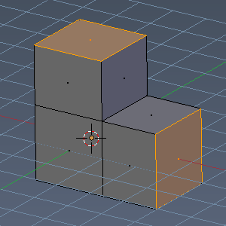
The extrude method Individual Faces is the exact same method than the method Individual - In Face mode
Individual Faces extrudes the faces individually. When you for example select two faces at a cube, then the extrusion happens at both faces in their own direction, which is defined by the normals of the faces. And not as a whole in one shared direction.
Individual Faces works in all mesh select methods the same. It needs selected faces. Stand-alone vertices or edges gets ignored.

Last Operator Extrude Individual Faces and Move
The Last operator Extrude Individual Faces and Move contains the tools to adjust the Extrude Individual Faces settings. It shows when you use the Individual tool in Face mode.

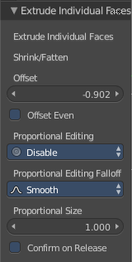
Extrude Individual Faces
Just ignore, it's a bug. It's the title of the panel when you call this menu by a hotkey.

Shrink/Fatten Offset
You have to read the two parts Shrink Fatten and Offset as one. Shrink Fatten Offset is a edit box where you can adjust the strength of the extrude offset numerically.

Offset Even
Scale the offset to give more even thickness.

Proportional Editing
Proportional Editing is a drop-down box where you can choose to use proportional editing. When you choose one of the active methods then the neighbour geometry gets influenced by Shrink/Fatten too in a proportional way.

Proportional Editing Falloff
Proportional Editing Falloff is a drop-down box where you can choose a method for the falloff for the proportional editing.

Proportional size
Proportional size is a edit box where you can adjust the strength of the Proportional falloff.

Confirm on Release
With Confirm on Release checked the action gets performed when you release the mouse button.

Extrude Drop-down box
The Extrude drop-down box contains the special Extrude methods. The methods that you don't use this often.
The available Extrude tools depends of the Mesh select mode. Edge, Vertice and Face select. And the tool works then of course for the current mode. Means when you are vertice select mode, then the extrude will extrude the vertices. But it also depends of what you have selected. And so you see different content in the drop-down box.
From left to right, with a whole cube selected: Vertices select mode, Edge select mode, Face select mode.
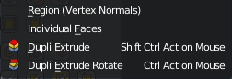
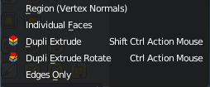
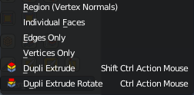

Dupli Extrude
Dupli Extrude is a two trick tool. With faces selected it creates a rotated copy of the geometry. With edges or vertices selected it extrudes to the mouse position. That's why it is a good idea to use this tool with the hotkey.

Dupli Extrude - with selected Faces
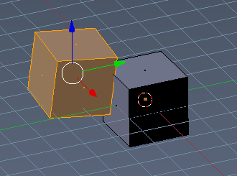
Dupli Extrude with selected faces creates a copy of the selection and rotates it slightly.

Dupli Extrude - with selected Vertices
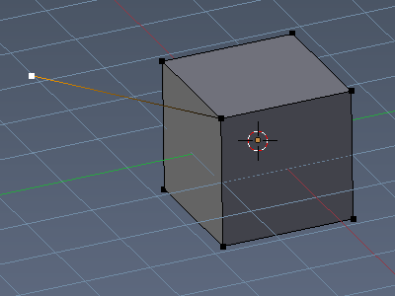
Dupli Extrude with selected vertices extrudes the vertice to the mouse position.

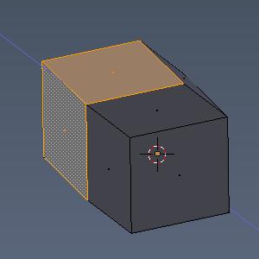
Extrude Region

Extrude region is the most common and most used extrude method. That's why it has a default hotkey. Shortcut S. It extrudes the whole selection into the direction of the middled normals of the selection.

Last Operator Region and Move
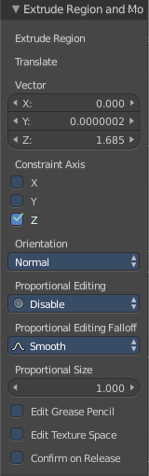
The Last operator Extrude Individual Faces and Move contains the tools to adjust the Extrude Individual Faces settings. It shows when you use the Individual tool in Face mode.

Extrude Region label
Just ignore, it's a bug. It's the title of the panel when you call this menu by a hotkey.

Translate Vector
You have to read the two parts Translate and Vector as one. Here you can adjust the extrude amount by a vector.

Constraint Axis
Tick or untick X, Y Z to limit the extrusion to one or more axis.

Orientation
Here you can adjust the orientation of the extrusion. It usually starts with Normal.

Proportional Editing
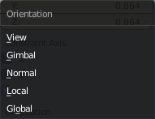
Proportional Editing is a drop-down box where you can choose to use proportional editing. When you choose one of the active methods then the neighbour geometry gets influenced by Shrink/Fatten too in a proportional way.

Proportional Editing Falloff
Proportional Editing Falloff is a drop-down box where you can choose a method for the falloff for the proportional editing.

Proportional size
Proportional size is a edit box where you can adjust the strength of the Proportional falloff.

Edit Grease Pencil
Edit Grease pencil ticked allows you to edit the grease pencil stroke.

Edit Texture Space
By default extrusion will not modify the UV mapping. With Edit texture Space ticked the UV mapping updates with the extrusion.

Confirm on Release
With Confirm on Release checked the action gets performed when you release the mouse button.

Extrude Individual - In Face mode
Individual in Face mode extrudes the elements individually. When you for example select two faces at a cube, then the extrusion happens at both faces in their own direction, which is defined by the normals of the faces. And not as a whole in one shared direction.

Last Operator Extrude Individual Faces and Move
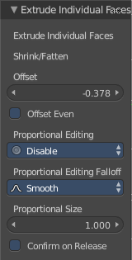
The Last operator Extrude Individual Faces and Move contains the tools to adjust the Extrude Individual Faces settings. It shows when you use the Individual tool in Face mode.

Extrude Individual Faces
Just ignore, it's a bug. It's the title of the panel when you call this menu by a hotkey.

Shrink/Fatten Offset
You have to read the two parts Shrink Fatten and Offset as one. Shrink Fatten Offset is a edit box where you can adjust the strength of the extrude offset numerically.

Offset Even
Scale the offset to give more even thickness.

Proportional Editing
Proportional Editing is a drop-down box where you can choose to use proportional editing. When you choose one of the active methods then the neighbour geometry gets influenced by Shrink/Fatten too in a proportional way.

Proportional Editing Falloff
Proportional Editing Falloff is a drop-down box where you can choose a method for the falloff for the proportional editing.

Proportional size
Proportional size is a edit box where you can adjust the strength of the Proportional falloff.

Confirm on Release
With Confirm on Release checked the action gets performed when you release the mouse button.

Extrude Individual in Edge and Vertice Mode
For Individual in Edge and Vertice Mode see the extrude methods Edges only and Vertices only. It's the same functionality.

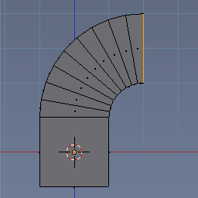
Spin
The Spin tool extrudes the selection and spins it by a defined amount and segments. This amount and number of segments can be adjusted in the Last operator. It is best performed in a orthographic view from side. It depends of the view orientation when extruding out.

Last Operator Spin

Steps
Steps is the number of segments.

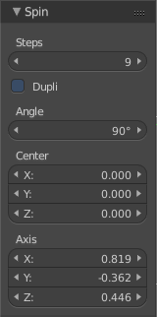
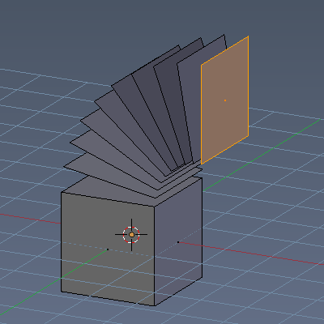
Dupli
With dupli checked the geometry gets duplicated instead of extruded. Angle
Angle defines the angle of the spin.

Centre
The Centre edit boxes defines the centre of the radius for the spin operation. In our example the X value is set to 2, and the Z value is set to 1.

Axis
Axis defines the extrude direction. With X and Z values you can twist the result.

Screw
With the Screw tool you can extrude edges to a screw shape. Examples:
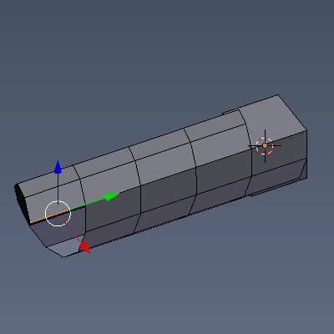 | 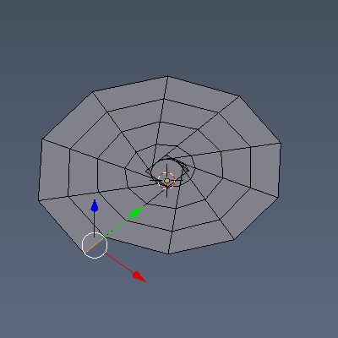 | 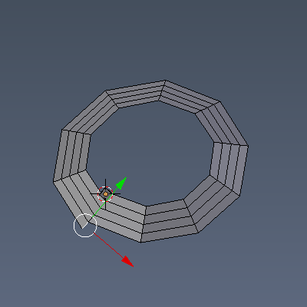

Last Operator Screw
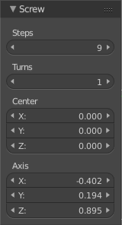

Steps
Steps is the number of segments.

Turns
Turns defines the repeating of the screw.

Centre
The Centre edit boxes defines the centre of the radius for the screw operation.

Axis
Axis defines the extrude direction.

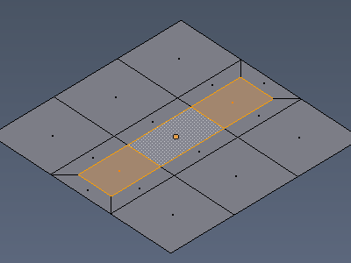
Inset
Inset insets edges into the selected faces. Think of it as a extrude inwards the face.

Last Operator Inset

Boundary
With Boundary ticked you will get the connect edges in the corners.

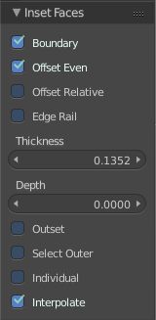
Offset Even
Scales the offset to give more even thickness.

Offset Relative
Scales the offset by surrounding geometry.

Edge Rail
Inset the region along existing edges.

Thickness
Thickness adjusts the thickness of the inset geometry.

Depth
With depth you can bevel the inset geometry. It is then not longer coplanar to the initial face.

Outset
With outset ticked the Inset will not extrude inwards but outwards.

Select Outer
With Select Outer the outer ring will be selected after the Inset.

Individual
Inset every face individually.

Interpolate
Blend Face Data across the inset.

Make Edge/Face
The Make Edge/Face tool adds a face when you have edges selected. And Edges when you have Vertices selected. It's a Bridge tool.
First select the edges or Vertices that you want to bridge. Then click the Make Edge/Face Button.
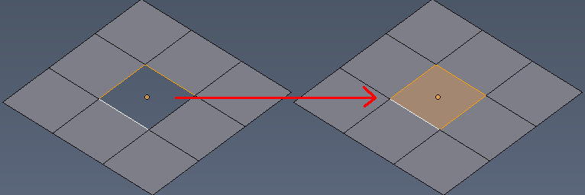 | 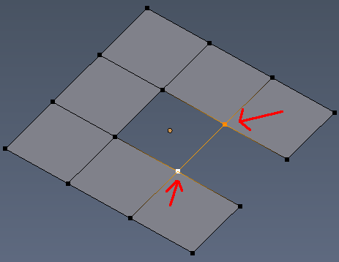

The Last Operator Make Edge/Face has no further options.

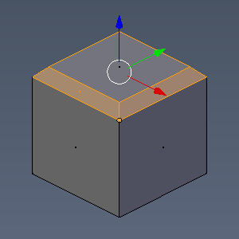
Bevel
The Bevel Tool adds a bevel to the selected geometry.
Usage: first select the geometry that you want to bevel. Then activate the tool. Don't wonder that the mouse movement does nothing. That's by design. Adjust the amount in the Last Operator Bevel panel.

Last Operator Bevel

Amount type
Amount Type is a drop-down box where you can choose the Amount type for the bevel action.

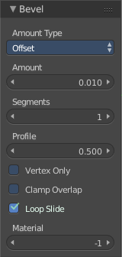
Amount
The Bevel amount

Segments
How many segments gets created

Profile
Controls the Profile shape. 0.5 means round.

Vertex only
Bevel Vertices only.

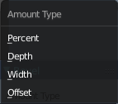
Clamp Overlap
Do not allow bevelled geometry to overlap each other.

Loop Slide
Prefer slide along edge to even widths.

Material
Material for bevelled faces. -1 is the surrounding material.

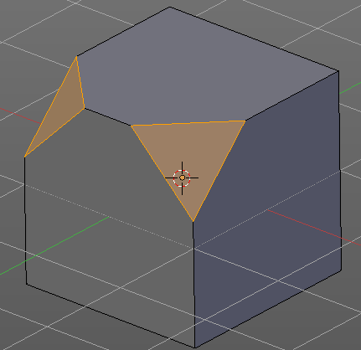
Vertex Bevel
Vertex Bevel is nothing else than Bevel. But with some pre adjustments to perform a vertex bevel directly. This saves some clicks.
This means that the Last Operator is of course the same than the one from Bevel since it is Bevel.

Subdivide
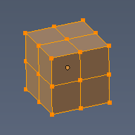
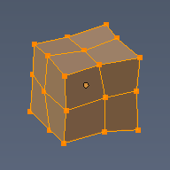
Subdivide divides the selected edges. It subdivides the involved faces too, and can create new vertices.
A more unknown functionality is that it can also randomize the result with the Fractal slider in the Last operator panel.

Last Operator Subdivide

Number of Cuts
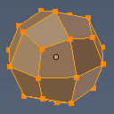
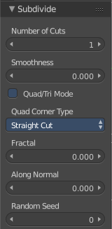
The number of cuts defines the amount of subdivisions.

Smoothness.
This value defines how smooth the subdivision result is. From flat to bent.

Quad/Tri Mode
With this tool ticked it tries to prevent N-Gons while subdivision.

Quad Corner Type
Here you can adjust the corner type.

Fractal
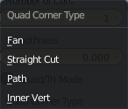
Randomize the selected vertices.

Along Normal
When randomized, this value defines how strong the subdivision follows the normals of the initial vertices.

Random Seed
Randomizing value for fractal randomizing.

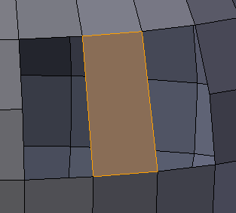
Bridge Edgeloops
The Bridge edgeloops tool bridges selected edges, and adds a polygon between them. You need to have at least two edges selected.

Last Operator Bridge Edgeloops

Connect Loops
Here you can choose the method how to deal with bridging multiple loops

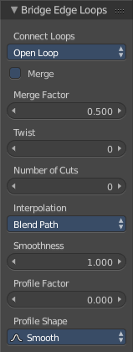
Merge
With merge ticked it will not create a bridge face, but merge the selected edges.

Merge Factor
The merge factor determines at which distance between the selected edges the merge happens. 0.5 is the middle of the selected edges.

Twist
The twist offset for closed loops.

Number of Cuts
Adds cuts to the bridge face.

Interpolation
Here you can choose the interpolation mode for the cuts.

Smoothness
Here you can adjust the smoothness for the cuts.

Profile Factor
Here you can adjust the profile factor for the cuts.

Profile shape
Here you can adjust the profile shape for the cuts.

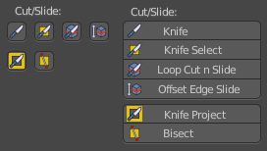
Cut Slide panel
This section contains tools around cut functionality.

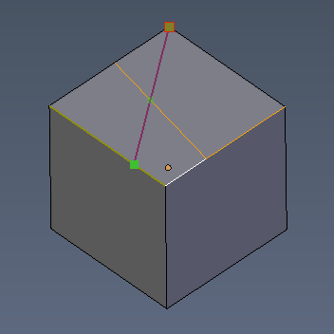
Knife tool
The Knife tool cuts the geometry, and adds edges. When it crosses existing geometry then it adds a vertice at the crossing point.
The Knife tool cuts across every geometry, selected or not.
Usage: activate the tool, left click to define the starting point. This can also be a point in the middle of a face. But ideally you choose an existing vertice or an edge as the start and endpoints. When done press Space bar to confirm.

Last Operator Knife Topology Tool
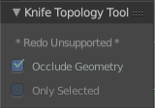
There is no adjustable setting in the Last Operator Knife Topology Tool.
Just a hint that Redo is not supported for this operator. And the states of the checkboxes are displayed.

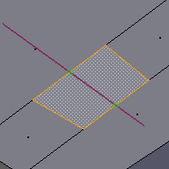
Knife Select Tool
Knife Select tool works similar to the Knife tool. But it cuts just selected faces.

Last Operator Knife Topology Tool
There is no adjustable setting in the Last Operator Knife Topology Tool.
Just a hint that Redo is not supported for this operator. And the states of the checkboxes are displayed. For Knife Select this checkboxes are checked different than for the normal knife tool.

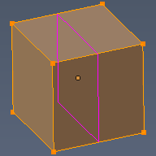
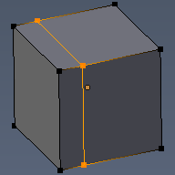
Loop Cut and Slide
Loop Cut and Slide is a tool that works in two steps. In the first step you divide the selected geometry by a loop. When you left click, then the added loop becomes moveable along the edges.

Last Operator Loop Cut and Slide

Number of Cuts
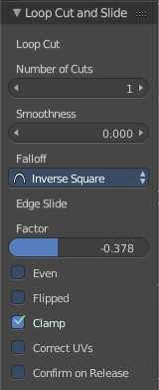
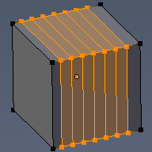
The number of cuts that gets added. It can be more than one loop at once.

Smoothness
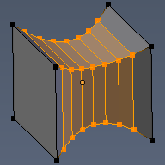
This value defines how smooth the loop cut gets added. From flat to bent.

Falloff
Here you can adjust the Falloff type for smoothness.

Edge Slide Factor
Where the loop is centred.

Even
Make the edge loop match the shape of the adjacent edge loop

Flipped
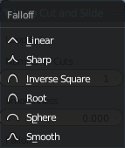
When Even mode is active, flips between the two adjacent edge loops.

Clamp
Clamp within the edge extend.

Correct UV's
Corrects the UV's when modifying the geometry.

Confirm on Release
With Confirm on Release checked the action gets performed when you release the mouse button.

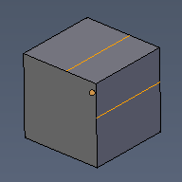
Offset Edge Slide
Edge slide slides the selected edge(s)
Usage: select the edges that you want to slide. Click to confirm. Then adjust the sliding amount in the Last Operator Offset Edge Slide.

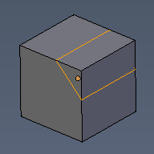
Last Operator Offset Edge Slide

Cap Endpoint
Cap Endpoint caps the loose edges.

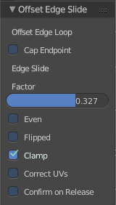
Edge Slide Factor
Here you can adjust the slide amount.

Even
Make the edge loop match the shape of the adjacent edge loop

Flipped
When Even mode is active, flips between the two adjacent edge loops.

Clamp
Clamp within the edge extend.

Correct UV's
Corrects the UV's when modifying the geometry.

Confirm on Release
With Confirm on Release checked the action gets performed when you release the mouse button.

Knife Project
Knife Project uses an object as a knife to cut edges into a mesh.
Usage: Create a cube. Create a circle. Rotate the circle by 90 degrees, and move it in front of the cube so that it does not overlap the cube. Now go into front view. Select circle, hold down shift, select Cube. Enter Edit Mode. Click the Knife Project tool.
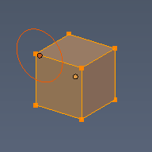 | 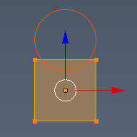 | 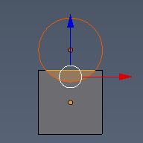 | 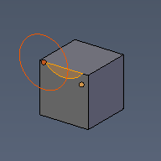

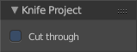
Last Operator Knife Project

Cut through
The cut goes through the whole object when the Cut through checkbox is ticked.

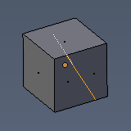
Bisect
Bisect cuts geometry along a plane. This description is a bit misleading though. You simply cut through the whole geometry by defining a line. And the cut goes through the geometry from the current view.

Last Operator Bisect

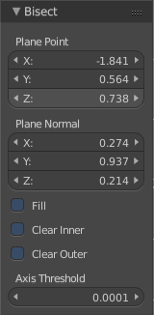
Plane Point
Defines the start point of the Bisect cut.

Plane Normal
The direction in which the bisect points.

Fill
Fills the cut

Clear Inner
Removes the inner part of the face to cut.

Clear Outer
Removes the outer part of the face to cut.

Axis threshold
Axis threshold.

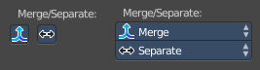
Merge / Separate
This section contains the merge and separate tools.

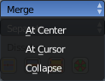
Merge
Merge merges the vertices of the selected geometry. There are three methods available. At centre, At Cursor and Collapse.
At Centre merges the geometry at the centre of the selected vertices.
At Cursor merges the geometry at the 3D Cursor.
Collapse merges the geometry at the centre of the selected vertices.

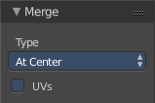
Last Operator Merge

Type
Type is the drop-down box again where you can choose what method to use for merge.

UV's
With UV's ticked the UV mapping will update with changes at the geometry.

Separate
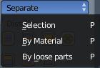
Separate separates the selected geometry, and creates a new object. The geometry becomes uneditable, since it is now a new object. You will have to leave the Edit mode, select the new object, and re-enter Edit mode when you want to edit it.
Selection separates the current selection.
By Material separates all geometry that has the same material than the current selection.
By Loose parts separates all geometry that is connected by edges to the current selection.
Separate has no Last Operator.

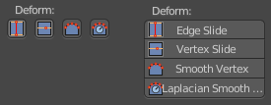
Deform section
The Deform section contains tools to deform the existing geometry.

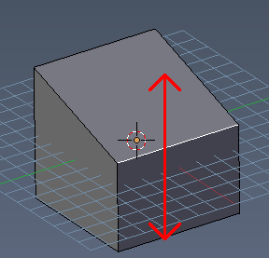
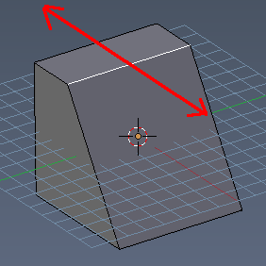
Edge Slide
Edge Slide slides the selected edge along the face that it is part of. This is for the edge at a cube into two possible directions.

Last Operator Edge Slide

Factor
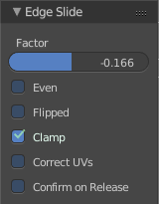
Factor is a sliding box Here you can adjust the slide strength numerically. The width of the face is the 0-1 range.

Even
Make the Edge loop match the shape of the adjacent edge loop.

Flipped
When Even Mode is active, flips between the two adjacent edge loops.

Clamp
Clamp within the edge extend.

Correct UV's
Correct UV's corrects the UV's while editing the geometry.

Confirm on Release
With Confirm on Release checked the action gets performed when you release the mouse button.

Vertex Slide
Vertex Slide slides the selected vertice along the edge that it is part of. This is for the corner vertice at a cube into three possible directions.

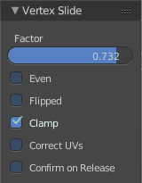
Last Operator Vertex Slide

Factor
Factor is a sliding box Here you can adjust the slide strength numerically. The width of the face is the 0-1 range.

Even
Make the Edge loop match the shape of the adjacent edge loop.

Flipped
When Even Mode is active, flips between the two adjacent edge loops.

Clamp
Clamp within the edge extend.

Correct UV's
Correct UV's corrects the UV's while editing the geometry.

Confirm on Release
With Confirm on Release checked the action gets performed when you release the mouse button.

Smooth Vertex
Smooth Vertex smooths the selected vertices. It is a tool to reduce noise at the mesh.

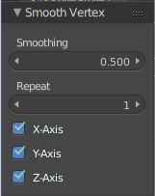
Last Operator Smooth Vertex

Smoothing
Smoothing is the strength of the smoothing

Repeat
Repeat is the number of iterations that the smoothing action gets repeated. With 1 the smoothing is just performed once. With 10 it is performed ten times.

Axis
The Axis checkboxes lets you limit the smoothing to specific world axis.

Laplacian Smooth Vertex
Laplacian Smooth Vertex smooths the selected vertices. It is a tool to reduce noise at the mesh. It works a bit different than the normal Smooth Vertex tool. And gives a different result. The Laplacian method allows you to preserve the volume, and to adjust border smoothing.

Last Operator Laplacian Smooth Vertex

Number of Iterations
Number of Iterations is the number of iterations that the smoothing action gets repeated. With 1 the smoothing is just performed once. With 10 it is performed ten times.

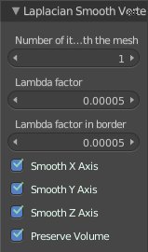
Lambda Factor
Lambda Factor is the strength of the smoothing.

Lambda Factor in border
Lambda Factor is the strength of the smoothing in border areas.

Smooth Axis
The Smooth Axis checkboxes allows you to limit the smoothing to specific world axis.

Preserve Volume
Preserve Volume preserves the volume of the object.

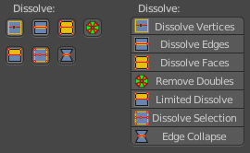
Dissolve Section
Dissolve operations removes for examples selected vertices, edges and faces. But they are not delete operations. It's not simply removing the selected element. Dissolve can behave different than delete. And offers some options.

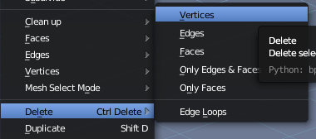
When you for example choose Delete vertices from the mesh menu, then the involved faces can get deleted too. When you choose Dissolve vertices, then the vertices gets removed, and the faces stays intact.

Dissolve Vertices
Dissolve Vertices dissolves the selected Vertices.
Note that pressing DEL in Vertice select mode calls Dissolve Vertices already. It's the same operator. But you don't get the Last operator that way.

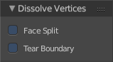
Last Operator Dissolve Vertices

Face Split
Split off Face corners to maintain surrounding geometry

Tear Boundary
Split off Face corners instead of merging faces

Dissolve Edges
Dissolve Edges dissolves the selected Edges.
Note that pressing DEL in Edge select mode calls Dissolve Edges already. It's the same operator. But you don't get the Last operator that way.

Last Operator Dissolve Edges

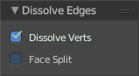
Dissolve Verts
When the dissolve operation leaves vertices behind, then this vertices will be dissolved too.

Face Split
Split off Face corners to maintain surrounding geometry

Dissolve Faces
Dissolve Faces removes the inlaying edges of the selected faces. This faces becomes one big N-Gon.

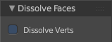
Last Operator Dissolve Faces

Dissolve Verts
When the dissolve operation leaves vertices behind, then this vertices will be dissolved too.

Remove Doubles
Remove doubles merges vertices that are close to each other or overlapping each other. This is sometimes necessary to remove vertices that overlaps each other, and cannot even be seen therefore.

Last Operator Remove Doubles

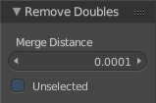
Merge Distance
The distance in which the vertices gets catched and merged.

Unselected
With Unselected ticked all surrounding vertices will be calculated.

Limited Dissolve
Limited Dissolve dissolves the selected Edges and Vertices, limited by the surrounding geometry.

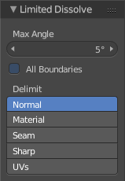
Last Operator Limited Dissolve

Max Angle
The limiting angle.

All Boundaries
All Boundaries dissolves in-between face boundaries.

Delimit
You can also delimit by other methods than normals.

Dissolve Selection
Dissolve Selection dissolves the geometry based at the selection mode.

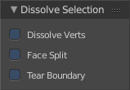
Last Operator Dissolve Selection

Dissolve Verts
When the dissolve operation leaves vertices behind, then this vertices will be dissolved too.

Face Split
Split off Face corners to maintain surrounding geometry.

Tear Boundary
Split off Face corners instead of merging faces.

Edge Collapse
Edge Collapse collapses the selected edges to a vertice at the centre of the selection.
Edge Collapse has no adjustable settings in the Last Operator panel.

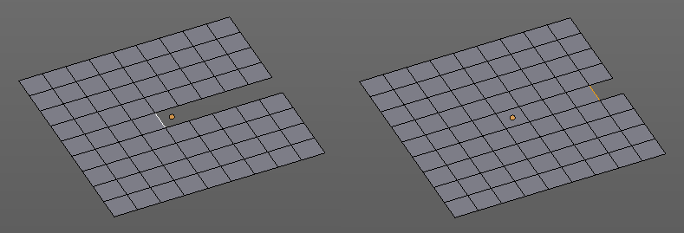
F2 Tool
The F2 Tool is an addon that speeds up modeling process. It allows you to quickly fill gaps in a mesh.

This addon can be disabled in the addon section of the user preferences.

Vertices Tools Panel
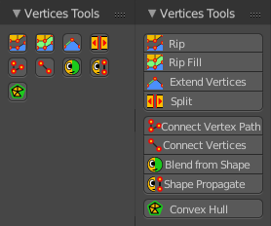
Vertices Tools is a panel that contains vertices related tools.

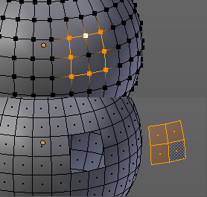
Rip
Rip splits the edges between the selected vertices. It creates two edges out of one.
This tool works similar to the Edge Split tool. But with selected edges instead of selected vertices. It also selects the outer edges so that you immediately move them. And it provides some options in the Last operator.

Last Operator Rip
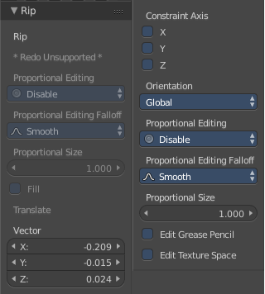
There are some greyed out parts. We will ignore them since it is most probably a bug, and we cannot edit them anyway.

Vector
Here you can adjust the position values for the three values

Constraint Axis
Here you can limit the position relative to the source object.

Orientation
Orientation is a drop-down box where you can choose the type of orientation for the mirroring action.

Proportional Editing
Proportional Editing is a drop-down box where you can choose to use proportional editing. When you choose one of the active methods then the neighbour geometry gets influenced by Shrink/Fatten too in a proportional way.

Proportional Editing Falloff
Proportional Editing Falloff is a drop-down box where you can choose a method for the falloff for the proportional editing.

Proportional Size
Proportional size is a edit box where you can adjust the strength of the Proportional falloff.

Edit Grease Pencil
Edit Grease Pencil edits the selected Grease Pencil strokes.

Edit Texture Space
With Confirm on Release checked the action gets performed when you release the mouse button.

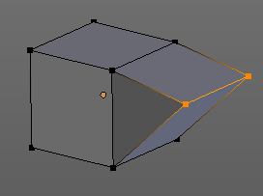
Rip Fill
Rip Fill works similar to the Rip tool. It splits the edges between the selected vertices. It creates two edges out of one. But it fills the gap between the new edges when you move the geometry.
This tool works similar to the Edge Split tool. But with selected edges instead of selected vertices. It also selects the outer edges so that you immediately move them. And it provides some options in the Last operator.

Last Operator Rip Fill
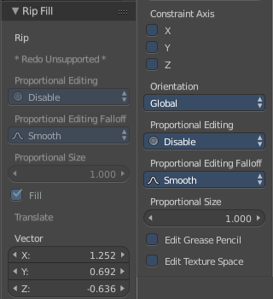
There are some greyed out parts. We will ignore them since it is most probably a bug, and we cannot edit them anyway.

Vector
Here you can adjust the position values for the three values

Constraint Axis
Here you can limit the position relative to the source object.

Orientation
Orientation is a drop-down box where you can choose the type of orientation for the mirroring action.

Proportional Editing
Proportional Editing is a drop-down box where you can choose to use proportional editing. When you choose one of the active methods then the neighbour geometry gets influenced by Shrink/Fatten too in a proportional way.

Proportional Editing Falloff
Proportional Editing Falloff is a drop-down box where you can choose a method for the falloff for the proportional editing.

Proportional Size
Proportional size is a edit box where you can adjust the strength of the Proportional falloff.

Edit Grease Pencil
Edit Grease Pencil edits the selected Grease Pencil strokes.

Edit Texture Space
With Confirm on Release checked the action gets performed when you release the mouse button.

Extend Vertices
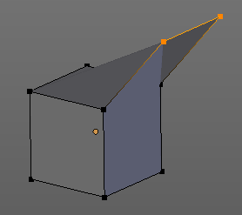
Extend vertices extrudes out the selected vertices. When you do this operation at an edge then you will create N-Gons that way.

Last Operator Extend Vertices
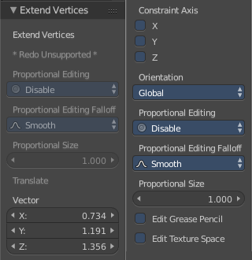
There are some greyed out parts. We will ignore them since it is most probably a bug, and we cannot edit them anyway.

Vector
Here you can adjust the position values for the three values

Constraint Axis
Here you can limit the position relative to the source object.

Orientation
Orientation is a drop-down box where you can choose the type of orientation for the mirroring action.

Proportional Editing
Proportional Editing is a drop-down box where you can choose to use proportional editing. When you choose one of the active methods then the neighbour geometry gets influenced by Shrink/Fatten too in a proportional way.

Proportional Editing Falloff
Proportional Editing Falloff is a drop-down box where you can choose a method for the falloff for the proportional editing.

Proportional Size
Proportional size is a edit box where you can adjust the strength of the Proportional falloff.

Edit Grease Pencil
Edit Grease Pencil edits the selected Grease Pencil strokes.

Edit Texture Space
With Confirm on Release checked the action gets performed when you release the mouse button.

Split
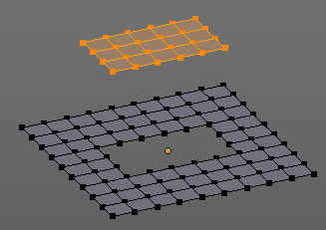
Split works similar to the Rip tool. It splits the edges between the selected vertices. It creates two edges out of one.
This tool works similar to the Edge Split tool. But with selected edges instead of selected vertices.

Connect Vertex Path
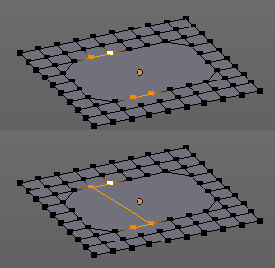
Connect Vertex path connects selected vertices, but takes the vertex order into account. It just creates edges between vertices that are not connected in this order.

Connect Vertices
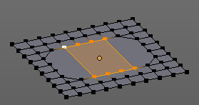
Connect Vertices connects the selected vertices. It does not fill the selection with edges though, but creates just the edges for the outside of a polygon.

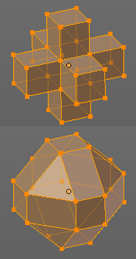
Convex Hull
Creates a convex hull around the selected vertices.

Last Operator Convex Hull

Delete Unused
Removes vertices that are not part of the convex geometry.

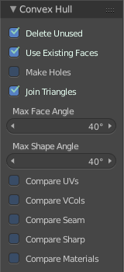
Use existing Faces
Use existing input faces that lies on the hull where possible. This option allows to have N-Gons in the convex hull.

Make Holes
Deletes edges and faces in the hull that were part of the input. This allows to delete faces between the existing mesh and the convex hull.

Join Triangles
Joins adjacent triangles into quads

Max Face Angle
Max Face Angle belongs to the Join Triangles setting. Here you can set the maximum face angle.

Max Shape Angle
Max Face Angle belongs to the Join Triangles setting. Here you can set the maximum shape angle.

Compare UV's
Takes existing UV patches for the calculation into account.

Compare Vcols
Takes existing Vertex colors for the calculation into account.

Compare Seam
Takes existing seams for the calculation into account.

Compare Sharp
Takes existing sharp edges for the calculation into account.

Compare Materials
Takes existing materials for the calculation into account.

Edges Tools Panel
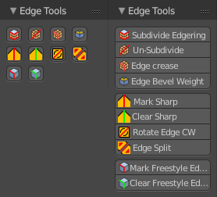
Edges Tools is a panel where you can find some Edges related tools.

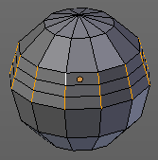
Subdivide Edge ring
Subdivides the selected edge ring(s).

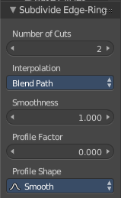
Last Operator Subdivide Edge ring

Number of Cuts
Here you can adjust the number of cuts for the subdivision.

Interpolation
Here you can chose a interpolation method for the new geometry.
Linear ends in a equal division and a flat result. Blend Surface interpolates the surrounding geometry. And can end in a curvy result.

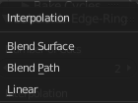
Smoothness
The Smoothness factor for the interpolation.

Profile Factor
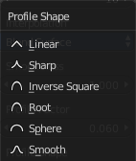
The profile strength

Profile Shape
A drop-down box where you can define a profile for the generated geometry.

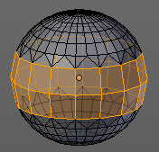
Un-Subdivide
Decimates the geometry by trying to make one quad out of four quads. But can also end in Tris where this is not possible.

Last Operator Un-Subdivide

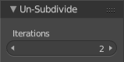
Iterations
Number of iterations. This means how deep the calculation should go. One level of SDS, two levels, three levels, etc. . Down to the point where you cannot decimate any geometry anymore.

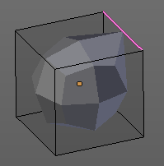
Edge Crease
When you use a Subdivision Surface Modifier, then you can define the sharpness of selected edges with this tool. Crease edges will be marked colored in edit mode.
You will see a value in the header that indicates the current strength when you activate the tool. Move with the mouse to increase or decrease the value. Or type in a value while you are in this mode. You can also scale into negative range.
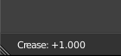
A negative crease value will subtract from the current active crease value in case it exists already from a former crease operation. A Crease value of -1 removes the crease from this edge.

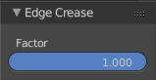
Last Operator Edge Crease

Factor
Here you can adjust the crease factor.

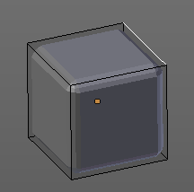
Edge Bevel Weight
This tool adjusts the edge bevel weight for selected edges when you use the Bevel modifier at the mesh.
You will see a value in the header that indicates the current strength when you activate the tool. Move with the mouse to increase or decrease the value. Or type in a value while you are in this mode. You can also scale into negative range.
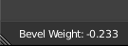
A negative Edge Bevel Weight value will subtract from the current active crease value in case it exists already from a former crease operation. A Edge Bevel Weight value of -1 removes the weight from this edge.

Last Operator Edge Bevel Weight

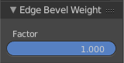
Factor
Here you can adjust the Edge Bevel Weight factor.

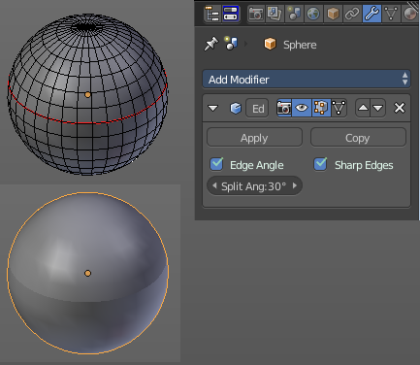
Mark Sharp
Mark Sharp is a tool that you need for the Edge Split modifier. Marked edges are displayed and rendered as sharp edges.

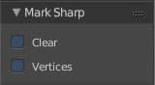
Last Operator Mark Sharp

Clear
Clears selected edges instead of marking it

Vertices
Calculate by the selected vertices instead of edges to mark the edges.

Clear Sharp
Clears formerly as sharp marked selected edges

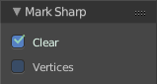
Last Operator Mark Sharp

Clear
Clears selected edges instead of marking it.

Vertices
Calculate by the selected vertices instead of edges to mark the edges.

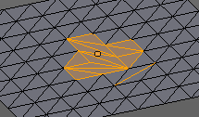
Rotate Edge CW
Rotate Edge rotates the selected edge clockwise.
This feature is useful when you have a triangulated quad mesh, and need to have some edges point into another direction as they currently do.
Rotate Edge CW rotates clockwise by default. But you can also rotate counter clockwise.

Last Operator Rotate Selected Edge

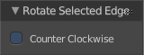
Counter Clockwise
Rotate selected edges counter clockwise

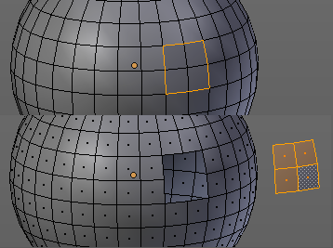
Edge Split
Edge split splits the selected edges. It creates two edges out of one.
This tool works similar to the Rip tool. But with selected edges instead of selected vertices. And this tool has no further settings.

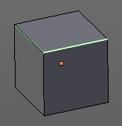
Mark Freestyle Edge
Freestyle is a comic renderer that is included in Bforartists. Mark Freestyle Edges marks the selected edges as Freestyle feature edges.

Last Operator Mark Freestyle Edge

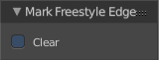
Clear
Unmarks the selected edges as Freestyle feature edges.

Clear Freestyle Edge
Freestyle is a comic renderer that is included in Bforartists. Clear Freestyle Edges unmarks the selected edges as Freestyle feature edges.

Last Operator Mark Freestyle Edge

Clear
Unmarks the selected edges as Freestyle feature edges.

Faces Tools Panel

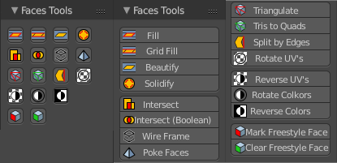
Faces
Faces is a menu where you can find some Faces related tools.

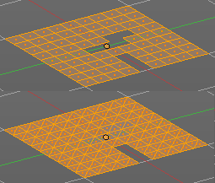
Fill
Fills holes and triangulates the geometry.

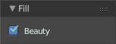
Last Operator Fill

Beauty
Use best triangulation division.

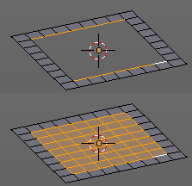
Grid Fill
Grid Fill allows you to fill two edge loops with quad geometry that follows the surrounding geometry.
Usage: select two opposite edge loops. Then perform the tool.

Last Operator Grid Fill

Span
Number of sides.

Offset
Here you can define a offset.

Simple Blending
Uses a simple interpolation. Faster but less accurate.

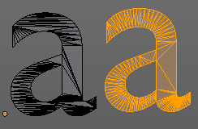
Beautify Faces
Beautify faces tries to optimize triangulations.

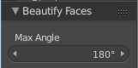
Last Operator Beautify Faces

Max Angle
Here you can set an angle limit.

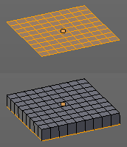
Solidify
Gives the selected faces a thickness, and makes it solid.
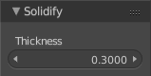
There is also a Solidify modifier available.

Last Operator Solidify

Thickness
Here you can adjust the thickness. You can scale also into the negative range.

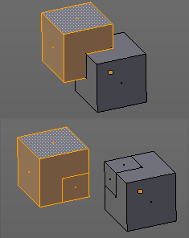
Intersect
Intersect creates edges where geometry intersects.
This operation happens in Edit mode, and so all parts must be in the same mesh.

Last Operator Intersect

Source
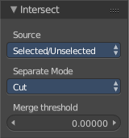
Source is a drop-down box where you can choose at which mesh part you want to operate.
Selected/Unselected works between the selected and unselected geometry.
Self Intersect works on the overlapping geometry of the mesh.

Separate Mode
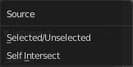
Separate mode is a drop-down box where you can choose the separation mode.
All splits the geometry at the new edge.
Cut keeps each side of the intersection separate without splitting the faces in half.
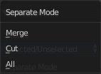
Merge merges all the geometry from the intersection.

Merge Threshold
Here you can adjust the merge threshold. Increase it when some geometry is not calculated. But keep it small for fast calculation.

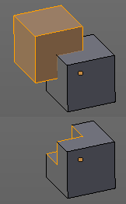
Intersect ( Boolean )
Intersect (Boolean) performs a boolean operation between the selected and unselected mesh parts.
This operation happens in Edit mode, and so all parts must be in the same mesh.

Last Operator Intersect (Boolean)

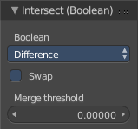
Boolean
Here you can choose the boolean method.

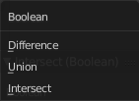

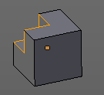
Difference subtracts the source geometry from the target geometry.

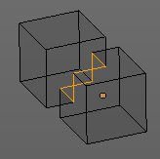
Union unions the source geometry with the target geometry. Geometry inside the source and target geometry gets removed.

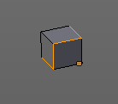
Intersect removes all geometry but the overlapping geometry.

Swap
Inverts source and target geometry.

Merge Threshold
Here you can adjust the tolerance for the boolean operation. Increase it when some geometry is not calculated. But keep it small for fast calculation.

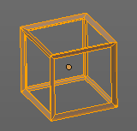
Wire Frame
Wireframe grabs the edges of the faces and turns them into tubes.

Last Operator Wire Frame

Boundary
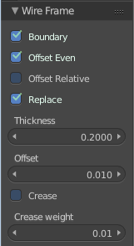
Inset Face Boundaries.

Offset Even
Scales the offset to give more even thickness.

Offset Relative
Scales the offset by surrounding geometry.

Replace
Removes the source geometry.

Thickness
Here you can adjust he thickness of the tubes.

Offset
Here you can adjust the offset of the tubes.

Crease
Crease adds close edges so that you have sharp corners when you use Subdivision Surface.

Crease Weight
Here you can adjust the crease weight.

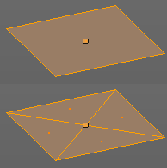
Poke Faces
Splits the selected faces to create a triangulated geometry.

Last Operator Poke Faces

Poke Offset
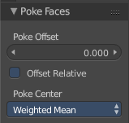
Normally the center vertice of the poke operation is planar with the rest. Here you can adjust an offset.

Offset Relative
Scale the offset by surrounding geometry.
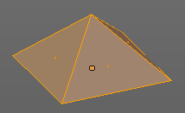

Poke Center
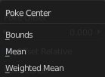
Poke Center is a drop-down box where you can choose what the center of the poke operation should be. You can choose between weighted mean, mean and bounds.

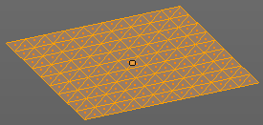
Triangulate Faces
Triangulate Faces triangulates the faces of the selected geometry.

Last Operator Triangulate Faces

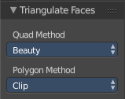
Quad Method
Here you can choose how quads should be triangulated.

Shortest diagonal
Splits the quads based on their distance between vertices.

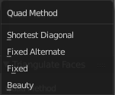
Fixed Alternate
Splits the quads on the second and fourth vertice.

Fixed
Splits the quads on the first and third vertice.

Beauty
Tries to optimize the triangulation.

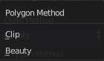
Polygon Method
Here you can choose how N-Gons should be triangulated.

Clip
Splits the polygons with an ear clipping algorithm.

Beauty
Tries to optimize the triangulation.

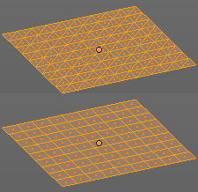
Tris to Quads
Tris to quads tries to convert triangulated geometry back to a quad geometry by removing the edges inside of the quads.

Last Operator Tris to Quads

Max Face Angle
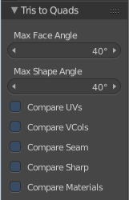
Here you can adjust the threshold to adjacent triangles.

Max Shape Angle
Here you can adjust the shape angle limit.

Compare UV's
Takes the UV patches for the calculation into account. Border geometry will not be calculated.

Compare VCols
Takes the Vertex colors for the calculation into account. Border geometry will not be calculated.

Compare Seam
Takes the Vertex colors for the calculation into account. Border geometry will not be calculated.

Compare Sharp
Takes the as sharp marked edges for the calculation into account. Border geometry will not be calculated.

Compare Materials
Takes the Materials colors for the calculation into account. Border geometry will not be calculated.

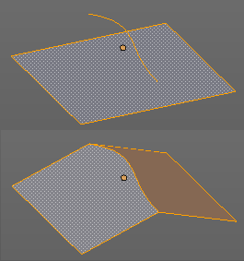
Split by Edges
This tool incorporates loose wire edges into selected faces.
You need a loose edge geometry to get it to work. By converting a curve to a Mesh geometry for example. You need to join the edge into the mesh where you want to use it. The operation happens in Edit mode.
In edit mode select the edge and the face where you want it to join. And then perform the tool.

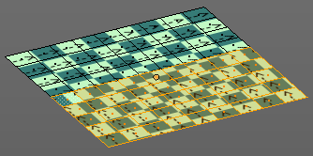
Rotate UV's
Rotates the UV space for the selected geometry by 90 degrees. This tool requires to have a working UV mapping.

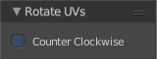
Last Operator Rotate UV's
The tool rotates clockwise by default. With this option ticked the rotation happens counter clockwise.

Reverse UV's
Reverses the UV Space for the selected geometry. This tool requires to have a working UV mapping.

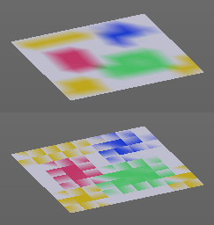
Rotate Colors
Rotates the vertex colors for the selected geometry. This tool requires to have vertex colors painted at the mesh.
Note that there is no way to display vertex colors in Edit mode. So you need to switch to Vertex paint mode to see the result.

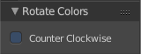
Last Operator Rotate Colors

Counter Clockwise
The tool rotates clockwise by default. With this option ticked the rotation happens counter clockwise.

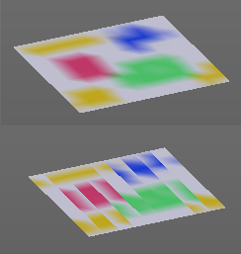
Reverse Colors
Reverses the vertex colors.
Note that there is no way to display vertex colors in Edit mode. So you need to switch to Vertex paint mode to see the result.

Mark Freestyle Face
Mark selected Faces for exclusion from Freestyle Feature edge detection. Freestyle is a cartoon renderer that is also included in Bforartists.

Clear Freestyle Face
Unmark selected Faces for exclusion from Freestyle Feature edge detection. Freestyle is a cartoon renderer that is also included in Bforartists.

Clean Up Panel
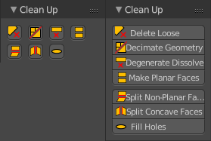
Clean Up is a menu that contains various functionality to clean up your geometry.

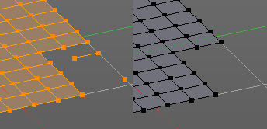
Delete Loose
Delete loose deletes not connected geometry. Vertices, Edges, and Faces. The tool starts with deleting Vertices and Edges. But you can tick Faces in the Last Operator too, and then it also removes not connected Faces.

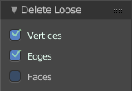
Last Operator Delete Loose

Vertices
Delete Vertices

Edges
Delete Edges

Faces
Delete Faces

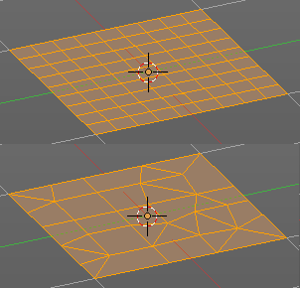
Decimate Geometry
Decimate Geometry decimates the currently selected geometry. It starts with a Ratio of 1. Which means no decimation. The lower the ratio the more decimation you will get. The Decimate Modifier works with Tris!

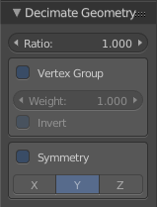
Last Operator Decimate Geometry

Ratio
Here you can adjust the strength of decimation

Vertex Group
Use active Vertex Group as an influence. You need to have a Vertex Group.

Weight
Here you can adjust the Vertex Group Strength.

Invert
Invert Vertex Group Influence

Symmetry
Here you can make the decimation geometry symmetric along a chosen world axis.

Degenerate Dissolve
Removes zero size Faces and Edges.

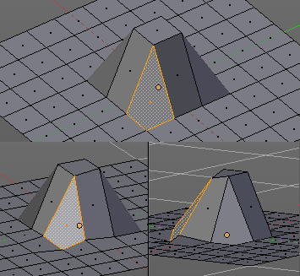
Make Planar Faces
Make Planar Faces tries to make the selected faces planar. Quads or N-Gons for example can have vertices that are not planar.

Last Operator Make Planar Faces

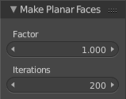
Factor
Here you adjust how strong the influence should be.

Iterations
Here you adjust how often it should repeat in the try to find a solution.

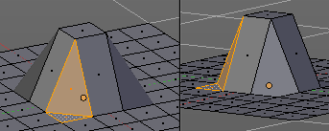
Split Non-Planar Faces
Split Non Planar Faces splits up non planar Quads and N-Gons to end in planar faces.

Last Operator Split Non-Planar Faces

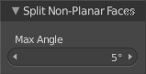
Max Angle
Here you can limit the action to a maximum angle.

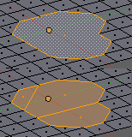
Split Concave Faces
Splits concave faces to make the geometry more stable. This tool is thought for N-Gons.

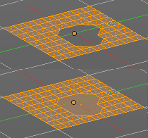
Fill Holes
Fill holes closes holes in the mesh geometry.
Fill holes can just calculate one face size at one time. So when you have several holes in the mesh, let's say one is a tri, and one is a quad, then you need to calculate twice.

Last Operator Fill Holes

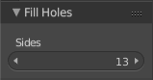
Sides
Here you can define what face size will be filled.

Weight Tools panel
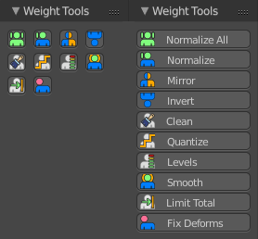
The Weight Tools panel contains Weight tools. Those tools are meant to modify the weight mapping. At characters for example. The Weight Tools requires Vertex Groups to work with. Such Vertex groups gets created when you do weight painting at a character for example. Here is defined what bone is connected to what vertice.
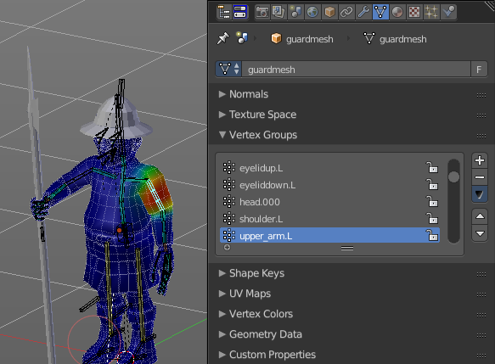
This Panel also exists in Weight Paint mode. Minus the Weight Gradient and Transfer Weight tools.

Normalize All
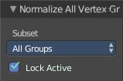
Normalize all normalizes the weight of all Vertex groups so that the values for the single vertices in the sum is 1.

Last Operator Normalize all

Subset
Subset is a drop-down menu where you can choose the Subset method.

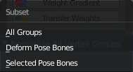
Lock Active
Keep the values of the active group while normalizing others.

Normalize
Normalize normalizes the weight of the current selected Vertex group so that the values for the single vertices in the sum is 1. Means when there is influence from other groups, then those values are kept, but the one for the current group gets lowered so that the sum is 1.
The Last Operator Normalize panel has no adjustable settings.

Mirror
Mirror Vertex Group mirrors Vertex Groups and flips weights and/or names. It only edits selected Vertices. It flips when both sides are selected. Otherwise it copies from Unselected.

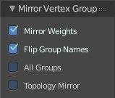
Last Operator Mirror Vertex Group

Mirror Weights
With Mirror Weights ticked it mirrors the weights.

Flip Group Names
With Flip Group Names ticked it flips the Group names

All Groups
Mirrors all Vertex Groups

Topology Mirror
Uses topology based mirroring. This requires matching mirrored topology.

Invert
Invert inverts the weight painting for the selected vertex group.

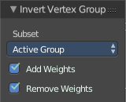
Last Operator Invert Vertex Group

Subset
Subset is a drop-down menu where you can choose the Subset method.

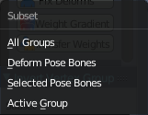
Add Weights
Add Vertices from Groups that have zero Weighting before inverting.

Remove Weights
Remove Vertices from Groups that have zero weight after inverting.

Clean
Removes Vertex group assignments that are not required from the active vertex group.

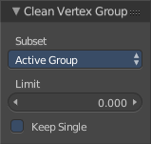
Last Operator Clean Vertex Group

Subset
Subset is a drop-down menu where you can choose the Subset method.

Limit
Remove weights that are below or equal to the limit value.

Keep Single
Keep Vertices assigned to at least one vertex group when cleaning.

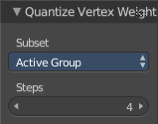
Quantize
Quantize quantizes the weight paint values. It starts with 4 steps. With a step of 1 you have a single vertex color, no matter how you have painted it before.

Last Operator Quantize

Subset
Subset is a drop-down menu where you can choose the Subset method.

Steps
Here you adjust in how many steps the weight paint colors should be divided.

Levels
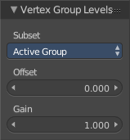
Adds some offset to the Weight paint, and multiplys it with some gain.

Last Operator Levels

Subset
Subset is a drop-down menu where you can choose the Subset method.

Offset
Here you adjust the offset.

Gain
Here you adjust the gain.

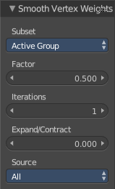
Smooth
Smooths the weight for selected vertices.

Last Operator Smooth Vertex Weights

Subset
Subset is a drop-down menu where you can choose the Subset method.

Factor
Here you adjust the factor.

Iterations
Here you adjust how many iterations you use.

Expand/Contract
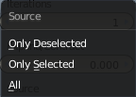
Expand or contract the weights.

Source
A drop-down box where you can choose what should be affected by Smooth.

Limit Total
Limit number of Weights per vertex. The lowest weights gets removed.
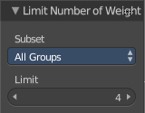
This is of interest when you have for example five bones associated with a vertice. But your game engine just allows four ...

Last Operator Limit Total

Subset
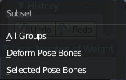
Subset is a drop-down menu where you can choose the Subset method.

Limit
Here you adjust how many weights are allowed.

Fix Deforms
Modify the position of selected vertices by changing only their respective group weights.
This tool may operate slow at too many vertices.

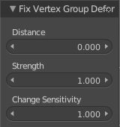
Last Operator Fix Deforms

Distance
Adjust the distance.

Strength
Adjust the strength.

Change Sensitivity
Adjust the sensitivity.

Tool Shelf in Edit Mode - Mesh Object, Create Tab

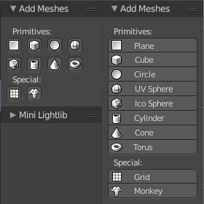
Add Meshes Panel
The create tab in edit mode contains an Add Meshes panel with the object types that can be added in Edit mode. That way you can add mesh primitives geometry in edit mode to the current object.
For detailed information and the Last Operator panels for the single buttons see chapter Tool Shelf in Object Mode - Create Tab .

Tool Shelf in Edit Mode - Mesh Object, Shade/UV's Tab

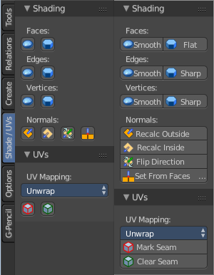
The Shade / UV's tab contains two panels. Shading and UV's.

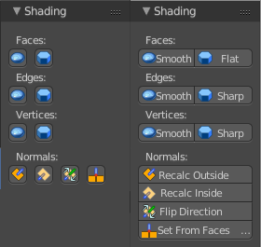
Shading Panel
The Shading panel contains shading relevant settings like smooth and flat shading and recalculate normals.

Faces, Edges and Vertices
Faces, Edges and Vertices can have either smooth or flat shading.
Faces, Edges and Vertices does not have content in the Last operator panel.

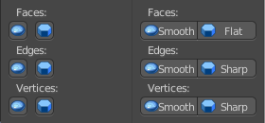
Faces

Smooth
Sets the shading for the selected faces to Smooth.

Flat
Sets the shading for the selected faces to Flat.

Edges

Smooth
Sets the shading for the selected edges to Smooth.

Sharp
Sets the shading for the selected edges to sharp.

Vertices

Smooth
Sets the shading for the selected vertices to Smooth.

Sharp
Sets the shading for the selected vertices to sharp.

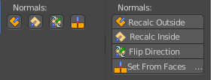
Normals
Normals influences the shading and the direction of a face. They can point inwards or outwards.

Recalc Outside
Recalculates the normals of the selected geometry so that everything points outwards.

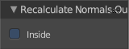
Last Operator Recalc Outside

Inside
Inside recalculates the normals of the selected geometry so that everything points inwards.

Recalc Inside
Recalculates the normals of the selected geometry so that everything points inwards.

Flip
Flips the direction of the normals of the selected geometry.

Set from Faces
Sets the vertex normals from the selected faces. This tool requires to have Autosmooth activated!

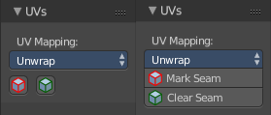
UVs Panel
The UVs Panel contains the Tools for UV Mapping. A drop-down box for the different methods. And a button to mark and to clear seam for the two Unwrap algorithms Angle Based (ABF) and Conformal ( LSCM).

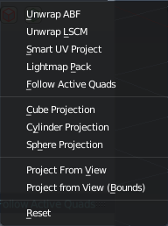
UV Mapping
Unwrap is a drop-down box that contains all the UV Mapping methods that are available in Blender. UV Mapping is best done in the UV Editing Layout. So that you can see what you produce.

Unwrap ABF
Unwrap ABF unwraps the selected geometry with the method Angle based. ABF stands for Angle Based Flattening. ABF can give a bit better result than LSCM when unwrapping organic shapes.

Unwrap LSCM
Unwrap ABF unwraps the selected geometry with the method Angle based. ABF stands for Angle Based Flattening. LSCM can give a bit better results than ABF with geometric shapes.

Last Operator Unwrap
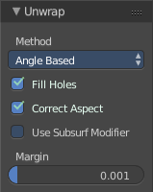
Unwrap ABF and Unwrap LSCM shares the same Last Operator.

Method
Method is a drop down box where you can choose between Unwrap method Angle Based and Conformal.

Fill Holes
Fill holes in the mesh before unwrapping.

Correct Aspect
Take the Image Aspect Ratio into account.

Use Subsurf Modifier
Unwraps an existing Subsurf Modifier. You need to add a Subsurf Modifier first.

Margin
The distance between the single UV patches.

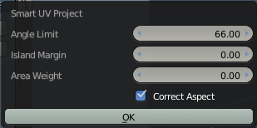
Smart UV Project
Smart UV Project projects the UV mapping from different angles.

Smart UV Project Settings dialogue

Angle Limit
The Angle Limit defines after which angle the mapping happens from the next side. With an angle of 66 you have around six sides to map from. The calculation is 360/66.

Island Margin
Island Margin defines the distance between the UV patches.

Area Weight
Weight Projection Vector by faces with larger areas.

Correct Aspect
Take the Image Aspect Ratio into account.

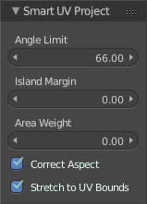
Last Operator Smart UV Project
The Last Operator for Smart UV Project contains the same settings than the Smart UV Project Settings dialogue.

Angle Limit
The Angle Limit defines after which angle the mapping happens from the next side. With an angle of 66 you have around six sides to map from. The calculation is 360/66.

Island Margin
Island Margin defines the distance between the UV patches.

Area Weight
Weight Projection Vector by faces with larger areas.

Correct Aspect
Take the Image Aspect Ratio into account.
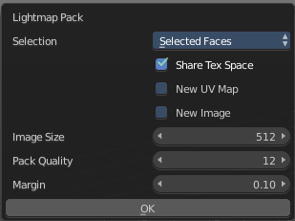

Lightmap Pack
Lightmap Pack maps each face individually, and puts the result into the UV space. Without margin.
Lightmap Pack has no Last Operator.

Settings

Selection
Selection is a drop-down box where you can choose what will be packed.

Share Tex Space
Map all objects into one lightmap.

New UV Map
Create a new UV map for every new mesh.

New Image
Assign new Image to every new mesh.

Image Size
The size for new images.

Pack Quality
The pack quality.

Margin
The distance between the single UV patches.

Follow Active Quads
Follow Active quads maps UV coordinates starting from an active face, and maps all adjacent faces in quad shape then. This way you can for example unwrap a pipe or a road. You first need to have a face selected. Then select everything. And then click at Follow Active Quads.

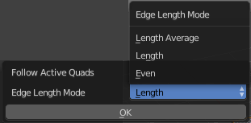
Settings

Edge Length Mode
Edge Length Mode is a drop-down box where you can choose the Length method.

Last Operator Follow Active Quads
The Last Operator contains the same settings than the Settings dialogue.

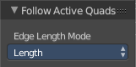
Edge Length Mode
Edge Length Mode is a drop-down box where you can choose the Length method.

Cube Projection
Cube Projection maps the mesh from six sides, means cubic.

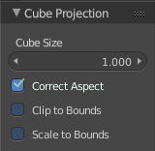
Last Operator Cube Projection

Cube Size
Cube Size defines the size of the UV mesh in the UV space.

Correct Aspect
Take Image Aspect ratio into account.

Clip to Bounds
Clip UV Coordinates to bounds after unwrapping.

Scale to Bounds
Scale UV Coordinates to bounds after unwrapping.

Cylinder Projection
Cylinder Projection tries to map cylindric.

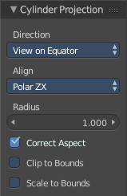
Last Operator Cylinder Projection

Direction
Direction is a drop-down box where you can choose in which direction the cylindric projection will be mapped.

Align
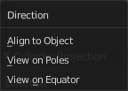
Align is a drop-down box where you can choose the Align method.

Radius
Radius defines the Polar size of the UV mesh in the UV space.

Correct Aspect
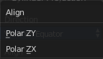
Take Image Aspect ratio into account.

Clip to Bounds
Clip UV Coordinates to bounds after unwrapping.

Scale to Bounds
Scale UV Coordinates to bounds after unwrapping.

Sphere Projection
Sphere Projection tries to map spherical.

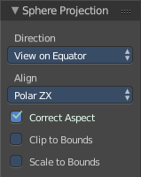
Last Operator Sphere Projection

Direction
Direction is a drop-down box where you can choose in which direction the spherical projection will be mapped.

Align
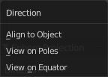
Align is a drop-down box where you can choose the Align method.

Correct Aspect
Take Image Aspect ratio into account.

Clip to Bounds
Clip UV Coordinates to bounds after unwrapping.

Scale to Bounds
Scale UV Coordinates to bounds after unwrapping.

Project from View
Project from View projects the UV from the current 3D view.

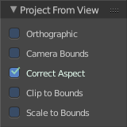
Last Operator Project from View

Orthographic
User orthographic projection

Camera Bounds
Map UV's to the camera region taking resolution and aspect into account.

Correct Aspect
Take Image Aspect ratio into account.

Clip to Bounds
Clip UV Coordinates to bounds after unwrapping.

Scale to Bounds
Scale UV Coordinates to bounds after unwrapping.

Project from View (Bounds)
Project from View projects the UV from the current 3D view.
Same as Project from View, but with Scale to Bounds ticked in the Last operator.

Reset
Resets the UV Projection
Reset has no Last Operator.

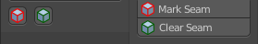
Mark Seam
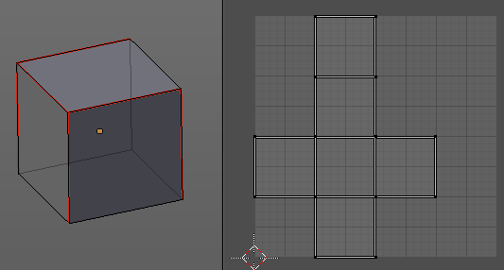
The unwrap algorithms Angle based and Conformal requires to have edges marked as seams. Think of it as a cutting pattern for a trouser for example. Such a trouser is also made of fabric patterns.
Same goes for the UV patches when you use Angle based or conformal unwrapping. You need to cut your mesh into parts and mark edges as seams, so that the algorithm knows where the seams are.
Mark seam marks the currently selected edge(s) as a seam. Seam edges will be displayed as red in the 3D viewport.
You need to unwrap the mesh again when you want to apply changes.

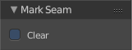
Last Operator Mark Seam

Clear
Clears the seam instead of marking it.

Clear Seam
Clear seam removes the seam from the currently selected edge(s)

Tool Shelf in Edit Mode - Mesh Object, Options Tab

The Options tab provides you with some Mesh Object options.
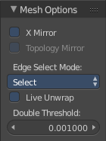

Mesh Options Panel

X Mirror
X Axis Mirror Editing.

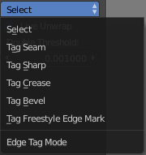
Topology Mirror
Use Topology based mirroring.

Edge Select Mode
Edge Select Mode is a drop-down box where you can choose the select method for edges.

Live Unwrap
Changing edges seam recalculates UV Unwrap.

Double Threshold
Limit for removing duplicates and 'Auto Merge'.

Tool Shelf in Edit Mode - Curve Object, Relations Tab

Relations Panel
The Relation panel contains tools around relations. In Edit Mode it's just Make Vertex Parent.
In Object mode select the object that you want to parent to a vertex. Shift select the parent object so that both are selected. Enter Edit mode. Then select one vertex for a single point. Or three for an area. Then click the Make Vertex Parent button to make the relation.

Tool Shelf in Edit Mode - Curve Object, Tools Tab

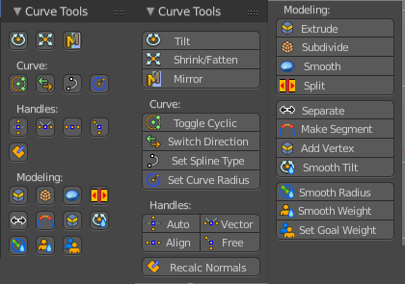
Curve Tools Panel
The Curve Tools panel contains the tools to modify the curve object in Edit Mode .

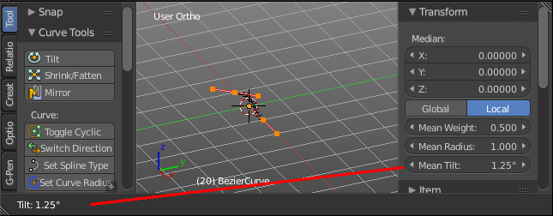
Tilt
Modifies the Mean Tilt.
Activate the tool, and drag the mouse. You will see a value in the header now. The selected curve path will rotate by dragging the mouse.
The Tilt angle always starts at zero. It is relative. To modify the Mean Tilt use the edit box in the Transform panel.

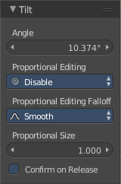
Last Operator Tilt

Angle
The Tilt angle.

Proportional Editing
Proportional Editing is a drop-down box where you can choose to use proportional editing. When you choose one of the active methods then the neighbour geometry gets influenced by Shrink/Fatten too in a proportional way.

Proportional Editing Falloff
Proportional Editing Falloff is a drop-down box where you can choose a method for the falloff for the proportional editing.

Proportional Size
The proportional size in case you have Proportional editing activated.

Confirm on Release
Always confirm operation when releasing button.

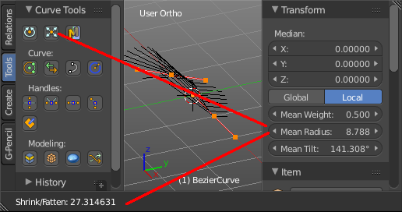
Shrink/ Fatten
Modifies the Mean Radius.
Activate the tool, and drag the mouse. You will see a value in the header now. The selected curve radius will increase / decrease.
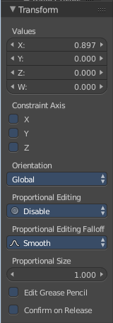
The Radius angle always starts at zero. It is relative. To modify the Mean Radius use the edit box in the Transform panel.

Last Operator Transform

Values
Transform values for Shrink Fatten.

Constraint Axis
Here you can constraint the operation to specific axis.

Proportional Editing
Proportional Editing is a drop-down box where you can choose to use proportional editing. When you choose one of the active methods then the neighbour geometry gets influenced by Shrink/Fatten too in a proportional way.

Proportional Editing Falloff
Proportional Editing Falloff is a drop-down box where you can choose a method for the falloff for the proportional editing.

Proportional Size
The proportional size in case you have Proportional editing activated.

Edit Grease Pencil
Edit selected Grease Pencil strokes.

Confirm on Release
Always confirm operation when releasing button.

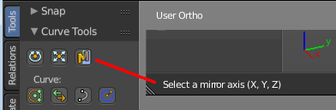
Mirror
Mirror mirrors the selected geometry along the defined axis. Click the Mirror button, type in X, Y or Z, then confirm with enter.

Last Operator Mirror
The Last Operator Mirror panel gives you tools to adjust the mirror action.

Constraint Axis
Constraint Axis gives you again the possibility to define the mirror axis. You can choose more than one axis here.

Orientation
Orientation is a drop-down box where you can choose the type of orientation for the mirroring action.

Proportional Editing
Proportional Editing is a drop-down box where you can choose to use proportional editing. When you choose one of the active methods then the neighbour geometry gets influenced by Shrink/Fatten too in a proportional way.

Proportional Editing Falloff
Proportional Editing Falloff is a drop-down box where you can choose a method for the falloff for the proportional editing.

Proportional size
Proportional size is a edit box where you can adjust the strength of the Proportional falloff.

Edit Grease Pencil
Edit Grease Pencil edits the selected Grease Pencil strokes.

Confirm on Release
With Confirm on Release checked the action gets performed when you release the mouse button.

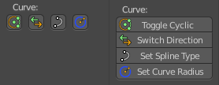
Curve
The Curve Tools contains the tools to modify the curves.

Toggle Cyclic
Toggle Cyclic closes or opens the curve.

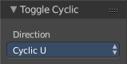
Last Operator Toggle Cyclic

Direction
Direction is a drop-down box where you can choose the direction in which the curve gets closed.

Switch Direction
Switch Direction inverts the direction of the selected curve.
Switch Direction has no settings in the Last Operator panel.

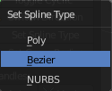
Set Spline Type
With set Spline Type you can set the type of the curve.

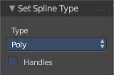
Last Operator Set Spline Type

Type
Type is a drop-down box where you can choose the spline type

Handles
Use Handles when converting Bezier curves into polygons.

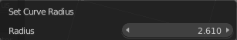
Set Curve Radius
Set the Point radius which is used for bevel tapering

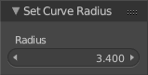
Last Operator Set Radius

Radius
Set the Point radius which is used for bevel tapering

Handles
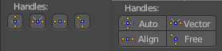
Handles defines the type of handle for the knots of the curve. You have the choice between Auto, Vector, Align and Free. And the Last Operator gives you a fifth possibility to toggle between Free and Align.

Auto
Auto aligns the handles automatically.

Vector
Set Handle type to Vector.

Align
Set Handle type to Align.

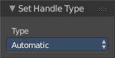
Free
Set Handle type to Free.

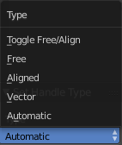
Last Operator Set Handle Type

Type
Type is a drop-down box where you can set the handle type. You have the choice between Auto, Vector, Align, Free. And the fifth possibility toggles between Free and Align.

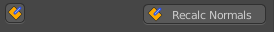
Recalc Normals
Recalculates the normals of the selected curve.

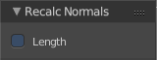
Last Operator Recalc Normals

Length
Recalculates the handle length too.

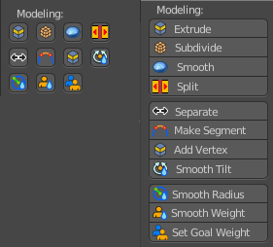
Modelling
The Modelling Section contains some modelling tools to modify the curve object.

Extrude
Extrudes the selected curve point(s).

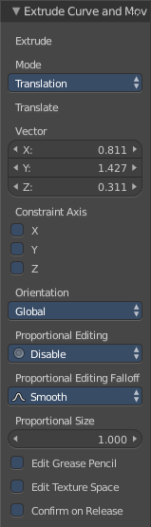
Last operator Extrude Curve and Move

Extrude
Confusing label. Just ignore

Mode
A drop-down box where you can choose between different extrude modes.

Translate
Confusing label. Just ignore

Vector
The position of the extruded point(s)

Constraint Axis
Here you can limit the extrusion to specific axes.

Orientation
Here you can adjust the orientation of the extrusion. It usually starts with Normal.

Proportional Editing
Proportional Editing is a drop-down box where you can choose to use proportional editing. When you choose one of the active methods then the neighbour geometry gets influenced by Shrink/Fatten too in a proportional way. Proportional Editing Falloff

Proportional Editing Falloff
Proportional Editing Falloff is a drop-down box where you can choose a method for the falloff for the proportional editing.

Proportional size
Proportional size is a edit box where you can adjust the strength of the Proportional falloff.

Edit Grease Pencil
Edit Grease pencil ticked allows you to edit the grease pencil stroke.

Edit Texture Space
By default extrusion will not modify the UV mapping. With Edit texture Space ticked the UV mapping updates with the extrusion.

Confirm on Release
With Confirm on Release checked the action gets performed when you release the mouse button.

Subdivide
Subdivide subdivides the selected curve part. You need to have at least two curve points selected.
Subdivide has no Last Operator panel.

Smooth
Smooth smooths the selected curve part. You need to have at least two curve points selected.
Smooth has no Last Operator panel.

Split
Splits the curve at the selected control point(s). You need to select two control points to select the segment between it.

Separate
Separates the selected control points, and creates a new curve object out of it. You need to select two control points to select the segment between it.

Make Segment
Joins two curves by adding a segment between the end of the one and the beginning of the other. You can also create a closed curve that way.

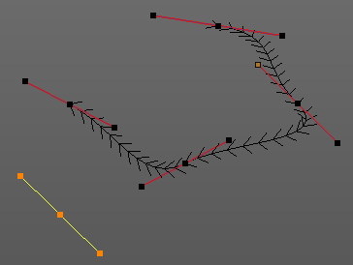
Add Vertex
Add Vertex adds a control point under the mouse, extruding from the selected endpoint(s). In case that you don't have an endpoint of your curve selected you will create a not connected control point.
The tool provides similar functionality to the extrude tool. But here you define the end point with the mouse position already.

Note!
Add Vertex is a hotkey only tool. Since it requires to have the mouse at the right position in the viewport.

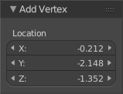
Last Operator Add Vertex

Location
Here you can change the position of the new created control point.

Smooth Curve Tilt
Smooths the curve tilt of the selected control point(s).

Smooth Curve Radius
Smooths the curve radius of the selected control point(s).

Smooth Curve Weight
Interpolates the weight of the selected control point(s).

Set Goal Weight
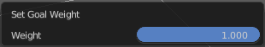
This tool requires to have a Soft Body physics applied to the curve. With this tool you can adjust the goal weight of the selected control points. A setting of zero allows to pin this control point vertice(s).
When you activate the tool then you will see a dialogue where you can adjust the weight.

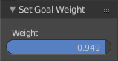
Last Operator Set Goal Weight

Weight
Here you can again adjust the weight strength.

Tool Shelf in Edit Mode - Curve Object, Create Tab

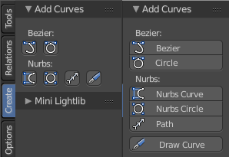
Add Curves Panel
The create tab in edit mode contains an Add Curves panel with the object types that can be added in Edit mode. That way you can add other curves edit mode to the current curve.
For detailed information and the Last Operator panels for the single buttons see chapter Tool Shelf in Object Mode - Create Tab

Tool Shelf in Edit Mode - Curve Object, Options Tab

Curve Stroke Panel
The Curve Stroke Panel provides you with some options to draw and modify the curves. It is divided into two parts. The curve type Bezier. And the curve type Poly.

Curve Stroke Panel type Bezier

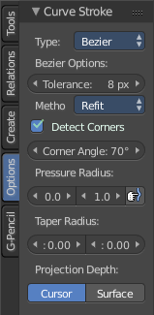
Type
Here you switch between the curve type Bezier and Poly.

Bezier Options

Tolerance
Allow deviation for a smoother but less precise line

Method
The curve fitting method. Here you can choose between Refit and Split.

Detect Corners
Detect corners and use non aligned angles.

Corner Angle
Corners above this angle are considered as corners.

Pressure Radius
Pressure radius is interesting when you use a tablet. Here you can adjust the Minimum and Maximum pressure radius. When you don't use a tablet then the maximum pressure value will be used.

Taper Radius
Taper factor for the radius of each point along the curve.

Projection depth
Here you can set the method of projection depth.

Cursor
Sets the projection depth to 3D Cursor.

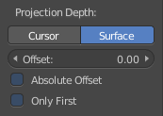
Surface
Sets the projection depth to Surface. Then the curve paints at a surface that is placed under the stroke. It also reveals some more settings for Projection Depth method Surface

Offset
Offset the stroke from the surface

Absolute Offset
Apply a fixed offset

Only First
Use the start of the stroke for depth.

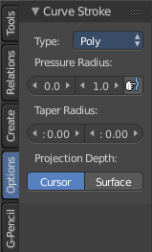
Curve Stroke Panel type Poly

Type
Here you switch between the curve type Bezier and Poly.

Pressure Radius
Pressure radius is interesting when you use a tablet. Here you can adjust the Minimum and Maximum pressure radius. When you don't use a tablet then the maximum pressure value will be used.

Taper Radius
Taper factor for the radius of each point along the curve.

Projection depth
Here you can set the method of projection depth.

Cursor
Sets the projection depth to 3D Cursor.

Surface
Sets the projection depth to Surface. Then the curve paints at a surface that is placed under the stroke. It also reveals some more settings for Projection Depth method Surface

Offset
Offset the stroke from the surface

Absolute Offset
Apply a fixed offset

Only First
Use the start of the stroke for depth.

Tool Shelf in Edit Mode - Surface Object, Tools Tab

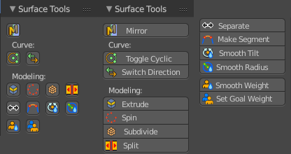
Surface Tools Panel
The Surface Tools panel contains the tools to modify the Surface object in Edit Mode.

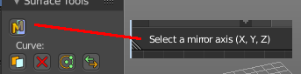
Mirror
Mirror mirrors the selected geometry along the defined axis. Click the Mirror button, type in X, Y or Z, then confirm with enter.

Last Operator Mirror
The Last Operator Mirror panel gives you tools to adjust the mirror action.

Constraint Axis
Constraint Axis gives you again the possibility to define the mirror axis. You can choose more than one axis here.

Orientation
Orientation is a drop-down box where you can choose the type of orientation for the mirroring action.

Proportional Editing
Proportional Editing is a drop-down box where you can choose to use proportional editing. When you choose one of the active methods then the neighbour geometry gets influenced by Shrink/Fatten too in a proportional way.

Proportional Editing Falloff
Proportional Editing Falloff is a drop-down box where you can choose a method for the falloff for the proportional editing.

Proportional size
Proportional size is a edit box where you can adjust the strength of the Proportional falloff.

Edit Grease Pencil
Edit Grease Pencil edits the selected Grease Pencil strokes.

Confirm on Release
With Confirm on Release checked the action gets performed when you release the mouse button.

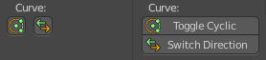
Curve
The Curve Tools contains the tools to modify the curves.

Toggle Cyclic
Toggle Cyclic closes or opens the curve.

Last Operator Toggle Cyclic

Direction
Direction is a drop-down box where you can choose the direction in which the curve gets closed.

Switch Direction
Switch Direction inverts the direction of the selected curve.
Switch Direction has no settings in the Last Operator panel.

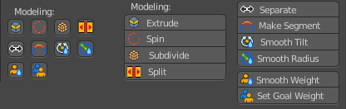
Modelling
The Modelling Section contains some modelling tools to influence the curve object.

Extrude
Extrudes the selected curve point(s).

Last operator Extrude Curve and Move

Extrude
Confusing label. Just ignore

Mode
A drop-down box where you can choose between different extrude modes.

Translate
Confusing label. Just ignore

Vector
The position of the extruded point(s)

Constraint Axis
Here you can limit the extrusion to specific axes.

Orientation
Here you can adjust the orientation of the extrusion. It usually starts with Normal.

Proportional Editing
Proportional Editing is a drop-down box where you can choose to use proportional editing. When you choose one of the active methods then the neighbour geometry gets influenced by Shrink/Fatten too in a proportional way.

Proportional Editing Falloff
Proportional Editing Falloff is a drop-down box where you can choose a method for the falloff for the proportional editing.

Proportional size
Proportional size is a edit box where you can adjust the strength of the Proportional falloff.

Edit Grease Pencil
Edit Grease pencil ticked allows you to edit the grease pencil stroke.

Edit Texture Space
By default extrusion will not modify the UV mapping. With Edit texture Space ticked the UV mapping updates with the extrusion.

Confirm on Release
With Confirm on Release checked the action gets performed when you release the mouse button.

Spin
Extrudes the selected curve part around the pivot point. You need to have at least two curve points selected.

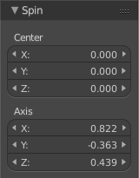
Last Operator Spin

Centre
Edit boxes to set the position of the Centre point

Axis
The rotation of the extrusion

Subdivide
Subdivide subdivides the selected curve part. You need to have at least two curve points selected.
Subdivide has no Last Operator panel.

Split
Splits the curve at the selected control point(s). You need to select two control points to select the segment between it.

Separate
Separates the selected control points, and creates a new curve object out of it. You need to select two control points to select the segment between it.

Make Segment
Joins two curves by adding a segment between the end of the one and the beginning of the other. You can also create a closed curve that way.

Add Vertex
Add Vertex adds a control point under the mouse, extruding from the selected endpoint(s). In case that you don't have an endpoint of your curve selected you will create a not connected control point.
The tool provides similar functionality to the extrude tool. But here you define the end point with the mouse position already.

Note!
Add Vertex is a hotkey only tool. Since it requires to have the mouse at the right position in the viewport.

Last Operator Add Vertex

Location
Here you can change the position of the new created control point.

Smooth Curve Tilt
Smooths the curve tilt of the selected control point(s).

Smooth Curve Radius
Smooths the curve radius of the selected control point(s).

Smooth Curve Weight
Interpolates the weight of the selected control point(s).

Set Goal Weight
This tool requires to have a Soft Body physics applied to the curve. With this tool you can adjust the goal weight of the selected control points. A setting of zero allows to pin this control point vertice(s).
When you activate the tool then you will see a dialogue where you can adjust the weight.

Last Operator Set Goal Weight

Weight
Here you can again adjust the weight strength.

Tool Shelf in Edit Mode - Surface Object, Create Tab

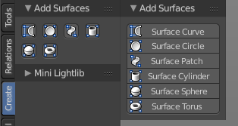
Add Surfaces Panel
The create tab in edit mode contains an Add Surfaces panel with the object types that can be added in Edit mode. That way you can add other Surfaces edit mode to the current Surface object.
For detailed information and the Last Operator panels for the single buttons see chapter Tool Shelf in Object Mode - Create Tab

Tool Shelf in Edit Mode - Surface Object, Relations Tab

Relations Panel
The Relation panel contains tools around relations. In Edit Mode it's just Make Vertex Parent.
In Object mode select the object that you want to parent to a vertex. Shift select the parent object so that both are selected. Enter Edit mode. Then select one vertex for a single point. Or three for an area. Then click the Make Vertex Parent button to make the relation.

Tool Shelf in Edit Mode - Metaball Object, Tools Tab

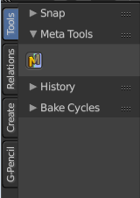
Meta Tools Panel
The Meta Tools panel contains the tools to modify the Metaball object in Edit Mode.

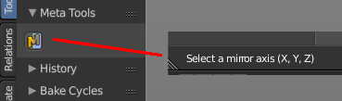
Mirror
Mirror mirrors the selected geometry along the defined axis. Click the Mirror button, type in X, Y or Z, then confirm with enter.

Last Operator Mirror
The Last Operator Mirror panel gives you tools to adjust the mirror action.

Constraint Axis
Constraint Axis gives you again the possibility to define the mirror axis. You can choose more than one axis here.

Orientation
Orientation is a drop-down box where you can choose the type of orientation for the mirroring action.

Proportional Editing
Proportional Editing is a drop-down box where you can choose to use proportional editing. When you choose one of the active methods then the neighbour geometry gets influenced by Shrink/Fatten too in a proportional way.

Proportional Editing Falloff
Proportional Editing Falloff is a drop-down box where you can choose a method for the falloff for the proportional editing.

Proportional size
Proportional size is a edit box where you can adjust the strength of the Proportional falloff.

Edit Grease Pencil
Edit Grease Pencil edits the selected Grease Pencil strokes.

Confirm on Release
With Confirm on Release checked the action gets performed when you release the mouse button.

Tool Shelf in Edit Mode - Metaball Object, Create Tab

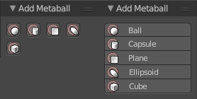
Add Metaball Panel
The create tab in edit mode contains an Add Metaball panel with the object types that can be added in Edit mode. That way you can add other Metaballs in edit mode to the current Metaball object.
For detailed information and the Last Operator panels for the single buttons see chapter Tool Shelf in Object Mode - Create Tab

Tool Shelf in Edit Mode - Metaball Object, Relations Tab

Relations Panel
The Relation panel contains tools around relations. In Edit Mode it's just Make Vertex Parent.
In Object mode select the object that you want to parent to a vertex. Shift select the parent object so that both are selected. Enter Edit mode. Then select one vertex for a single point. Or three for an area. Then click the Make Vertex Parent button to make the relation.

Tool Shelf in Edit Mode - Text Object, Tools Tab

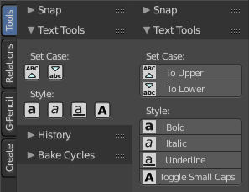
Text Tools Panel
The Text tools panel contains the tools to adjust the created text object.
Select the text part that you want to modify, then click at the tools.

Set Case
Set case sets selected the letters to be uppercase or lower case.

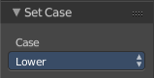
Last Operator Set Case
Set Case has one Last Operator for all items.

Case
Case is a drop-down box where you can choose to set the selected letters to be uppercase or lower case.

To Upper
To Upper sets the selected text to be uppercase letters.

To Lower
To Lower sets the selected text to be lowercase letters.

Style
Style sets the selected letters to some styles.

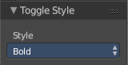
Last Operator Toggle Style
Style has one Last Operator for all items.
Style is a drop-down box where you can choose to set the selected letters to be displayed in some styles.

Bold
Bold sets the selected letters to be displayed as bold letters.

Italic
Italic sets the selected letters to be displayed as italic letters.

Underline
Underline sets the selected letters to be displayed as underlined letters.

Toggle Small Caps
Toggle small caps sets the selected letters to be displayed as if they were upper case letters, but with lower case size.

Tool Shelf in Edit Mode - Text Object, Relations Tab

Relations Panel
The Relation panel contains tools around relations. In Edit Mode it's just Make Vertex Parent.
In Object mode select the object that you want to parent to a vertex. Shift select the parent object so that both are selected. Enter Edit mode. Then select one vertex for a single point. Or three for an area. Then click the Make Vertex Parent button to make the relation.

Tool Shelf in Edit Mode - Armature Object, Tools Tab

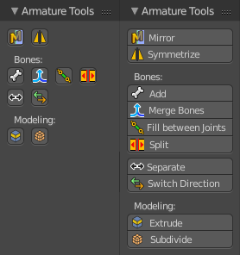
Armature Tools Panel
The Armature Tools panel contains the tools to modify the selected armature in Edit mode.

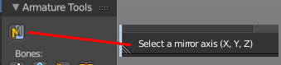
Mirror
Mirror mirrors the selected geometry along the defined axis. Click the Mirror button, type in X, Y or Z, then confirm with enter.

Last Operator Mirror
The Last Operator Mirror panel gives you tools to adjust the mirror action.

Constraint Axis
Constraint Axis gives you again the possibility to define the mirror axis. You can choose more than one axis here.

Orientation
Orientation is a drop-down box where you can choose the type of orientation for the mirroring action.

Proportional Editing
Proportional Editing is a drop-down box where you can choose to use proportional editing. When you choose one of the active methods then the neighbour geometry gets influenced by Shrink/Fatten too in a proportional way.

Proportional Editing Falloff
Proportional Editing Falloff is a drop-down box where you can choose a method for the falloff for the proportional editing.

Proportional size
Proportional size is a edit box where you can adjust the strength of the Proportional falloff.

Edit Grease Pencil
Edit Grease Pencil edits the selected Grease Pencil strokes.

Confirm on Release
With Confirm on Release checked the action gets performed when you release the mouse button.

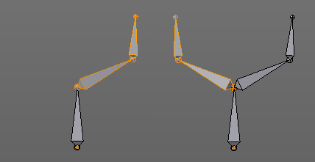
Symmetrize
Creates a symmetrical mirrored copy of the currently selected bones along the X axis. The mirror center is the pivot of the armature.
Symmetrize follows the name conventions for bones. If there is a lower or upper case “L”, “R”, “left” or “right” with a separating dot in the bone name, then this tool renames the bones names to its counter part. Bone.L becomes Bone.R.

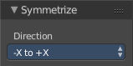
Last Operator Symmetrize

Direction
Here you can define the calculation direction. From -X to + X or from +X to -X

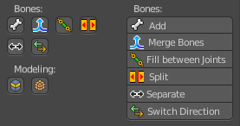
Bones section
The Bones section contains tools around the bones of the armature.

Add
Adds a new bone to the armature. This new created bone is not connected to other bones of the armature.

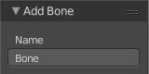
Last Operator Add Bone

Name
Name is an edit field where you can rename the created bone

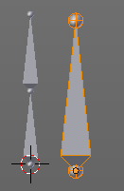
Merge Bones
Merges two connected bones in a chain into one bone.
When you click the Merge Bones button then you will get a pop-up where you can choose between exactly nothing since there is one choice. Within chains.
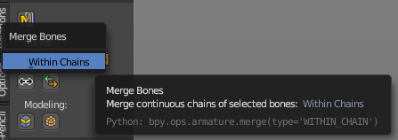

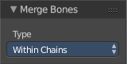
Last Operator Merge Bones

Type
Type is a drop-down box where you can choose between exactly nothing since there is one choice. Within chains.

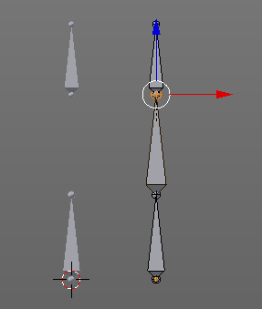
Fill between Joints
Fill between joints fills a bone between two selected joints.
When there is just one joint selected, then the bone is created between this selected joint and the 3D cursor.
The Last operator for Fill Between Joints has no content.

Split
Split splits the selected bone(s) from connected bones. They are still part of the armature. But the bone is now floating. And you can pull this bone(s) around without pulling the rest of the armature around.
The Last operator for Split has no content.

Separate
Separate separates the selected bone(s) from the armature. And creates a new, independent, armature.
The Last operator for Separate has no content.

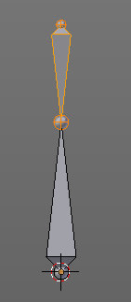
Switch Direction
Switches the direction in which the bone points at. The head becomes the tail, and the tail becomes the head.
The Last operator for Switch Direction has no content.

Tool Shelf in Edit Mode - Armature Object, Relations Tab

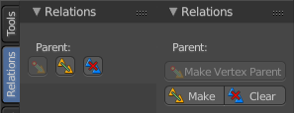
Relations Panel
The Relation panel contains tools around relations inside the currently edited armature.

Make Vertex Parent
In Object mode select the object that you want to parent to a vertex. Shift select the parent object so that both are selected. Enter Edit mode. Then select one vertex for a single point. Or three for an area. Then click the Make Vertex Parent button to make the relation.

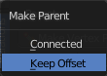
Make
Make calls a sub menu. When you have one bone selected then you get just the Connected menu part. But this doesn't make much sense since then there is nothing to parent.
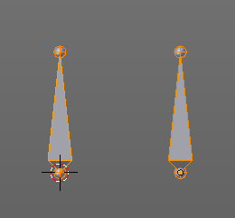
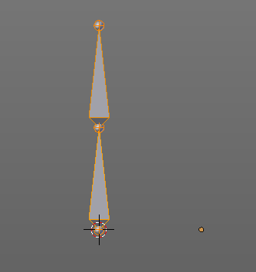
Make requires to have at least two bones selected that are not parented to each other already. Select first bone, hold down shift, select second bone. The first selected bone will be the child, the second selected bone the parent.

Connected
Connected connects the Head joint of the one bone with the Tail joint of the other. The child bone will be placed at the position of the head joint of the parent bone. And the joints will be merged.

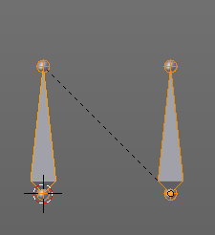
Keep Offset
Keep Offset connects the Head joint of the one bone with the Tail joint of the other. The target bone will remain in its position. The joints are not merged. The relationship is indicated by the black dotted line. The child bone will move with the parent bone.

Last Operator Make Parent

Parent Type
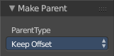
Parent Type is a drop-down box where you can again choose to use the method Connected or the method Keep Offset.

Tool Shelf in Edit Mode - Armature Object, Options Tab

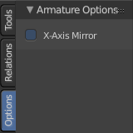
Armature Options Panel
The Armature Options panel contains some options.

X Axis Mirror
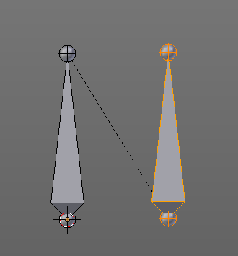
X Axis Mirror is made to sync the right side of a symmetrical armature with the left side of a symmetrical armature. Means you can create just one half of a skeleton. And then simply mirror it over to the other half. And any further changes that you do at the one side will also apply to the other side of the armature. This includes the whole FK IK setup. And can save you lots of work therefore.
To get X Axis mirror to work requires a bit preparation work.
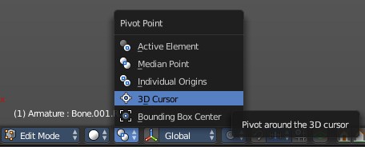
Create a armature, with some bones at the one side. Like this. The 3D cursor needs to be at 0/0/0. The left bone is in the middle. Think of it as the backbone. The right bone has an offset, and shall represent our right side of the armature.
Change the Pivot Point in the Header to 3D Cursor. Important step. We want to mirror around the 3D Cursor.
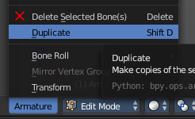
Now select the right side of the armature. Border select is one fast way. But NOT the bone in the middle, which is our backbone. We don't want to mirror this one too.

Duplicate what we have selected. And click immediately to leave the duplicate mode. Or you will pull the duplicated part around. Which is not what we want.

Next we will scale our new created armature part by -1 to mirror it over to the other side. Activate Scale, don't move the mouse, but type immediately in X for the axis and -1 for the scale factor.
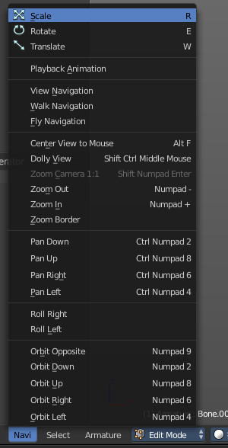
This will create our mirrored armature part.

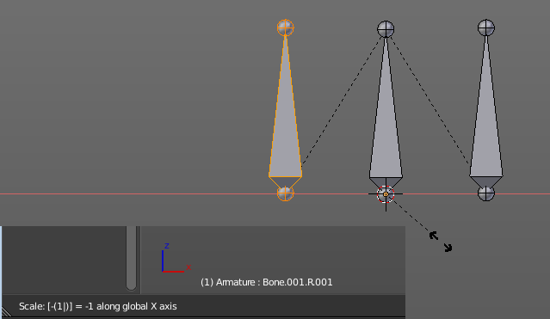

Next important step is to Flip Names. This renames the mirrored bones. Bone.001.R becomes without this step Bone.001.R.001. With rename we get Bone.001.L

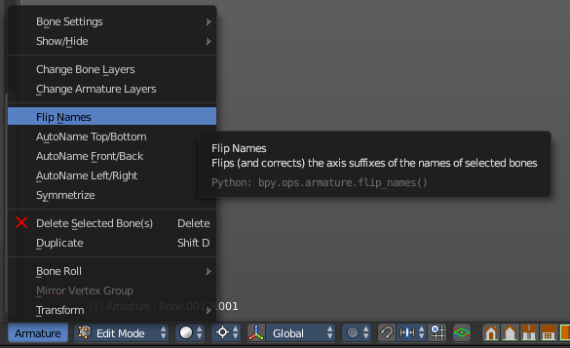

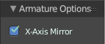
And now we are finally arrived at X Axis Mirror. Tick it.

Now you should be able to modify the one side of the armature, and the other side will be modified too. This includes as told above also FK IK set-ups that you do in Pose mode.
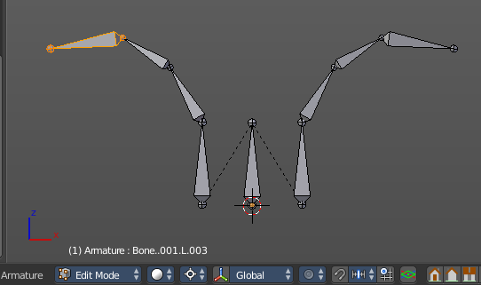

Tool Shelf in Edit Mode - Lattice Object, Tools Tab

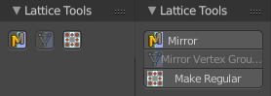
Lattice Tools Panel
Lattice is a deform cage. You can use it to deform other objects.

Mirror
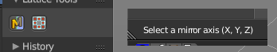
Mirror mirrors the selected geometry along the defined axis. Click the Mirror button, type in X, Y or Z, then confirm with enter.

Last Operator Mirror
The Last Operator Mirror panel gives you tools to adjust the mirror action.

Constraint Axis
Constraint Axis gives you again the possibility to define the mirror axis. You can choose more than one axis here.

Orientation
Orientation is a drop-down box where you can choose the type of orientation for the mirroring action.

Proportional Editing
Proportional Editing is a drop-down box where you can choose to use proportional editing. When you choose one of the active methods then the neighbour geometry gets influenced by Shrink/Fatten too in a proportional way.

Proportional Editing Falloff
Proportional Editing Falloff is a drop-down box where you can choose a method for the falloff for the proportional editing.

Proportional size
Proportional size is a edit box where you can adjust the strength of the Proportional falloff.

Edit Grease Pencil
Edit Grease Pencil edits the selected Grease Pencil strokes.

Confirm on Release
With Confirm on Release checked the action gets performed when you release the mouse button.

Mirror Vertex Group
This tool requires to have a vertex group assigned. It mirrors the selected vertex group.
This tool works only with a perfectly symmetrical mesh along the local X axis. Vertices that have no corresponding vertex on the other side will not be affected.

Last Operator Mirror Vertex Group

Mirror Weights
Mirrors the Weight Painting informations from the symmetrical counterpart. When both are selected it will become a group and weight information exchange. If only one is selected, then the information from the unselected vertice will go to the selected vertice.

Flip Group Names
Flip selected group names. This works with vertex groups with symmetrical name conventions. Like .L , .R, right, left.

All Groups
Pass information to all groups instead of the active one.

Topology Mirror
Use topology based mirroring.

Make Regular
Make regular sets the shape of the Lattice cage back to a regular cube.
The Last operator Make Regular has no settings.

Tool Shelf in Edit Mode - Force Field, Curve Guide Force
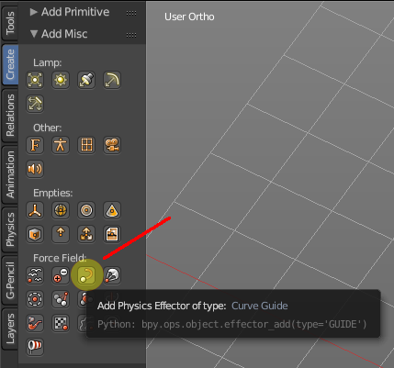
Normally the Force Fields does not have any edit mode. With one exception. The force Curve Guide. It is not only a force object, but also a curve object. And so you need a way to modify the curve.

When you enter the edit mode with the force object "Curve Guide", then you will find yourself in the same panels in the tool shelf like if you would edit a normal curve object. And in fact that's what you do here.

Please have a look at the Curve Object chapters to find out more about the functionality.

Tool Shelf in Pose Mode

The Pose Mode is a mode especially for armatures. Other object types have no Pose mode. In Pose mode you can pose and animate your armature. This is best done in the Animation layout.

Tool Shelf in Pose Mode - Armature Object, Tools Tab

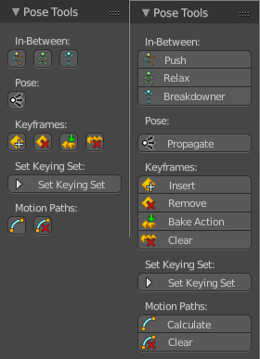
Pose Tools Panel
The Pose Tools Panel contains the tools that are needed to pose the armature.

In Between
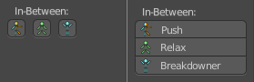
In Between are tools to influence the look of the pose between the keyframes.
For example, record a keyframe at frame 1, then record a keyframe at frame 20. Then go to frame 10, and activate one of the tools. Now you can play around with the settings. And when you are satisfied with the result then you can record a keyframe at this position.

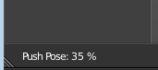
Push
Push exxagerrates the current pose. When you activate it then you will see a percentage value in the header.

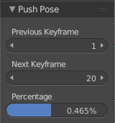
Last Operator Push Pose

Previous Keyframe
The keyframe position before the current frame.

Next Keyframe
The keyframe position after the current frame.

Percentage
The percentage of exxageration. Interestingly the value in the Last operator differs from the value in the header.

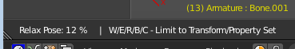
Relax
Relax relaxes the current pose. When you activate it then you will see a percentage value in the header. And some hotkeys. The hotkeys W E and R allows you just to move, rotate or scale. Hotkey B stands for Bendy Bones. And C is for a custom property. This hotkeys are hard coded, and cannot be changed in the input manager.

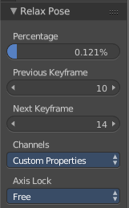
Last Operator Relax Pose

Previous Keyframe
The keyframe position before the current frame.

Next Keyframe
The keyframe position after the current frame.

Percentage
The percentage of exxageration. Interestingly the value in the Last operator differs from the value in the header.

Channels
Here you can again choose if you just want to limit a specific channel.

Axis Lock
Allows you to lock a specific axis.

Breakdowner
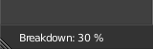
Creates a suitable breakdowner pose on the current frame. When you activate it then you will see a percentage value in the header.

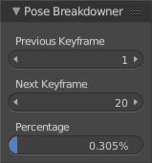
Last Operator Pose Breakdowner

Previous Keyframe
The keyframe position before the current frame.

Next Keyframe
The keyframe position after the current frame.

Percentage
The percentage of exxageration. Interestingly the value in the Last operator differs from the value in the header.

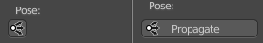
Pose
The Pose section contains the Propagate tool. The Propagate tool automates the process of copying and pasting between keyframes. It copies the pose of the selected bones on the current frame over to the keyframes by the chosen Termination mode in the Last Operator Propagate Pose.
The different Propagate methods can be adjustetd in the Last operator.

Usage example with Termination mode "On Selected Keyframes".
Create a little armature.
Set a keyframe at frame 0.
Set a keyframe at frame 20.
Pose frame 20.
Set a keyframe at frame 40. It will most probably be identical with Frame 20.
Now select those Keyframes at position 40 in the Dope Sheet Editor.
Set position to Frame 0.
Press Propagate, and in the Last operator Propagate Pose choose On Selected Keyframes.
The selected keyframes at frame 40 will now turn into the corresponding keyframes from position 0.

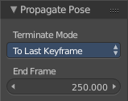
Last Operator Propagate Pose

Terminate Mode
A dropdown box where you can choose between different termination modes for Propagate.

While Held
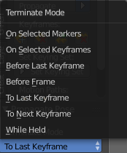
While held it tries to guess when to stop propagating by examining the pauses in the animation curves per control (This means all F-Curves for a bone instead of per F-Curve).

To Next Keyframe
Copies the pose to the first keyframe after the current frame.

To Last Keyframe
Replaces the last keyframe.

Before Frame
Copies to all keyframes between current frame and the End frame option.

Before Last Keyframe
To all keyframes from current frame until no more are found.

On Selected Keyframes
Applies the pose of the selected bones to all selected keyframes.

On Selected Markers
Copies to all keyframes on frames with Scene Markers after the current frame.

End Frame
Defines the end frame for the Propagate.

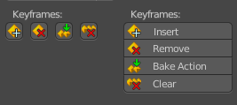
Keyframes
Contains some keyframing tools.

Insert
Inserts keyframes for the specified keying set. Insert has no settings in the Last Operator.

Remove
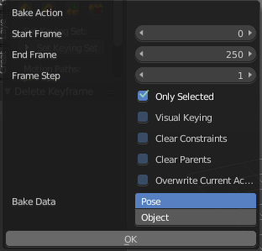
Removes the keyframes at the current frame. Remove has no settings in the Last Operator.

Bake Action
Calls a popup where you can adjust the bake settings to bake the action. Bake Action bakes the current action into a clip for the NLA editor.

Last Operator Bake Action
The Last Operator Bake Action contains the same settings from the Popup.

Start Frame
Defines the start frame.

End Frame
Defines the end frame.

Frame Step
Defines the number of keyframes per step.

Only Selected
Only key selected bones.

Visual Keying
Keyframe from the final transformations.

Clear Constraints
Remove all constraints and do visual keying.

Clear Parents
Bake animation onto teh object, then clear parents. This is for objects only.

Overwrite current Action
Bake animation into current action.

Bake Data
You can either bake to pose, or bake to object.

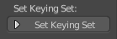
Set keying set
Set keying set is a dropdown box where you can choose between the different available keying sets.
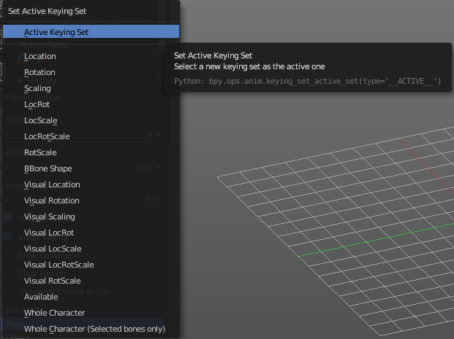

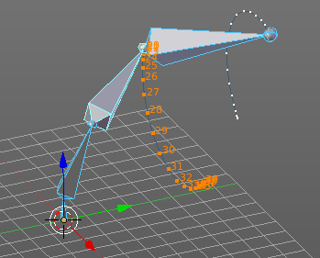
Motion Paths

Calculate Bone Paths
Calculate Bone Paths calculates the paths of the bones. And displays them visually in the 3D space.

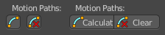

Last Operator Calculate Bone Paths

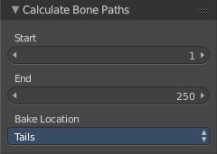
Start
Defines the start frame

End
Defines the end frame

Bake Locaton
Here you can adjust if the motion path gets displayed at the tail of the bone(s) or the head of the bone(s).

Clear Bone Path
Clears the calculated Bone paths.

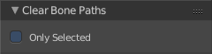
Last Operator Clear Bone Paths

Only Selected
Only clear paths from selected bones.

Tool Shelf in Pose Mode - Armature Object, Relations Tab

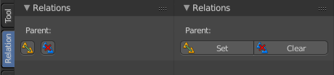
Relations Panel
The Relation panel contains tools around relations.

Parent

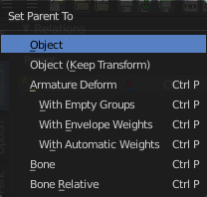
Set
Set calls a menu where you can choose between different parenting methods.

Object
Sets the parent to selected object.

Object ( Keep Transform)
Sets the parent to selected object, but keeps the transform position / rotation

Armature Deform
Sets the parent to selected Armature.

With empty Groups
Sets the parent to selected Armature, using empty groups.

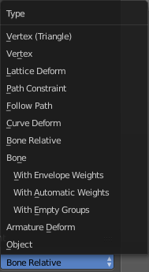
With Envelope Weights
Sets the parent to selected Armature, using envelope weights

With automatic Weights
Sets the parent to selected Armature, with automatic weights.

Bone
Sets the parent absolute to selected Bone.

Bone Relative
Sets the parent relative to selected Bone.

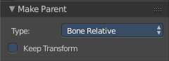
Last Operator Make Parent

Type
is a dropdown box where you can choose between different parenting methods. The working methods are the same than from the Parent popup. The other methods doesn't belong to Armature.

Keep Transform
Apply transformation before parenting.

Clear
Clears the parenting.

Tool Shelf in Pose Mode - Armature Object, Options Tab

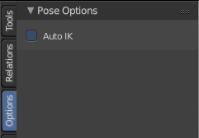
Pose Options Panel

Auto IK
Add temporary IK constraints while grabbing bones in Pose mode.

Tool Shelf in Sculpt Mode

The Tool Shelf in Sculpt Mode provides you the tools to sculpt a mesh. The high poly version of a game character for example, where you bake the normal map from.
The Sculpt mode is just available for mesh objects. And requires a tesselated mesh to have useful results.

Tool Shelf in Sculpt Mode - Mesh Object, Tools Tab

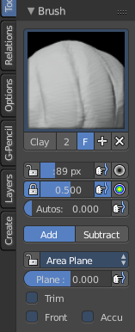
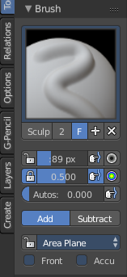
Brush Panel
The Brush Panel contains the different Sculpt Brushes and some Brush settings.

Browse Brush
The big image at the top is a dropdown box where you can choose a brush. Click at it, and you will see the different brushes. A click at one of the images will choose this brush then.
Persistent and Set Persistent Base is just available with the brush type Layer.

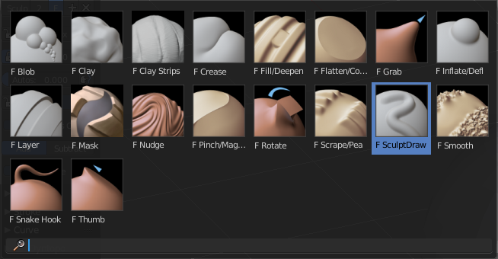
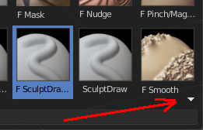
When you have added a few more brushes then the dropdown box may be more than full. You will see some little white arrows then. Either in the top left or in the bottom right corner. They indicate that some brushes are hidden before or after the current display.
To scroll to this hidden content use the mouse wheel, or the arrow up and down buttons at the keyboard.

The edit box below the Image shows you the name of the current active brush.
The number right of it, in this case 2, indicates how much number of users ( internally ) this brush uses. This means that this data block (the brush) shares currently settings with at least one other object. Most probably the parent brush where we have created it from. Click at the value to make this brush a single user. The button will vanish then.
F set the brush to have a fake user. Zero user data-blocks are normally not saved. But sometimes you want to force the data to be kept even when the data block has no user.
The + button allows you to add a new pencil with the current settings. Note that the brushes are NOT saved when you close Bforartists. You can save them into the current blend file. Or you can save the startup file. But be careful here. This saves everything else of the current state of Bforartists too.
The X button deletes the brush as the active one. It does NOT delete it from the brushes list.

Radius
The Radius edit box allows you to adjust the radius of the brush. When the Lock symbol at the front is ticked, then the pencil keeps its size relative to the object when zooming in and out. The button behind the edit box enables tablet pressure sensitivity for radius.
And the button at the end allows you to set the radius of the pencil by hotkey. A click at this button works of course too. But this is a hotkey tool. The button is just a visible reminder.

Strength
The Strength edit box allows you to adjust the strength of the brush. When the Lock symbol at the front is ticked, then the pencil keeps its strength relative to the object when zooming in and out. The button behind the edit box enables tablet pressure sensitivity for strength.
And the button at the end allows you to set the strength by hotkey. A click at this button works of course too. But this is a hotkey tool. The button is just a visible reminder.

Autosmooth
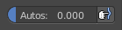
The autosmooth edit box allows you to adjust the amout of smoothing that gets automatically applied to each stroke. The button behind the edit box enables tablet pressure sensitivity for autosmooth.

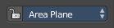
Sculpt Plane
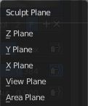
The sculpt plane defines how the sculpting is aligned. It is a dropdown box where you can choose different methods. By default the Area Plane gets used.
When the Lock symbol at the front is ticked, then it keeps using the normal of the surface where the stroke was initiated.


Front Faces Only
Front Faces only means that the stroke just affects the vertices that are pointing forwards to the camera.

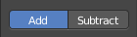
Add / Subtract
Add means the stroke adds to the geometry. Subtract means the stroke subtracts from the geometry.

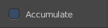
Accumulate, Persistent, etc.
In this area you will find the brush related settings. They differ from brush to brush.

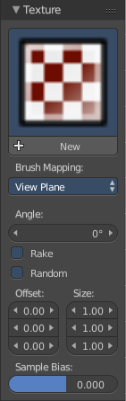
Texture Panel
The Texture panel allows you to sculpt with textures. This allows you for example to grab a foto from some fish scales, and simply sculpt them into the surface of your object by using this image as a pencil. Or as a blueprint where you calk through ( Stencil method ).

Note that the following shots are made with Symmetry off and without Brush falloff. Since they disturbed.

Symmetry can be turned off here:
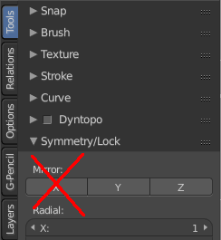
And the brush falloff can be adjusted here. Choose the last method here to have no falloff towards the borders of the brush.

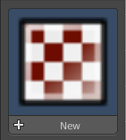
Browse Texture to be linked
The image at the top of the panel is a image browser. Here you can choose a texture that you can choose for sculpting then. You can also have more than one image loaded at once.

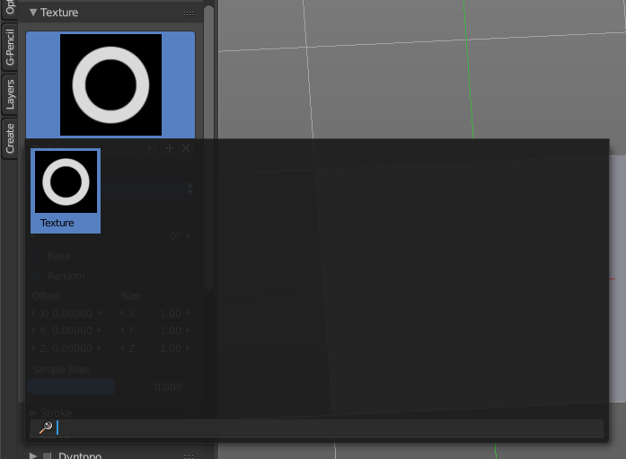
In this shot there is already a texture added. The way to add the texture here is a bit more complicated. And not done with clicking at the New button.

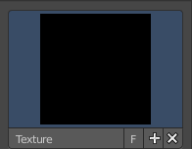
First click at the New button below the image. This will create a new texture slot. This slot is still empty, it displays black.

We need to load the texture in this slot. This must be done in the Properties editor in the Textures tab. And then the texture finally shows in the Texture panel in the Tool Shelf.
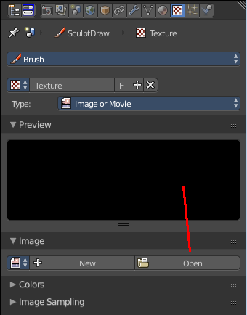
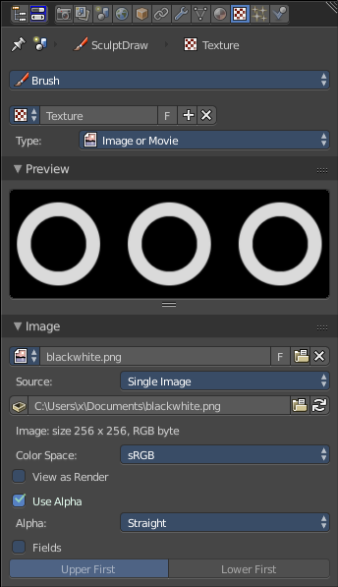
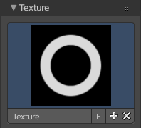

Texture Edit box
The Texture edit box is the edit box below the Image browser. When there's no image loaded then it displays the New button. When there's a image (or more) loaded, then you will see the name of the current texture.
The F button turns this texture into a data block with a fake user. Means it will exists even when there is no data connected to it anymore.
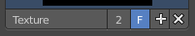
When you activate Fake User, then you may get a value in front of it, which displays how much users this data block (our texture slot) currently has.
The + Button adds another texture slot. Note that you will have to load a texture too, as explained above.
The X button deletes the texture slot.

Brush Mapping
Our texture can be mapped in different methods. The Brush mapping is a dropdown box where you can choose this different brush mapping methods.
The settings vary. So we will go through them by the different brush mapping methods.

Brush Mapping with mapping method View Plane and Area Plane
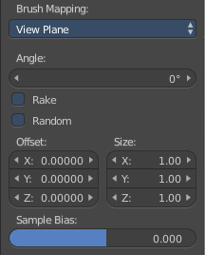
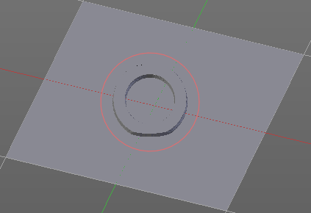
The brush mapping method View Plane maps the brush onto the surface of the object, calculating the mapping from the current view. The result may be distorted when the view does not align with the surface of the object.
The brush mapping method Area Plane maps the brush onto the surface of the object, calculating the mapping from the current view. The result is not distorted.

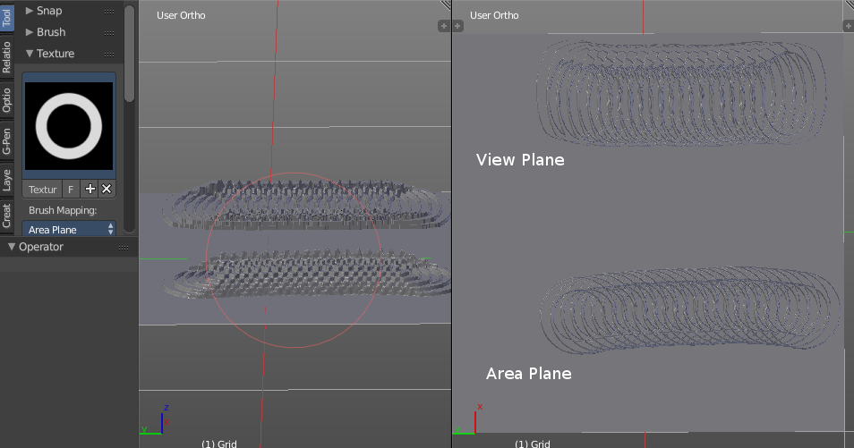
Angle edit box
Here you can adjust the angle of the brush.

Rake
The angle follows the direction of the brush stroke.

Random
The brush angle gets set random.

Random edit box
Becomes visible when you tick Random. Here you can adjust the maximum value of the random angle.

Offset
Fine tune the offset of the texture in the brush.

Size
Fine tune the size of the texture in the brush.

Sample Bias
Here you can add to or subtract from the amount that gets added by the brush texture.

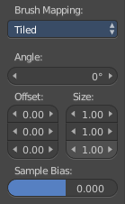
Brush Mapping with mapping method Tiled
The brush mapping method View Plane maps the brush onto the surface of the object, and tiles the pencil onto the surface. The mapping happens from the View plane. Means you get distortions when you sculpt from an angle.
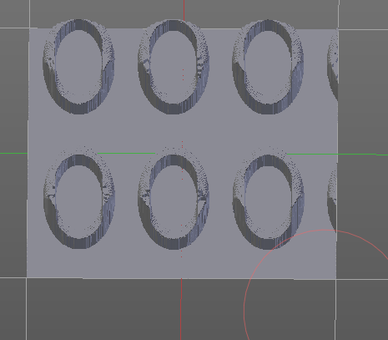

Angle edit box
Here you can adjust the angle of the brush.

Offset
Fine tune the offset of the texture in the brush.

Size
Fine tune the size of the texture in the brush.

Sample Bias
Here you can add to or subtract from the amount that gets added by the brush texture.

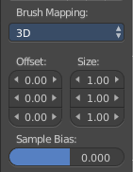
Brush Mapping with mapping method 3D
The brush mapping method View Plane and Area Plane sculpts where the pencil is. The method 3D sculpts at the initial position of the pencil, as long as you don't release the mouse. The mapping happens from the View plane. Means you get distortions when you sculpt from an angle.

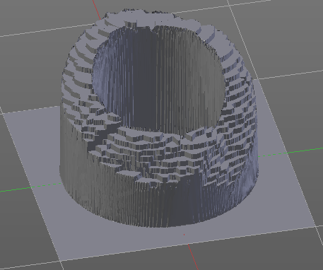
Offset
Fine tune the offset of the texture in the brush.

Size
Fine tune the size of the texture in the brush.

Sample Bias
Here you can add to or subtract from the amount that gets added by the brush texture.

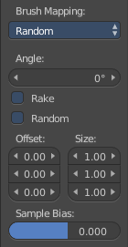
Brush Mapping with mapping method Random
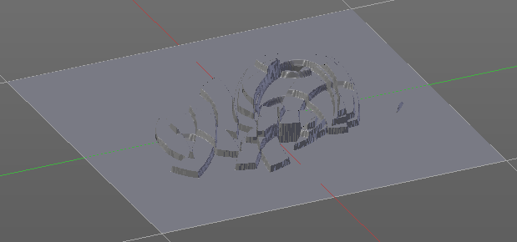
The brush mapping method Random randomizes the texture position of the pencil texture. And so it sculpts random fragments of the pencil.

Angle edit box
Here you can adjust the angle of the brush.

Rake
The angle follows the direction of the brush stroke.

Random
The brush angle gets set random.

Random edit box
Becomes visible when you tick Random. Here you can adjust the maximum value of the random angle.

Offset
Fine tune the offset of the texture in the brush.

Size
Fine tune the size of the texture in the brush.

Sample Bias
Here you can add to or subtract from the amount that gets added by the brush texture.

Brush Mapping with mapping method Stencil
The former methods uses the textures for the brush. The method Stencil works different. You have your texture displayed in the workspace above the object, and you paint this texture onto your object with your pencil strokes.
Note that the texture in the 3d space is just visible when you are with the mouse over the viewport.
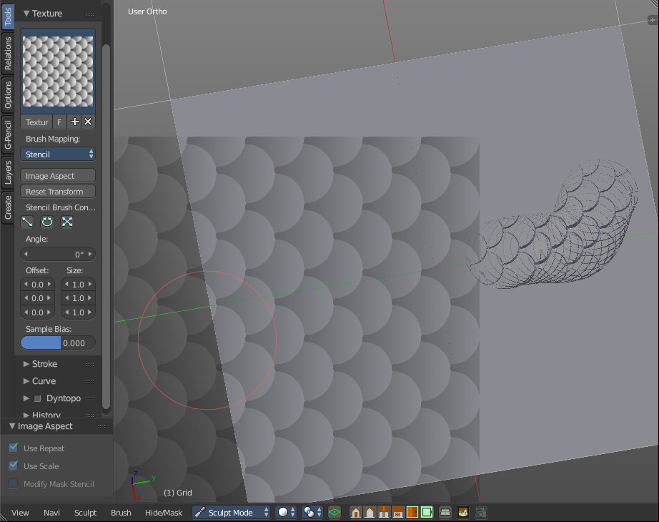
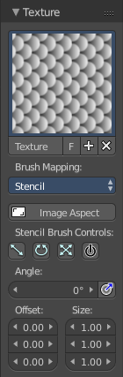

Image Aspect
Adjust the stencil size to fit to the image aspect ratio

Stencil Brush controls
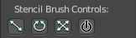
Here you can move, rotate and scale the stencil image in the 3D viewport. And reset the transform. You better use the hotkeys here that gets displayed in the tool tips, since the image is not displayed when the mouse is not over the 3D viewport.

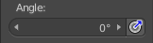
Angle edit box
Here you can adjust the angle of the brush. The button at the end allows you to set the radius by dragging the mouse. This should be done in the viewport and with the hotkey. This button is just a visible reminder.

Offset
Fine tune the offset of the texture in the brush.

Size
Fine tune the size of the texture in the brush.

Stroke Panel
The Stroke panel contains settings to influence the behaviour of the brush stroke. There are various stroke methods available. We will go through them one by one.

Stroke Panel with Stroke method Space
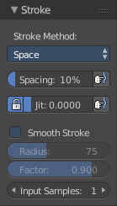
This is the default Stroke method. The sculpt stroke gets added continuously with given settings.
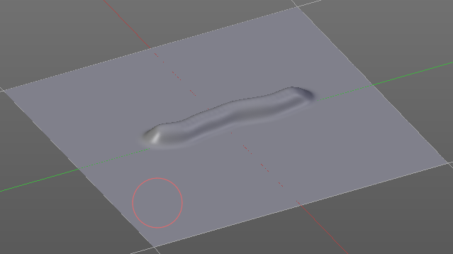

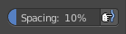
Spacing Edit Box
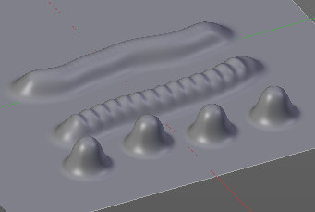
The sculpt drawing happens by mapping the pencil onto the mouse position. And when you move the mouse then the next mapping happens. Here you can adjust the spacing after what mouse movement the next mapping should happen. The lower the value, the lower the distance between the single dots.
The icon behind the edit box enables tablet pressure sensitivity for tablets.

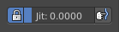
Jitter Edit Box
Here you can add Jitter to the brush while painting.
The icon in front of the edit box toggles between jittering in screen space and relative to brush size.
The icon behind the edit box enables tablet pressure sensitivity for tablets.

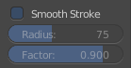
Smooth Stroke
The brush lags behind the mouse position, and produces a much smoother stroke by that.

Smooth Stroke Radius Edit Box
Is just active when Smooth Stroke is activated. Here you can adjust the radius of the smoothing.

Smooth Stroke Factor Edit Box
Is just active when Smooth Stroke is activated. Here you can adjust the factor of the smoothing.

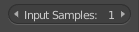
Input Samples Edit Box
Average multiple input samples together to smooth the brush stroke.

Stroke Panel with Stroke method Curve
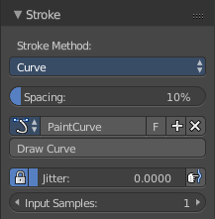
The Stroke method curve doesn't simply influence the way how the stroke is painted. It is a special method. First you draw a curve object by holding down ctrl and clicking with left mouse button. Then you tweak the curve. You can click at the curve point, and drag out handlers to make the curve points smoooth
Then you hit the Draw Curve button. And the curve gets sculpted.

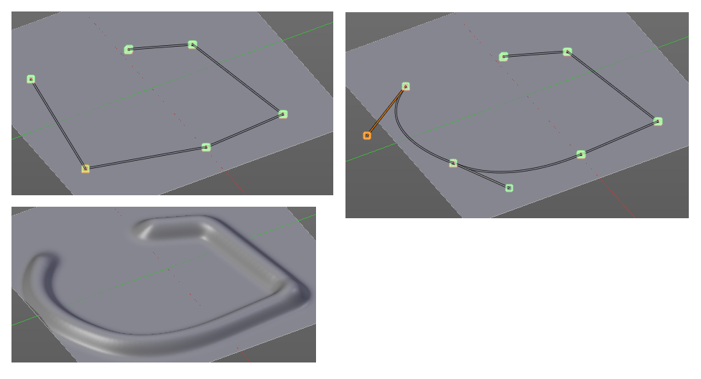

Spacing Edit Box
The sculpt drawing happens by mapping the pencil onto the mouse position. And when you move the mouse then the next mapping happens. Here you can adjust the spacing after what mouse movement the next mapping should happen. The lower the value, the lower the distance between the single dots.
The icon behind the edit box enables tablet pressure sensitivity for tablets.

Paint Curve edit box
Here you set the active curve.
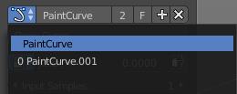
The first element is a dropdown box where you will find your curves objects. You can have more than one.
The second element is the edit box that displays the active curve.
The number right of it, in this case 2, indicates how much number of users ( internally ) this brush uses. This means that this data block (the brush) shares currently settings with at least one other object. Most probably the parent brush where we have created it from. Click at the value to make this brush a single user. The button will vanish then.
F set the brush to have a fake user. Zero user data-blocks are normally not saved. But sometimes you want to force the data to be kept even when the data block has no user.
The + button allows you to add a new pencil with the current settings. Note that the brushes are NOT saved when you close Bforartists. You can save them into the current blend file. Or you can save the startup file. But be careful here. This saves everything else of the current state of Bforartists too.
The X button deletes the brush as the active one. It does NOT delete it from the brushes list.

Draw Curve Button
A click at it to turns the curve into a sculpt stroke.

Jitter Edit Box
Here you can add Jitter to the brush while painting.
The icon in front of the edit box toggles between jittering in screen space and relative to brush size.
The icon behind the edit box enables tablet pressure sensitivity for tablets.

Input Samples Edit Box
Average multiple input samples together to smooth the brush stroke.

Stroke Panel with Stroke method Line
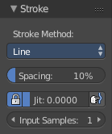
With Stroke method line you draw a line between a starting point and a endpoint. And when you release the mouse then the line gets sculpted.

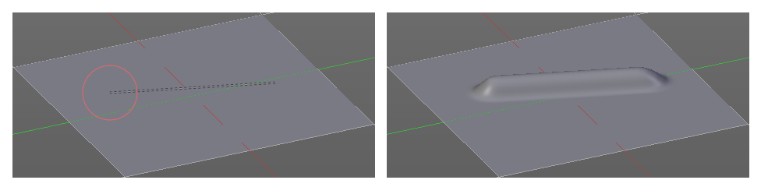

Spacing Edit Box
The sculpt drawing happens by mapping the pencil onto the mouse position. And when you move the mouse then the next mapping happens. Here you can adjust the spacing after what mouse movement the next mapping should happen. The lower the value, the lower the distance between the single dots.
The icon behind the edit box enables tablet pressure sensitivity for tablets.

Jitter Edit Box
Here you can add Jitter to the brush while painting.
The icon in front of the edit box toggles between jittering in screen space and relative to brush size.
The icon behind the edit box enables tablet pressure sensitivity for tablets.

Input Samples Edit Box
Average multiple input samples together to smooth the brush stroke.

Stroke Panel with Stroke method Airbrush
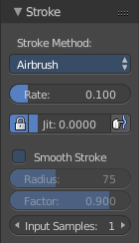
The sculpt stroke acts like an airbrush pencil. The dots gets placed randomly.
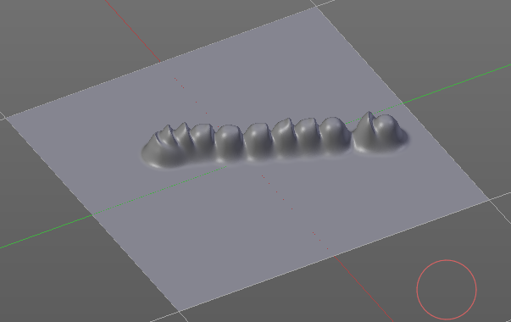

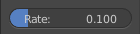
Rate Edit Box
Here you can define the rate of the drawing.

Jitter Edit Box
Here you can add Jitter to the brush while painting.
The icon in front of the edit box toggles between jittering in screen space and relative to brush size.
The icon behind the edit box enables tablet pressure sensitivity for tablets.

Smooth Stroke
The brush lags behind the mouse position, and produces a much smoother stroke by that.

Smooth Stroke Radius Edit Box
Is just active when Smooth Stroke is activated. Here you can adjust the radius of the smoothing.

Smooth Stroke Factor Edit Box
Is just active when Smooth Stroke is activated. Here you can adjust the factor of the smoothing.

Input Samples Edit Box
Average multiple input samples together to smooth the brush stroke.

Stroke Panel with Stroke method Anchored
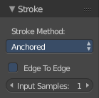
Click and drag to place a dot and to scale it.
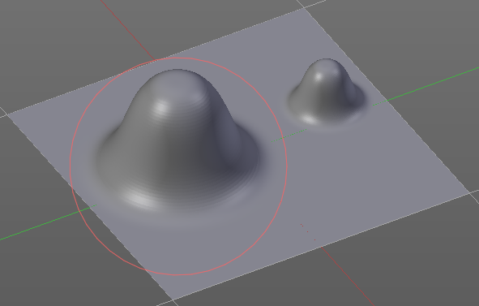

Edge to Edge
Without Edge to Edge the scaling happens from the center of the brush. With edge to edge the scaling happesn from the edge of the brush.

Input Samples Edit Box
Average multiple input samples together to smooth the brush stroke.

Stroke Panel with Stroke method Drag dot
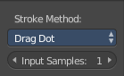
Click and drag to place a dot.
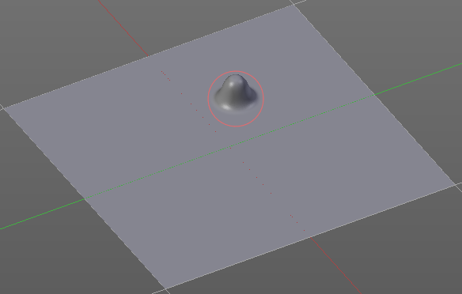

Input Samples Edit Box
Average multiple input samples together to smooth the brush stroke.

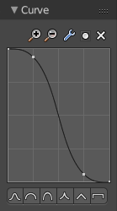
Curve Panel
The curve panel allows you to define different fallofs methods for the border of the brush.

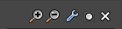
Navigation elements
The navigation elements at the top are described from left to right

Zoom in and out
The two buttons with the magnifying glass at it zooms in and out in the curve window.

Tools
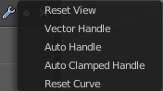
Tools is a menu where you can find some cuve related tools.

Reset View
Resets the curve windows zoom

Vector Handle
Set handle type to Vector

Auto Handle
Set handle type to Auto

Auto Clamped Handle
Set handle type to Auto Clamped

Reset Curve
Resets the curve to the initial shape.

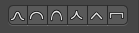
Curve Presets
Here you can find some predefined curve presets.

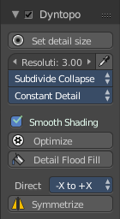
Dyntopo Panel
Dyntopo stands for Dynamic Topology Sculpting.
Without dyntopo you just deform the existing geometry. With Dyntopo geometry gets subdivided when needed. This makes it possible to sculpt complex shapes out of a block.
Left without Dyntopo, right with Dyntopo.
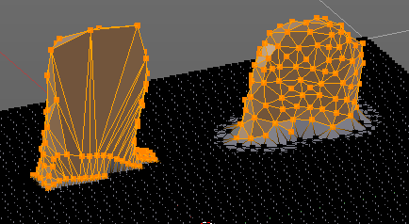
Note that some brushes does not work with Dyntopo. They are Grab brush, Rotate brush, Thumb brush, Layer brush, Smooth brush (including alt-key smoothing with a different brush) and Mask brush.
The topology will also not be updated if the stroke mode is Anchored or Drag Dot.

Detail Size
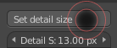
The Detail size defines how fine the subdivision will be. When you click at the upper button then a widget appears where you can set the detail size by dragging. This button contains also the hotkey to change the detail size in the viewport so that you don't have to grab the slider all the time when working.
The edit box below does the same. But with a slider, and without visible feedback in form of a widget.

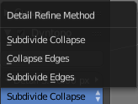
Detail Refine method
Here you can define the Detail refine method.

Subdivide Collapse
Both methods in one. Subdivide long edges to add mesh detail where needed. And collapse short edges to remove mesh detail where possible.

Collapse Edges
Collapse short edges to remove mesh detail where possible.

Subdivide Edges
Subdivide long edges to add mesh detail where needed.

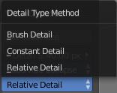
Detail Type Method
Here you can define the Detail Type method.

Brush Detail
Mesh Detail is relative to brush radius.

Constant Detail
Mesh detail is constant in object space according to detail size.

Relative Detail
Mesh Detail is relative to brush size and detail size

Smooth shading
Show faces in smooth shading instead of flat shading.

Optimize
Recalculate the sculpt BVH to improve performance.

Detail Floodfill
Flood fill the mesh with the selected detail settings.

Direction
Source and Destination for Symmetrize operator. This has to do with the symmetrize button below.

Symmetrize
Symmetrize the topology modifications.

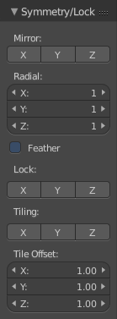
Symmetry / Lock
The Symmetry Lock panel contains tools around symmetry and lock features. Here you can turn on or off mirroring along axis, etc.

Mirror
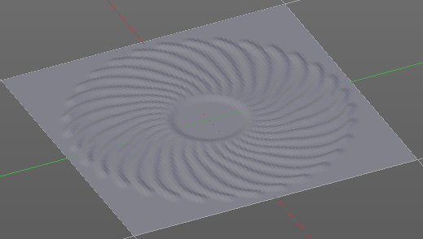
Mirror sculpt along activated axis. By default the mirroring is activated around X axis.

Radial
Adjust the repeatings across some axis. For example, when you change Z to 32, then you can draw 32 segments simultaneously around the Z axis instead of just one, distributed around the Z axis.

Feather
Reduce the strength of the brush where it overlaps symmetrical daubs

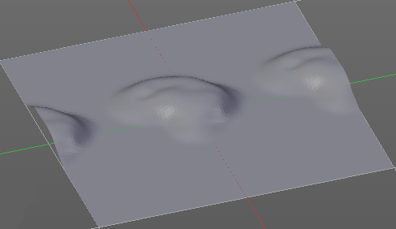
Lock
Disallow vertices movement in locked axis direction.

Tiling
Produces a mesh that is tilable in the activated directions.

Tile Offset
Here you can adjust the offset of the tiling.

Tool Shelf in Sculpt Mode - Mesh Object, Options tab
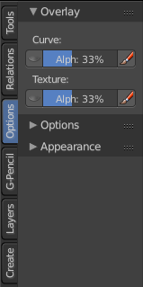
The Options tab for sculpting provides you with some settings and options for sculpting.

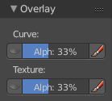
Overlay Panel

Curve
This setting is interesting for the Stroke method Curve. Here you can adjust how transparent the curve is.
The eye icon button in front of the slider is to show the curve object in viewport. The brush icon button behind the slider is to hide the overlay during a stroke.

Texture
This setting is interesting for Texture painting. Here you can adjust how transparent the texture is.
The eye icon button in front of the slider is to show the texture in the viewport. The brush icon button behind the slider is to hide the overlay during a stroke.
The Stencil map texture has no eye icon button since it gets shown in the viewport anyways.

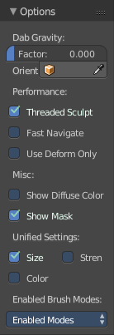
Options Panel

Dab Gravity
Here you can add gravity after each stroke.

Factor
The factor silder defines the amount.

Orientation
Here you define an object that gets used to determine the gravity from. The Z axis of this object gets used.

Threaded Sculpt
Use multiple CPU cores for sculpting.

Fast Navigate
For Multires, show Low Res mesh when navigating.

Use Deform only
Use only deformation modifiers ( The other constructive modifiers except multi-resolution gets temporary disabled)

Show Diffuse Color
Show the diffuse color of the object while sculpting.

Unified Settings

Size
Instead of per Brush radius, the radius is shared across brushes.

Strength
Instead of per Brush strength, the strength is shared across brushes.

Color
Instead of per Brush color, the color is shared across brushes.

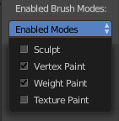
Enabled Brush Modes

Enabled Modes
Enabled modes is a dropdown menu where you can adjust in which modes the brushes shows.

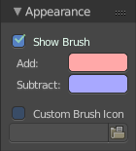
Appearance Panel
The Appearance panel provides you with some settings to adjust the appearance of the brush.

Show Brush
Show the brush in 3D view.

Add
The color that the brush cursor has when adding to geometry.

Subtract
The color of the brush cursor when subtracting from the geometry.

Custom Brush Icon
Here you can define a custom icon for the brush.

Tool Shelf in Vertex Paint Mode

The Tool Shelf in Vertex Paint Mode provides you the tools to paint vertices.
Vertex painting assigns colors to single vertices. And this color gets interpolated between the different vertices then. This is what makes the faces colored. And this means that you can NOT paint in the middle of a face with this method. You just paint the vertices from the mesh.
The Vertex Paint mode is just available for mesh objects.

Tool Shelf in Vertex Paint Mode - Mesh Object, Tools Tab

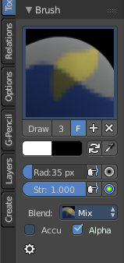
Brush Panel
The Brush Panel contains the different Brushes and some Brush settings. Here you can choose and adjust your current active brush.
At down left you can find the display options. The button with the gear symbol at it. Here you will find two toggles to hide away the color picker and the palette edit box.

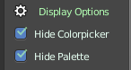

Browse Brush
The big image at the top is a dropdown box where you can choose a brush. Click at it, and you will see the different brushes. A click at one of the images will choose this brush then.
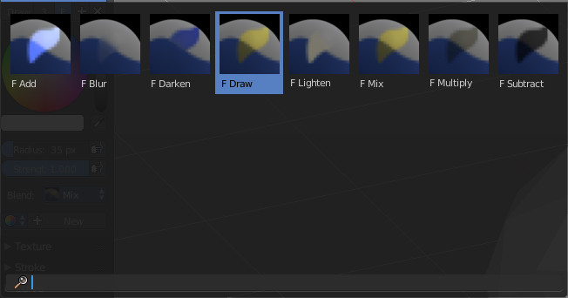
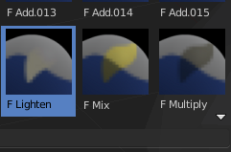
When you have added a few more brushes then the dropdown box may be more than full. You will see some little white arrows then. Either in the top left or in the bottom right corner. They indicate that some brushes are hidden before or after the current display.
To scroll to this hidden content use the mouse wheel, or the arrow up and down buttons at the keyboard.
The edit box below the Image shows you the name of the current active brush.
The number right of it, in this case 2, indicates how much number of users ( internally ) this brush uses. This means that this data block (the brush) shares currently settings with at least one other object. Most probably the parent brush where we have created it from. Click at the value to make this brush a single user. The button will vanish then.
F set the brush to have a fake user. Zero user data-blocks are normally not saved. But sometimes you want to force the data to be kept even when the data block has no user.
The + button allows you to add a new pencil with the current settings. Note that the brushes are NOT saved when you close Bforartists. You can save them into the current blend file. Or you can save the startup file. But be careful here. This saves everything else of the current state of Bforartists too.
The X button deletes the brush as the active one. It does NOT delete it from the brushes list.

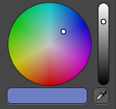
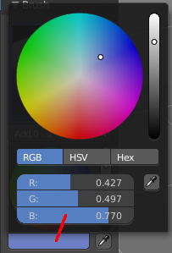
Color dialog
The color dialog is hidden by default. See display options at the bottom of the panel. You can define the color in the color element below the brush browser. It will also open a color dialog then.
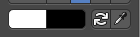

When you set it to visible, then you can set the color for painting by a click with the mouse in the color wheel. The slider at the right defines the brightness.
The button below shows you the active color.
A click at the color button will open a more detailed color dialog, where you can set up rgb, hsv and hex colors and with sliders.

Color Element
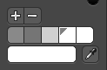
Here you can set a primary and a secondary color. The button with the arrows at it switches the active and the secondary color. And with the pipette you can pick a color from the screen. This will reveal some more elements, and create a palette. Here you can choose now the color to use it for painting. You can add and remove colors here too.
This color picker can just pick a color in the 3D view. It does not work elsewhere.

Radius
The Radius edit box allows you to adjust the radius of the brush. The button behind the edit box enables tablet pressure sensitivity for radius.
And the button at the end allows you to set the radius of the pencil by hotkey. A click at this button works of course too. But this is a hotkey tool. The button is just a visible reminder.

Strength
The Strength edit box allows you to adjust the strength of the brush. The button behind the edit box enables tablet pressure sensitivity for strength.
And the button at the end allows you to set the strength by hotkey. A click at this button works of course too. But this is a hotkey tool. The button is just a visible reminder.

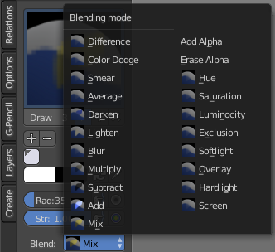
Blending Modes
Here you can define how the stroke will blend.

Accumulate, Alpha, etc.
This are brush specific settings. They change with the brush.

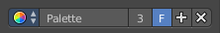
Palette Editbox
Palette Edit box is hidden by default.
Here you can give your palette a name, create another palette, remove palette, and give it a fake user.


Display options
Here you can show or hide the Colorpicker and the Palette Editbox.

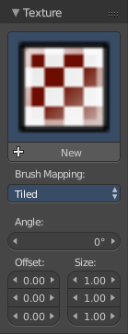
Texture Panel
The Texture panel allows you to paint with textures. This allows you for example to grab a foto from some fish scales, and simply paint them onto the vertices by using this image as a pencil. Or as a blueprint where you calk through ( Stencil method ).

Browse Texture to be linked
The image at the top of the panel is a image browser. Here you can choose a texture that you can choose for sculpting then. You can also have more than one image loaded at once.

In this shot there is already a texture added. The way to add the texture here is a bit more complicated. And not done with clicking at the New button.

First click at the New button below the image. This will create a new texture slot. This slot is still empty, it displays black.

We need to load the texture in this slot. This must be done in the Properties editor in the Textures tab. And then the texture finally shows in the Texture panel in the Tool Shelf.

Texture Edit box

The Texture edit box is the edit box below the Image browser. When there's no image loaded then it displays the New button. When there's a image (or more) loaded, then you will see the name of the current texture.
The F button turns this texture into a data block with a fake user. Means it will exists even when there is no data connected to it anymore.
When you activate Fake User, then you may get a value in front of it, which displays how much users this data block (our texture slot) currently has.
The + Button adds another texture slot. Note that you will have to load a texture too, as explained above.
The X button deletes the texture slot.

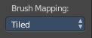
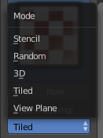
Brush Mapping
Our texture can be mapped in different methods. The Brush mapping is a dropdown box where you can choose this different brush mapping methods.
The settings vary. So we will go through them by the different brush mapping methods.

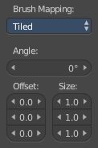
Brush Mapping with mapping method Tiled
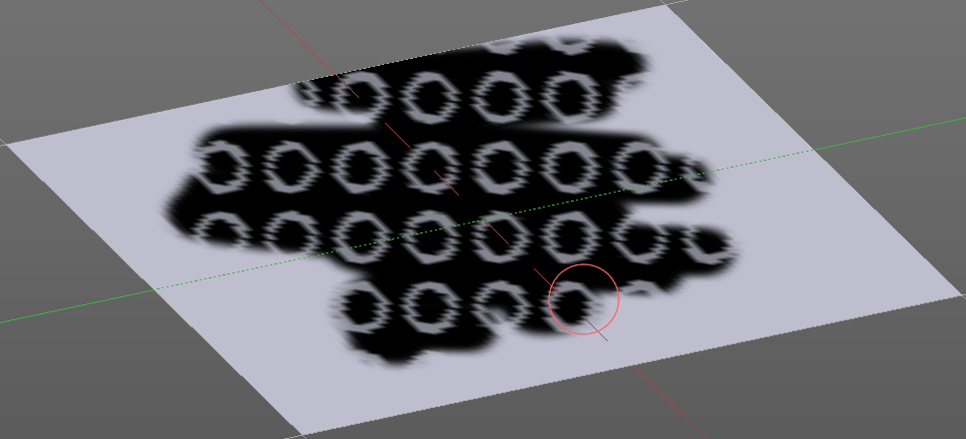
The brush mapping method Tiled tiles the brush stroke at the surface. The mapping happens from the current view. The result may be distorted when the view does not align with the surface of the object.

Angle
The angle of the brush.

Offset
The offset of the texture in the brush.

Size
The size of the texture in the brush.

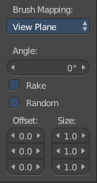
Brush Mapping with mapping method View Plane
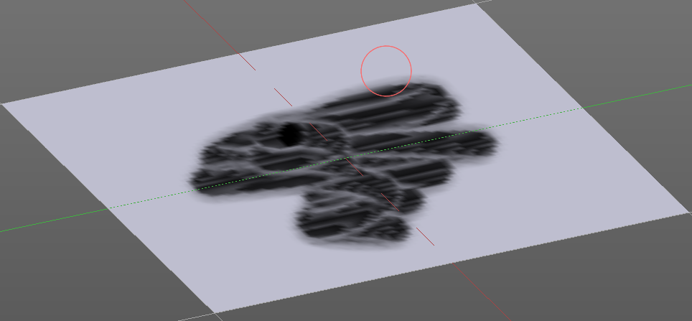
The brush mapping method View Plane simply paints onto the surface. The mapping happens from the current view. The result may be distorted when the view does not align with the surface of the object.

Angle
The angle of the brush.

Rake
The angle follows the direction of the brush stroke.

Random
The brush angle gets set random.

Offset
The offset of the texture in the brush.

Size
The size of the texture in the brush.

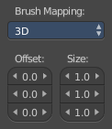
Brush Mapping with mapping method 3D
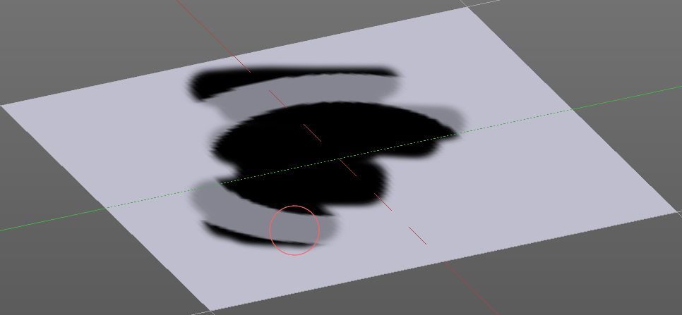
The brush mapping method 3D paints the texture at the surface, by tiling it 1/1 at the object surface.

Offset
The offset of the texture in the brush.

Size
The size of the texture in the brush.

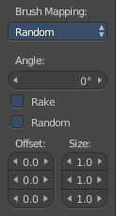
Brush Mapping with mapping method Random
The brush mapping method Random paints onto the surface, and randomizes the texture position in the brush while that. The mapping happens from the current view. The result may be distorted when the view does not align with the surface of the object.

Angle
The angle of the brush.

Rake
The angle follows the direction of the brush stroke.

Random
The brush angle gets set random.

Offset
The offset of the texture in the brush.

Size
The size of the texture in the brush.

Brush Mapping with mapping method Stencil
The former methods uses the textures for the brush. The method Stencil works different. You have your texture displayed in the workspace above the object, and you paint this texture onto your object with your pencil strokes.
Note that the texture in the 3d space is just visible when you are with the mouse over the viewport.

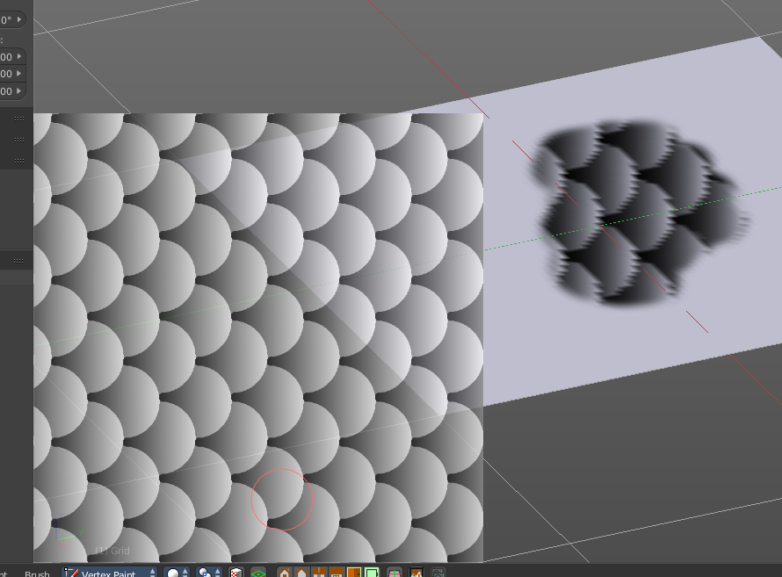
Image Aspect
Adjust the stencil size to fit to the image aspect ratio

Stencil Brush controls
Here you can move, rotate and scale the stencil image in the 3D viewport. And reset the transform. You better use the hotkeys here that gets displayed in the tool tips, since the image is not displayed when the mouse is not over the 3D viewport.

Angle edit box
Here you can adjust the angle of the brush. The button at the end allows you to set the radius by dragging the mouse. This should be done in the viewport and with the hotkey. This button is just a visible reminder.

Offset
Fine tune the offset of the texture in the brush.

Size
Fine tune the size of the texture in the brush.

Stroke Panel
The Stroke panel contains settings to influence the behaviour of the brush stroke. There are various stroke methods available. We will go through them one by one.

Stroke Panel with Stroke method Space
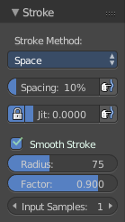
This is the default Stroke method. The sculpt stroke gets added continuously with given settings.
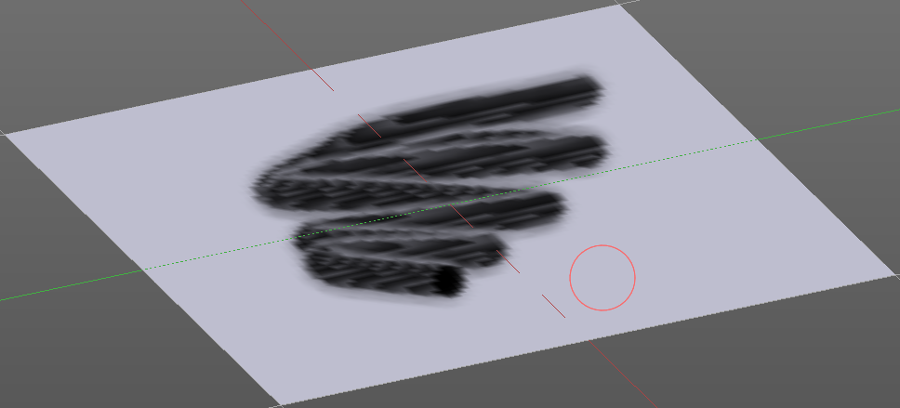

Spacing Edit Box
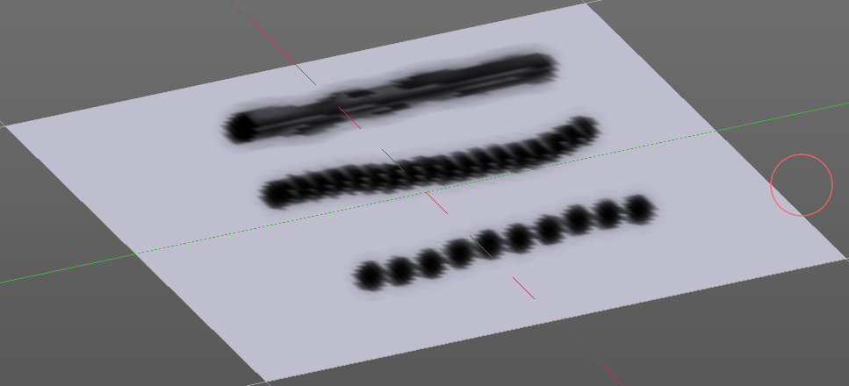
The sculpt drawing happens by mapping the pencil onto the mouse position. And when you move the mouse then the next mapping happens. Here you can adjust the spacing after what mouse movement the next mapping should happen. The lower the value, the lower the distance between the single dots.
The icon behind the edit box enables tablet pressure sensitivity for tablets.

Jitter Edit Box
Here you can add Jitter to the brush while painting.
The icon in front of the edit box toggles between jittering in screen space and relative to brush size.
The icon behind the edit box enables tablet pressure sensitivity for tablets.

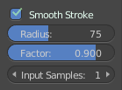
Smooth Stroke
The brush lags behind the mouse position, and produces a much smoother stroke by that. The Smooth Stroke relatet settings are hidden as long as Smooth Stroke is not activated.

Smooth Stroke Radius Edit Box
Is just active when Smooth Stroke is activated. Here you can adjust the radius of the smoothing.

Smooth Stroke Factor Edit Box
Is just active when Smooth Stroke is activated. Here you can adjust the factor of the smoothing.

Input Samples Edit Box
Is just active when Smooth Stroke is activated. Average multiple input samples together to smooth the brush stroke.

Stroke Panel with Stroke method Curve
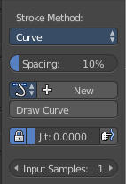
The Stroke method curve doesn't simply influence the way how the stroke is painted. It is a special method. First you draw a curve object by holding down ctrl and clicking with left mouse button. Then you tweak the curve. You can click at the curve point, and drag out handlers to make the curve points smoooth.
Then you hit the Draw Curve button. And the curve gets drawn onto the surface.

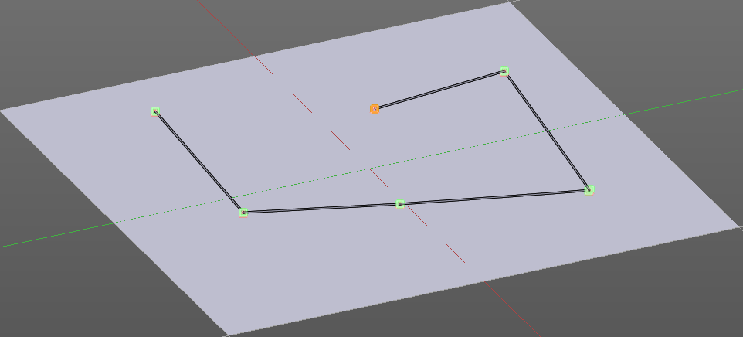
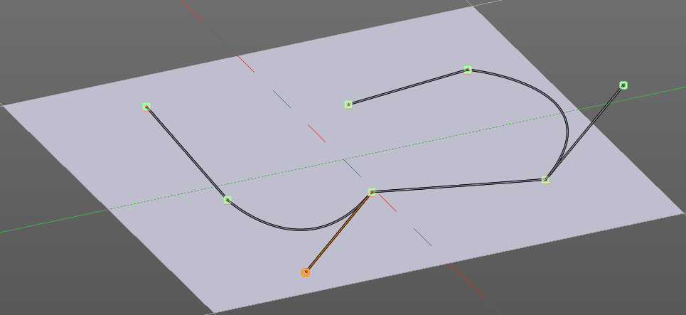
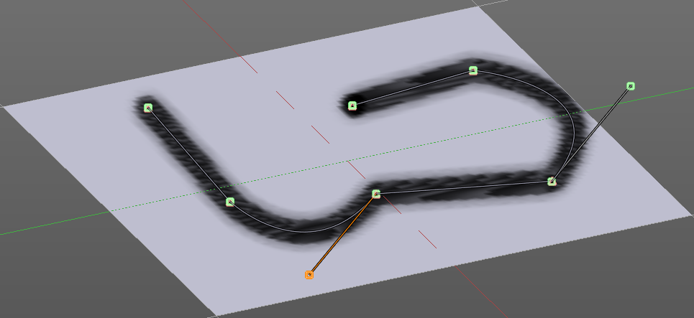

Spacing Edit Box
The drawing happens by mapping the pencil onto the mouse position. And when you move the mouse then the next mapping happens. Here you can adjust the spacing after what mouse movement the next mapping should happen. The lower the value, the lower the distance between the single dots.
The icon behind the edit box enables tablet pressure sensitivity for tablets.

Paint Curve edit box
Here you set the active curve.
The first element is a dropdown box where you will find your curves objects. You can have more than one.
The second element is the edit box that displays the active curve.
The number right of it, in this case 2, indicates how much number of users ( internally ) this brush uses. This means that this data block (the brush) shares currently settings with at least one other object. Most probably the parent brush where we have created it from. Click at the value to make this brush a single user. The button will vanish then.
F set the brush to have a fake user. Zero user data-blocks are normally not saved. But sometimes you want to force the data to be kept even when the data block has no user.
The + button allows you to add a new pencil with the current settings. Note that the brushes are NOT saved when you close Bforartists. You can save them into the current blend file. Or you can save the startup file. But be careful here. This saves everything else of the current state of Bforartists too.
The X button deletes the brush as the active one. It does NOT delete it from the brushes list.

Draw Curve Button
A click at it to turns the curve into a sculpt stroke.

Jitter Edit Box
Here you can add Jitter to the brush while painting.
The icon in front of the edit box toggles between jittering in screen space and relative to brush size.
The icon behind the edit box enables tablet pressure sensitivity for tablets.

Input Samples Edit Box
Average multiple input samples together to smooth the brush stroke.

Stroke Panel with Stroke method Line
With Stroke method line you draw a line between a starting point and a endpoint. And when you release the mouse then the line gets sculpted.

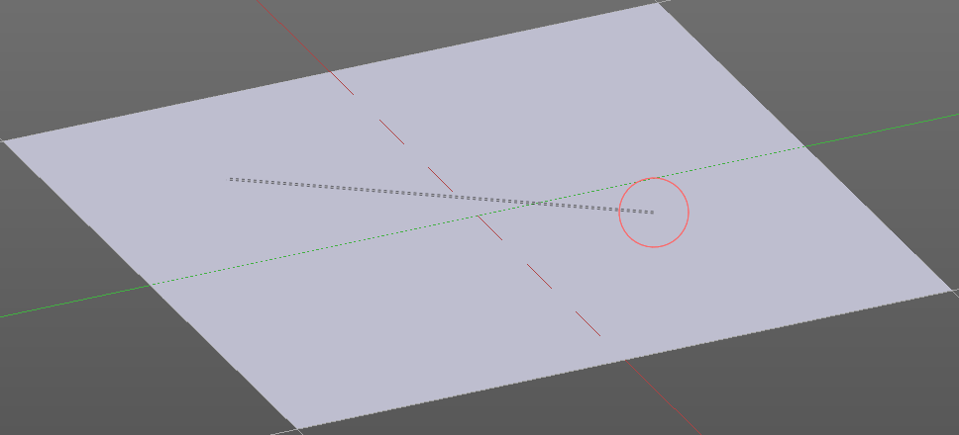
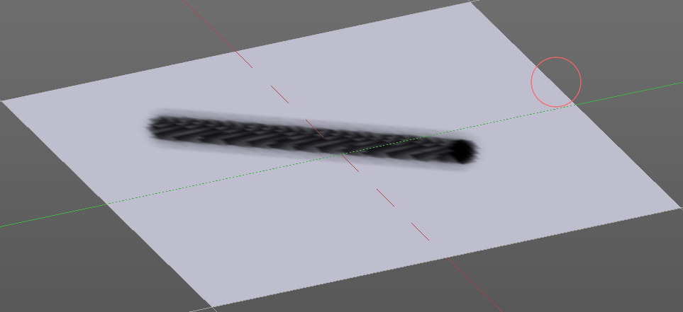

Spacing Edit Box
The sculpt drawing happens by mapping the pencil onto the mouse position. And when you move the mouse then the next mapping happens. Here you can adjust the spacing after what mouse movement the next mapping should happen. The lower the value, the lower the distance between the single dots.
The icon behind the edit box enables tablet pressure sensitivity for tablets.

Jitter Edit Box
Here you can add Jitter to the brush while painting.
The icon in front of the edit box toggles between jittering in screen space and relative to brush size.
The icon behind the edit box enables tablet pressure sensitivity for tablets.

Input Samples Edit Box
Average multiple input samples together to smooth the brush stroke.

Stroke Panel with Stroke method Airbrush
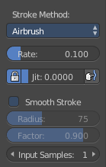
The stroke acts like an airbrush pencil. The dots gets placed randomly.
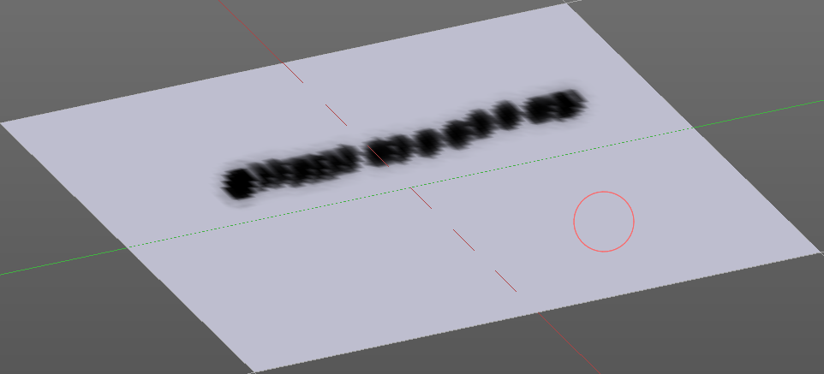

Rate Edit Box
Here you can define the rate of the drawing.

Jitter Edit Box
Here you can add Jitter to the brush while painting.
The icon in front of the edit box toggles between jittering in screen space and relative to brush size.
The icon behind the edit box enables tablet pressure sensitivity for tablets.

Smooth Stroke
The brush lags behind the mouse position, and produces a much smoother stroke by that.

Smooth Stroke Radius Edit Box
Is just active when Smooth Stroke is activated. Here you can adjust the radius of the smoothing.

Smooth Stroke Factor Edit Box
Is just active when Smooth Stroke is activated. Here you can adjust the factor of the smoothing.

Input Samples Edit Box
Average multiple input samples together to smooth the brush stroke.

Stroke Panel with Stroke method Dots
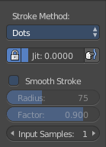
The stroke method Dots draws dots of the pencil onto the surface. The mapping happens from the current view. Means you will get distortions when your view is not aligned with the surface of the object.

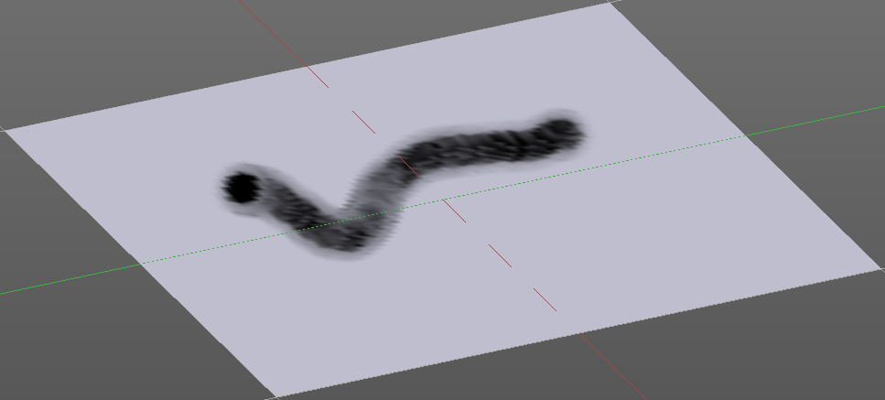
Jitter Edit Box
Here you can add Jitter to the brush while painting.
The icon in front of the edit box toggles between jittering in screen space and relative to brush size.
The icon behind the edit box enables tablet pressure sensitivity for tablets.

Smooth Stroke
The brush lags behind the mouse position, and produces a much smoother stroke by that.

Smooth Stroke Radius Edit Box
Is just active when Smooth Stroke is activated. Here you can adjust the radius of the smoothing.

Smooth Stroke Factor Edit Box
Is just active when Smooth Stroke is activated. Here you can adjust the factor of the smoothing.

Input Samples Edit Box
Average multiple input samples together to smooth the brush stroke.

Curve Panel
The curve panel allows you to define different fallofs methods for the border of the brush.

Navigation elements
The navigation elements at the top are described from left to right

Zoom in and out
The two buttons with the magnifying glass at it zooms in and out in the curve window.

Tools
Tools is a menu where you can find some cuve related tools.

Reset View
Resets the curve windows zoom

Vector Handle
Set handle type to Vector

Auto Handle
Set handle type to Auto

Auto Clamped Handle
Set handle type to Auto Clamped

Reset Curve
Resets the curve to the initial shape.

Curve Presets
Here you can find some predefined curve presets.

Tool Shelf in Vertex paint Mode - Mesh Object, Options tab
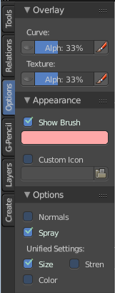
The Options tab for sculpting provides you with some settings and options for vertex painting.

Overlay Panel

Curve
This setting is interesting for the Stroke method Curve. Here you can adjust how transparent the curve is.
The eye icon button in front of the slider is to show the curve object in viewport. The brush icon button behind the slider is to hide the overlay during a stroke.

Texture
This setting is interesting for Texture painting. Here you can adjust how transparent the texture is.
The eye icon button in front of the slider is to show the texture in the viewport. The brush icon button behind the slider is to hide the overlay during a stroke.
The Stencil map texture has no eye icon button since it gets shown in the viewport anyways.

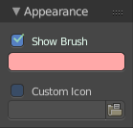
Appearance Panel
The Appearance panel provides you with some settings to adjust the appearance of the brush.

Show Brush
Show the brush in 3D view.

Color of cursor when adding
The color that the brush cursor has when painting

Custom Icon
Here you can define a custom icon for the brush.

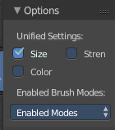
Options Panel

Unified Settings

Size
Instead of per Brush radius, the radius is shared across brushes.

Strength
Instead of per Brush strength, the strength is shared across brushes.

Color
Instead of per Brush color, the color is shared across brushes.

Enabled Brush Modes

Enabled Modes
Enabled modes is a dropdown menu where you can adjust in which modes the brushes shows.

Tool Shelf in Weight Paint Mode

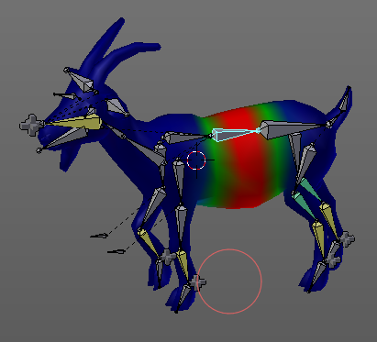
Weight painting general
The Tool Shelf in Weight Paint Mode provides you the tools to do weight painting at a mesh. Skinned characters for example.
The vertices becomes a "weighting" assigned in this process. Means a per centage influence of the bone to a vertice. And under the hood you create vertex groups with the vertices that are assigned to the bones.
The amount of influence is defined by the weight paint color. Pure red has an influence value of 1. Pure blue has an influence value of 0. And the gradients between red and blue defines the inbetween steps in the 0-1 range. This is needed since there can be more than one bone influence and deform a vertice. Usually at the transition areas between two bones. The green areas in this shot.
The Weight Paint mode is just available for mesh objects.

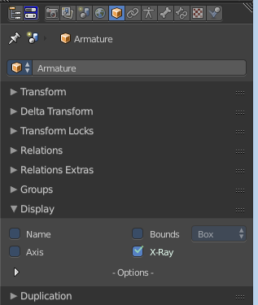
Weight painting at characters
The main purpose for Weightpainting is to weight the skin for characters. So that they deform proper when you pose your armature.

Skinning
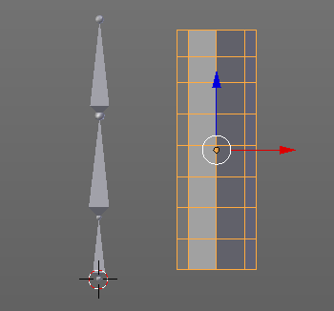
To do weightpainting at a character you first have to assign the skin to the armature. So we need a mesh and a armature here.
Let's do a quick run through skinning. This method works in Object mode, but also in Pose mode.
First we activate X Ray at the armature. So that we can still see the armature inside of the mesh.
Position the mesh at its final location.
Now select the Mesh, hold down Shift key, and select the Armature. Both should be selected now.
In the Tool Shelf switch to the Relations tab and click at the Parent button. You can also press the hotkey Ctrl P. This calls the parenting menu under the mouse position.
Here we choose "With Automatic Weights". Automatic weighting means that the bones grabs the nearest vertices within a given radius, and assignes them to this bone.
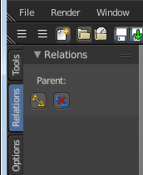
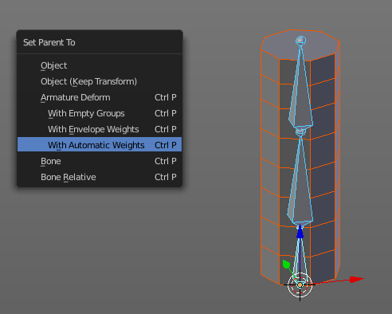

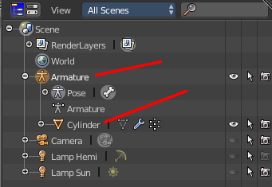
When everything went well then the mesh, in our case the Cylinder, is now part of the hierarchy of the armature. Which can be seen in the outliner.
And when you select the armature, and switch to Pose mode now, then you can already deform the mesh by posing the armature.
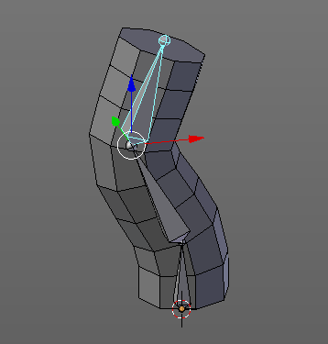

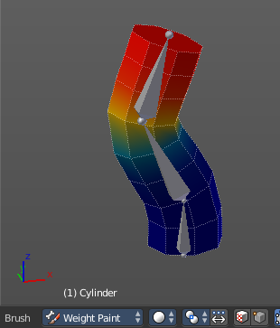
Enter and leave Weight painting
You can enter Weight Painting for the mesh in any state of the armature. But weight painting should happen in Pose mode so that you can pose your mesh to see the resulting deformings.
So with the armature in Pose mode, select the mesh by clicking at it. Then enter Weight Paint mode. You can now do weight painting at the mesh.
To leave Weight painting, simply switch back to Object mode.

Switch bones
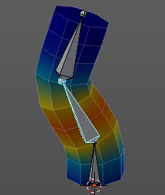
The weighting that gets displayed when you enter Weight Paint mode is from the last active bone. You might want to do weight painting for another bone. So we need to switch the bone.
Hold down Ctrl, and click at the bone that you want to set active. Then the weighting for this bone gets displayed.

Weight painting without any further combination
You can also do weightpainting without an armature. Just at the pure mesh. In this case you just create the vertex groups for the mesh. And those vertex groups can be accessed in edit mode then for further useage. As shown in the shots below.
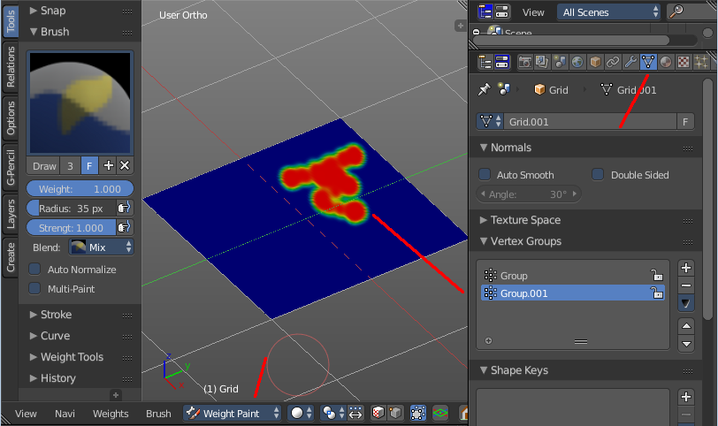
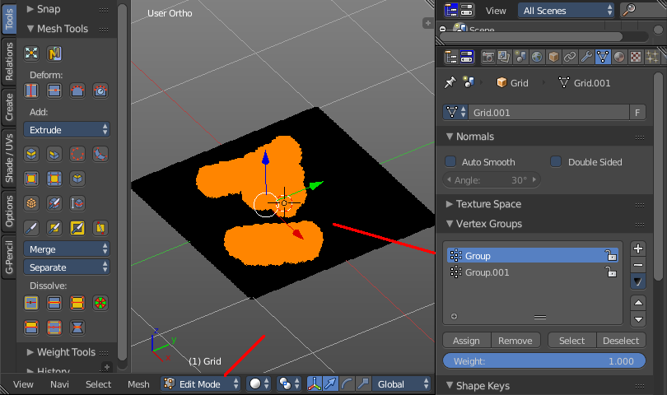

Weight painting in combination with particles
You can also combine weight painting with particles. To influence the length of hair for example. The weightmap can be assigned in the Vertex Groups panel in the Particles tab.
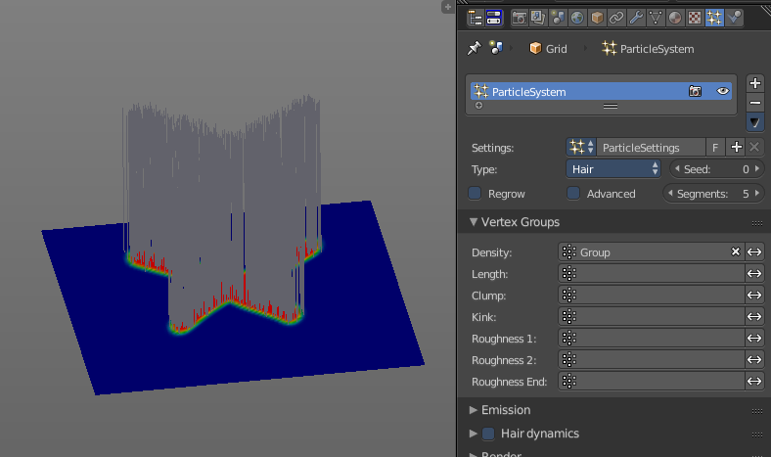

Tool Shelf in Weight Paint Mode - Mesh Object, Tools Tab

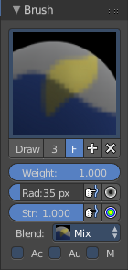
Brush Panel
The Brush Panel contains the different Brushes and some Brush settings. Here you can choose and adjust your current active brush.

Browse Brush
The big image at the top is a dropdown box where you can choose a brush. Click at it, and you will see the different brushes. A click at one of the images will choose this brush then.

When you have added a few more brushes then the dropdown box may be more than full. You will see some little white arrows then. Either in the top left or in the bottom right corner. They indicate that some brushes are hidden before or after the current display.
To scroll to this hidden content use the mouse wheel, or the arrow up and down buttons at the keyboard.
The edit box below the Image shows you the name of the current active brush.
The number right of it, in this case 2, indicates how much number of users ( internally ) this brush uses. This means that this data block (the brush) shares currently settings with at least one other object. Most probably the parent brush where we have created it from. Click at the value to make this brush a single user. The button will vanish then.
F set the brush to have a fake user. Zero user data-blocks are normally not saved. But sometimes you want to force the data to be kept even when the data block has no user.
The + button allows you to add a new pencil with the current settings. Note that the brushes are NOT saved when you close Bforartists. You can save them into the current blend file. Or you can save the startup file. But be careful here. This saves everything else of the current state of Bforartists too.
The X button deletes the brush as the active one. It does NOT delete it from the brushes list.

Weight edit box
Here you can adjust the strength of the weight painting.

Radius
The Radius edit box allows you to adjust the radius of the brush. The button behind the edit box enables tablet pressure sensitivity for radius.
And the button at the end allows you to set the radius of the pencil by hotkey. A click at this button works of course too. But this is a hotkey tool. The button is just a visible reminder.

Strength
The Strength edit box allows you to adjust the strength of the brush. The button behind the edit box enables tablet pressure sensitivity for strength.
And the button at the end allows you to set the strength by hotkey. A click at this button works of course too. But this is a hotkey tool. The button is just a visible reminder.

Blend
Blend is a dropdown box where you can choose between different blend modes for the color that you paint.

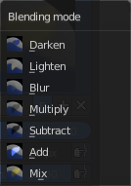
Darken
Darkens the color under the brush.

Lighten
Brightens the color under the brush.

Blur
Blurs the color under the brush.

Multiply
Multiplys with the color under the brush.

Subtract
Subtract from the color under the brush.

Add
Adds to the color under the brush.

Mix
Mixes with the color under the brush.

Auto Normalize
Auto normalizes the weighting so that in the sum all vertex groups does not go over 1.0

Multipaint
Paint across the weights of all selected bones, maintaining their relative influence.

Stroke Panel
The Stroke panel contains settings to influence the behaviour of the brush stroke. There are various stroke methods available. We will go through them one by one.

Stroke Panel with Stroke method Space
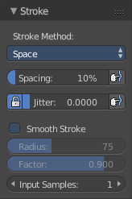
This is the default Stroke method. The sculpt stroke gets added continuously with given settings.
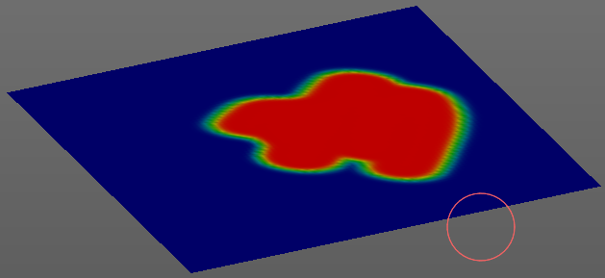

Spacing Edit Box
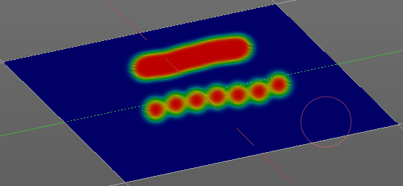
The drawing happens by mapping the pencil onto the mouse position. And when you move the mouse then the next mapping happens. Here you can adjust the spacing after what mouse movement the next mapping should happen. The lower the value, the lower the distance between the single dots.
The icon behind the edit box enables tablet pressure sensitivity for tablets.

Jitter Edit Box
Here you can add Jitter to the brush while painting.
The icon in front of the edit box toggles between jittering in screen space and relative to brush size.
The icon behind the edit box enables tablet pressure sensitivity for tablets.

Smooth Stroke
The brush lags behind the mouse position, and produces a much smoother stroke by that.

Smooth Stroke Radius Edit Box
Is just active when Smooth Stroke is activated. Here you can adjust the radius of the smoothing.

Smooth Stroke Factor Edit Box
Is just active when Smooth Stroke is activated. Here you can adjust the factor of the smoothing.

Input Samples Edit Box
Average multiple input samples together to smooth the brush stroke.

Stroke Panel with Stroke method Curve
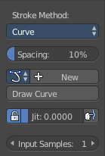
The Stroke method curve doesn't simply influence the way how the stroke is painted. It is a special method. First you draw a curve object by holding down ctrl and clicking with left mouse button. Then you tweak the curve. You can click at the curve point, and drag out handlers to make the curve points smoooth.
Then you hit the Draw Curve button. And the curve gets drawn onto the surface.
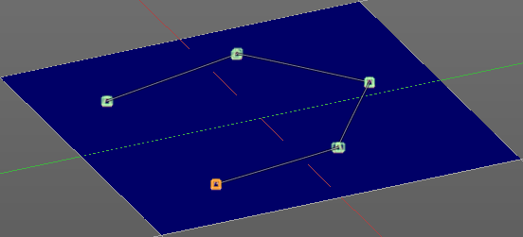
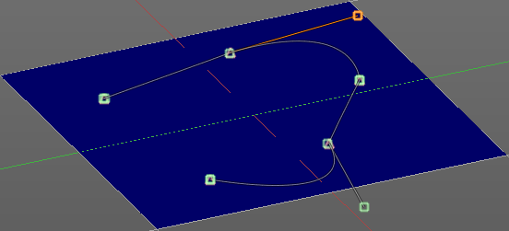
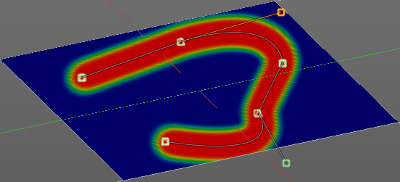

Spacing Edit Box
The drawing happens by mapping the pencil onto the mouse position. And when you move the mouse then the next mapping happens. Here you can adjust the spacing after what mouse movement the next mapping should happen. The lower the value, the lower the distance between the single dots.
The icon behind the edit box enables tablet pressure sensitivity for tablets.

Paint Curve edit box
Here you set the active curve.
The first element is a dropdown box where you will find your curves objects. You can have more than one.
The second element is the edit box that displays the active curve.
The number right of it, in this case 2, indicates how much number of users ( internally ) this brush uses. This means that this data block (the brush) shares currently settings with at least one other object. Most probably the parent brush where we have created it from. Click at the value to make this brush a single user. The button will vanish then.
F set the brush to have a fake user. Zero user data-blocks are normally not saved. But sometimes you want to force the data to be kept even when the data block has no user.
The + button allows you to add a new pencil with the current settings. Note that the brushes are NOT saved when you close Bforartists. You can save them into the current blend file. Or you can save the startup file. But be careful here. This saves everything else of the current state of Bforartists too.
The X button deletes the brush as the active one. It does NOT delete it from the brushes list.

Draw Curve Button
A click at it to turns the curve into a sculpt stroke.

Jitter Edit Box
Here you can add Jitter to the brush while painting.
The icon in front of the edit box toggles between jittering in screen space and relative to brush size.
The icon behind the edit box enables tablet pressure sensitivity for tablets.

Input Samples Edit Box
Average multiple input samples together to smooth the brush stroke.

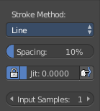
Stroke Panel with Stroke method Line
With Stroke method line you draw a line between a starting point and a endpoint. And when you release the mouse then the line gets sculpted.

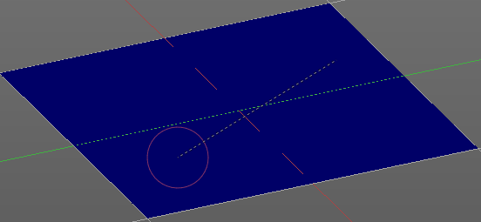
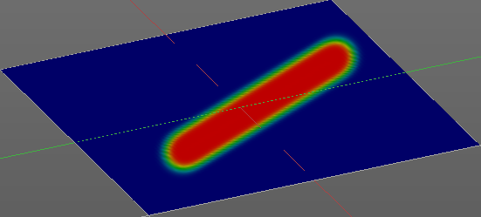

Spacing Edit Box
The sculpt drawing happens by mapping the pencil onto the mouse position. And when you move the mouse then the next mapping happens. Here you can adjust the spacing after what mouse movement the next mapping should happen. The lower the value, the lower the distance between the single dots.
The icon behind the edit box enables tablet pressure sensitivity for tablets.

Jitter Edit Box
Here you can add Jitter to the brush while painting.
The icon in front of the edit box toggles between jittering in screen space and relative to brush size.
The icon behind the edit box enables tablet pressure sensitivity for tablets.

Input Samples Edit Box
Average multiple input samples together to smooth the brush stroke.

Stroke Panel with Stroke method Airbrush
The stroke acts like an airbrush pencil. The dots gets sprayed randomly.
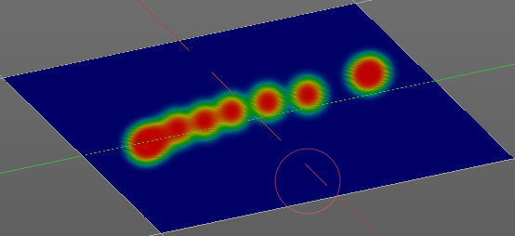

Rate Edit Box
Here you can define the rate of the drawing.

Jitter Edit Box
Here you can add Jitter to the brush while painting.
The icon in front of the edit box toggles between jittering in screen space and relative to brush size.
The icon behind the edit box enables tablet pressure sensitivity for tablets.

Smooth Stroke
The brush lags behind the mouse position, and produces a much smoother stroke by that.

Smooth Stroke Radius Edit Box
Is just active when Smooth Stroke is activated. Here you can adjust the radius of the smoothing.

Smooth Stroke Factor Edit Box
Is just active when Smooth Stroke is activated. Here you can adjust the factor of the smoothing.

Input Samples Edit Box
Average multiple input samples together to smooth the brush stroke.

Stroke Panel with Stroke method Dots
The stroke method Dots draws dots of the pencil onto the surface. The mapping happens from the current view. Means you will get distortions when your view is not aligned with the surface of the object.

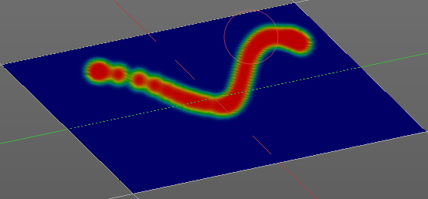
Jitter Edit Box
Here you can add Jitter to the brush while painting.
The icon in front of the edit box toggles between jittering in screen space and relative to brush size.
The icon behind the edit box enables tablet pressure sensitivity for tablets.

Smooth Stroke
The brush lags behind the mouse position, and produces a much smoother stroke by that.

Smooth Stroke Radius Edit Box
Is just active when Smooth Stroke is activated. Here you can adjust the radius of the smoothing.

Smooth Stroke Factor Edit Box
Is just active when Smooth Stroke is activated. Here you can adjust the factor of the smoothing.

Input Samples Edit Box
Average multiple input samples together to smooth the brush stroke.

Curve Panel
The curve panel allows you to define different fallofs methods for the border of the brush.

Navigation elements
The navigation elements at the top are described from left to right

Zoom in and out
The two buttons with the magnifying glass at it zooms in and out in the curve window.

Tools
Tools is a menu where you can find some cuve related tools.

Reset View
Resets the curve windows zoom

Vector Handle
Set handle type to Vector

Auto Handle
Set handle type to Auto

Auto Clamped Handle
Set handle type to Auto Clamped

Reset Curve
Resets the curve to the initial shape.

Curve Presets
Here you can find some predefined curve presets.

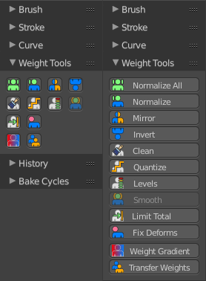
Weight Tools
The Weight Tools provides you with tools to manipulate the existing weight painting and its vertex groups in various ways.

Normalize All
Normalize all vertex groups. So that for each vertex the sum of all weights is 1.0

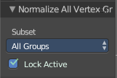
Last Operator Normalize All Vertex Groups

Subset
Defines which group of subset shall be used. There is just one in the dropdown list. So nothing really to choose here.

Lock Active
Keep the values of the active groupd while normalizing the others.

Normalize
Normalize the current active vertex group.
Normalize has no settings in the Last operator.

Mirror
Mirrors the weighting of the current active vertex group.

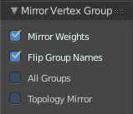
Last Operator Mirror Vertex Group

Mirror Weights
Mirror the weights

Flip Group Names
Flip the vertex group names

All Groups
Mirror all groups, not just the current active one.

Topology Mirror
Use topology based mirroring (for when both sides of th emesh have matching, unique topology)

Invert
Inverts the colors of the weight painting.

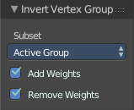
Last Operator Invert Vertex Groups

Subset
A dropdown box where you can choose to work with the Active Group or All Groups.

Add Weights
Add Vertices to groups that has zero weighting before inverting.

Remove Weights
Remove Vertices from groups that have zero weighting after inverting.

Clean
Remove Vertex Group assignments that are below a defined limit. This limit can be set in the Last Operator panel.

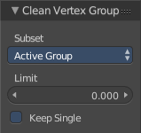
Last Operator Clean Vertex Groups

Subset
A dropdown box where you can choose to work with the Active Group or All Groups.

Limit
Here you can define the limit. Every vertice with a weighting below this value will be removed from the current vertex group.

Keep Single
Keep vertices assigned to at least one vertex group when cleaning.

Quantize
Reduces the number of colours that are used for weight painting. A smooth gradient reduces to a few colors.

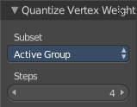
Last Operator Quantize Vertex Weights

Subset
A dropdown box where you can choose to work with the Active Group or All Groups.

Steps
The number of colors after quantize.

Levels
Here you can manipulate the colors of the weight painting similar to contrast and brightness. The tool adds an offset and a scale to all weights of the selected Weight Groups.

Last Operator Vertex Group Levels

Subset
A dropdown box where you can choose to work with the Active Group or All Groups.

Offset
Adjust the brightness of the color.

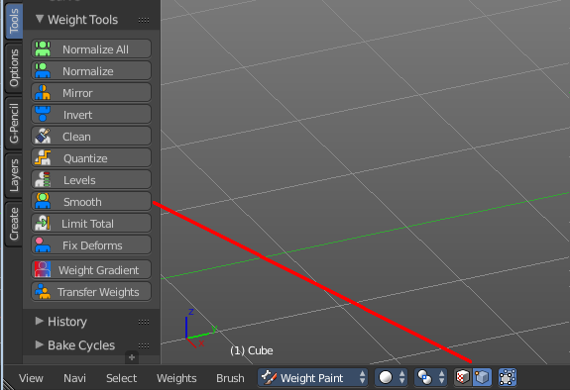
Gain
Adjust the contrast of the color.

Smooth
Smooth smoothens the weight painting by blending the weights of selected vertices with adjacent unselected vertices.
You need to have Vertex Selection masking set to active to set this tool active. Then every vertice of the mesh gets displayed as a dot. And then you can select the vertices that you want to smooth.
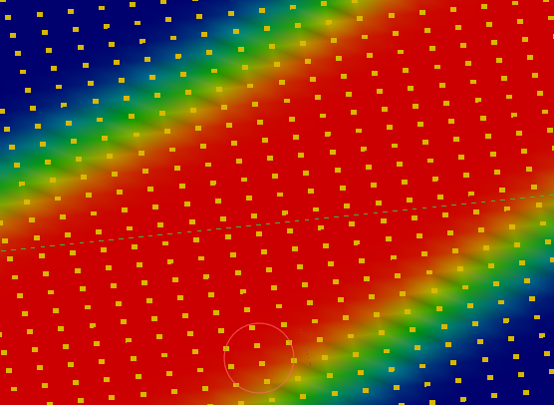

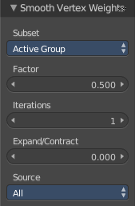

Last Operator Smooth Vertex Weights

Subset
A dropdown box where you can choose to work with the Active Group or All Groups.

Factor
The smoothing factor.

Iterations
The number of iterations to smooth.

Expand/Contract
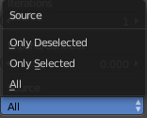
With positive values it expands the smoothing. With negative values it contracts the smoothing.

Source
A dropdown box where you can choose with what vertices you want to work.

Limit Total
Limit the number of deform weights for a vertex by removing the lowest weights. For example when five vertex groups are assigned to one vertice, and you set the limit to 4, then the vertice will just be assigned to the four vertex groups with the highest weight. This is useful for game content where the game engine has a limit for how much bones can be connected to one vertice.

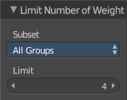
Last Operator Limit Number of Weights

Subset
A dropdown box where you can choose to work with the Active Group or All Groups.

Limit
Here you can set the limit.

Fix Deforms
When complex models are deformed to their most extreme poses, they often show visibly incorrect deformations. Shoulder or elbow for example. Fix Deforms tries to fix this incorrect deformations by modifying the positions of the selected vertices to fit better into the positions of the surrounding vertices.
The problem with this tool is that it is meant for complex models, but doesn't play well with complex models at all. More than a handful selected vertices slows even strong PC's down to a crawl. So you might be better suited to fix the incorrect deformations by simply doing manual weight painting at the trouble makers. Or by adding a shape key in the extreme pose to clean up the incorrect deformations.

Usage
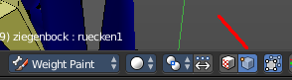
Make sure that there is no mirroring applied. The tool does not work with mirroring.
In Pose mode pose your mesh into the extreme pose.
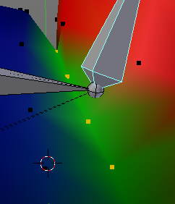
Select the mesh, switch to Weigth Paint.
In Weight Paint mode turn on Vertex Selection Masking.
Then select the trouble vertices. By Border select for example. Or by Shift LMB click.
Then click at Fix Deforms. You might or might not get a visible result.
Play around with the Distance in the Last Operator to get other results.

Last Operator Fix Vertex Group Deform

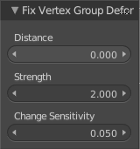
Distance
The distance to move to.

Strength
A modifier for the Distance.

Change Sensitivity
Change the amount that the weights are altered with each iteration. The lower the value the slower the calculation.

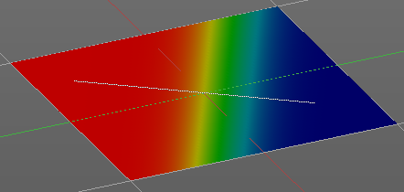
Weight Gradient
Weight gradient allows you to draw a gradient by defining the start point and the end point.

Last Operator Weight Gradient

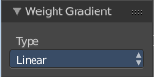
Type
A dropdown box where you can choose between a linear gradient and a radial gradient.

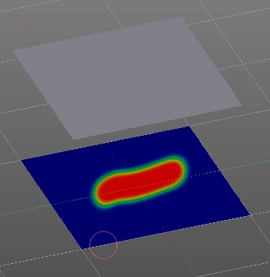
Transfer Weights
Transfer weights allows you to transfer weights from one object to another object in the same space. For example to copy the weight of a body shape to a covering cloth.

Usage
Make sure the target part is at its location.
In Object mode Select the source object(s). Then shift click to select the target object too. This makes the target object the active object
Switch to Weight Paint mode.
Click the Transfer Weight Button, and the weighting should be transfered to the target object.
You can adjust the result in the Last Operator Transfer Mesh Data panel.
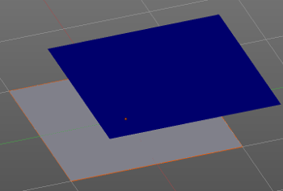
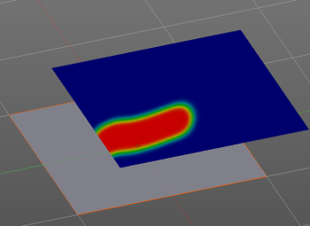

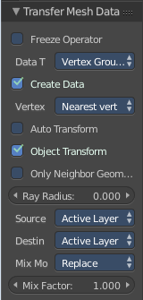
Last Operator Transfer Mesh Data

Freeze Operator
Prevent the operator to rerun when you tweak the settings. So that you can tweak many settings at once, then untick to run the operator again.

Data Type
A dropdown box where you can choose the data type to work with.
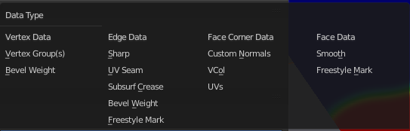

Create Data
Add Data layers on target object if needed.

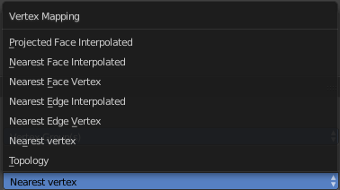
Vertex Mapping
A dropdown box where you can choose the vertex mapping method.

Auto Transform
Automatically compute transformation to get the best possible match between source and target object.

Object Transform
Calculate the objects in Global space. Unticked means the transfer happens from and to the origin of the objects.

Only Neighbour Geometry
Source Objects must be closer than given distance to the target objects.

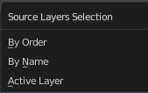
Ray Radius
The ray distance for Only Neighbour Geometry.

Source Layers Selection
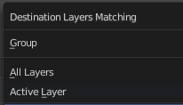
A dropdown box where you can choose the Source Layer selection method.

Destination Layers Matching
A dropdown box where you can choose the Destination Layers matching.

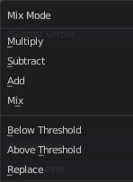
Mix Mode
A dropdown box where you can choose the mix mode. That's how the mapping gets transfered into the target object.

Mix Factor
The strength of the chosen mix mode.

Tool Shelf in Weight Paint Mode - Options Tab

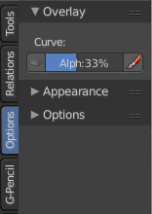
The Options tab provides you with some options for the weight painting tools.

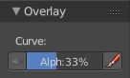
Overlay Panel

Curve
This item is for the Stroke method Curve. Here you can adjust how transparent the curve itself gets drawn.
The eye icon in front of the edit box shows or hides the cursor while drawing a curve.
The pencil icon behind the edit box is for don't show overlay during a stroke.

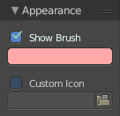
Appearance Panel

Show Brush
Show or hide the brush in the viewport.

Brush color
The color of the brush icon.

Custom Icon
Here you can define a custom brush icon.

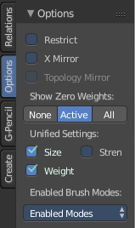
Options Panel

Normals
Apply the vertex normals before painting.

Spray
Keep applying paint effect while holding down mouse button.

Restrict
Restrict painting to vertices in the group.

X Mirror
X Axis Mirror Editing.

Topology Mirror
Needs X Mirror ticked. Use topology based mirroring. For when both sides of the mesh have matching, unique topology.

Show Zero Weights

None
Doesn't show zero weights. Not weighted vertices gets displayed as blue. Which is also the color for very low weighted vertices.

Active
Displays the not weighted vertices for the active vertex group as black.

All
Displays the not weighted vertices for all vertex groups as black.

Unified Settings

Size
The radius of the brush is shared across brushes.

Strength
The strength is shared across brushes.

Weight
The weight is shared across brushes.

Enabled Brush Modes

Enabled Modes
Enabled modes is a dropdown menu where you can adjust in which modes the brushes shows.

Tool Shelf in Texture Paint Mode

The Tool Shelf in Texture Paint Mode provides you the tools to paint directly at the texture of your mesh in the viewport. To fix visible seams for example.
The Texture Paint mode is just available for mesh objects.

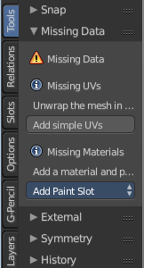
Requirements
Texture Painting requires to have a working UV mapping and a texture applied. When there is no UV mapping and no assigned texture, then you will get a warning about missing data. In this warning dialog you can fix the problem to some degree. The simple UV's is no substitute for real UV mapping though. It is simple cubic mapping. And also the material might need some tweaking to get it rendered.

Available Renderers
Currently you can choose between two render engines for texture painting. Blender Internal and Cycles. This means that you end in two possible materials.

Save Texture
The result of texture painting can be found in the UV Image Editor. You can also paint in the UV editor.
The modified texture does NOT save with the scene. You have to save out the image when you want to save the changes at the texture. There is no warning. So DON'T FORGET TO SAVE THE TEXTURE.
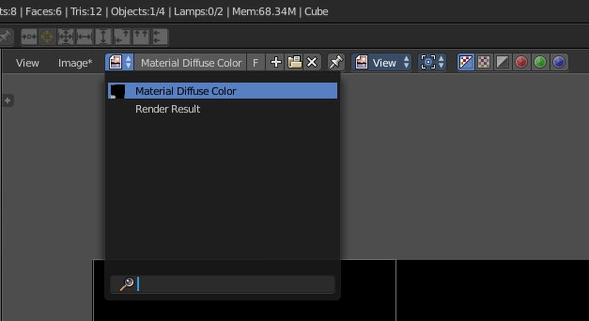
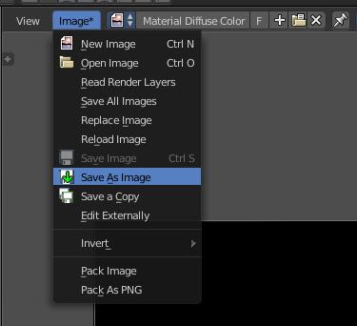

Tool Shelf in Texture Paint Mode - Mesh Object, Tools Tab

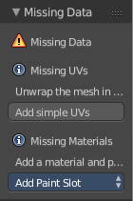
Missing Data Panel
Texture Painting requires to have a working UV mapping and a texture applied. When your mesh already has UV mapping and a texture applied then you won't see this warning. When there is no UV mapping and no assigned texture, then you will see the warning about missing data. You have to add those two missing elements to get texture painting to work.

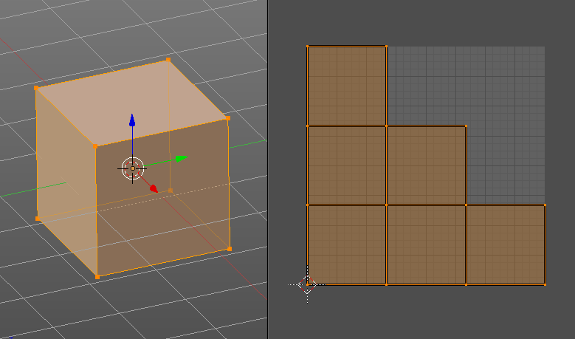
Add Simple UV's
Add Simple UV's adds a simple cubic UV Mapping.

The shot from the simple UV mapping is taken in Edit mode to make the UV patches more visible. Left 3D View, right UV Image Editor.

In case you need better UV mapping, then the recommended method is to unwrap it with Angle Based or Conformal method. Or any other method that doesn't produce overlapping geometry in the UV's. LikeSmart UV project. This is done in Edit mode. When done switch back to Texture Paint mode.

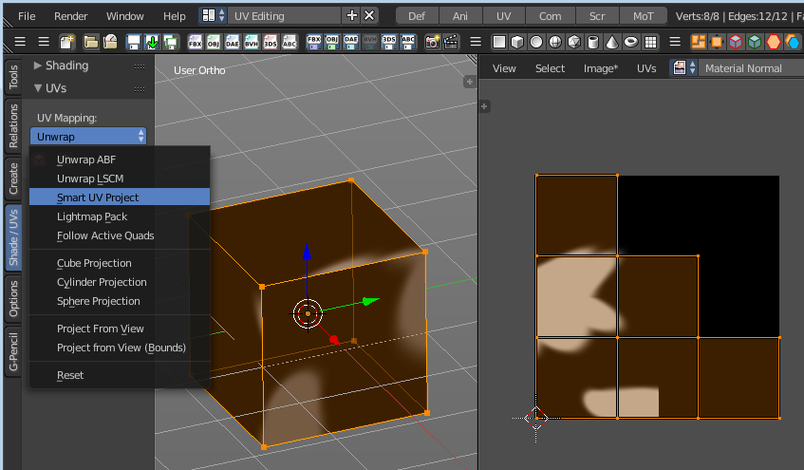

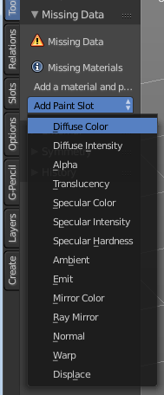
Add Paint Slot
Here you can add a paint slot, and choose what texture type you want to paint. This creates a material with a blank texture. When unsure start with a Diffuse Color. You can at a later point use any texture for any purpose. It's the useage that defines if a texture is the normal map or the diffuse, not the name.
We have two integrated render engines in Bforartists, and so we have two possible materials that can be created. Bforartists has Cycles as the default renderer. When you use the Cycles renderer then it will create a Cycles material. When you switch to Blender Internal then it will create a BI Material.

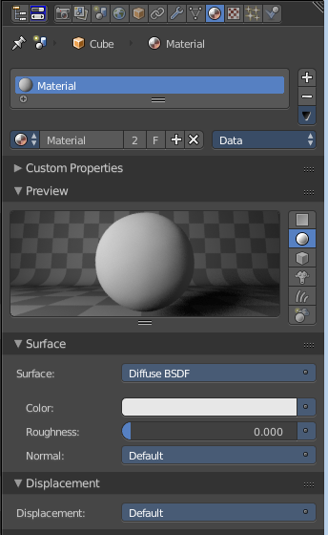
Add Paint Slot with Cycles
When you add a Paint slot with Cycles then a Cycles material will be created.
The texture of this material will not render yet. We have to fix one thing here.
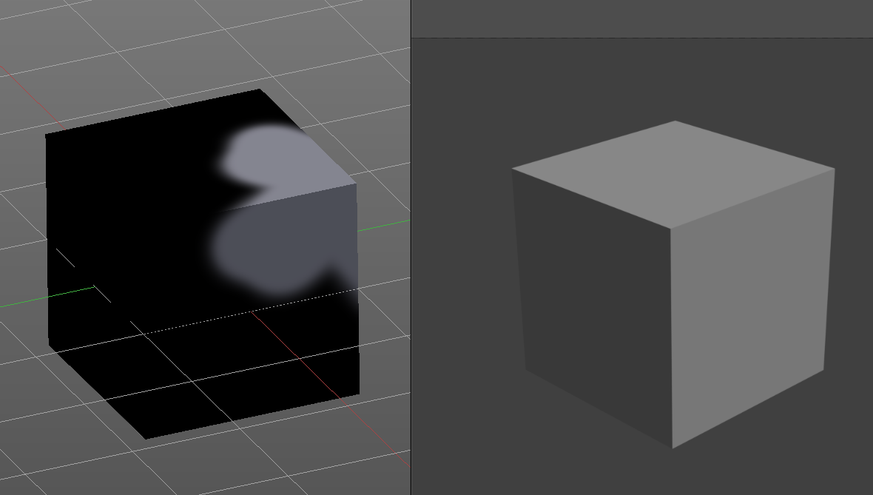

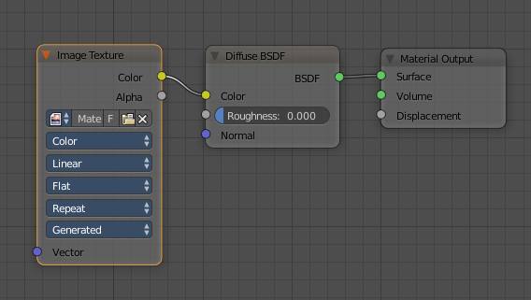
Switch to Compositing layout. Have a look at the nodes. You will notice that the Texture node is not connected. Connect Color output with Color input as shown in the image.
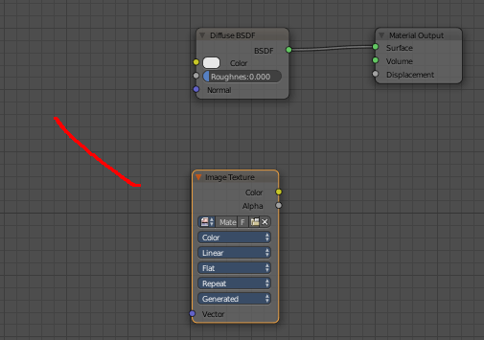

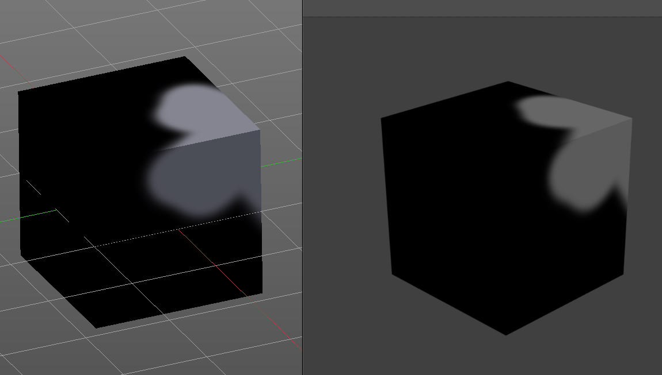
And the texture will now render too.

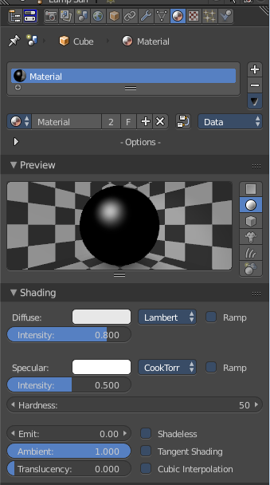

Add Paint Slot with Blender Internal
When you add a Paint slot with Cycles then a BI material will be created.
The texture of this material will immediately render.

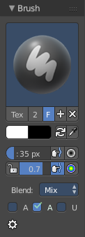
Brush Panel
The Brush Panel contains the different paint brushes, a color dialog, and some brush settings.

At down left you can find the display options. The button with the gear symbol at it. Here you will find two toggles to hide away the color picker and the palette edit box.

Browse Brush
The big image at the top is a dropdown box where you can choose a brush. Click at it, and you will see the different brushes. A click at one of the images will choose this brush then.
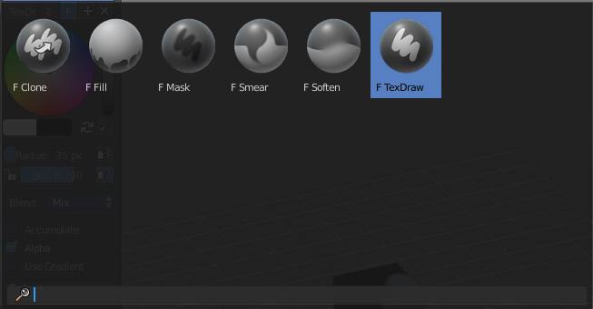
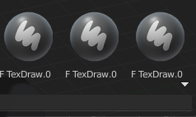
When you have added a few more brushes then the dropdown box may be more than full. You will see some little white arrows then. Either in the top left or in the bottom right corner. They indicate that some brushes are hidden before or after the current display.
To scroll to this hidden content use the mouse wheel, or the arrow up and down buttons at the keyboard.

The edit box below the Image shows you the name of the current active brush.
The number right of it, in this case 2, indicates how much number of users ( internally ) this brush uses. This means that this data block (the brush) shares currently settings with at least one other object. Most probably the parent brush where we have created it from. Click at the value to make this brush a single user. The button will vanish then.
F set the brush to have a fake user. Zero user data-blocks are normally not saved. But sometimes you want to force the data to be kept even when the data block has no user.
The + button allows you to add a new pencil with the current settings. Note that the brushes are NOT saved when you close Bforartists. You can save them into the current blend file. Or you can save the startup file. But be careful here. This saves everything else of the current state of Bforartists too.
The X button deletes the brush as the active one. It does NOT delete it from the brushes list.

Color dialog
The color dialog is hidden by default. See display options at the bottom of the panel. You can define the color in the color element below the brush browser. It will also open a color dialog then.

When you set it to visible, then you can set the color for painting by a click with the mouse in the color wheel. The slider at the right defines the brightness.
The button below shows you the active color.
A click at the color button will open a more detailed color dialog, where you can set up rgb, hsv and hex colors and with sliders.

Color Element
Here you can set a primary and a secondary color. The button with the arrows at it switches the active and the secondary color. And with the pipette you can pick a color from the screen. This will reveal some more elements, and create a palette. Here you can choose now the color to use it for painting. You can add and remove colors here too.
This color picker can just pick a color in the 3D view. It does not work elsewhere.

Radius
The Radius edit box allows you to adjust the radius of the brush. The button behind the edit box enables tablet pressure sensitivity for radius.
And the button at the end allows you to set the radius of the pencil by hotkey. A click at this button works of course too. But this is a hotkey tool. The button is just a visible reminder.

Strength
The Strength edit box allows you to adjust the strength of the brush. When the Lock symbol at the front is ticked, then the pencil keeps its strength relative to the object when zooming in and out. The button behind the edit box enables tablet pressure sensitivity for strength.
And the button at the end allows you to set the strength by hotkey. A click at this button works of course too. But this is a hotkey tool. The button is just a visible reminder.

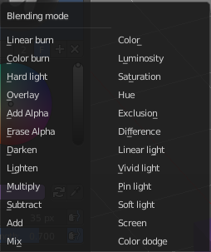
Blend
A dropdown box where you can adjust the blend mode of the paint stroke. Default method is Mix.

Accumulate
Accumulates stroke daubs on top of each other.

Alpha
When unchecked, lock Alpha while painting.

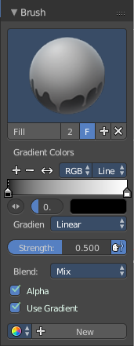
Use Gradient
When you tick Use Gradient then you reveal a Gradient dialog. Here you can set up a gradient.
Important!
Painting a gradient requires to have the Fill pencil chosen. It will not work with the other pencil types.
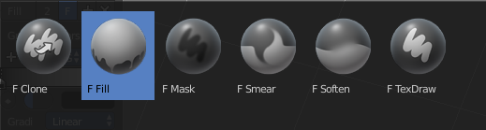

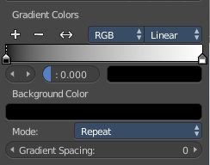
Gradient Colors dialog
The + Button adds a color ramp point. That way you can have more than one color in the gradient.

The - Button removes the currently selected color ramp point.
The <> Element flips the color ramp
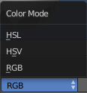
Color Mode is a dropdown box where you can choose the color mode for the gradient.

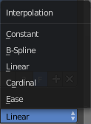
Interpolation is a dropdown box where you can choose the interpolation mode for the gradient.

In the Color Ramp element you will see the color ramp with the single color points.
Choose Active Color Stop is the stop point of the gradient.
Position is a edit box where you can fine tune the position of the currently selected color point

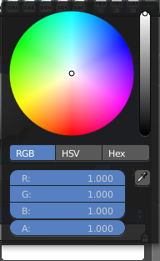
Set Color of selected color stop is the color of the currently selected color point. When you click at it then you will get a color dialog that allows you to setup the color.

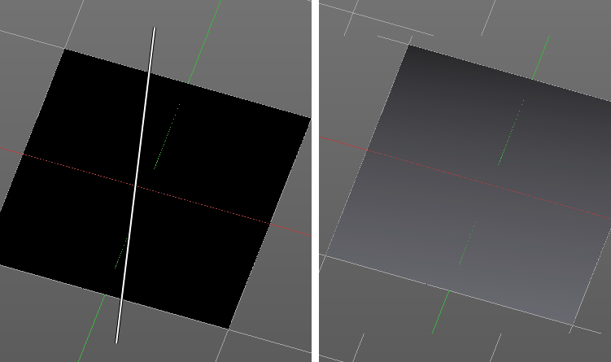
Usage
Set up the gradient in the Gradient dialog.
Choose the Fill pencil. Gradient will not work with other pencils.
Click at the start point of the gradient.
Drag the mouse to the end point of the gradient. This will draw a line that defines the gradient direction.
Release the mouse.

Palette
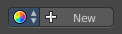
When you pick up a color with the color picker then a palette of colors gets created. This color palette is stored here. You can have more than one palette.
Palettes saves with the scene.
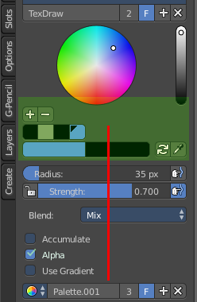
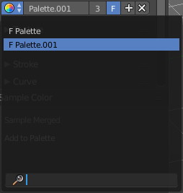

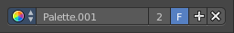
The icon with the color wheel is a dropdown box where you can choose the active palette.

The Palette edit box shows you the current active palette. Here you can also rename it.

The number right of it, in this case 2, indicates how much number of users ( internally ) this palette uses. This means that this data block (the palette) shares currently settings with at least one other object. Most probably the parent palette where we have created it from. Click at the value to make this palette a single user. The button will vanish then.
F set the item to have a fake user. Zero user data-blocks are normally not saved. But sometimes you want to force the data to be kept even when the data block has no user.
The + button allows you to add a new palette with the current settings.
The X button deletes the palette as the active one. You will see the "New" button then. It does NOT delete it from the palette list.

Texture Panel
The Texture panel allows you to paint with textures. This allows you for example to grab a foto from some fish scales, and simply paint them onto the mesh by using this image as a pencil. Or as a blueprint where you calk through ( Stencil method ).

Browse Texture to be linked
The image at the top of the panel is a image browser. Here you can choose a texture that you can choose for painting then. You can also have more than one image loaded at once.

In this shot there is already a texture added. The way to add the texture here is a bit more complicated. And not done with clicking at the New button.

First click at the New button below the image. This will create a new texture slot. This slot is still empty, it displays black.

We need to load a texture in this slot. This must be done in the Properties editor in the Textures tab.

The problem is, we have an object with a material and a texture already selected. And when we change this texture , then we don't get the pencil texture loaded. But we change the texture at our mesh.

What we need to do is to create a material first. And in this material we load our pencil texture then. And then this texture becomes available in the image browser of the Texture panel.

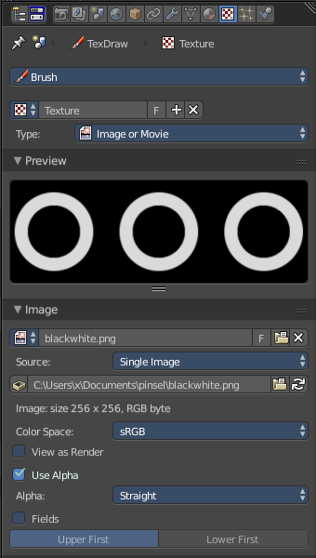
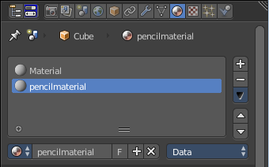

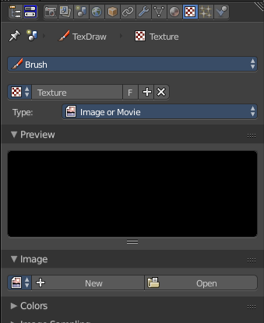

Texture Edit box
The Texture edit box is the edit box below the Image browser. When there's no image loaded then it displays the New button. When there's a image (or more) loaded, then you will see the name of the current texture.
The F button turns this texture into a data block with a fake user. Means it will exists even when there is no data connected to it anymore.
When you activate Fake User, then you may get a value in front of it, which displays how much users this data block (our texture slot) currently has.
The + Button adds another texture slot. Note that you will have to load a texture too, as explained above.
The X button deletes the texture slot.

Brush Mapping
Our texture can be mapped in different methods. The Brush mapping is a dropdown box where you can choose this different brush mapping methods.
The settings vary. So we will go through them by the different brush mapping methods.

Brush Mapping with mapping method Tiled
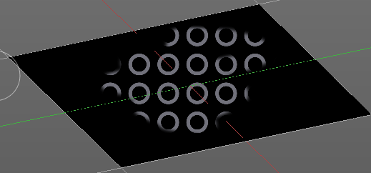
The brush mapping method Tiled tiles the brush stroke at the surface. The mapping happens from the current view. The result may be distorted when the view does not align with the surface of the object.

Angle
The angle of the brush.

Offset
The offset of the texture in the brush.

Size
The size of the texture in the brush.

Brush Mapping with mapping method View Plane
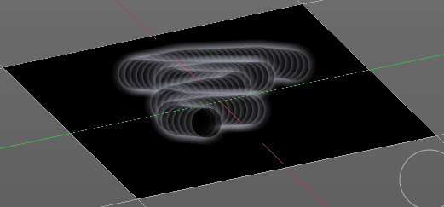
The brush mapping method View Plane simply paints onto the surface. The mapping happens from the current view. The result may be distorted when the view does not align with the surface of the object.

Angle
The angle of the brush.

Rake
The angle follows the direction of the brush stroke.

Random
The brush angle gets set random.

Offset
The offset of the texture in the brush.

Size
The size of the texture in the brush.

Brush Mapping with mapping method 3D
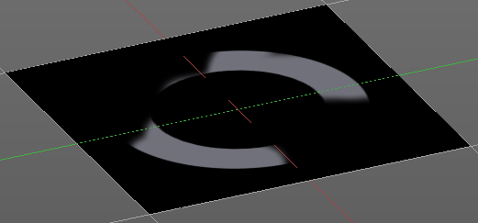
The brush mapping method 3D paints the texture at the surface, by tiling it 1/1 at the object surface.

Offset
The offset of the texture in the brush.

Size
The size of the texture in the brush.

Brush Mapping with mapping method Random
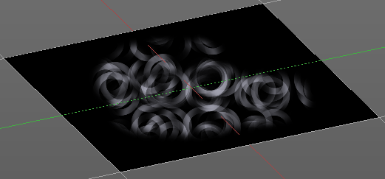
The brush mapping method Random paints onto the surface, and randomizes the texture position in the brush while that. The mapping happens from the current view. The result may be distorted when the view does not align with the surface of the object.

Angle
The angle of the brush.

Rake
The angle follows the direction of the brush stroke.

Random
The brush angle gets set random.

Offset
The offset of the texture in the brush.

Size
The size of the texture in the brush.

Brush Mapping with mapping method Stencil
The former methods uses the textures for the brush. The method Stencil works different. You have your texture displayed in the workspace above the object, and you paint this texture onto your object with your pencil strokes.
Note that the texture in the 3d space is just visible when you are with the mouse over the viewport.
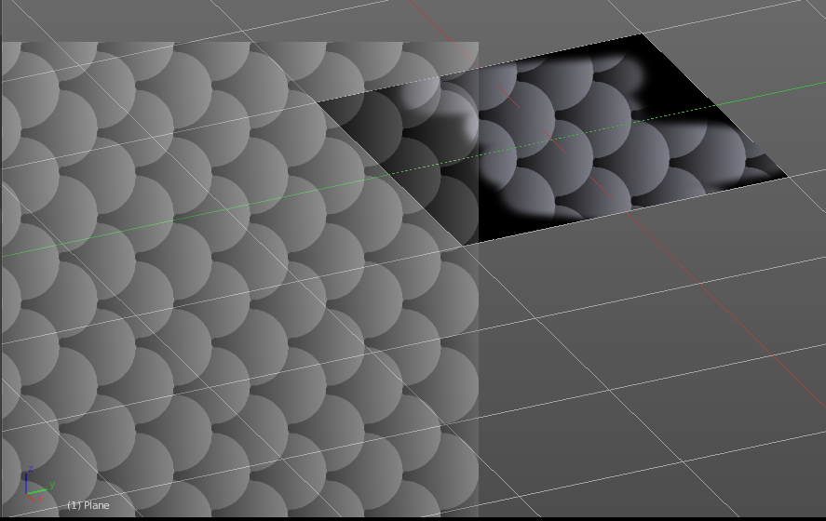

Image Aspect
Adjust the stencil size to fit to the image aspect ratio

Stencil Brush controls
Here you can move, rotate and scale the stencil image in the 3D viewport. And reset the transform. You better use the hotkeys here that gets displayed in the tool tips, since the image is not displayed when the mouse is not over the 3D viewport.

Angle edit box
Here you can adjust the angle of the brush. The button at the end allows you to set the radius by dragging the mouse. This should be done in the viewport and with the hotkey. This button is just a visible reminder.

Offset
Fine tune the offset of the texture in the brush.

Size
Fine tune the size of the texture in the brush.

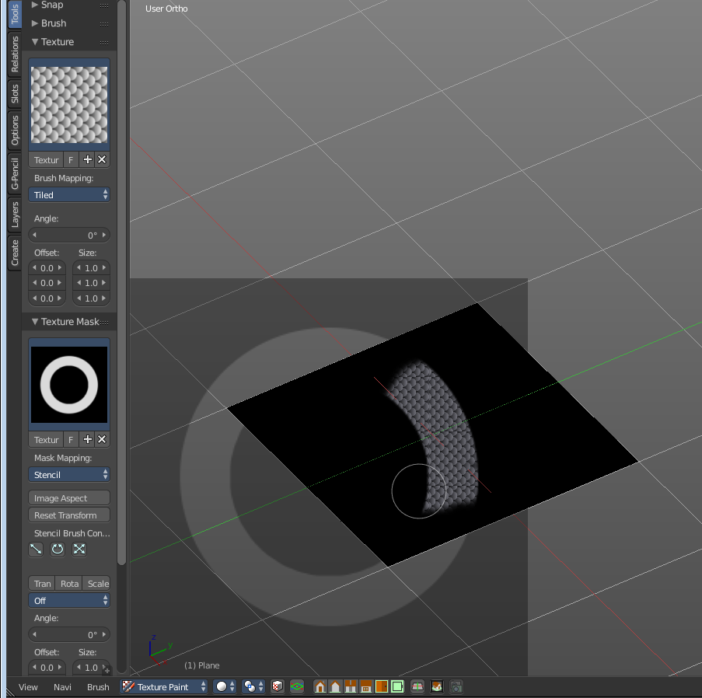
Texture Mask Panel
The texture mask panel allows you to use a texture as a mask to define the strength of painting. In the shot example we use a tiled Texture as a pencil, and a stencil map as our texture mask. And it paints just where the mask texture is bright. You can of course use gradients here to define the paint strength.

Browse Texture to be linked
The image at the top of the panel is a image browser. Here you can choose a texture that you can choose for painting then. You can also have more than one image loaded at once.

In this shot there is already a texture added. The way to add the texture here is a bit more complicated. And not done with clicking at the New button.

First click at the New button below the image. This will create a new texture slot. This slot is still empty, it displays black.

We need to load a texture in this slot. This must be done in the Properties editor in the Textures tab.

The problem is, we have an object with a material and a texture already selected. And when we change this texture , then we don't get the pencil texture loaded. But we change the texture at our mesh.

What we need to do is to create a material first. And in this material we load our pencil texture then. And then we can choose this texture in the image browser of the texture.

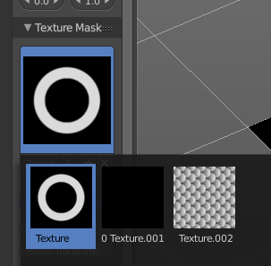

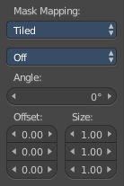
Brush Mapping with mapping method Tiled
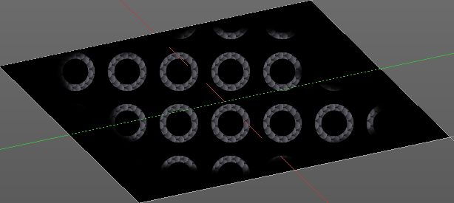
The brush mapping method Tiled tiles the brush stroke at the surface. The mapping happens from the current view. The result may be distorted when the view does not align with the surface of the object.

Mask Pressure Mode
A dropdown box where you can choose the mask pressure mode for tablets.

Angle
The angle of the brush.

Offset
The offset of the texture in the brush.

Size
The size of the texture in the brush.

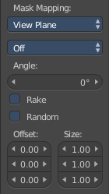
Brush Mapping with mapping method View Plane
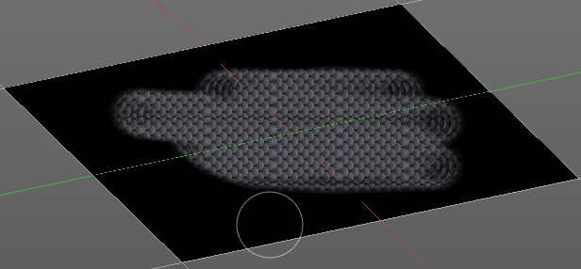
The brush mapping method View Plane simply paints onto the surface. The mapping happens from the current view. The result may be distorted when the view does not align with the surface of the object.

Mask Pressure Mode
A dropdown box where you can choose the mask pressure mode for tablets.

Angle
The angle of the brush.

Rake
The angle follows the direction of the brush stroke.

Random
The brush angle gets set random.

Offset
The offset of the texture in the brush.

Size
The size of the texture in the brush.

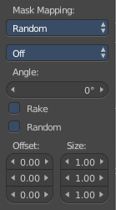
Brush Mapping with mapping method Random
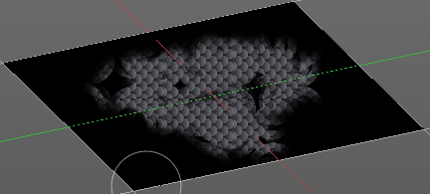
The brush mapping method Random paints onto the surface, and randomizes the texture position in the brush while that. The mapping happens from the current view. The result may be distorted when the view does not align with the surface of the object.

Mask Pressure Mode
A dropdown box where you can choose the mask pressure mode for tablets.

Angle
The angle of the brush.

Rake
The angle follows the direction of the brush stroke.

Random
The brush angle gets set random.

Offset
The offset of the texture in the brush.

Size
The size of the texture in the brush.

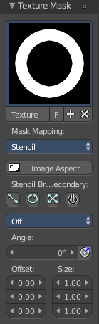
Brush Mapping with mapping method Stencil
The former methods uses the textures for the brush. The method Stencil works different. You have your texture displayed in the workspace above the object, and you paint this texture onto your object with your pencil strokes.
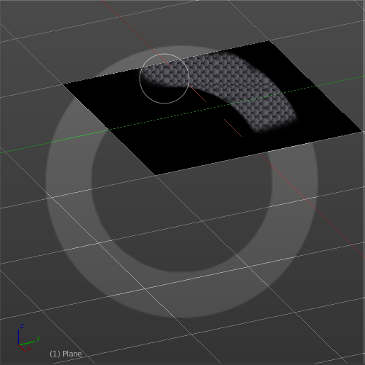
Note that the texture in the 3d space is just visible when you are with the mouse over the viewport.

Mask Pressure Mode
A dropdown box where you can choose the mask pressure mode for tablets.

Stencil Brush controls Secondary
Here you can move, rotate and scale the stencil image from the TEXTURE MASK panel, And reset the transform. You better use the hotkeys here that gets displayed in the tool tips, since the image is not displayed when the mouse is not over the 3D viewport.

Angle edit box
Here you can adjust the angle of the brush. The button at the end allows you to set the radius by dragging the mouse. This should be done in the viewport and with the hotkey. This button is just a visible reminder.

Offset
Fine tune the offset of the texture in the brush.

Size
Fine tune the size of the texture in the brush.

Stroke Panel
The Stroke panel contains settings to influence the behaviour of the brush stroke. There are various stroke methods available. We will go through them one by one.

Stroke Panel with Stroke method Space
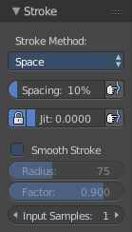
This is the default Stroke method. The sculpt stroke gets added continuously with given settings.
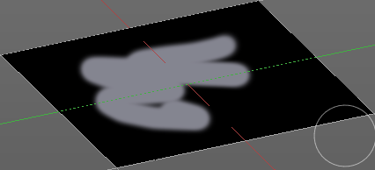

Spacing Edit Box
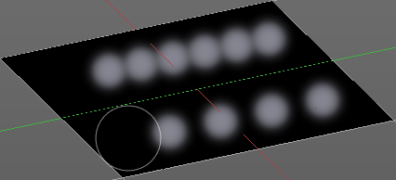
The sculpt drawing happens by mapping the pencil onto the mouse position. And when you move the mouse then the next mapping happens. Here you can adjust the spacing after what mouse movement the next mapping should happen. The lower the value, the lower the distance between the single dots.
The icon behind the edit box enables tablet pressure sensitivity for tablets.

Jitter Edit Box
Here you can add Jitter to the brush while painting.
The icon in front of the edit box toggles between jittering in screen space and relative to brush size.
The icon behind the edit box enables tablet pressure sensitivity for tablets.

Smooth Stroke
The brush lags behind the mouse position, and produces a much smoother stroke by that.

Smooth Stroke Radius Edit Box
Is just active when Smooth Stroke is activated. Here you can adjust the radius of the smoothing.

Smooth Stroke Factor Edit Box
Is just active when Smooth Stroke is activated. Here you can adjust the factor of the smoothing.

Input Samples Edit Box
Average multiple input samples together to smooth the brush stroke.

Stroke Panel with Stroke method Curve
The Stroke method curve doesn't simply influence the way how the stroke is painted. It is a special method. First you draw a curve object by holding down ctrl and clicking with left mouse button. Then you tweak the curve. You can click at the curve point, and drag out handlers to make the curve points smoooth.
Then you hit the Draw Curve button. And the curve gets drawn onto the surface.

Spacing Edit Box
The drawing happens by mapping the pencil onto the mouse position. And when you move the mouse then the next mapping happens. Here you can adjust the spacing after what mouse movement the next mapping should happen. The lower the value, the lower the distance between the single dots.
The icon behind the edit box enables tablet pressure sensitivity for tablets.

Paint Curve edit box
Here you set the active curve.
The first element is a dropdown box where you will find your curves objects. You can have more than one.
The second element is the edit box that displays the active curve.
The number right of it, in this case 2, indicates how much number of users ( internally ) this brush uses. This means that this data block (the brush) shares currently settings with at least one other object. Most probably the parent brush where we have created it from. Click at the value to make this brush a single user. The button will vanish then.
F set the brush to have a fake user. Zero user data-blocks are normally not saved. But sometimes you want to force the data to be kept even when the data block has no user.
The + button allows you to add a new pencil with the current settings. Note that the brushes are NOT saved when you close Bforartists. You can save them into the current blend file. Or you can save the startup file. But be careful here. This saves everything else of the current state of Bforartists too.
The X button deletes the brush as the active one. It does NOT delete it from the brushes list.

Draw Curve Button
A click at it to turns the curve into a sculpt stroke.

Jitter Edit Box
Here you can add Jitter to the brush while painting.
The icon in front of the edit box toggles between jittering in screen space and relative to brush size.
The icon behind the edit box enables tablet pressure sensitivity for tablets.

Input Samples Edit Box
Average multiple input samples together to smooth the brush stroke.

Stroke Panel with Stroke method Line
With Stroke method line you draw a line between a starting point and a endpoint. And when you release the mouse then the line gets sculpted.

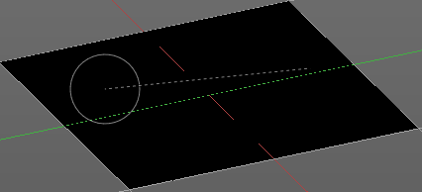
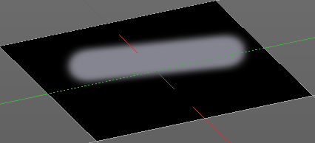

Spacing Edit Box
The drawing happens by mapping the pencil onto the mouse position. And when you move the mouse then the next mapping happens. Here you can adjust the spacing after what mouse movement the next mapping should happen. The lower the value, the lower the distance between the single dots.
The icon behind the edit box enables tablet pressure sensitivity for tablets.

Jitter Edit Box
Here you can add Jitter to the brush while painting.
The icon in front of the edit box toggles between jittering in screen space and relative to brush size.
The icon behind the edit box enables tablet pressure sensitivity for tablets.

Input Samples Edit Box
Average multiple input samples together to smooth the brush stroke.

Stroke Panel with Stroke method Airbrush
The stroke acts like an airbrush pencil. The dots gets placed randomly.
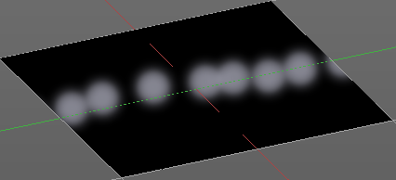

Rate Edit Box
Here you can define the rate of the drawing.

Jitter Edit Box
Here you can add Jitter to the brush while painting.
The icon in front of the edit box toggles between jittering in screen space and relative to brush size.
The icon behind the edit box enables tablet pressure sensitivity for tablets.

Smooth Stroke
The brush lags behind the mouse position, and produces a much smoother stroke by that.

Smooth Stroke Radius Edit Box
Is just active when Smooth Stroke is activated. Here you can adjust the radius of the smoothing.

Smooth Stroke Factor Edit Box
Is just active when Smooth Stroke is activated. Here you can adjust the factor of the smoothing.

Input Samples Edit Box
Average multiple input samples together to smooth the brush stroke.

Stroke Panel with Stroke method Dots
The stroke method Dots draws dots of the pencil onto the surface. The mapping happens from the current view. Means you will get distortions when your view is not aligned with the surface of the object.

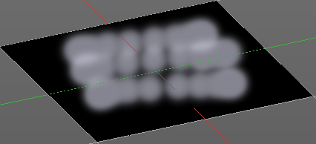
Jitter Edit Box
Here you can add Jitter to the brush while painting.
The icon in front of the edit box toggles between jittering in screen space and relative to brush size.
The icon behind the edit box enables tablet pressure sensitivity for tablets.

Smooth Stroke
The brush lags behind the mouse position, and produces a much smoother stroke by that.

Smooth Stroke Radius Edit Box
Is just active when Smooth Stroke is activated. Here you can adjust the radius of the smoothing.

Smooth Stroke Factor Edit Box
Is just active when Smooth Stroke is activated. Here you can adjust the factor of the smoothing.

Input Samples Edit Box
Average multiple input samples together to smooth the brush stroke.

Curve Panel
The curve panel allows you to define different fallofs methods for the border of the brush.

Navigation elements
The navigation elements at the top are described from left to right

Zoom in and out
The two buttons with the magnifying glass at it zooms in and out in the curve window.

Tools
Tools is a menu where you can find some cuve related tools.

Reset View
Resets the curve windows zoom

Vector Handle
Set handle type to Vector

Auto Handle
Set handle type to Auto

Auto Clamped Handle
Set handle type to Auto Clamped

Reset Curve
Resets the curve to the initial shape.

Curve Presets
Here you can find some predefined curve presets.

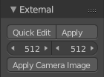
External Panel
The external panel allows you to do projection painting by using an external 2d image editor. The projection happens from the current view. So this can lead to distortions.

Quick Edit
Opens a shot of the current view in your 2D Image Editor.

Apply
Applies the changes that you made and saved in your 2D Image Editor.

Resolution
Here you can set the resolution of the shot.

Apply Camera Image
Project an edited render from the active camera back onto the object.
This feature requires to have a background image loaded. Then this background image can be projected onto the object from the camera view.
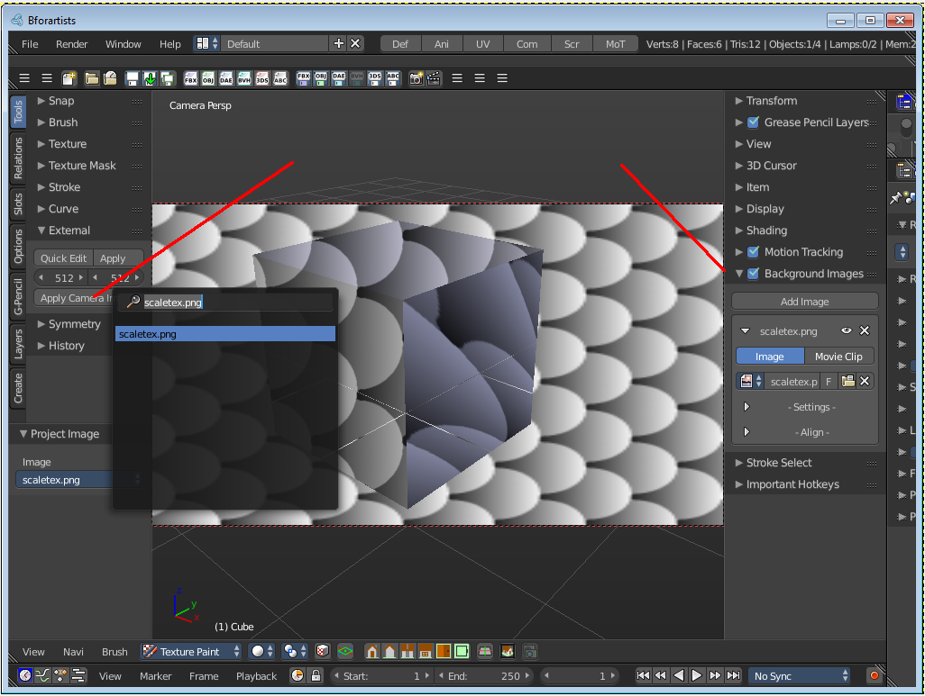

Preparations
You first have to link your software that you want to use here. When there is no image editor linked then you will get a warning.
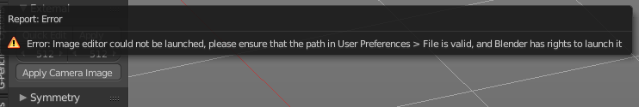
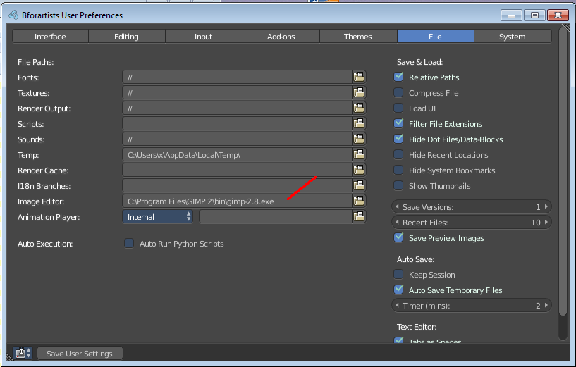
Open the User Preferences, go to the File tab. Here choose the Image Editor section, and browse for your image editor. I have chosen Gimp here at Windows 7.

Save User Settings.

For further options have a look in the Project Paint panel in the Options tab in Weight paint mode. There can be quite a few things adjusted.

Usage

Click at the Quick Edit Button. And your image editor will open up with a shot from the current view. Modify your image.

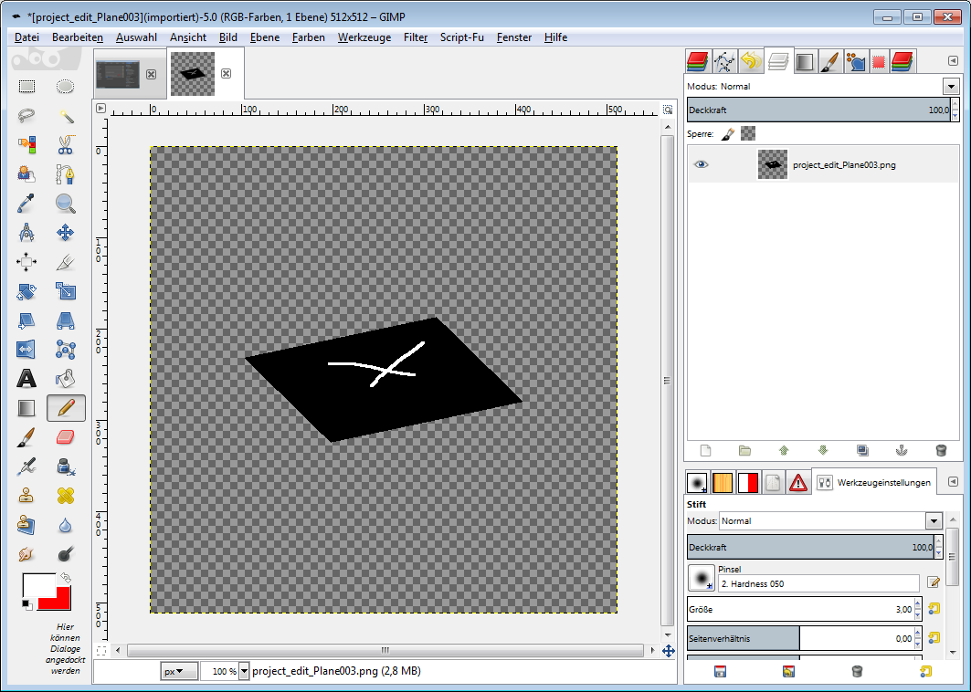

Then overwrite the image. Sorry for the german shot ...

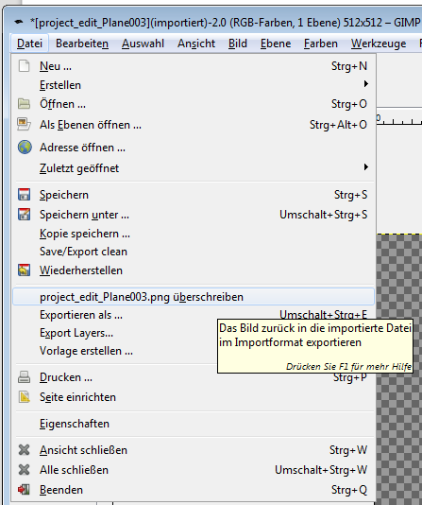
Back in Bforartists click at the Apply button. And the result gets mapped onto your object.

Symmetry Panel
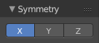
Here you can turn on/off symmetry painting along X, Y and Z axis. The mirroring happens along the world axis.
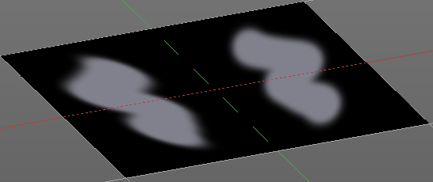

Tool Shelf in Texture Paint Mode - Slots Tab

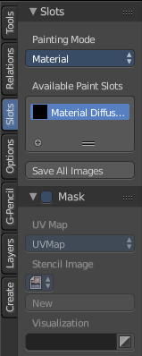
The slots tab contains some settings around the paint slots.

Slots Panel
Here you can choose to paint by using the textures in a material. Those textures gets auto detected. Material is the standard settings.
Or directly onto an image that you choose or create. This image is not part of the material then. But uses the UV mapping from the mesh.
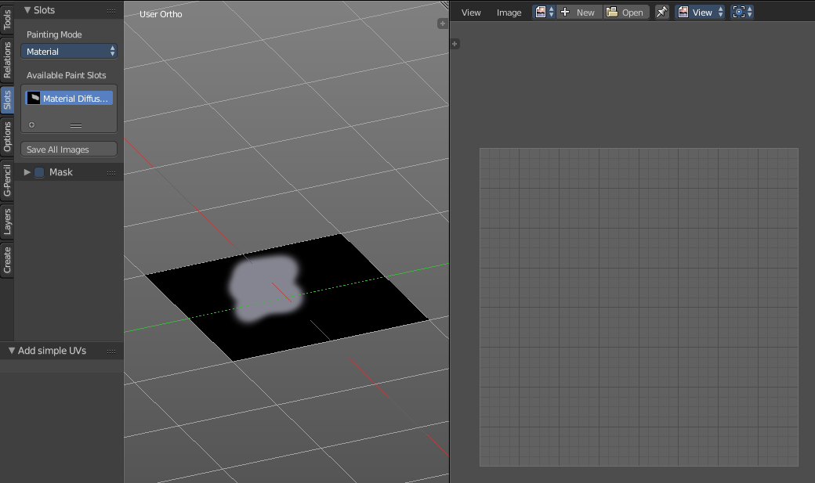
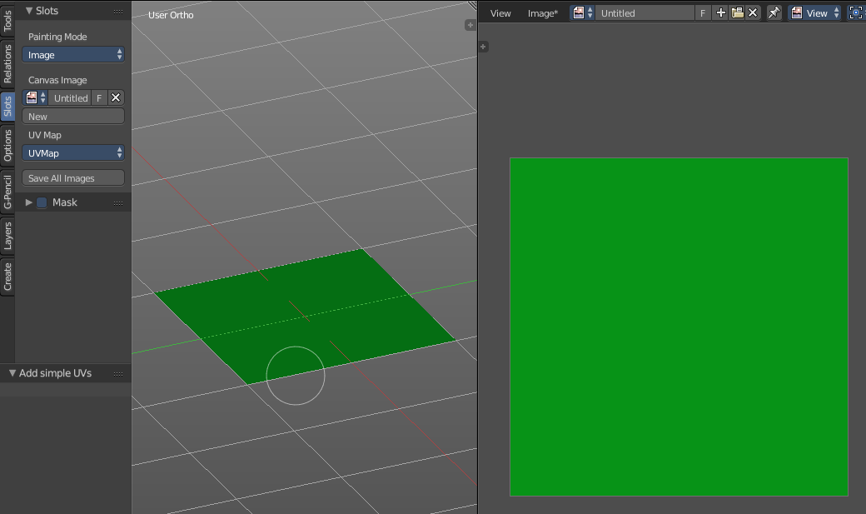

With painting mode Material

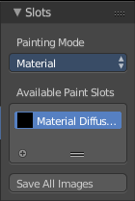
Painting Mode
The dropdown box where you can choose between Material and Image.

Available Paint Slots
The list of available materials. A mesh can have more than one material applied.

Save all Images
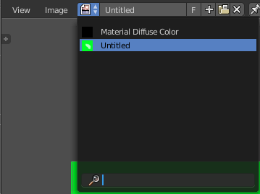
Saves all images at once. This feature requires valid texture paths, means that the images are already saved somewhere at your pc. It throws a "Invalid Path" warning when one or more images does not have a valid texture path. This is for example the case when you create a texture in Blender. And you haven't saved it yet.
So when you get this warning, switch to the UV Image Editor and check which image in the list isn't saved yet. The ones that aren't saved yet shows an asterisk in the Header when you choose them.
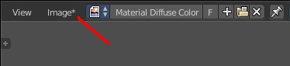

With painting mode Image

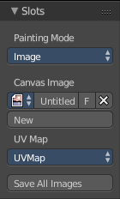
Painting Mode
The dropdown box where you can choose between Material and Image.

Canvas Image
Here you can choose or create a Image that gets used for the texture painting. You can choose any image that is loaded.

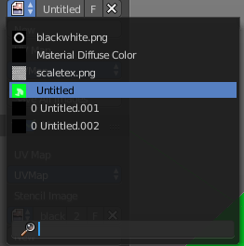

UV Map
A dropdown box with the UV map to use for image painting. A mesh can have more than one material and more than one UV Map applied.

Save all Images
Saves all images at once. This feature requires valid texture paths, means that the images are already saved somewhere at your pc. It throws a "Invalid Path" warning when one or more images does not have a valid texture path. This is for example the case when you create a image in Blender's UV Image Editor. And you haven't saved it to file yet.
So when you get this warning, switch to the UV Image Editor and check which image in the list isn't saved yet. The ones that aren't saved yet shows an asterisk in the Header when you choose them. Unfortunately not in the list itself. So you have to go through one by one.

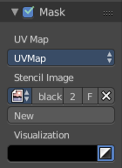
Mask Panel
Here you can load a stencil map to mask out parts of the texture. You have to activate it in the panel header.

UV Map
A dropdown box with the UV map to use for image painting. A mesh can have more than one material and more than one UV Map applied.

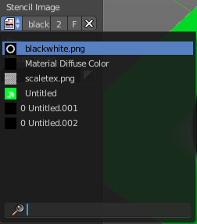
Stencil Image
Here you can choose or create a Image that gets used for the masking. You can choose any image that is loaded.

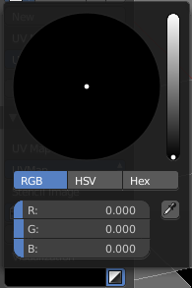
Visualization
You usually want a black n white image for masking. But here you can set up the color for the stencil map. A click at the button opens a color dialog. The button at the right flips the colors.

Tool Shelf in Texture Paint Mode - Options Tab

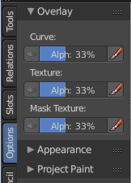
Here you can find some more options and settings for texture painting tools.

Overlay Panel

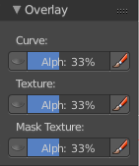
Curve
This setting is interesting for the Stroke method Curve. Here you can adjust how transparent the curve is.
The eye icon button in front of the slider is to show the curve object in viewport. The brush icon button behind the slider is to hide the overlay during a stroke.

Texture
This setting is interesting for Texture painting. Here you can adjust how transparent the texture is.
The eye icon button in front of the slider is to show the texture in the viewport. The brush icon button behind the slider is to hide the overlay during a stroke.

Mask Texture
This setting is interesting for Texture painting. Here you can adjust how transparent the Mask texture is.
The eye icon button in front of the slider is to show the texture in the viewport. The brush icon button behind the slider is to hide the overlay during a stroke.

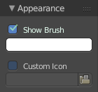
Appearance panel
The Appearance panel provides you with some settings to adjust the appearance of the brush.

Show Brush
Show the brush in 3D view.

Color Button
The color that the brush cursor has when adding to geometry.

Custom Icon
Here you can define a custom icon for the brush.

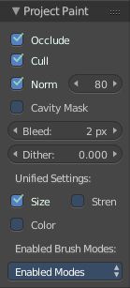
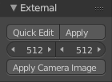
Project Paint panel
The Project Paint panel contains the settings for the External painting panel from the Tools tab.

Occlude
Only paint the faces directly under the mouse

Cull
Ingore faces that points away from the current view.

Normal
This defines the angle after which the painting is not applied anymore. That way you can avoid heavy distortions at higher angles since it projects from the current view.

Cavity Mask
Mask painting according to mesh geometry cavity

Bleed
An edit box to adjust the amount of bleeding into the areas outside of the faces uv.

Dither
An Edit box to adjust the amount of dither when painting on byte images

Unified Settings

Size
Instead of per Brush radius, the radius is shared across brushes.

Strength
Instead of per Brush strength, the strength is shared across brushes.

Color
Instead of per Brush color, the color is shared across brushes.

Enabled Brush Modes

Enabled Modes
Enabled modes is a dropdown menu where you can adjust in which modes the brushes shows.

Tool shelf in Particle edit mode - Tools Tab

The particle edit mode requires to have a particle system at the object.

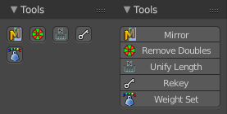

Tools Panel
This panel contains tools to modify the particles.

Mirror

Mirrors the selected particles.
If you want a symmetrical haircut, first select all particles, then mirror the particles, then tick X Mirror in the Particle panel.

Remove Doubles
Remove double vertices that are very close to each other. This can for example happen when you mirror the particles.

Unify Length
Unifies the length of the selected hair particles. The length is calculated by the average length of the selection.

Rekey
You need to have some hair particles selected.
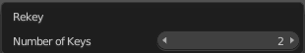
Rekey changes the number of keys for the selected particles, including root and tip keys. This tool brings up a popup where you can adjust the number of keys. Two means you have only a root and a tip key. Everything more subdivides the selected hair particle with more keys.

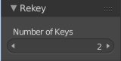
Last Operator Rekey

Number of keys
Here you can again adjust the number of keys.

Weight Set
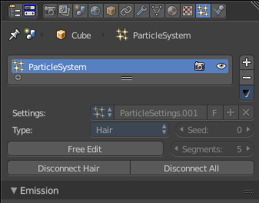
Here you can manually set a weight for the selected keys to interpolate between the current key weight and the brushes weight.
Using this tool activates and reveals Free Edit in the particle system settings.

Last Operator Weight Set

Factor
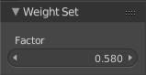
The strength of the keys weighting.

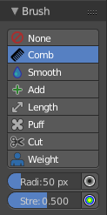

Brush Panel
The Brush panel contains brushes to modify the particles in various ways. Dependant of what brush is selected you will also see some settings below the brush buttons.

The brushes are meant for the particle system type Hair.

None
No Brush is selected

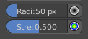
Comb
Allows you to comb the strands of the particle system.

Radius
The brush radius. The button behind the edit box allows you to set the radius by mouse move. This is a hotkey tool, and should be performed in the viewport.

Strength
The brush strength. The button behind the edit box allows you to set the radius by mouse move. This is a hotkey tool, and should be performed in the viewport.

Smooth
Allows you to smooth the strands of the particle system.

Radius
The brush radius. The button behind the edit box allows you to set the radius by mouse move. This is a hotkey tool, and should be performed in the viewport.

Strength
The brush strength. The button behind the edit box allows you to set the radius by mouse move. This is a hotkey tool, and should be performed in the viewport.

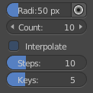
Add
Allows you to add strands to the particle system.

Radius
The brush radius. The button behind the edit box allows you to set the radius by mouse move. This is a hotkey tool, and should be performed in the viewport.

Count
The amount of strands.

Interpolate
Interpolate new particles from the existing ones.

Steps
Brush steps. Steps is connected with Interpolate.

Keys
How many keys to make new particles with

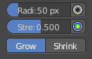
Length
Manipulate the length of the strands

Radius
The brush radius. The button behind the edit box allows you to set the radius by mouse move. This is a hotkey tool, and should be performed in the viewport.

Strength
The brush strength. The button behind the edit box allows you to set the radius by mouse move. This is a hotkey tool, and should be performed in the viewport.

Grow/ Shrink
Grow or shrink the particles.

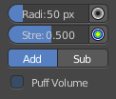
Puff
Manipulate the volume of the strands.

Radius
The brush radius. The button behind the edit box allows you to set the radius by mouse move. This is a hotkey tool, and should be performed in the viewport.

Strength
The brush strength. The button behind the edit box allows you to set the radius by mouse move. This is a hotkey tool, and should be performed in the viewport.

Add / Sub
Add or subtract to the current volume.

Puff Volume
Apply Puff to unselected end points.

Cut
Cut away particles.

Radius
The brush radius. The button behind the edit box allows you to set the radius by mouse move. This is a hotkey tool, and should be performed in the viewport.

Strength
The brush strength. The button behind the edit box allows you to set the radius by mouse move. This is a hotkey tool, and should be performed in the viewport.

Weight
Manipulate the weight of the strands

Radius
The brush radius. The button behind the edit box allows you to set the radius by mouse move. This is a hotkey tool, and should be performed in the viewport.

Strength
The brush strength. The button behind the edit box allows you to set the radius by mouse move. This is a hotkey tool, and should be performed in the viewport.

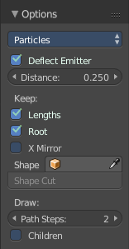
Options Panel
The Options panel provides you some options and settings for particle editing.

Particle Edit Type
Particle Edit Type Dropdown box.

Honestly, i don't have the slightest idea what this is good for. Thanks Blender Devs for your "fabulous" documentation.

Most obviously you can switch to other editing modes here. But it is not to find out under what circumstances.

Deflect Emitter
Keep Paths from intersecting the emitter

Distance
Is connected with the Deflect Emitter. The distance to the emitter.

Keep Lengths
Keep Path Lengths constant.

Keep Root
Keep Root keys unmodified.

X Mirror
X Axis Mirror Editing

Shape
Define a outer shape object to use for tools.

Shape Cut
Is connected with Shape, Cut hair to conform to the defined shape object.

Draw Path Steps
How many steps a path should draw.

Children
Draw actual particles.

Tool Shelf in all Modes but Edit Mode

There are a few panels that are visible in all modes and with all object types. Snapping for example. Or layers. To list them again and again in all modes with all available combinations would just blow up the manual. So we list them in the following chapters instead.

Tool Shelf in all Modes but Edit Mode - Layers Tab
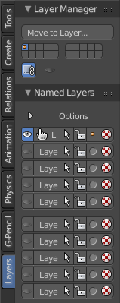
Layers are a way to organize the scene. With Object layers you can display objects from a layer, and hide others. Physics and particles is also layer dependant. Means you can exclude objects from physics by simply putting them onto another layer. You can also in- or exclude complete layers from rendering. For compositing you can use render layers. And for armatures you can use Armature layers.

Bforartists offers currently 20 layers. Which can be named in the Layers tab.

The layers tab is available in all modes but the Edit mode. And shows for all object types the same content.

Layer Manager Panel
The layer manager panel gives you the tools to manage the layers in a quick way.

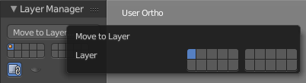
Move to Layer
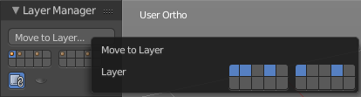
The move to Layer button opens a pop-up where you can move the currently selected object to a new layer.
An object does not necessarily have to be at one layer only. You can place it at multiple layers. Shift click adds the selected object(s) to more than one layer. You can also use the Move to Layer tool ...

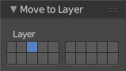
Last Operator Move to Layer
The last operator Move to Layer gives you again the possibility to move your selected object(s) to a new layer.

Visible Layers
Visible layers is a quick access element to manage the layers and to have an overview if the layer has any content. A orange or grey dot in the button means there is content in this layer.
Visible is what is activated. Active layers gets indicated as blue. To select more than one layer hold down shift, and select the other elements that you want to select.

Lock Camera and Layers
With Lock camera and layers activated the active camera and layers in this view gets used instead local layers. Means the camera renders all layers then.

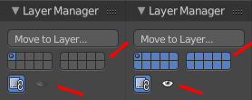
Show Hide all Layers
Show Hide all Layers shows or hides all layers at once.

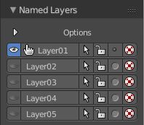
Named Layers Panel
The named layers panel gives you an extended overview of the layers, with the possibility to give the layers a name.

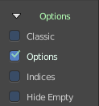
Options
The options are hidden at first. Click at the Options title to reveal them.

Classic
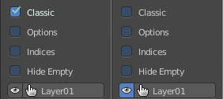
The classic option shows the eye icon for the layer visibility grey instead blue.

Options
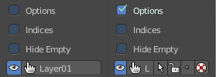
The Options option shows the option buttons at the layers. Select, Lock, Move to Layer, Show as Wire.

Indices
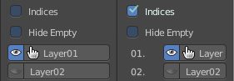
The Indices option shows numbers before the layers.

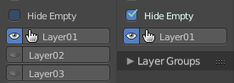
Hide Empty
The Hide Empty option hides all not active layers.

Layer Bar
The layer bar in the Named Layers tab is made of some sub elements.

Eye icon at the left
You can show or hide the layer with this button.

Edit box
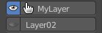
The edit box is where you can name a layer. Click with the left mouse into the edit box to make it editable. Type in your text. Then press enter to confirm the change.
The green check icon tells you that this is the currently active layer.

The option buttons
When you have Options ticked then you will see the options buttons at the right of the edit box. They are from left to right: Select, Lock, Move to Layer, Render as Wire

Select
Clicking at the Select icon button will select all objects in this layer.

Lock
Clicking at the Lock icon button will lock all objects in this layer. They become unelectable.

Move to Layer
With this button you can move objects to other layers. Select the object, click at the Move to Layer button. Shift click to attach the object to several layers.

Render as Wire
Render as wire will toggle the display for all objects between chosen state and wireframe.

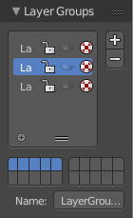
Layer Groups Panel
The Layer groups panel enables you to create groups of layers. It is pretty self explaining. Create a group with the + button. Name it. And activate which layers are affected by this group by clicking at the corresponding fields in the layers widget.
To remove a layer group select the group and click at the - Button

Tool Shelf in all Modes - Grease Pencil Tab

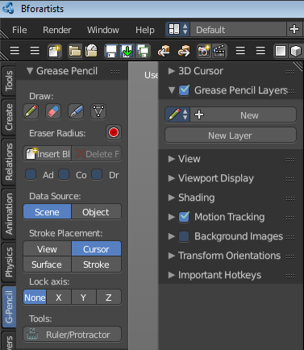
The Grease Pencil tool is a tool with which you can paint strokes in editors like the 3D view. They can be converted into polygons. The Grease Pencil tool is available in all modes.

It is unfortunately cluttered across two shelves. The Tool Shelf and the Properties Editor. Means you have to adjust settings at two places.

The first thing that you have to do is to create a new Grease pencil. This can either be done in the Properties Editor by clicking at New. Or in the Grease Pencil Tab in the Tool Shelf by simply clicking at the Draw button. Then all Grease Pencil tools becomes visible. And a Grease Pencil layer gets created.

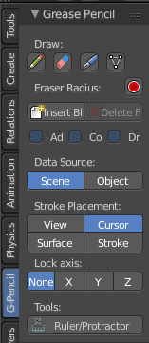
Grease Pencil Panel

The Grease Pencil panel contains the general Grease Pencil tools. The Draw tool, eraser, some settings and tools.

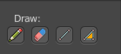
Draw
The Draw section contains the draw tools.

Draw
Draw activates the freehand draw mode.

Erase
Erase is the eraser tool with which you can delete strokes.

Line
Line paints a straight line between start and end point.

Poly
Poly allows you to paint polygon shapes.

Eraser Radius
Here you can adjust the radius of the eraser tool. Have a look at the hotkey, it's a hotkey only tool for proper functionality.

Insert Blank Frame
Insert a blank frame on the current frame.

Delete all active frames
Delete the active frame(s) of all editable grease pencil layers.

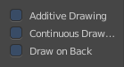
Draw Settings
The draw settings are placed besides each other, to save space.

Additive Drawing
When you create new frames then the strokes from the previous active frame are included as the base for the current frame.

Continuous Draw
The Continuous Draw checkbox enables and disables the continuous draw mode. Normally the draw mode ends when you stop drawing the current line. And you have to activate the draw tool again when you want to continue with painting. With continuous draw you can immediately paint the second stroke without to enable the draw tool again.

Eraser in Continuous Draw
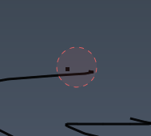
The draw tools are disabled as long as you are in continuous draw. To erase a stroke use the right mouse button. The pencil turns into a red circle. With which you can erase strokes now.

End Continuous Draw
The draw tools are disabled as long as you are in continuous draw. To end the continuous draw mode click outside of the viewport. In the tool shelf for example.

Draw on Back
New strokes will be drawn behind all other strokes in the layer

Data Source
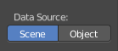
Data source defines if the paint stroke is placed in the data block of the scene or the data block of the currently selected object.

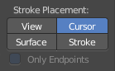
Stroke Placement
Stroke Placement defines where the Grease Pencil stroke is placed.

View
View will place the stroke at the top of the viewport. It is not drawn in the 3D view.

Cursor
Cursor will place the stroke aligned with the 3d cursor, and aligned with the current camera view. It is drawn in the 3D view.

Surface
Surface will place the stroke aligned to the surface of the underlying object. It is drawn in the 3D View.

Stroke
New strokes will align to existing visible strokes. Does not work with View strokes. It is drawn in the 3D View.

Only Endpoints
The only Endpoints checkbox is connected to the Stroke setting. And just shows when Stroke is selected. With Only Endpoints enabled the alignment of the stroke is just applied to the endpoints.

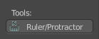
Tools
The Tools section contains one tool. Ruler/Protractor. It activates a ruler protractor tool with which you can measure distances.
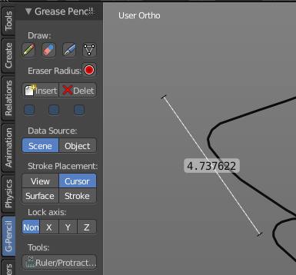

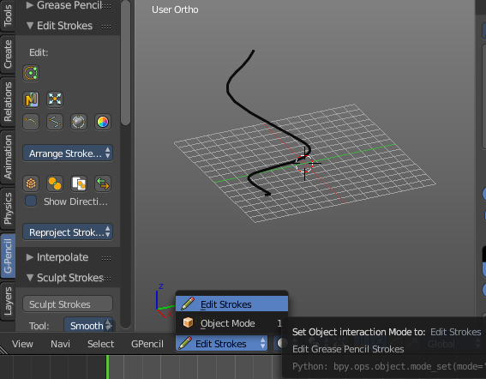
Edit Strokes
Sometimes you want to edit the strokes that you have placed. Edit Strokes is a mode of the 3D view. And can be entered in the header of the 3d view in the modes drop-down box.
When you are in Edit Strokes mode, then you will see the Edit Strokes Panel. Where you will find the tools to edit the Grease Pencil strokes.

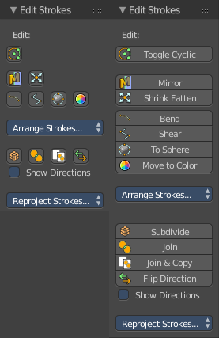
Edit Strokes Panel
The Edit Strokes Panel contains the tools to edit the Grease Pencil strokes. Most of the tools are pretty self explaining.

Note!
The Edit Strokes Panel is just visible in Edit Strokes Mode!

Toggle Cyclic
Toggle Cyclic closes a stroke to become a loop.

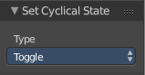
Last operator Set Cyclical State
The Last operator for Toggle cyclic contains a drop-down box where you can adjust the cyclic state.

Mirror
Mirror mirrors the selection.

Last Operator Mirror
The Last Operator Mirror panel gives you tools to adjust the mirror action.

Constraint Axis
Constraint Axis gives you again the possibility to define the mirror axis. You can choose more than one axis here.

Orientation
Orientation is a drop-down box where you can choose the type of orientation for the mirroring action.

Proportional Editing
Proportional Editing is a drop-down box where you can choose to use proportional editing. When you choose one of the active methods then the neighbour geometry gets influenced by Shrink/Fatten too in a proportional way.

Proportional Editing Falloff
Proportional Editing Falloff is a drop-down box where you can choose a method for the falloff for the proportional editing.

Proportional size
Proportional size is a edit box where you can adjust the strength of the Proportional falloff.

Edit Grease Pencil
Edit Grease Pencil edits the selected Grease Pencil strokes.

Confirm on Release
With Confirm on Release checked the action gets performed when you release the mouse button.

Shrink / Fatten
Shrink / Fatten shrink fattens the selection.

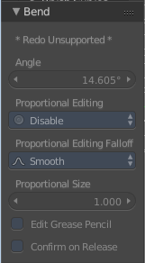
Bend
Bend bends the selection.

Last Operator Bend
The last operator Bend is disabled for Grease Pencil.

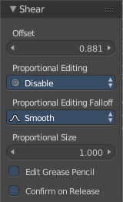
Shear
Shear shears the selection.

Last Operator Shear

Offset
Adjust the offset

Proportional Editing
Proportional Editing is a drop-down box where you can choose to use proportional editing. When you choose one of the active methods then the neighbour geometry gets influenced by Shrink/Fatten too in a proportional way.

Proportional Editing Falloff
Proportional Editing Falloff is a drop-down box where you can choose a method for the falloff for the proportional editing.

Edit Grease Pencil
Edit Grease Pencil edits the selected Grease Pencil strokes.

Confirm on Release
With Confirm on Release checked the action gets performed when you release the mouse button.

To Sphere
To Sphere transforms the selection into a spherical form.

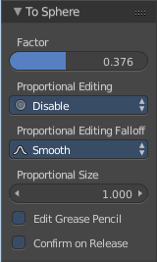
Last Operator To Sphere

Factor
Adjust the rounding factor

Proportional Editing
Proportional Editing is a drop-down box where you can choose to use proportional editing. When you choose one of the active methods then the neighbour geometry gets influenced by Shrink/Fatten too in a proportional way.

Proportional Editing Falloff
Proportional Editing Falloff is a drop-down box where you can choose a method for the falloff for the proportional editing.

Proportional Size
Adjust the proportional size

Edit Grease Pencil
Edit Grease Pencil edits the selected Grease Pencil strokes.

Confirm on Release
With Confirm on Release checked the action gets performed when you release the mouse button.

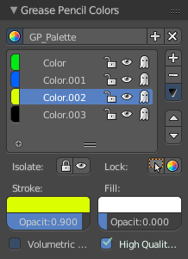
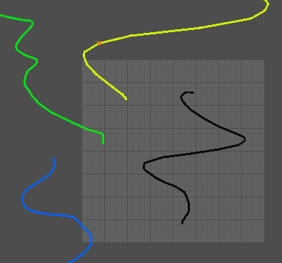
Move to Color
Recolors the currently selected grease pencil stroke with the active color in the Grease Pencil Colors color.
The grease pencil colors can be found in the properties sidebar at the right.

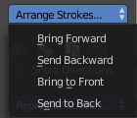
Arrange Strokes drop-down box
Arrange the layering of the current stroke.

Subdivide
Subdivide subdivides the current selection.

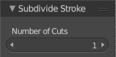
Last Operator Subdivide Stroke

Number of Cuts
Adjust the number of subdivisions

Join
Joins strokes.

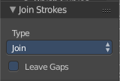
Last Operator Join Strokes

Type
Here you can choose if it should only join, or join and also copy the strokes.

Leave Gaps
Leave Gaps between joined strokes instead of linking them.

Join & Copy
Joins strokes and copies it.
For last operator see above.

Flip Direction
Change the direction of the stroke.

Show Directions
Shows the direction of the stroke by displaying a green dot at the beginning, and a red dot at the end of the stroke.

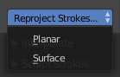
Re project Strokes Drop-down Box
Here you can re project the stroke(s) planar or across the surface of the target object as if you would have drawn it new to the current viewport.

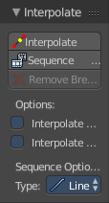
Interpolate Panel
The Interpolate Panel provides some tools for interpolation between different animation frames.
Note!
The Interpolate Panel is just visible in Edit Strokes Mode!

Interpolate
Interpolate Grease Pencil Strokes between frames.

Sequence
Generate In-Betweens for smooth interpolation between Grease Pencil Frames.

Remove Breakdowns
Remove Breakdown Frames generated by interpolation between two Grease Pencil frames.

Interpolate all Layers
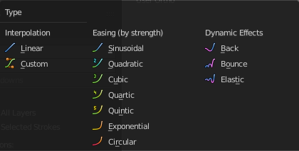
Interpolate all layers, not only active

Interpolate selected Strokes
Interpolate only selected strokes in the original frame

Sequence Options, Type
Sequence Options, Type is a drop-down box where you can choose between three different effect types. Interpolation, Easing and Dynamic Effects. You can get even more options, depending of the type you choose here.

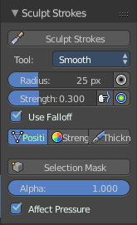
Sculpt Strokes Panel

The Sculpt Strokes Panel provides tools to sculpt the Grease pencil strokes.

Note!
The Sculpt Strokes Panel is just visible in Edit Strokes Mode!

Sculpt Strokes Button
The Sculpt Strokes Button activates the Sculpt brush. Now you can sculpt the Grease Pencil stroke with left mouse button. Clicking with right mouse button ends the sculpt mode.

Radius
The radius of the sculpt brush.

The button behind the edit box allows you to set the radius by moving the mouse. This should be done in the viewport and with the hotkey. This button is just a visible reminder.

Strength
The strength of the sculpt brush.

The button behind the edit box allows you to set the strength by moving the mouse. This should be done in the viewport and with the hotkey. This button is just a visible reminder.

Use Falloff
Defines if the brush has a falloff from the centre to the border of the pencil.

Position
The Brush affects the position of the point.

Strength
The Brush affects the strength of the point.

Thickness
The Brush affects the thickness of the point.

Selection Mask
Only sculpt the selected points.

Alpha
Alpha value for selected vertices.

Affect Pressure
Affect pressure values as well when smoothing strokes.

Drawing Brushes panel
The Drawing Brushes panel contains everything around the Brushes and their settings. It is visible in all modes. But the content just shows when you have activated the draw tool already.

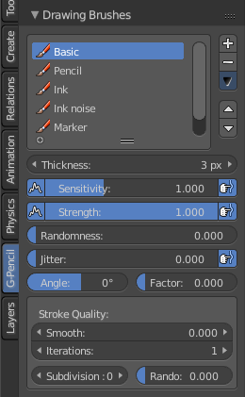
Brushes selection box
Here you can choose different brush types. At the right you can add and remove brushes. And you can sort the brushes order.

Thickness
Defines the thickness of the stroke.

Sensitivity
Pressure sensitivity for new strokes.

Strength
Color strength for new strokes. The alpha factor of the color is affected.

Randomness
Randomness factor for pressure and strength of new strokes.

Jitter
Jitter factor for new strokes.

Angle
Direction of the stroke at which the brush gives the maximum thickness.

Factor
Reduce Brush thickness by this factor when stroke is perpendicular to angle direction

Smooth
Amount of smoothing to apply to newly created strokes to reduce jitter / noise.

Iterations
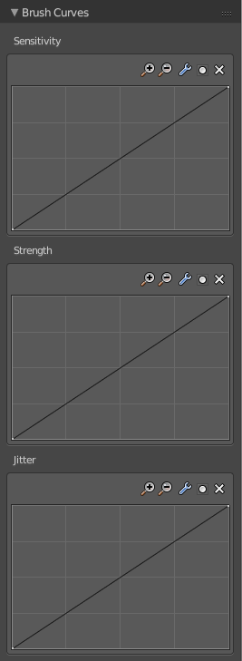
Number of times to smooth newly created strokes.

Subdivision
Number of times to subdivide newly created strokes, for less jagged strokes.

Randomness
Randomness factor for new strokes after subdivision.

Brush Curves Panel
The Brush curves panel is meant for usage with tablets. Here you can manipulate the curves for Sensitivity, Strength and Jitter.

Tool Shelf in all Modes - Tools Tab - Snap panel

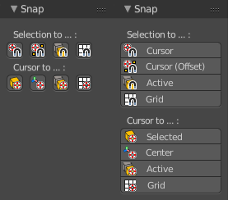
Snap Panel
The Snap panel contains the snapping tools.
The one half snaps a selected element to ...
The other half snaps the 3D cursor to ...
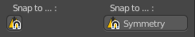
In Edit Mode with Mesh object you will also have the Snap to Symmetry tool here.

Selection to Grid
Selection to Grid snaps the selected element(s) to the closest Grid point.

Selection to Cursor
Selection to Grid snaps the selected element(s) to the 3D cursor. ALL selected elements will end at cursor position. For example all selected vertices.

Selection to Cursor ( Offset )
Selection to Grid snaps the selected element(s) to the 3D cursor. The centre of the selected elements will snap to the 3D cursor. A group of vertices for example will remain its shape.

Selection to Active
Selection to Active snaps the selected element(s) to the current active element.

Cursor to Selected
Cursor to Selected snaps the 3D cursor to the selected element.

Cursor to Centre
Cursor to Centre snaps the 3D cursor to the centre of the world.

Cursor to Grid
Cursor to Grid snaps the 3D cursor to the closest Grid point.

Cursor to Active
Cursor to Grid snaps the 3D cursor to the current active element.

Snap to Symmetry
Tries to snap the selected vertices symmetrical along the chosen world orientation.

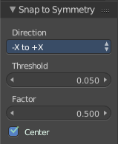
Last Operator Snap to Symmetry

Direction
The calculation direction.

Threshold
The threshold defines the radius in which matching vertices gets located. When you get a warning that snapping failed try increasing the threshold value.

Factor
The snapping factor. Blend mirrored locations from one side to the other. 0.5 is blending both sides equal.

Center
Snap vertices in the center axis to zero.

Tool Shelf in all Modes - Tools Tab - Transform panel
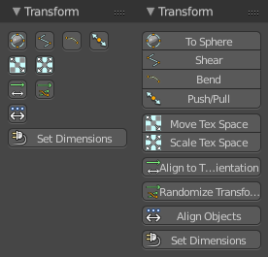
Transform is a menu that contains some special transform functionality. It exists in all modes. But is not functional in all modes.
In Edit Mode with a mesh object we have a few more options. For armatures we have some tools fewer, and one more. Align Bones.
Set dimensions is an addon meant for Mesh Objects in Edit Mode. Using it will lead you to Edit mode.
In Object mode some tools requires to have more than one object selected. To Sphere for example.

To Sphere
To Sphere tries to transform the selection to a sphere shape, using the center of the selected objects as a center point for the operation.
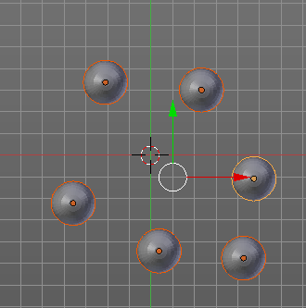
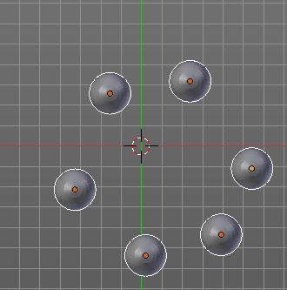

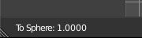
While the operation you will see in the header the strength value for the spherical shape.

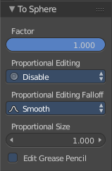
Last Operator To Sphere

Factor
A edit box where you can adjust the strength of influence of the tool.

Proportional Editing
Proportional Editing is a drop-down box where you can choose to use proportional editing. When you choose one of the active methods then the neighbour geometry gets influenced by Shrink/Fatten too in a proportional way.

Proportional Editing Falloff
Proportional Editing Falloff is a drop-down box where you can choose a method for the falloff for the proportional editing.

Proportional Size
Proportional size is a edit box where you can adjust the strength of the Proportional falloff.

Edit Grease Pencil
Edit Grease Pencil edits the selected Grease Pencil strokes.

Shear
Shear shears the object positions relative to the center of the selection.
While the operation you can press x or y to change the direction of shearing.
While the operation you will see the strength value in the header.

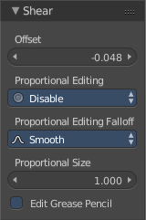
Last Operator Shear

Factor
A edit box where you can adjust the strength of influence of the tool.

Proportional Editing
Proportional Editing is a drop-down box where you can choose to use proportional editing. When you choose one of the active methods then the neighbour geometry gets influenced by Shrink/Fatten too in a proportional way.

Proportional Editing Falloff
Proportional Editing Falloff is a drop-down box where you can choose a method for the falloff for the proportional editing.

Proportional Size
Proportional size is a edit box where you can adjust the strength of the Proportional falloff.

Edit Grease Pencil
Edit Grease Pencil edits the selected Grease Pencil strokes.

Bend
Bends the selected objects between 3D cursor and mouse.
HOTKEY ONLY TOOL!
You might want to add/use a hotkey here, since the operation calculates from the mouse position starting point. And the menu item might not be at the wanted position.
While the operation you will see in the header the strength value for the bend. Holding down Alt turns off Clamp.
The Last operator for Bend is greyed out. Undo is not supported.

Push/Pull
In Object mode this tool requires to have more than one object selected. It pushes or pulls the object positions relative to the center of the selection.

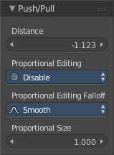
Last Operator Shear

Factor
A edit box where you can adjust the strength of influence of the tool.

Proportional Editing
Proportional Editing is a drop-down box where you can choose to use proportional editing. When you choose one of the active methods then the neighbour geometry gets influenced by Shrink/Fatten too in a proportional way.

Proportional Editing Falloff
Proportional Editing Falloff is a drop-down box where you can choose a method for the falloff for the proportional editing.

Proportional Size
Proportional size is a edit box where you can adjust the strength of the Proportional falloff.

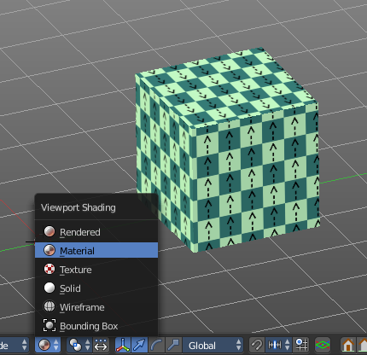
Move Texture Space
This tool relies at the move tool. With the difference that it moves the texture space instead of the object. It has also a very special use case, and just works with a material with a Texture Coordinate / Generated node. And requires to have the shading at Material or Rendered to see a result in the viewport.
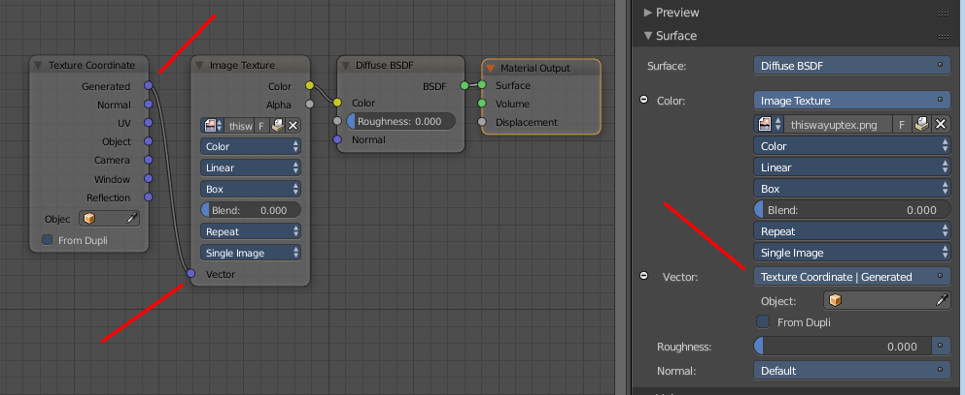


Last Operator Translate

Vector
Here you can adjust the position values for the three axis.

Constraint Axis
Here you can limit the position relative to the source object.

Orientation
Orientation is a drop-down box where you can choose the type of orientation for the mirroring action.

Proportional Editing
Proportional Editing is a drop-down box where you can choose to use proportional editing. When you choose one of the active methods then the neighbour geometry gets influenced by Shrink/Fatten too in a proportional way.

Proportional Editing Falloff
Proportional Editing Falloff is a drop-down box where you can choose a method for the falloff for the proportional editing.

Proportional Size
Proportional size is a edit box where you can adjust the strength of the Proportional falloff.

Edit Grease Pencil
Edit Grease Pencil edits the selected Grease Pencil strokes.

Edit Texture Space
With Confirm on Release checked the action gets performed when you release the mouse button.

Scale Texture Space
This tool relies at the scale tool. With the difference that it scales the texture space instead of the object. It has also a very special use case, and just works with a material with a Texture Coordinate / Generated node. And requires to have the shading at Material or Rendered to see a result in the viewport.

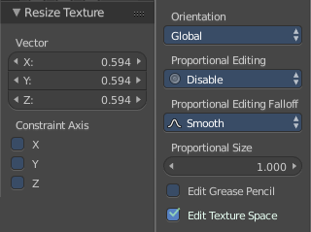
Last Operator Resize Texture

Vector
Here you can adjust the position values for the three values

Constraint Axis
Here you can limit the position relative to the source object.

Orientation
Orientation is a drop-down box where you can choose the type of orientation for the mirroring action.

Proportional Editing
Proportional Editing is a drop-down box where you can choose to use proportional editing. When you choose one of the active methods then the neighbour geometry gets influenced by Shrink/Fatten too in a proportional way.

Proportional Editing Falloff
Proportional Editing Falloff is a drop-down box where you can choose a method for the falloff for the proportional editing.

Proportional Size
Proportional size is a edit box where you can adjust the strength of the Proportional falloff.

Edit Grease Pencil
Edit Grease Pencil edits the selected Grease Pencil strokes.

Edit Texture Space
With Confirm on Release checked the action gets performed when you release the mouse button.

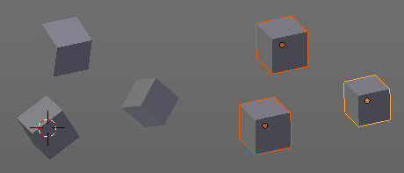
Align to Transform Orientation
Rotates the selected objects so that their local orientation matches the active transform orientation in the Transform orientation panel or the Orientation selection in the Transform Operator panels.
For example when you have a few cubes that are rotated differently, then perform align to transform orientation with Global coordinates, then the cubes rotations gets set back to 0/0/0

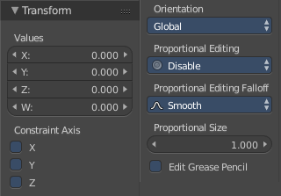
Last Operator Transform
Align Transform Orientation is a subset of the Transform tool. And so it comes with the full set.

Values
The transform values for the single axis.

Constraint Axis
Here you can limit the transform of single axis.

Orientation
Orientation is a drop-down box where you can choose the type of orientation for the mirroring action.

Proportional Editing
Proportional Editing is a drop-down box where you can choose to use proportional editing. When you choose one of the active methods then the neighbour geometry gets influenced by Shrink/Fatten too in a proportional way.

Proportional Editing Falloff
Proportional Editing Falloff is a drop-down box where you can choose a method for the falloff for the proportional editing.

Proportional Size
Proportional size is a edit box where you can adjust the strength of the Proportional falloff.

Edit Grease Pencil
Edit Grease Pencil edits the selected Grease Pencil strokes.

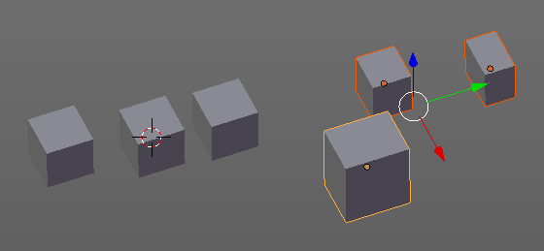
Randomize Transform
This tool allows to randomize position rotation and scale of selected objects. Each object gets threaten individually by a random value.
It starts with zeroed values. You need to adjust the values in the last operator.

Last Operator Randomize Transform

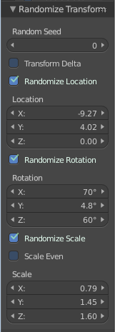
Random Seed
Here you can adjust the random seed value.

Transform Delta
Randomize Delta transform values instead of the regular transform values.

Randomize Location checkbox
With this checkbox ticked the location of the selected objects gets randomized.

Location edit boxes
Here you can adjust the strength of the transform for the single axis.

Randomize Rotation checkbox
With this checkbox ticked the rotation of the selected objects gets randomized.

Rotation edit boxes
Here you can adjust the strength of the transform for the single axis.

Randomize Scale checkbox
With this checkbox ticked the scale of the selected objects gets randomized.

Scale Even
Use the same scale values for all axis.

Scale edit boxes
Here you can adjust the strength of the transform for the single axis.

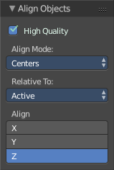
Align Objects
Align Objects allows you to align the selected objects in various ways. You need to adjust the settings in the Last operator panel. The align operation happens in world coordinates.

Last Operator Align Objects

High Quality
When ticked the calculation gets performed in a higher precision.

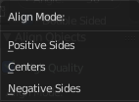
Align Mode
Align Mode is a drop-down box where you can choose between different align modes.

Relative To
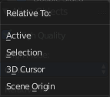
Relative to is a drop-down box. Here you adjust in what method the alignment happens. Relative to the active object, to the center of selection, to the 3D cursor or to the scene origin.

Align
Here you can turn on or off the single axis for the align operation.

Warp
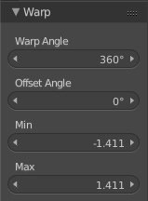
Edit Mode only! Warps the selected vertices around the 3D cursor.

Last Operator Warp

Warp Angle
The amount to wrap around the 3D cursor.

Offset Angle
Angle to use as the basis for warping

Min
The minimum amount

Max
The maximum amount

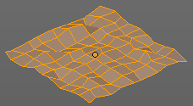
Randomize
Edit Mode Only! Randomizes the positions of the selected vertices.

Last Operator Randomize

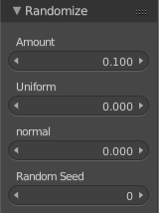
Amount
The distance to offset.

Uniform
Increase for uniform offset distance.

Normal
Align Offset direction to normals.

Random Seed
The seed for the random number generator.

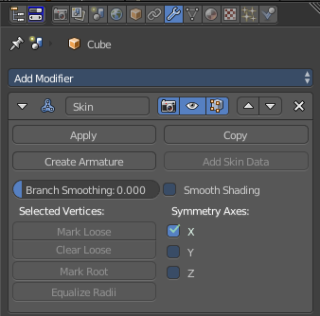
Skin Resize
This tool requires to have a skin modifier at the mesh. It scales the thickness of the skin.
While the operation you will see in the header the strength value for the skin.

Last Operator Skin Resize

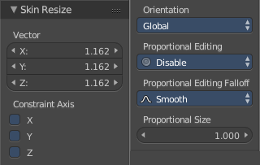
Vector
Here you can adjust the position values for the three values.

Constraint Axis
Here you can limit the position relative to the source object.

Orientation
Orientation is a drop-down box where you can choose the type of orientation for the mirroring action.

Proportional Editing
Proportional Editing is a drop-down box where you can choose to use proportional editing. When you choose one of the active methods then the neighbour geometry gets influenced by Shrink/Fatten too in a proportional way.

Proportional Editing Falloff
Proportional Editing Falloff is a drop-down box where you can choose a method for the falloff for the proportional editing.

Proportional Size
Proportional size is a edit box where you can adjust the strength of the Proportional falloff.

Align Bones
Armature only.
Align bones aligns the selected bones.

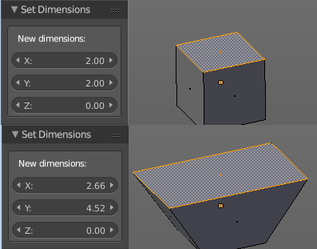
Set Dimensions
Edit Mode Only!
Normally all scale operations in Bforartists are relative to the current selection and dimensions. Set dimensions allows to scale mesh selections in absolute world values. No matter how the initial values are. The new values gets set in the Last Operator.
Set dimensions is an add-on. You can turn it off in the add-ons section of the user preferences when you want.

Last Operator Set Dimensions

New Dimensions
When you activate the tool then you will see the world coordinates of the selection. Here you can change the values to other world coordinates.

Tool Shelf in all Modes - Tools Tab - History Panel

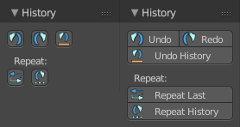
History Panel
The History Panel contains the tools around undo , redo and repeat. It is in the Tools tab.

Undo
Undo undoes the previous action.

Redo
Redo redoes the previous action.

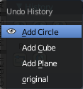
Undo History
Undo History opens a menu where you can redo a last action in history.

Repeat last
Repeat last repeats the last operation. For example, when you have moved a object by 5 in x, then it moves the object by 5 in x with every new repeat last step.

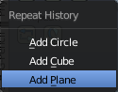
Repeat History
Repeat History calls a menu with the last actions where yon can choose an action to be repeated.

Tool Shelf in all Modes - Tools Tab - Bake Panel general

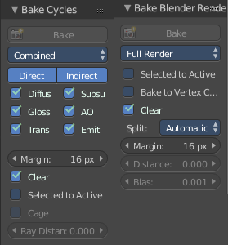
Bake Panel
Texture baking is the process to bake specific informations from one object into the texture or the vertex colors of another object. Ambient Occlusion. Or a Normal Map for example.

NOTE
Baking requires to have a working UV mapping and a texture at the target object!

How to use: Select the source object where you want to bake from, hold down Shift, select the target object where you want to bake to, so that both objects are selected. Adjust the settings to your needs. Then hit the Bake button.

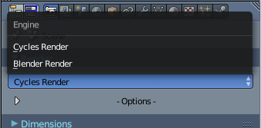
Texture baking can be done with two available render engines. Blender Internal. And Cycles. The list of available bake types differs a bit, even when some of the texture types are similar.

Which renderer gets used for baking can be adjusted in the Properties Editor.

When you have the Blender Render selected then the Bake Panel is called Bake Blender Render. When you have the Cycles Render selected then the Bake Panel is called Bake Cycles.

NOTE
The Bake panel is visible in all Modes. But you have to bake in Object Mode.

Tool Shelf in all Modes - Tools Tab - Bake Blender Render

When you have Blender Renderer selected then the Bake panel will show the settings to bake with Blender Render.

Texture baking uses the settings of the chosen renderer. This includes Antialias, Global Illumination, Ambient Occlusion, etc.

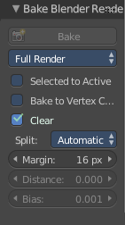
Settings for all Texture types
Most settings in the Bake panel are available for all texture types.

Bake
The Bake Button will start the baking process.

Bake Mode
Bake Mode is a drop-down box where you can choose what type of information you want to bake from the source object into the texture or the vertex colors of the target object.
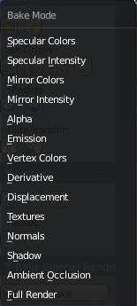
You can bake Specular Colors, Specular Intensity, Mirror Colors, Mirror Intensity, Alpha, Emission, Vertex Colors, Derivate, Displacement, Textures, Normals, Shadow, Ambient Occlusion and Full Render.

Specular Colors
Bakes the specular colors of a material into the texture of the target object.

Specular Intensity
Bakes the specular intensity of a material into the texture of the target object.

Mirror Colors
Bakes the Mirror colors into the texture of the target object.

Mirror Intensity
Bakes the Mirror Intensity of a material into the texture of the target object.

Alpha
Bakes the Alpha channel colors of a material into the texture of the target object.

Emission
Bakes the Emission colors of a material into the texture of the target object.

Vertex Colors
Bakes the Vertex colors of the source object into the texture of the target object.

Derivate
Bakes the Derivate colors of a material into the texture of the target object.

Displacement
Creates a displacement map by using the vertex positions of the source object, and baking them as greyscale colors into the texture of the target object.

Textures
Bakes the texture colors of the source object into the texture of the target object.

Normals
Creates a Normal map by using the normals of the source object, and baking them as colors into the texture of the target object.

Shadow
Bakes the Shadow into the texture of the target object.

Ambient Occlusion
Bakes the Vertex colors of the source object into the texture of the target object.

Full Render
Bakes the full rendering, means materials, textures, lightning, into the texture of the target object.

Selected to Active
The usual way to bake is first select the Source Object, where you want to bake from, hold down Shift, select the target object where you want to bake to, so that both objects are selected. Then hit the Bake button. That's Selected to Active.

Bake to Vertex Color
Usually bake bakes into the texture of the target object. Bake to Vertex Color bakes the information into the Vertex colors of the mesh instead into the texture.

Clear
Clear clears the target image before baking.

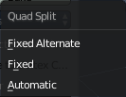
Split
Here you can adjust the Quad Split method for baking.

Margin
Adjust the margin width.

Distance
Maximum Distance in Blender Units from source object to target object(s).

Bias
Bias in Blender Units towards faces further away from the object(s).

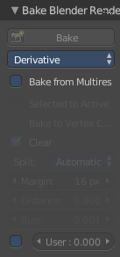
Settings for specific Texture types

Derivative

Bake from Multires
Bake directly from Multires mesh.

User
Here you can apply a user scale to the derivate map instead of automatically normalizing to 0-1.

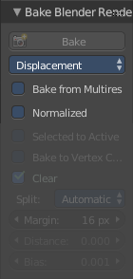
Displacement

Bake from Multires
Bake directly from Multires mesh.

Normalized
Normalizes to the Distance.

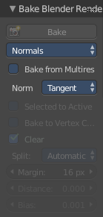
Normals

Bake from Multires
Bake directly from Multires mesh.

Normal Space
Normal Space is a drop-down box where you can choose what normals to calculate.
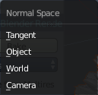

Ambient Occlusion

Bake from Multires
Bake directly from Multires mesh.

Normalized
Normalizes without using material settings.

Tool Shelf in all Modes - Tools Tab - Bake Cycles

When you have Cycles as the Renderer selected then the Bake panel will show the settings to bake with Cycles Render.

Texture baking uses the settings of the chosen renderer. This includes Antialias, Global Illumination, Ambient Occlusion, etc.
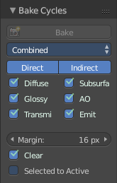

Settings for all Texture types
Most settings in the Bake panel are available for all texture types.

Bake
The Bake Button will start the baking process.

Bake Type
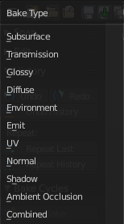
Bake Mode is a drop-down box where you can choose what type of information you want to bake from the source object into the texture or the vertex colors of the target object.
You can bake Subsurface, Transmission, Glossy, Diffuse, Environment, Emit, UV, Normal, Shadow, Ambient Occlusion and Combined.

Subsurface
Bakes the Subsurface Passes of a material into the texture of the target object.

Transmission
Bakes the transmission Passes of a material into the texture of the target object.

Glossy
Bakes the Glossy Passes of a material into the texture of the target object.

Environment
Bakes the Environment texture into the texture of the target object. As seen from the center of the object.

Emit
Bakes the Emission or the glow color of a material into the texture of the target object.

UV
Bakes colors of materials and textures only, without shading.

Normals
Creates a Normal map by using the normals of the source object, and baking them as colors into the texture of the target object.

Shadow
Bakes the Shadow into the texture of the target object.

Ambient Occlusion
Bakes ambient occlusion as specified in the World panels. Ignores all lights in the scene.

Combined
Bakes the full rendering, means materials, textures, lightning, into the texture of the target object. Except Specularity.

Margin
Adjust the margin width.

Clear
Clear clears the target image before baking.

Selected to Active
The usual way to bake is first select the Source Object, where you want to bake from, hold down Shift, select the target object where you want to bake to, so that both objects are selected. Then hit the Bake button. That's Selected to Active.

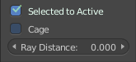
Cage
This setting is hidden as long as Selected to active is not ticked.
Cast Rays to active object from a cage.

Ray Distance
Distance to use for the inward ray cast when using Selected to Active.

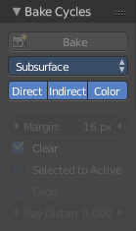
Settings for specific Texture types

Subsurface, Transmission, Glossy, Diffuse

Direct
Add direct Light.

Indirect
Add indirect Light.

Color
Add Color.

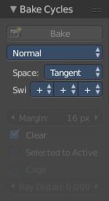
Normal

Space
A drop-down box where you can chooses the Normal Space to use.

Swizzle
Axis to bake in red, green and blue channels.

Normals

Bake from Multires
Bake directly from Multires mesh.

Normal Space
Normal Space is a drop-down box where you can choose what normals to calculate.

Ambient Occlusion

Bake from Multires
Bake directly from Multires mesh.

Normalized
Normalizes without using material settings.

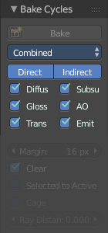
Combined

Direct
Bake directly from Multires mesh.

Indirect
Normalizes without using material settings.

Diffuse
Bake with Diffuse.

Glossy
Bake with Glossy.

Transmission
Bake with Transmission.

Subsurface
Bake with Subsurface.

AO
Bake with Ambient Occlusion.

Emit
Bake with Emit.

